Occupational Therapist Procedure for Daily Notes

Checking in Appointment 2
Daily Subjective 3
Goals Addressed/Assessment Information 3
Assessment (S); freeform narrative text box: 6
Plan 8
Charges 8

Checking in Appointment
- On your daily scheduler you will right click on the client appointment in the EMR system and hit check-in UNLESS they have already checked in at the kiosk/front desk. There will be a yellow box in the upper left-hand corner to indicate a client has been checked in to their appointment.
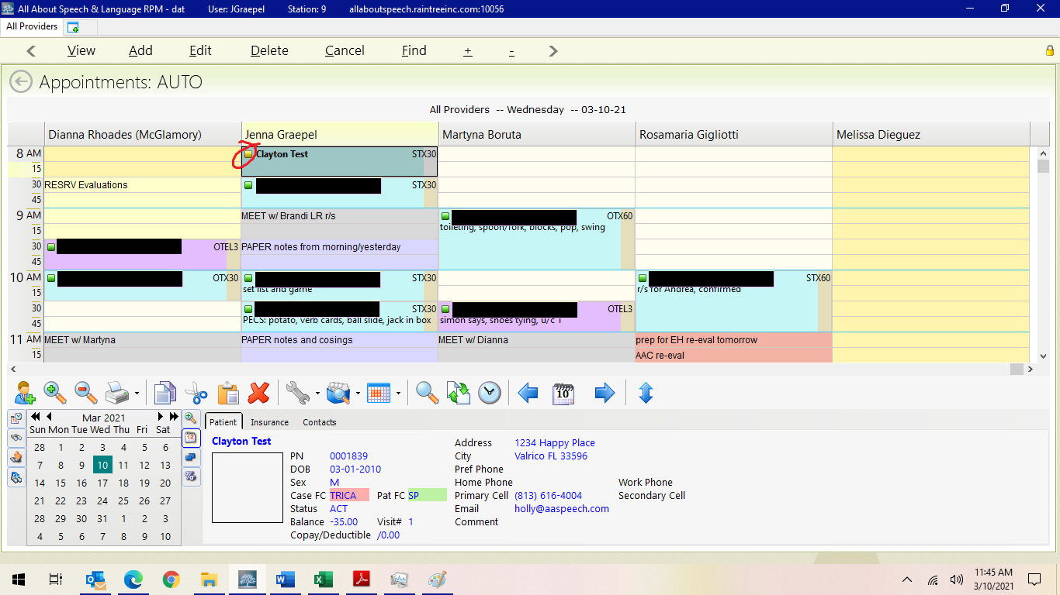
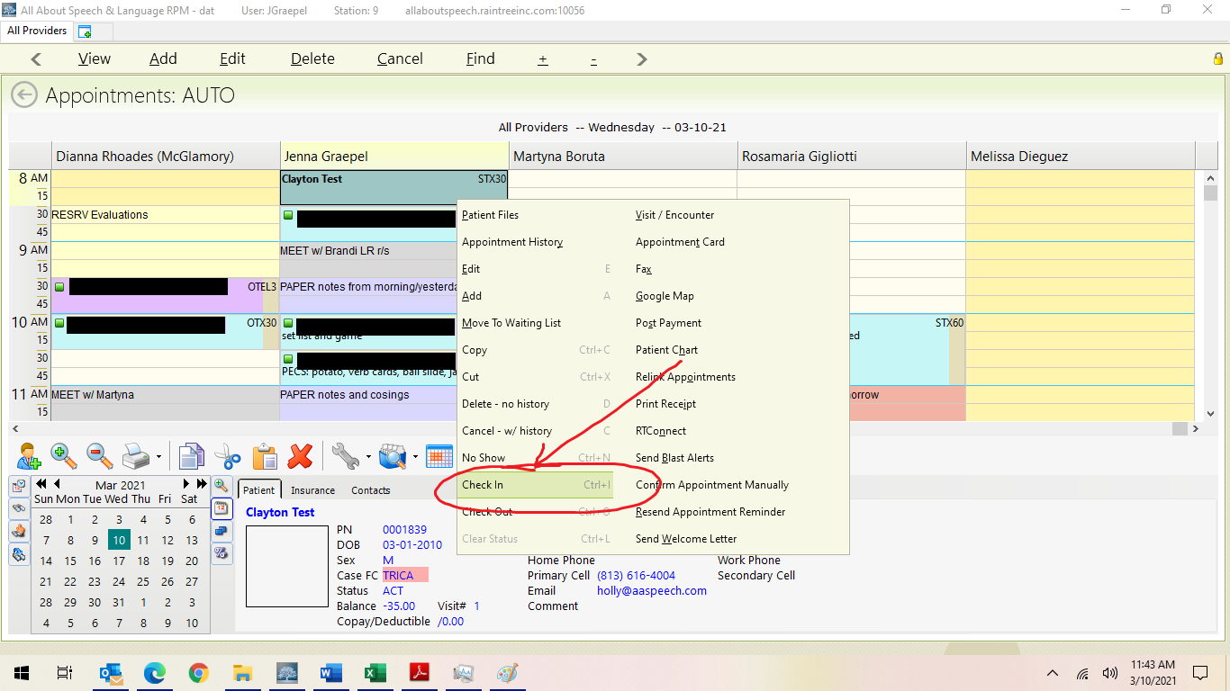

- This will initiate the daily note for that visit. Double click the appointment to open the note.
- You will work across the following tabs and fill out the respective information in each section

Daily Subjective
- Use boxes to fill in with check boxes
- Narrative comments/freeform descriptions are optional here, usually written in the Assessment portion. Please be mindful of your word choice when adding information to the subjective section. It needs to be factual while also being pragmatic. Cause of behaviors cannot be assumed but can be described.

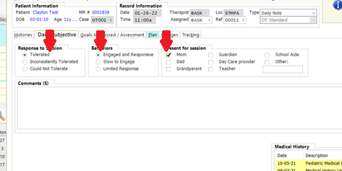

Goals Addressed/Assessment Information
- Goal Selection: Select each long-term goal that is pertinent for each session (carrot arrow on the left side of each long-term goal). Double click a long-term goal to populate its corresponding short-term goals.
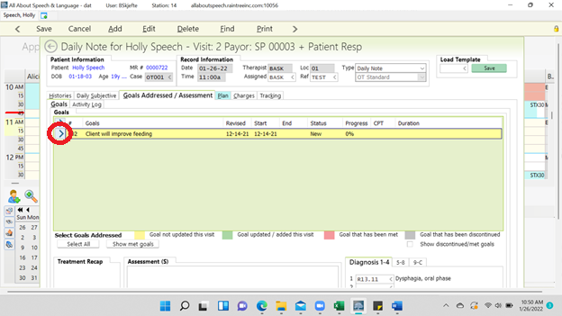
- The short-term goals will initially be grayed out- select “Address Goal” button
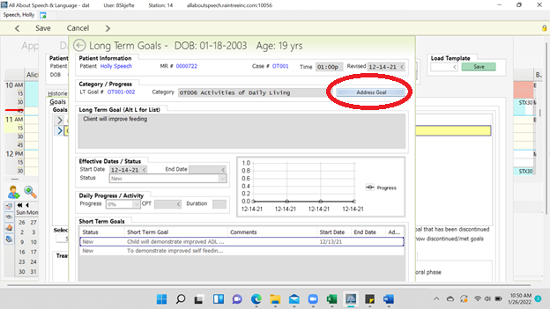

- Double click on the short-term goal “status” to open the comment box.
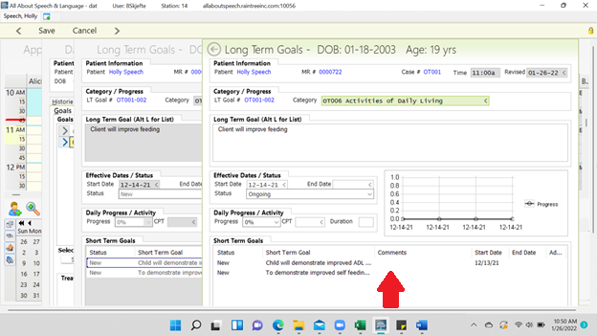

- Review all cells and select applicable options:
    - Status: Met, Ongoing, New (new goals need to be changed to Ongoing if they are being selected/addressed)
    - Comments: If you have already addressed this goal in the Assessment portion, you do not need to comment again. You may add “See data” in the comment box in its place. You can add commentary here if you feel it is necessary (i.e. “Goal met 1/3 sessions”).
    - Start Date – This should already be inputted from the date the goals were added (from the initial eval, re-eval, or progress note).
    - End Date – Add the date when the goal was met or discontinued
    - Addressed – Select “Yes” (Note, when you select “yes” for addressing that goal, it will populate on the final draft)
    - Once the aforementioned cells are completed, select “Save” which is located at the top-left side. Repeat for each short-term goal you addressed in the session.

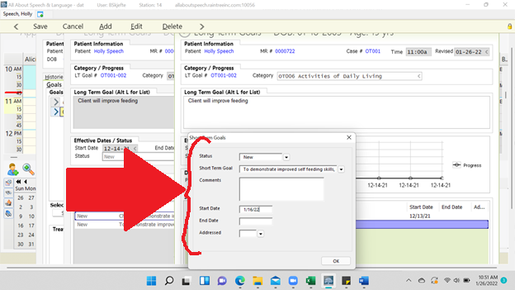

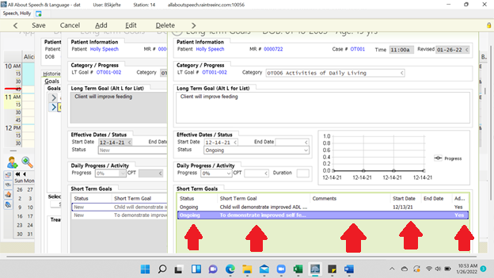

Assessment (S); freeform narrative text box:
- Right click the text box directly under the word “Assessments” and select the word “Edit”. This will open the text box. Here you will write your note in a narrative form.
- For Mac users, make sure you are opening up the box (see lower right corner to expand or hit control + e to expand) to view with spell check. If you type in the box as it initially appears, you will not see edits that need to be made.
- Once you have completed your note, select “close editor”.
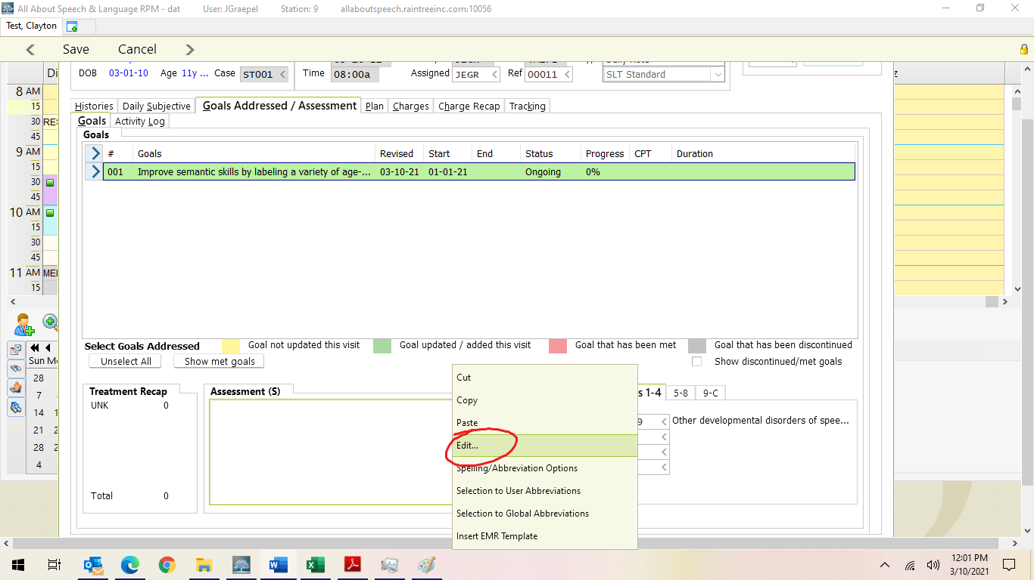
- Please see your CM for examples of OT Daily Notes.
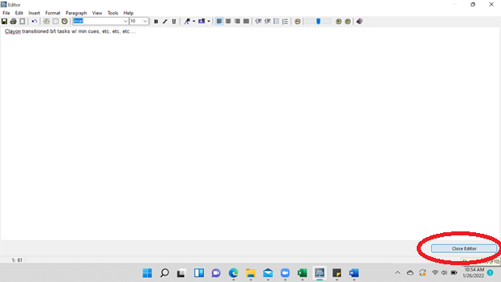

Plan
  - Use boxes to fill in cells below: the “Plan”, “Tolerance to Treatment” (including: excellent, fair, good, poor). Make sure to select the cell “Parent and caregiver consent to treatment plan.

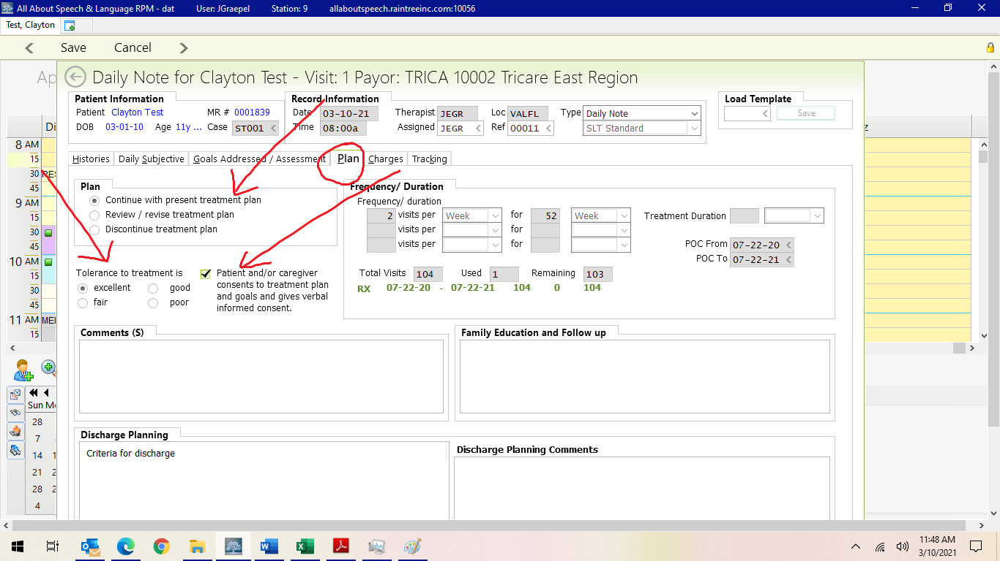

Charges
- Apply all charges to notes before end of the same business day and complete the written note by the end of the next business day.
- Under 97530 Therapeutic Activities enter the number of units for Tricare clients *Follow 8-minute rule* (1 unit=15 minutes of treatment; a 30-minute session would be 2 units) .
- Therapeutic Activities 30/45/60-SP are for clients that are self-paying, FES/Step Up Scholarship. Select the appropriate duration for each session.

CHARGES FOR TRICARE INSURANCE
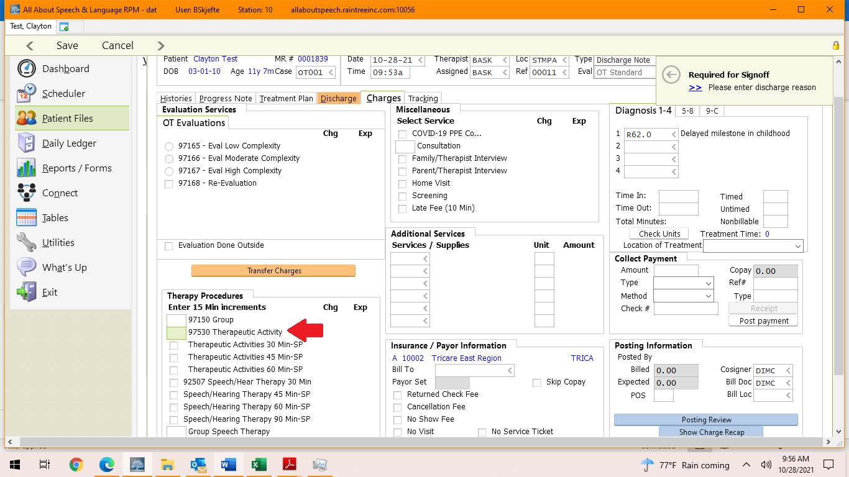

CHARGES FOR SELF PAY/SCHOLARSHIP
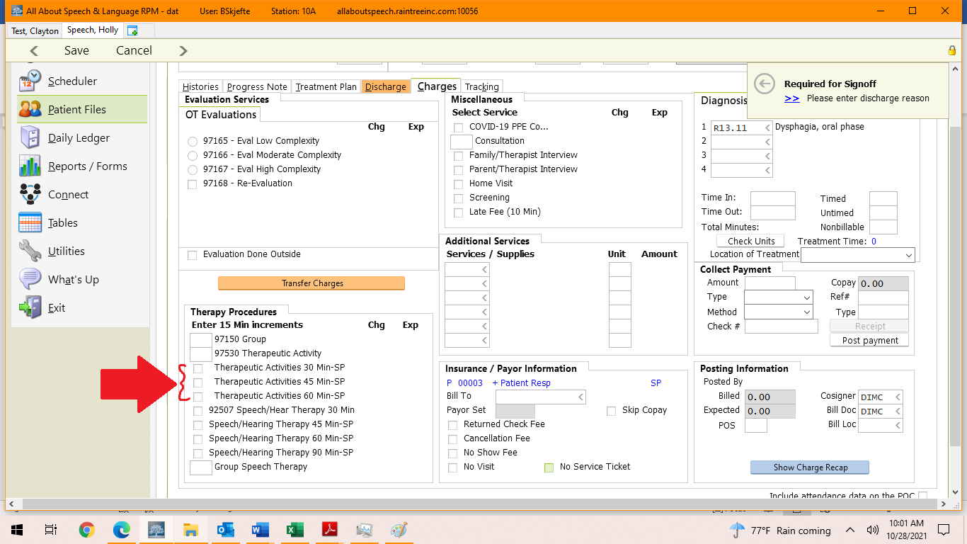

- Once you have completed all the tabs (Daily Subjective, Goals Addressed/Assessments, Plan, Charges) click “Save”, at the top left corner. Then select “Save and sign off” on the bottom right corner. This will then prompt you to put in your Raintree password – Note if you are not done with your note and need to revise or come back later to complete it, you will select “Save and Exit”. You can then access the note from your scheduler again later.
  - If your notes are being cosigned, and you have to make revisions, please select “save and mark reviewed” once changes are completed so your cosigner knows the edits have been made.

