Contents

Offering a Telehealth Option 2
Using Zoom for Telehealth Appointments 3
Last Minute Switch to Telehealth: 7
Policy: 7
Out of State Restrictions: 8

Offering a Telehealth Option for Reschedules OR Emergency and Weather-Related Office Closure
- Reschedules: If a client has not attempted a telehealth session, but you think they would be a good fit:
  - “Hi _____! Given your absence today/this week, I’d love to offer a teletherapy appointment to ensure we continue to progress towards meeting our goals. It would be a great opportunity to practice in your home environment for carryover and generalization of skills. I am confident _____ will do very well with this platform and if it is not successful, we will know for future sessions.”

- In the occurrence of emergency or weather-related office closures, you and/or Front Desk will respectfully communicate to clients about options for rescheduling. Feel free to use the provided verbiage as a template to guide you:
  - For families who did virtual during COVID OR you know they would be a good fit for it:

"Hi _______! I wanted to be in touch that tomorrow all in-person appointments will be moved to virtual sessions due to the unknowns of the tropical storm. We want to keep our families and whole team safe! Our usual in-person session will take place at the same time tomorrow, (time); I will send you the Zoom link to connect on your computer or tablet. Look forward to seeing you then and working toward our goals!”

  - For families who you do not think are the best fit for Virtual:

"Hi _______! I wanted to be in touch that tomorrow all in-person appointments will be moved to virtual sessions due to the unknowns of the tropical storm. We want to keep our families and whole team safe!
I wanted to give you the options: We can schedule a virtual session in which you will be "my in-person hands" given coaching I will directly provide to you over the computer screen or tablet. We will both be involved in the session together in this way which is proven to be an effective mode of delivery for therapy.

OR, we can reschedule our in-person session next week or during the week of ______ (when kids are off from school). I have _______(time/day) or _______(time/day) available. Which works best for you? [If they decline these two options.....work with them to identify another free time and remind them there's more flexibility during _______ week for AM and PM times (given many kids have no school).”

  - For families who are NEW and never participated with virtual before: follow step 1 or 2 depending on if you believe they are a fit or not. Be excited and proactive to encourage giving virtual a try!

Using Zoom for Telehealth Appointments
- If you are going to be conducting teletherapy with a client, you will need to use the Zoom platform that the company has purchased and is licensed with. AASL has purchased the HIPAA compliant version with Zoom for use with clients.
- Upon onboarding, Brieann will set you up with a licensed zoom account.
- Once set up, you will use your Zoom to set up meetings for your clients. You will need their email to send them the meeting invite so they can use this to join your meetings each week. Please use the EMR system for accessing client emails. You can set up weekly, recurring meetings via the app or website by doing the following:
  - Select “Schedule a Meeting”
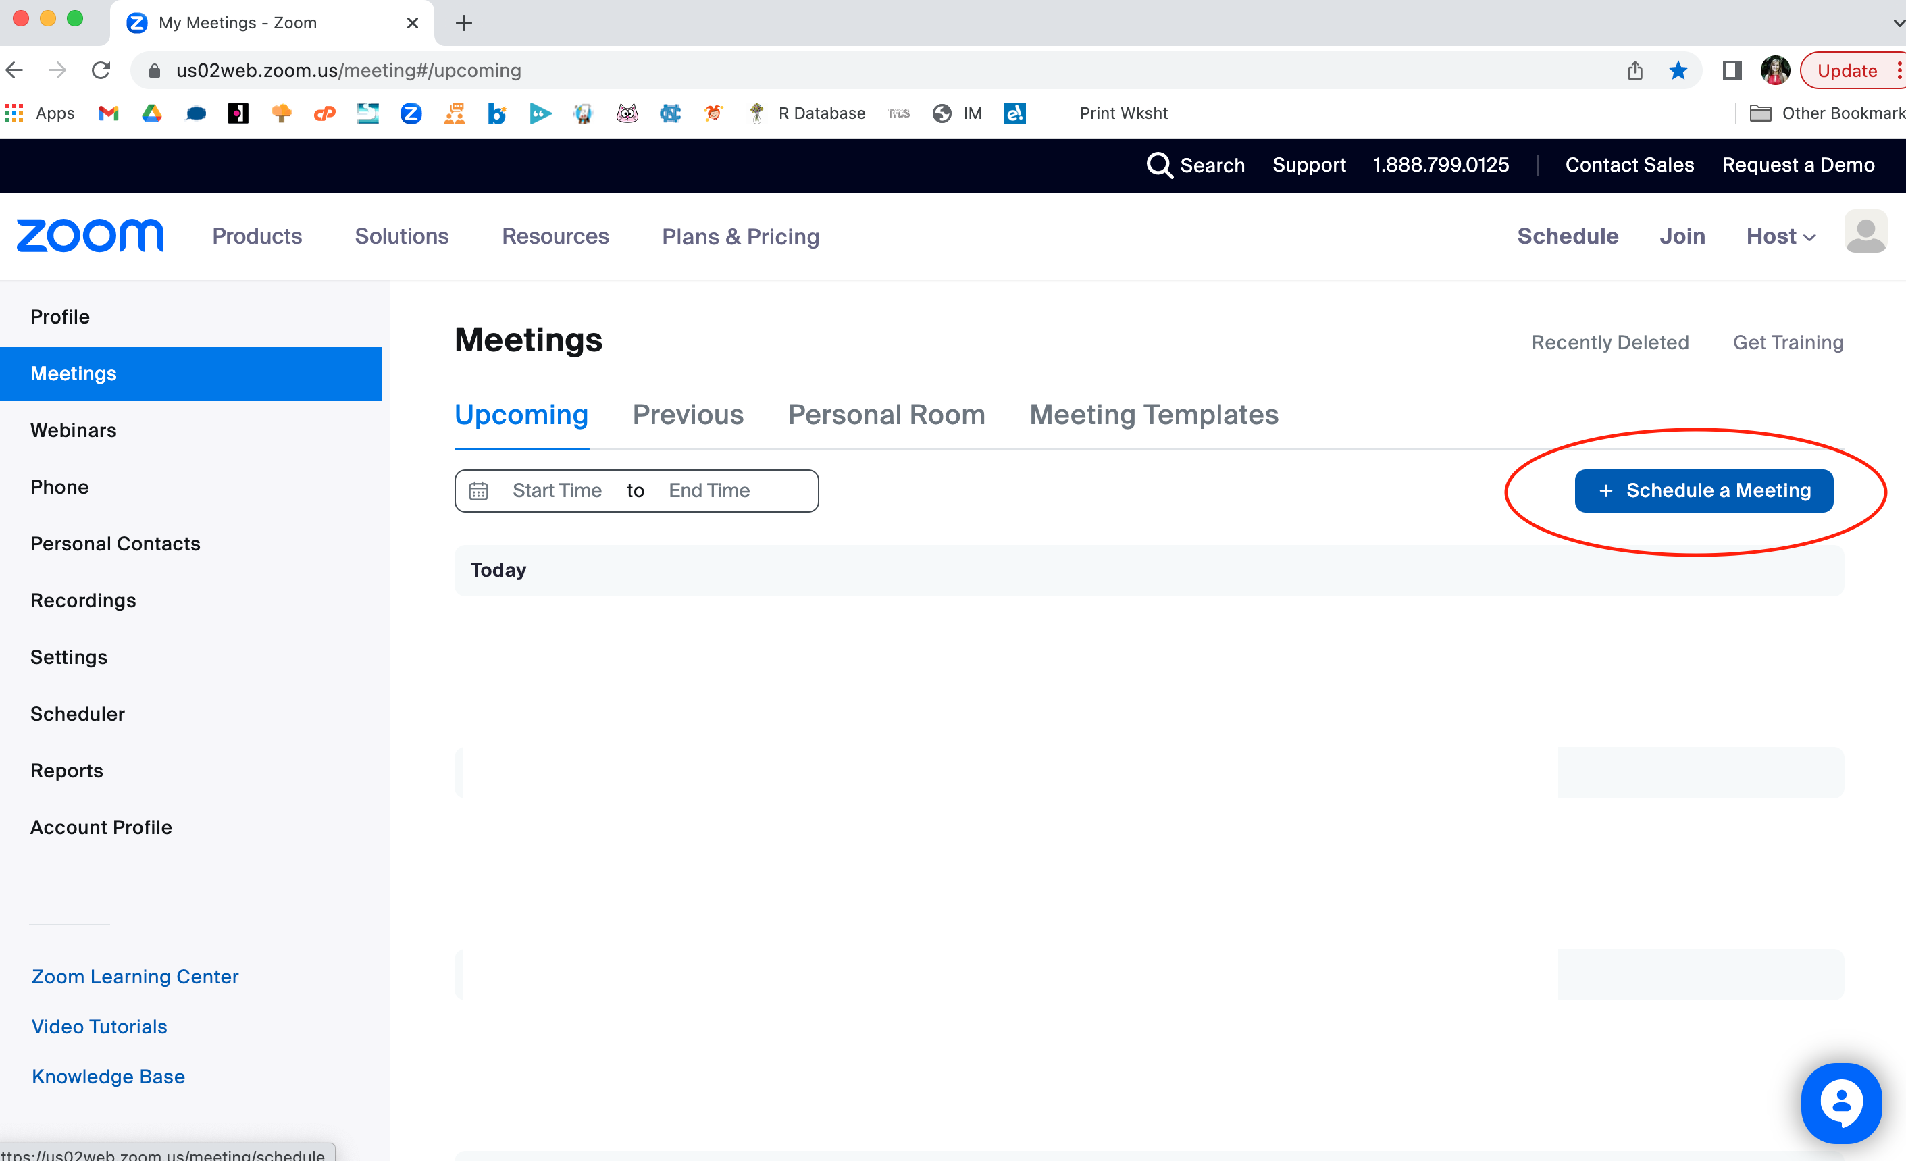
  - Name the meeting.
    - Recurring Meetings
      - Check the “recurring” box for recurring meetings; you may change the recurrence and repeat features accordingly but it is also not required. The specified Date/Time options will not disappear if you select “recurring.” You will need to also select “no fixed time” under Recurrence.
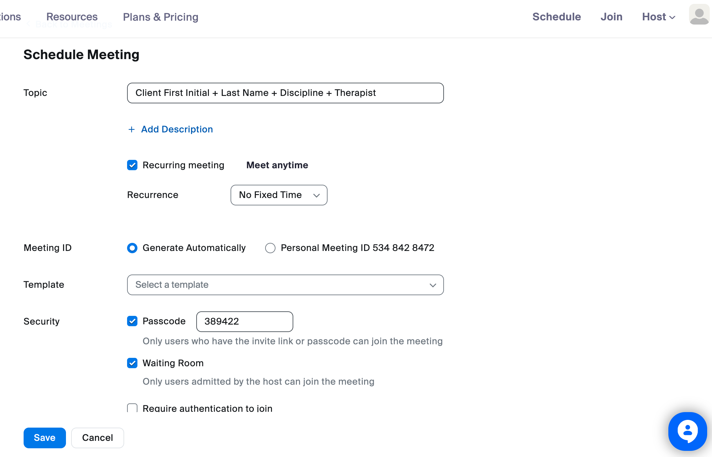
    - Rescheduled Appointments with client’s not on your regular caseload
      - Label with the client’s first initial and last name with YOUR name and the date and time (i.e. E. Hayes Speech with Ms. Brittany 5/23/23 4:00)
  - You may choose to include passcode or enable the waiting room for accessing the Zoom meeting; You must select one of these options. Waiting Room is preferred by most therapists regardless of enabling passcode.
  - Any features that are already auto-filled in by Zoom you can leave as is.
  - Select “Save” to save the meeting; this will then generate a link for you to share.
  - You can then copy the invitation on the next screen and paste that into an email to your client from your AASL email account so they are able to join by clicking on the link accordingly
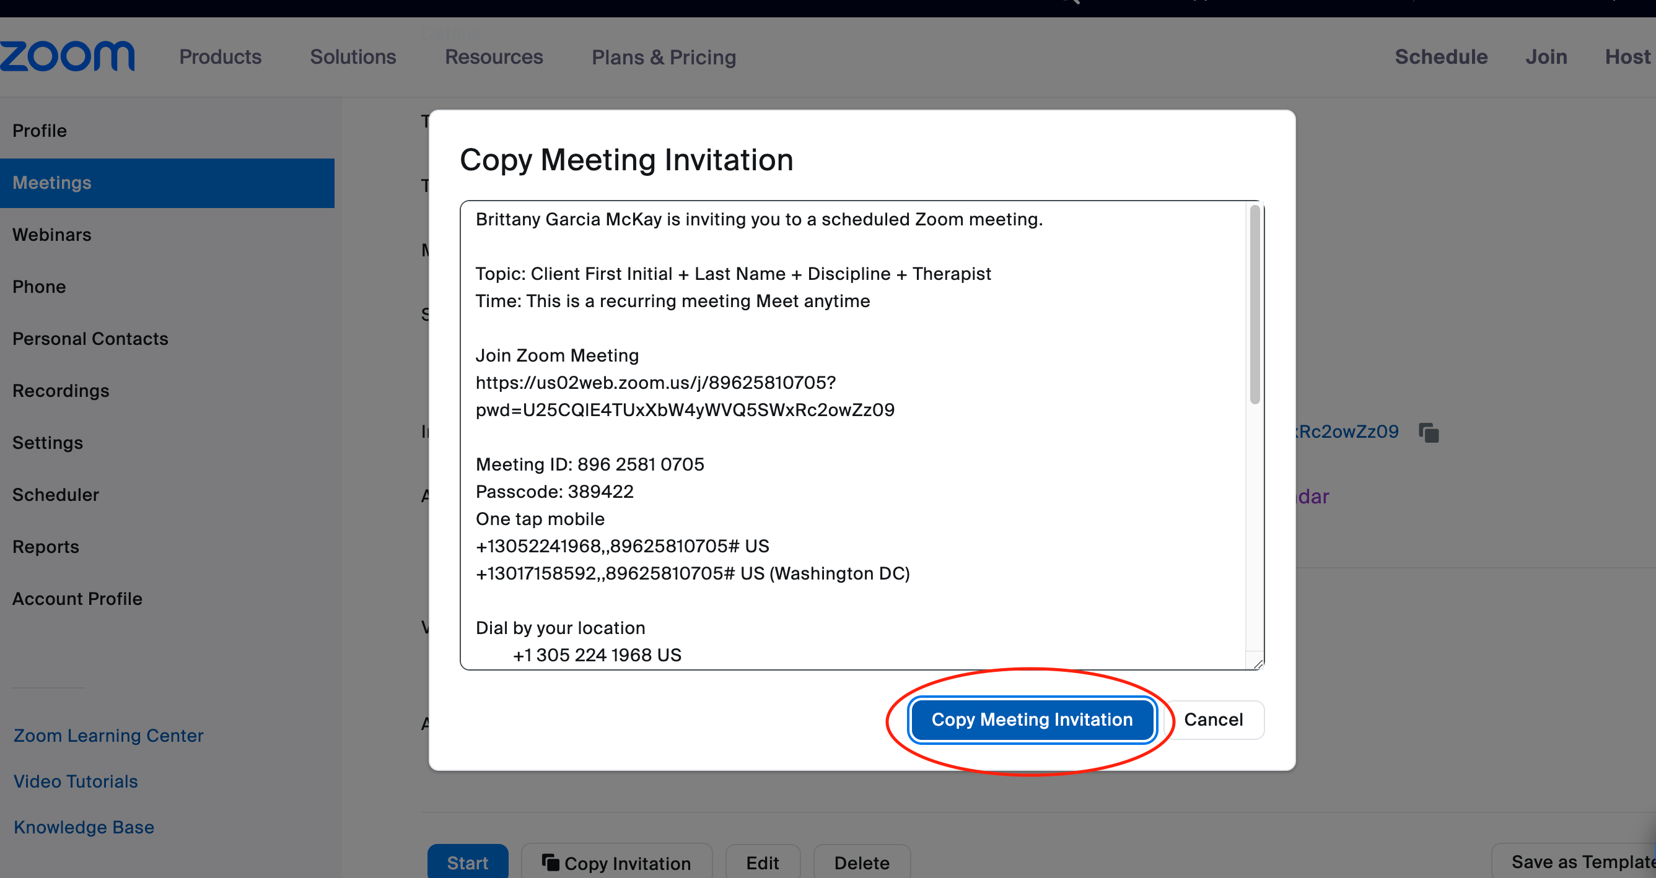

- Be sure to change the appointment type to telehealth, you will need to change the Location and Type of appointment. You will right click the appointment in Raintree and select “Edit” Use the following codes:

Location  - TELE for telehealth South Tampa clients  - TELEV for telehealth Valrico clients | Type  - STEL3 for 30 min ST  - STEL 6 for 60 min ST  - OTEL3 for 30 min OT  - OTEL 6 for 60 min OT

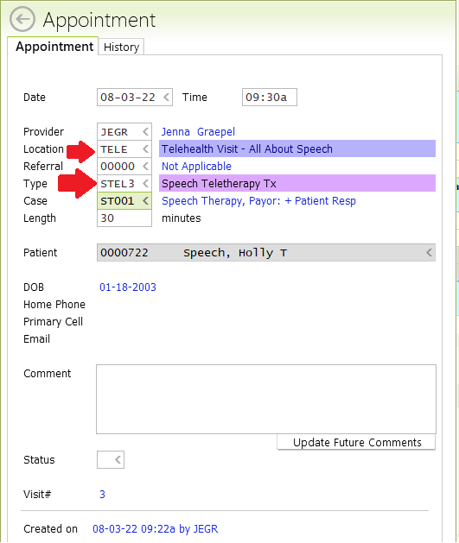

- Add the zoom link to the client’s chart/communication log so that it may be used for future visits or so that front desk can easily share with parents if they misplace the link.

- You will then follow then conduct the therapy session as you would an in-person session.

- Use company-provided or other teletherapy resources (below):

- UltimateSLP.com, everdayspeech.com, etc. on company website with logins and passwords  - Boom Cards (not provided by the company but team members can use and purchase on their own) | - Google Drive with Teletherapy Folder and respective links  - Resources shared by Colleagues  - In-office Materials

- Communicate with your client about what materials you would like them to use from home as a part of your session
- Zoom has the “screen share” feature to use and share your browser with the client for interactive games/websites, as well as their white board feature to write/type on, and you can also give shared mouse control access for your clients to take control of our mouse for shared, interactive activities

Last Minute Switch to Telehealth:
For clients that contact you directly and/or the front office for asking to move an in-person therapy session to a telehealth session with less than 24 hours’ notice: Your username and password for your Zoom account will be provided to Front Desk Division so they can access this information to help set up zoom visits for these appointments. These credentials are to be shared with Front Desk Division upon creation of the account.

- If the family contacts you directly and does not already have a recurring link set up, forward the email to Front Desk.
- Front Desk will then follow up with the family directly to confirm moving to a telehealth session.
  - If covering a session for a client who is not normally on your caseload: a link will be sent by Front Desk for that day only.
  - If a family on your regular caseload switches to teletherapy for a makeup session, a recurring link will be sent that they can use for all future appointments that switch to telehealth.
- Front Desk will then email the family the Zoom link, cc the treating therapist as confirmation, and change the visit type in RT to designated telehealth session. PLEASE NOTE: A one-time passcode may be required by Zoom to allow Front Desk access to your account. In the event that you cannot get Front Desk the code in time, you may be required to create and send the link yourself.
- Front Desk will also verbally re-iterate to the family while on the phone and include in the follow-up email to the family cc the treating therapist the policy as outlined below

Policy:
- For therapy appointments that get moved day of from in person to telehealth sessions, with less than 24 hours’ notice, all wrap ups will be forgone with the parent for that session only, and therapists will use the first 5 minutes of a 30-minute session or the first 7 minutes of a 60-minute session (in place of the wrap up) to make sure they are adequately prepared for their session given the change of materials, platforms, etc. They will then start the session and conduct it until the end of the session (on the :30 or :00), again foregoing wrap up for this session only.

- As a reminder to ensure the highest quality experience for this telehealth session, please refer to our list of Teletherapy Reminders (please let us know if you need this document re-sent to you again for reference). It is imperative that, whenever possible, a telehealth session take place in a quiet environment without distractions for the integrity of the therapy session to be preserved. Thank you for your cooperation!

Out of State Restrictions:
- If the client is temporarily located in a state where they do not reside at the time of service, ASHA suggests contacting that state’s licensure board to determine whether the board will allow services to be provided within their state if an emergency provision is not in place. Members are encouraged to indicate that the client is a permanent resident of the state where you are credentialed and that there is an existing client/provider relationship

(https://www.asha.org/advocacy/serving-clients-in-other-states-and-countries-through-telepractice-in-a-private-practice/)
https://www.asha.org/siteassets/uploadedfiles/state-telepractice-policy-covid-tracking.pdf

If you have a client out of town (outside of FL), use this PDF as a guide. Look at the state and the requirements to determine if the client can be seen based on where they are located.

Updated May 2023

