Contents
Scheduling Information 2
Client Services Correspondence 3
Tracking Re-Evaluation and Progress Note Due Dates 6
Reviewing Patient Chart Information 10
Checking Authorization for Re-evaluations 16
Checking Out Therapy and Evaluation Measures & Preparing Protocols 20
Greeting for an Evaluation 21
Establishing Rapport 21
Conducting the Evaluation 22
Scoring Protocols and Expanded Procedures for Drafting Report in EMR System: 23
Handling Clients Who Do Not Qualify for Therapy 27
Subjective Tab: 28
Objective Tab: 33
Standardized Tests 35
Treatment Plan Tab and Pick Lists for Short-term Goals: 39
Updating, Meeting, Discontinuing Goals for Re-evaluations 46
Assessment Tab: 50
Recommendations Tab: 52
Charges: 60
Adding Diagnoses Codes 60
Cosigns: 63
Shared Clients: 64
Further information regarding Literacy Only Evaluations: 64
BOTTOM LINE/NEW CLIENT ACQUISITION FULL LOOP 66

Scheduling Information
SCHEDULING INITIAL EVALUATIONS
- Client Services handles all scheduling and rescheduling of initial evaluations. Once scheduled, you will receive an email from Client Services including the date, time, and a brief summary of concerns.
- Client Services will contact the family if the medical history has not been received at the one-week mark prior to the evaluation. If the medical history has still not been received at the time of the evaluation, a hard copy will be provided to the family at the time of the evaluation.
- For an initial evaluation day of, please inform Patient Scheduler if your evaluation is 5-8 minutes late so they can reach out accordingly.

SCHEDULING RE-EVALUATIONS
- Please see section on tracking re-evaluations and progress notes below. Therapists should attempt to schedule re-evaluations during a client’s regular treatment time by extending the session, if warranted, to 60 minutes or by scheduling the evaluation another day and time that the client is available. In the case neither of the aforementioned options works, a re-evaluation can be split into the client’s 2 30-minute sessions at their usual appointment time. If a therapist is unable to successfully schedule a re-evaluation appointment, they may recruit the help of Front Desk.
  - For Tricare clients, the therapist will use Raintree to confirm an upcoming re-evaluation due date will coincide with the authorization’s Date of Service (DOS) for the evaluation. If the date of the authorization and the due date of the re-evaluation do not coincide, the therapist will email the designated employee checking Tricare authorizations (see ORG Board) so she can extend the DOS on the authorization, and make a note in their calendar one month prior to the re-evaluation due date to start the re-evaluation process.
- Once confirmed, change the appointment type on your schedule to “STREV”; adjust time if needed. Notify Front Desk of scheduled re-evaluation.
  - If the client is SELF-PAY and the evaluation is being split into two 30-minute sessions, please notify Front Desk. The first session will be booked and changed to STREV. The second appointment will be deleted from the scheduler, but the time will be reserved so that the family can have testing completed in the allotted 60 minutes, but they are not being billed for another session.
  - If the client is TRICARE and the evaluation is being split into two 30-minute sessions, please get with your CM to review steps.
- Front Desk Receptionist will send an email to the family to confirm the re-evaluation date, attaching the Re-evaluation Parent Questionnaire form asking to receive back at least two-weeks prior to scheduled re-evaluation.
- Once the Parent Questionnaire is received, the Front Desk Receptionist will notify the treating therapist that pertinent documents are uploaded to RT and ready for review.
- If we do not have the medical history update prior to the time of the re-evaluation, Front Desk Receptionist will either hand deliver to family, or request that the treating therapist do so. It will then be scanned into the chart (in the documents tab) and emailed to the evaluating therapist.
- Front Desk will provide the family the AASL Quality Assurance Form at time of check-in for the re-evaluation, asking them to fill out and return before they leave. Front Desk will scan and email the form to the Clinic Manager, and upload the form to the client’s chart upon receipt.

FOR INITIAL AND RE-EVALUATIONS:
Therapist will email Front Desk (cc’ing Patient Scheduler for initial evaluations) within one business day of completing the evaluation with the recommendations for therapy moving forward, the frequency and duration. Front Desk needs this information to satisfy the regulations of the No Surprises Act, Good Faith Estimate, to inform the client of the 12-month projected cost of therapy services.
  - NOTE: Frequency and duration should always be what would benefit the child the most and ensure the estimate is based on this amount of therapy recommended for the child. This is crucial as it provides the Front Desk with the needed information to fill out the form.
  - The Front Desk will always fill out the form per the recommendations of the re-evaluation, not the actual scheduled appointments which could be less due to scheduling conflicts, client’s tolerance level, etc.

Client Services Correspondence

TRICARE Authorizations
At the time of their upcoming expiration on their authorization/referral, the designated employee checking Tricare authorizations (see ORG Board) will email the parent to notify them of the upcoming expiration (approximately one month in advance), copying Front Desk Receptionist and the treating therapist(s). Following is an example of the email:
Dear parent/legal guardian of _________________,

We hope you are having a great day!

AASL would like to remind you that you have an upcoming expiration to your annual authorization for us to provide therapy to your child. Following are the details:

Therapy Type: Speech
Authorization #: 1946-200914-00170
Expiration Date: September 6, 2021

We will require a new authorization with an effective date of: September 7, 2021, for us to continue providing therapy services without interruption. Some primary care physicians require an appointment with your child prior to issuing a new authorization; so, please plan accordingly.

Please note that a re-evaluation is required by TRICARE once per year in line typically with authorization renewals. A re-evaluation typically requires 60 minutes to fully execute. Your therapist will coordinate with you a day and time outside your current therapy session to conduct this re-evaluation. Your cooperation is appreciated in working with us to accommodate this re-evaluation as it will be required in order to ensure no disruption in therapy services.

Thank you so much for your prompt attention to this information. If you have already taken steps to get a new authorization, please disregard this notice.

Self-Pay
Front Desk Reception will email the parent/caregiver of the scheduled re-evaluation, copying the therapist, including the cost of such, with terminology consistent with the requirement of this annual assessment in order to ensure the proper goals are established and for purposes of assessing progress made on current goals, i.e.:
“AASL Family,
Hello! I am reaching out to notify you of your child’s upcoming (speech/OT) re-evaluation. The requirement of this annual assessment is to ensure proper goals are established and for purposes of assessing progress made on current goals. The cost of this re-evaluation is $190.00.

Ms. ______________ has available <Day of Week>, <Date>, from <timeframe>. Please be reminded that this is an annual evaluation, done one time per year, to ensure the highest level of continued therapy provided to your child.

To provide the therapist with the most accurate information, we will need you to update your child’s current medical history. Please find attached the Parent Re-Evaluation Questionnaire. In order to provide the best quality services, we need this back two weeks prior to the re-evaluation date, on <provide the due date one week prior>, to provide ample time for the therapist’s review.
Thank you for your assistance.

Raintree Visuals for scheduling re-evaluation appointments:
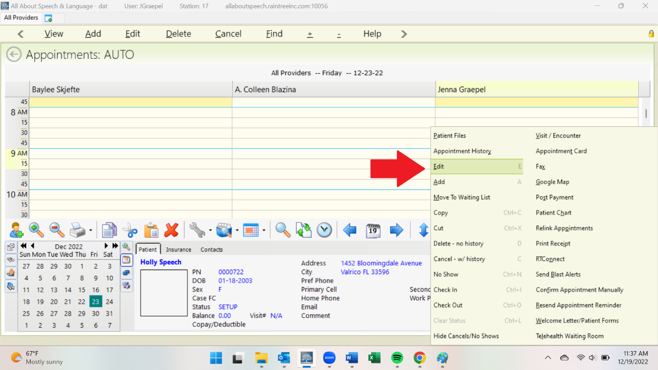

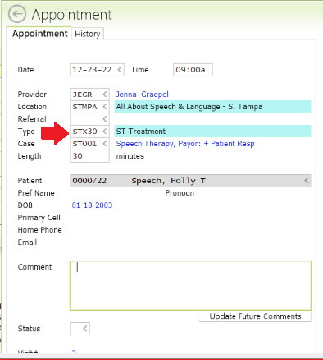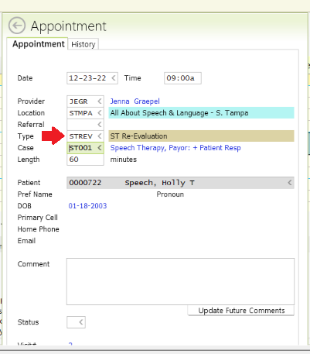

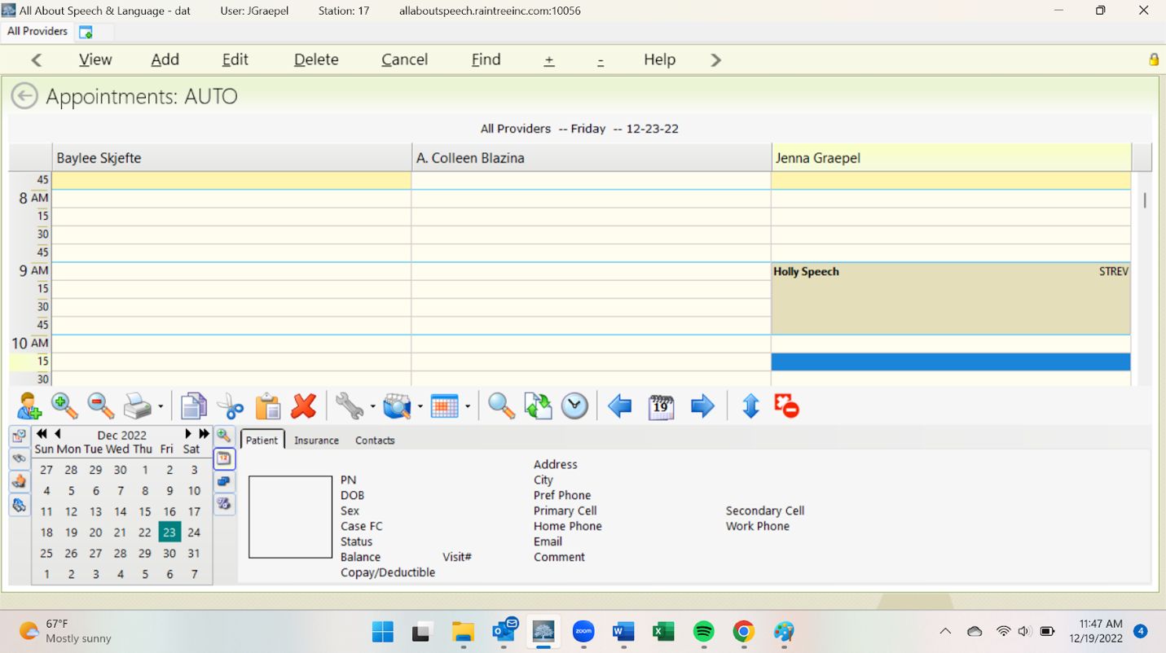

Tracking Re-Evaluation and Progress Note Due Dates
- It is the responsibility of the treating therapist(s) to:
- track due dates for re-evaluations/progress notes
- keep their dashboard up-to-date (i.e., remove discharged or covered clients), NOTE: Front Desk will monitor Flex Schedule clients’ due dates and notify treating therapists of upcoming due dates. Please communicate with your fellow therapists on sharing the responsibilities for progress notes and re-evaluations.
- ensure due dates are accurate (i.e., conversion note clients require manual updates)
- To track upcoming Progress Notes and Re-evaluations, use the chart below:
It is the responsibility of the treating therapist(s) to track due dates for re-evaluations and progress notes. Re-evaluations, in particular, require teamwork to make sure that we are prepared with paperwork and have appropriate communication with the family in preparation for the appointment. Raintree is a tool that should be utilized to efficiently track these due dates and this document contains the procedure for utilizing the Caseload Tab in a therapist’s Dashboard to do so. Login to Raintree and go to your respective Dashboard, locating your Caseload Tab. See chart below for tracking to ensure no re-evaluations are missed.

Date to start scheduling | Upcoming Re-eval Dates
End of January | March and April
End of February | April and May
End of March | May and June
End of April | June and July
End of May | July and August
End of June | August and September
End of July | September and October
End of August | October and November
End of September | November and December
End of October | December and January
End of November | January and February
End of December | February and March

FOR RE-EVALUATIONS: Start looking ahead at your schedule using the chart above and communicating with your family by the date listed to schedule the re-evaluation. Recruit Front Desk to help you in communicating with the family around getting the re-evaluation scheduled as needed (please attempt first on your own). As re-evaluations are approaching, begin commenting on goal areas at least 3 sessions prior to completing testing to determine goal progress.

- To update your Caseload tab, log into Raintree and go to your respective Dashboard, locating the tab titled “Case Load”:
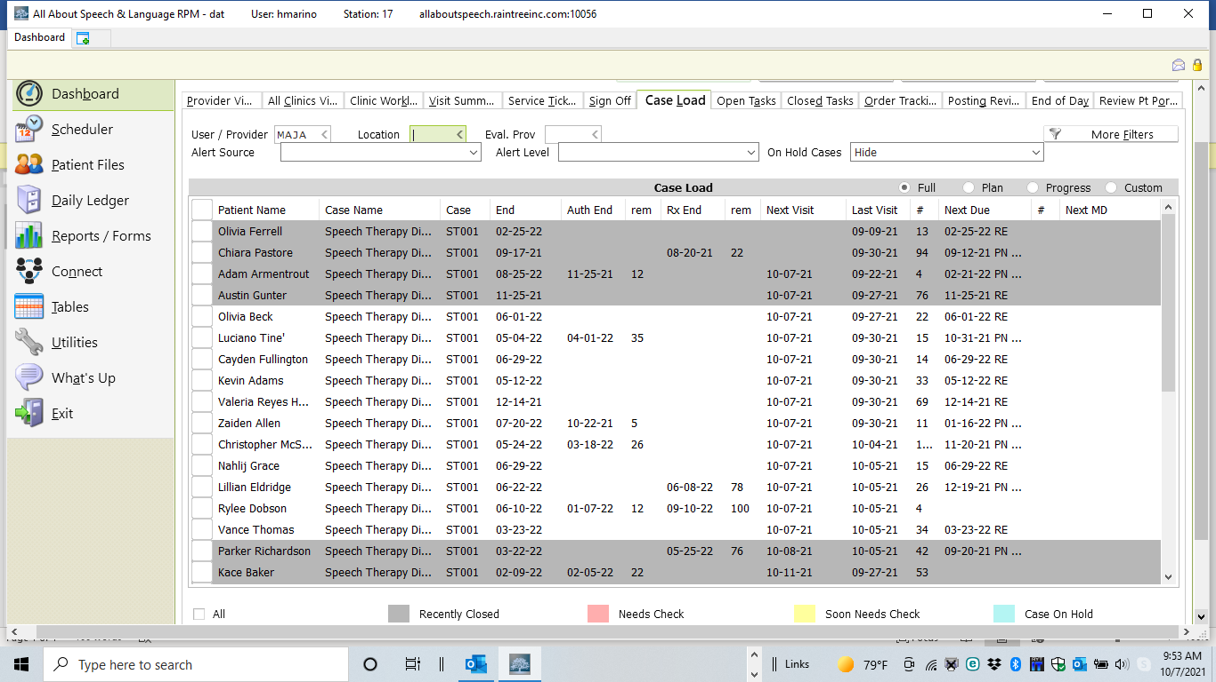

4. Remove clients seen for coverage, or clients no longer on your caseload by doing the following:
  - Select the client by checking the box next to their name
  - Select the Remove from Active Caseload button, located at the bottom of the screen. This will remove this client from your caseload list.
  - If the client dropped out or was discharged, please be sure to complete a discharge note prior to removing them from your caseload.
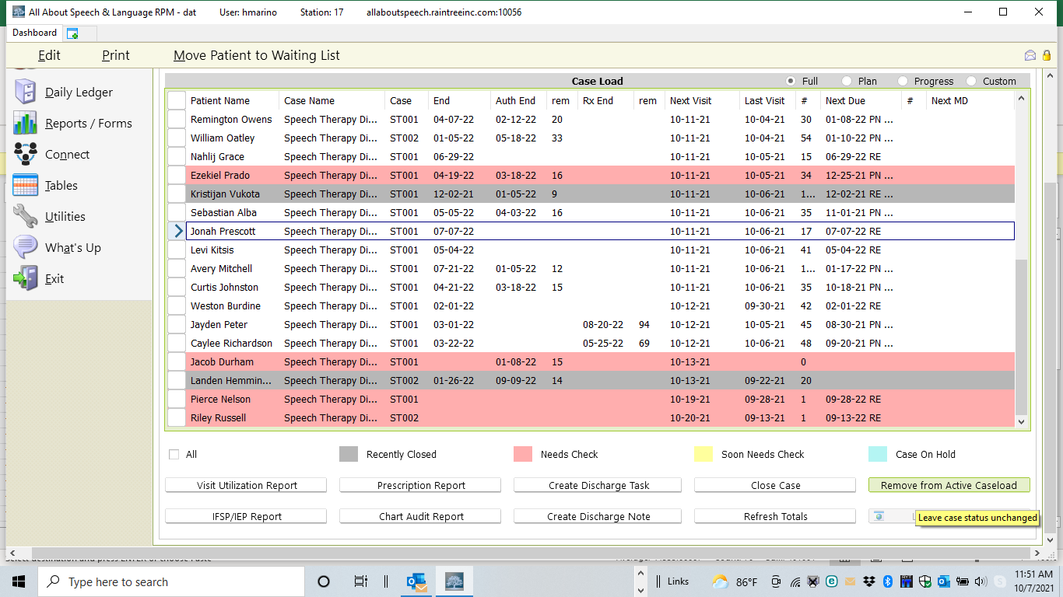
To manually update re-evaluation and progress note due dates, do the following:
- Select the name with your mouse:

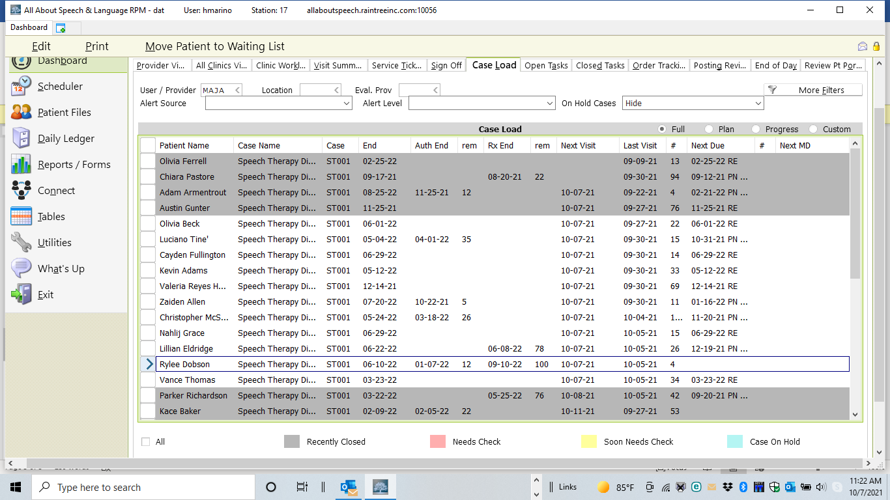

- Select Edit.
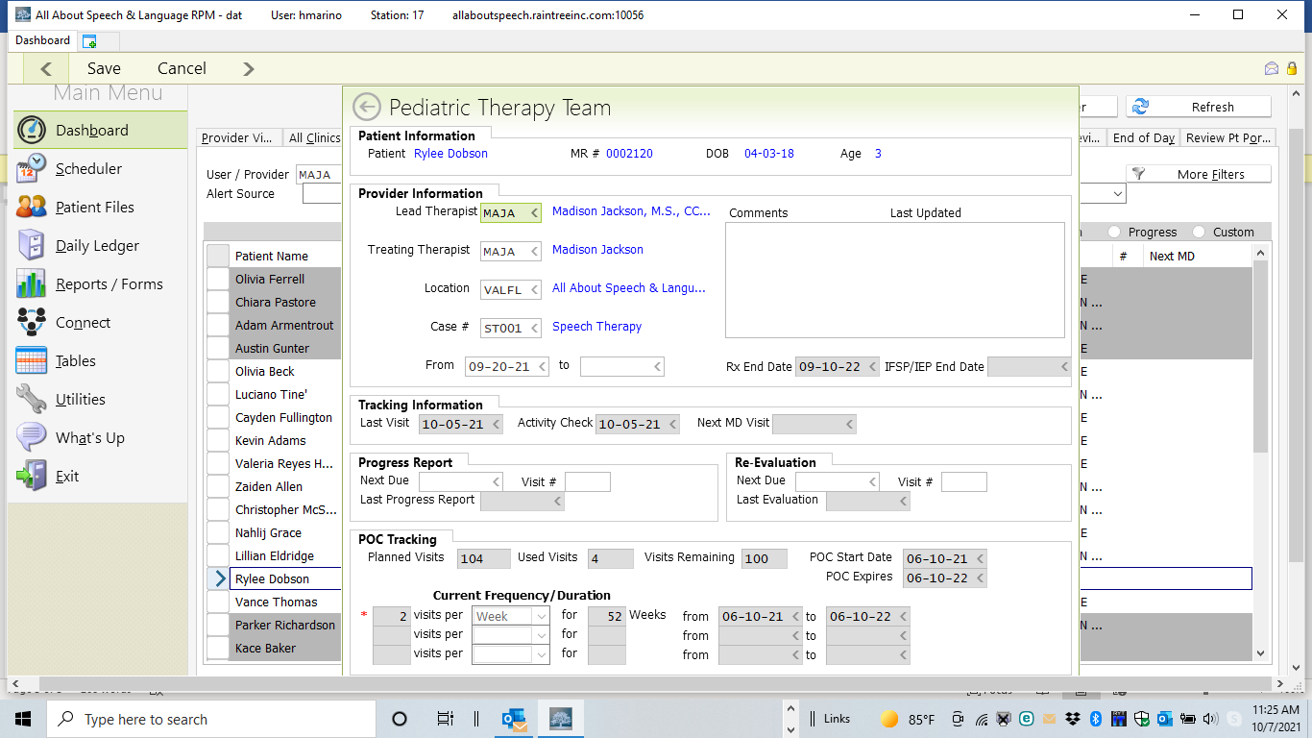
- Enter the Progress Report Next Due date: 6 months from time of evaluation and re-evaluation due date would be 12 months from the time previous testing was completed.

Reviewing Patient Chart Information
- Please plan to review chart information prior to the day of the evaluation. Keep in mind the locations of various testing materials and ensure you arrange to have them at the desired location in advance. You will select suitable assessment measures after reviewing notes provided in the patient chart under the communication tab or any other pertinent information in the Documents Tab or provided by Patient Scheduler. You may discuss any questions you may have with your CM.
- You will also receive notice from Client Services that the medical history has been completed and/or uploaded to the chart. Review and pull the relevant information for ST/OT and place it into the evaluation template.

Locating information/documents: Under each client when you click on their name you can pull up Patient Files and then Chart. The third tab across the top, Documents/Tasks, will be where you find medical history. The 4th tab, Communication, is where information from the intake call will be provided as additional notes/communication (i.e. email/phone).

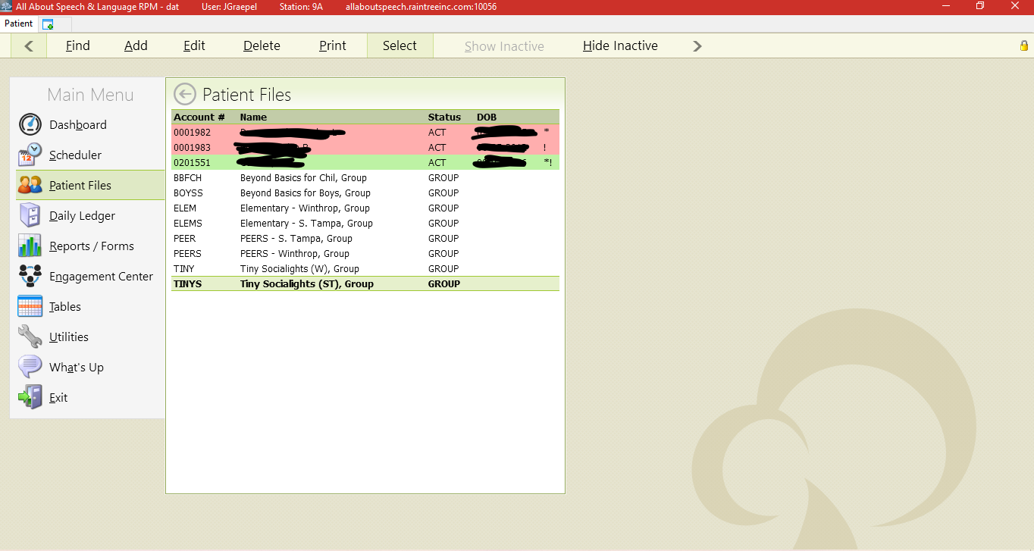
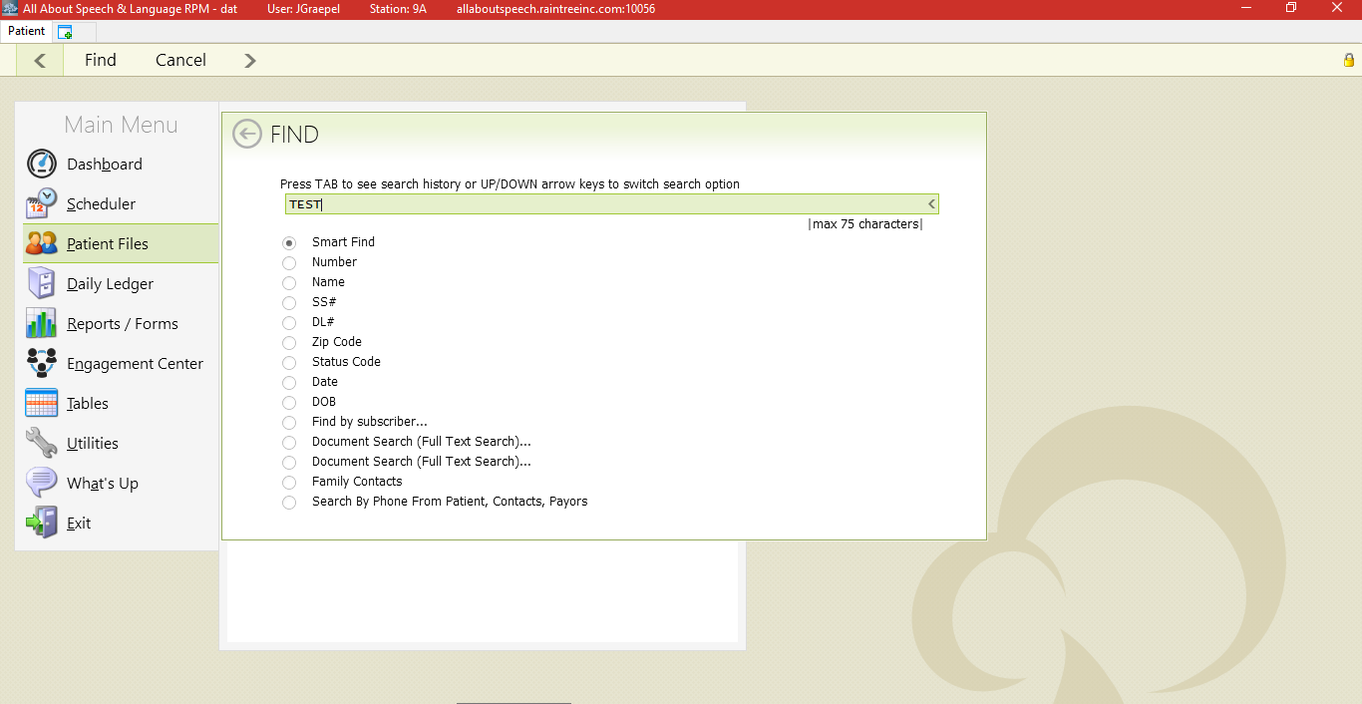

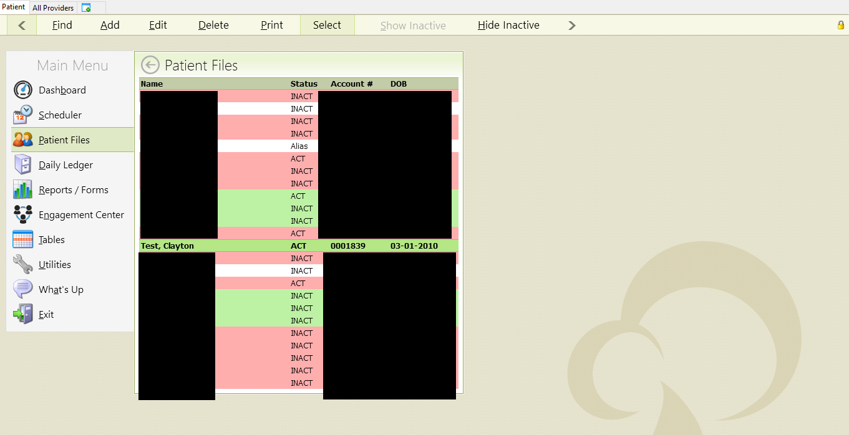

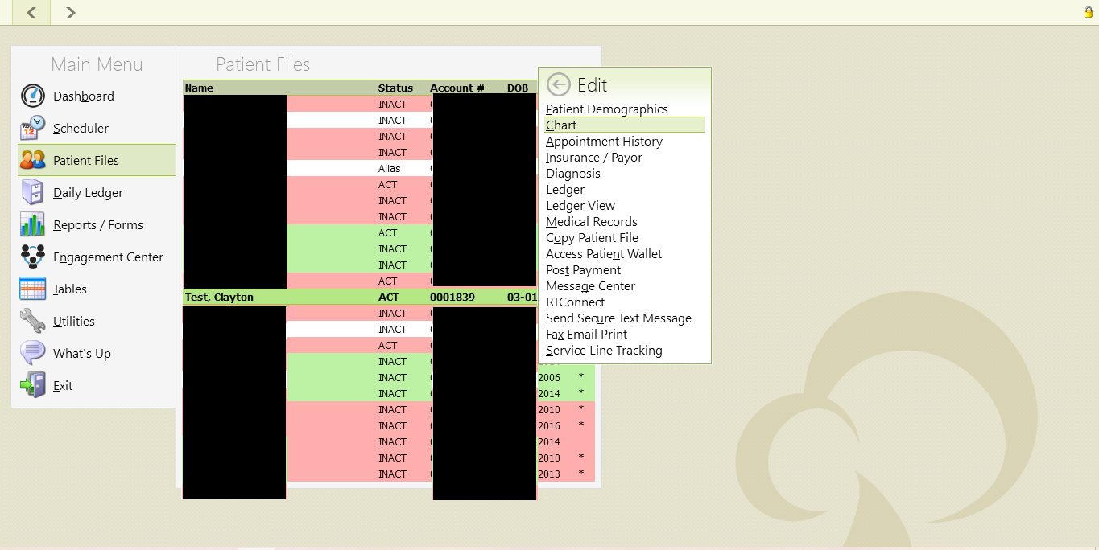
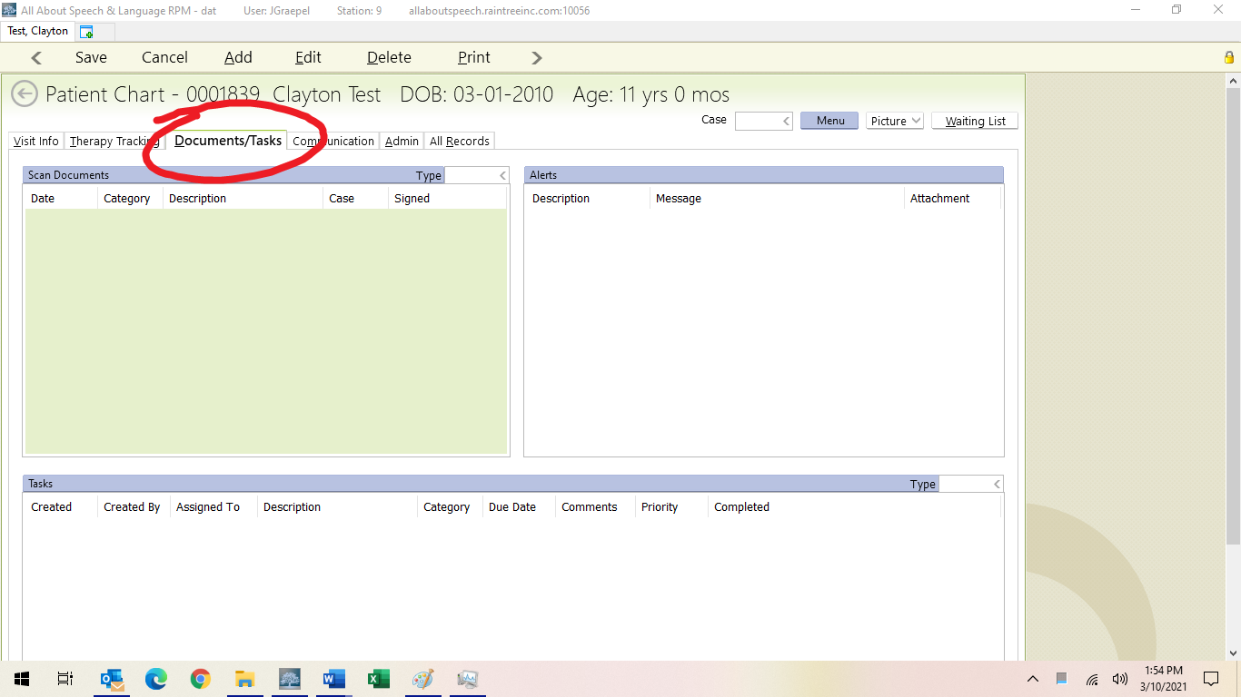

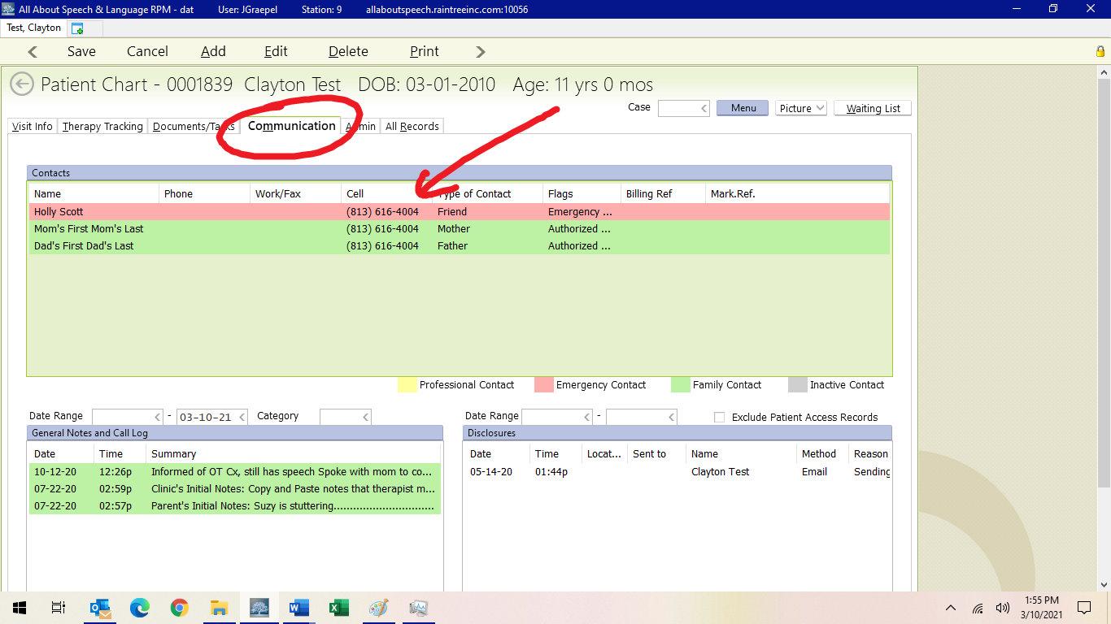

- If any additional information needs to be communicated, it can also get added directly to the client’s appointment on the scheduler by right clicking and hitting Edit and then noting any relevant notes in the Edit Box directly (i.e. see communication tab, please ask mom ____, need paperwork, copy X for evaluation etc.)
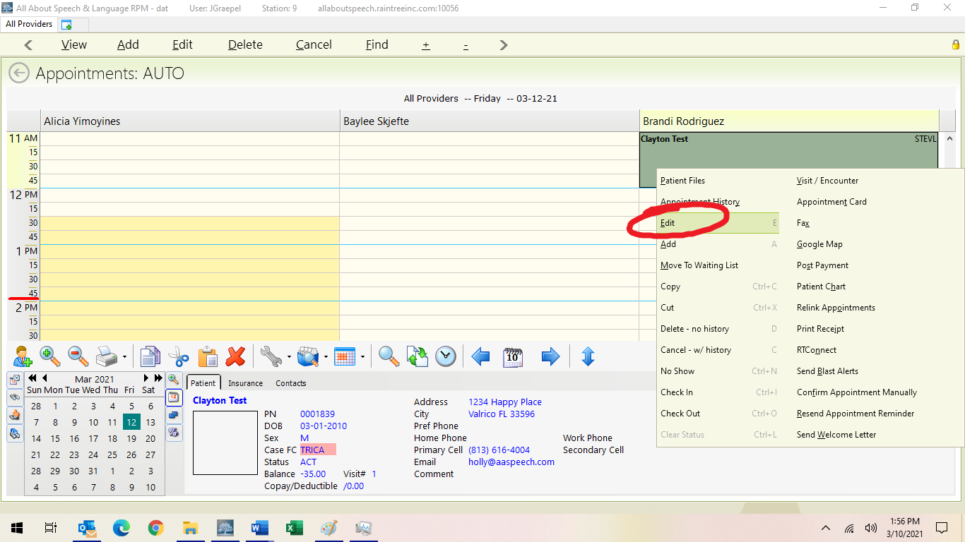

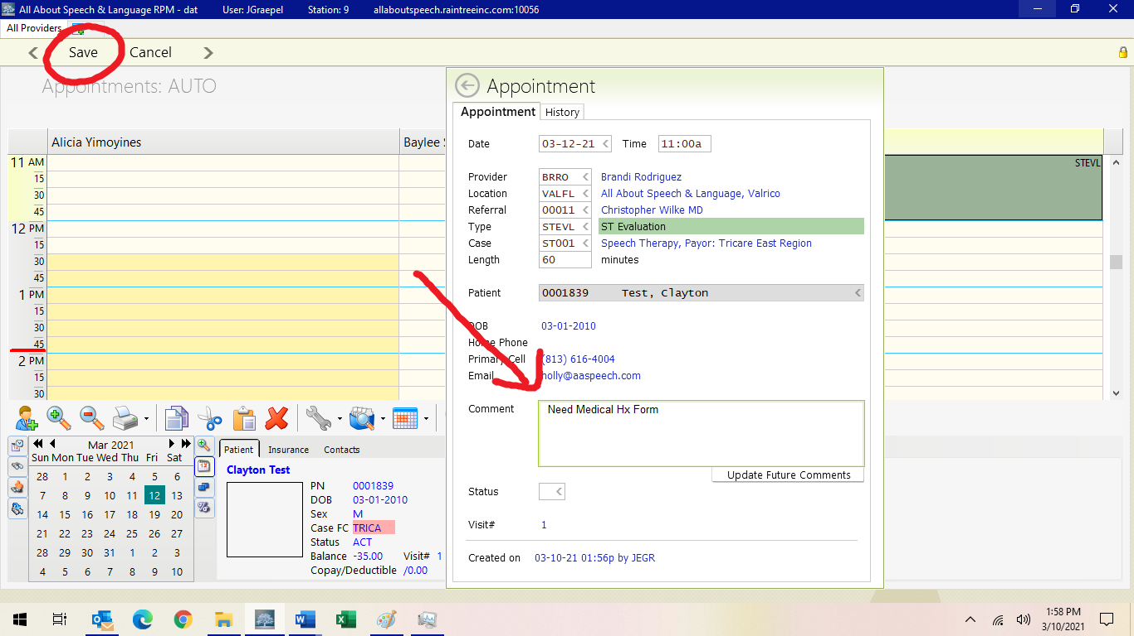
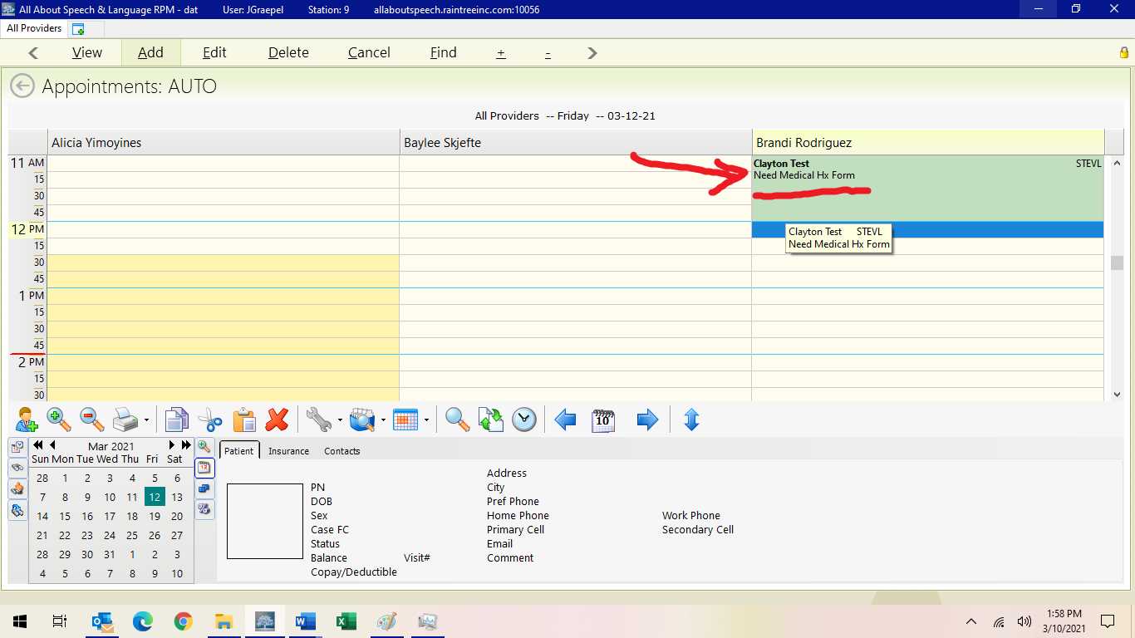

- If you need to learn about administration of a new standardized test, you will need to prepare accordingly as well and have any follow up discussions with your CM, as warranted.
- Please begin commenting on goal progress for each short-term goal at least 3 sessions before completing the evaluation. This will save time once you begin writing your report.

Checking Authorization for Re-evaluations
- Select “Patients” and use Smart Find to find the client by last name
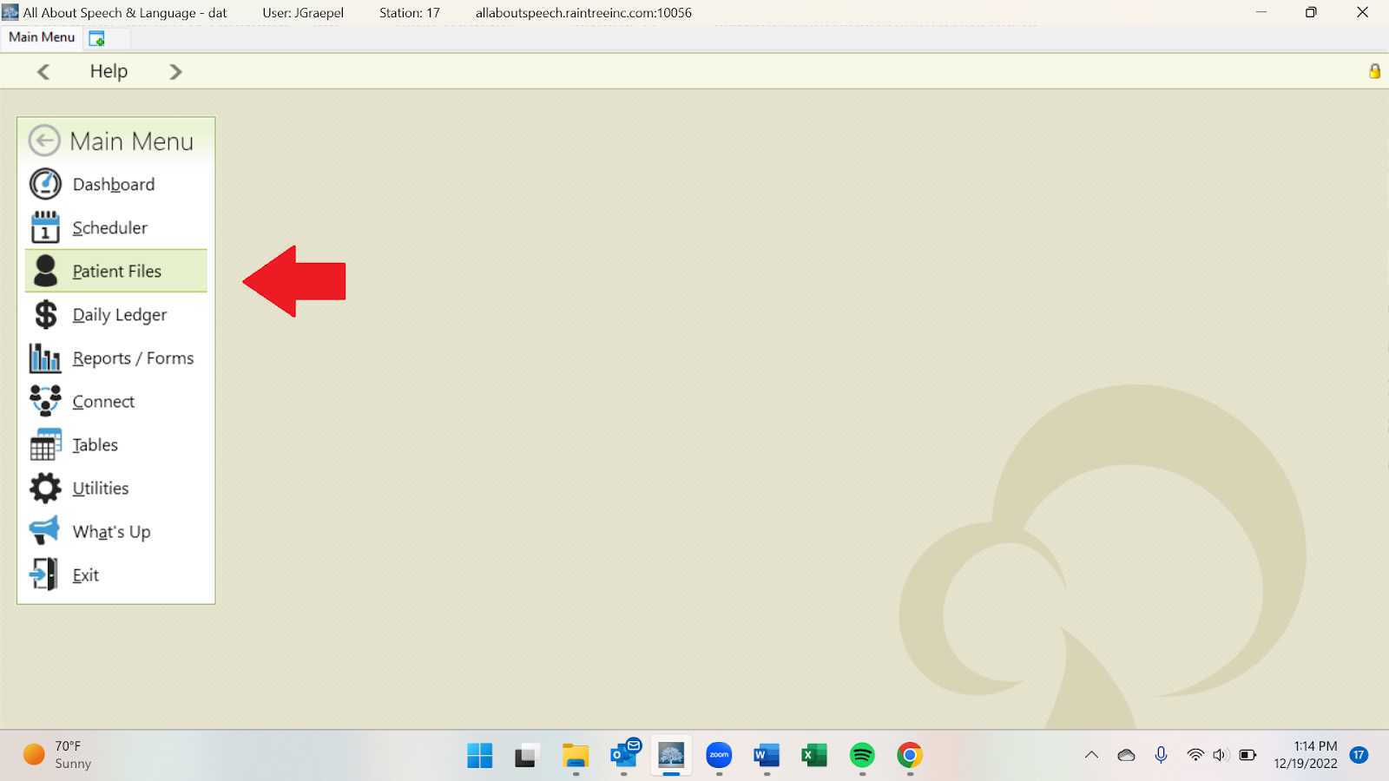

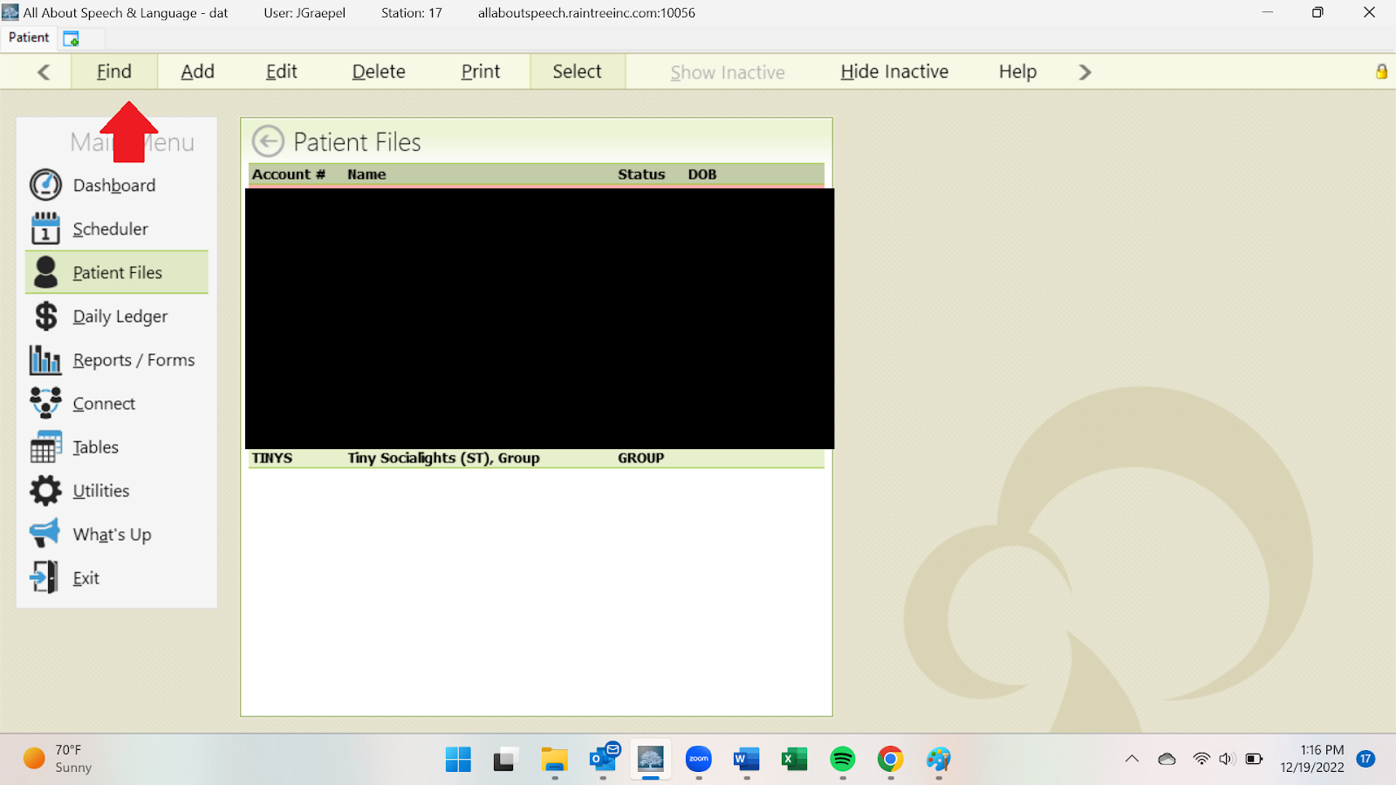
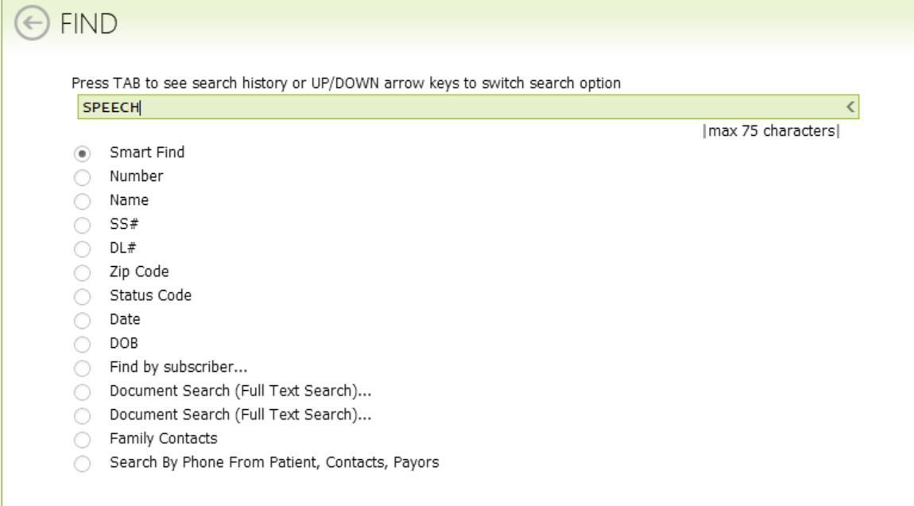

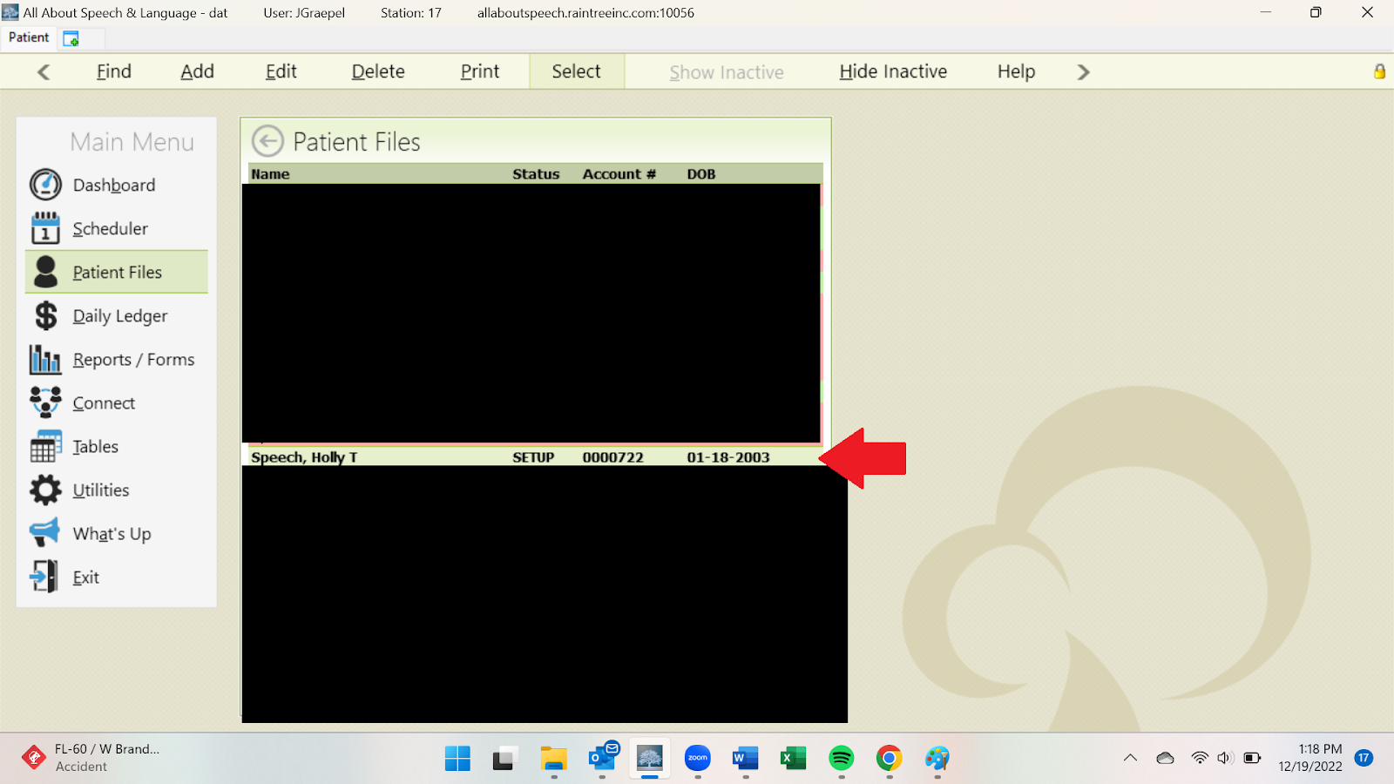
- Once you have found the client’s name, click on the name, and a menu will populate. Select “Insurance/Payor” on this menu. This will open another window with 2 payor options; select the one that says “TRICARE”
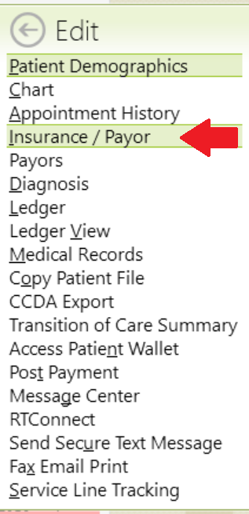

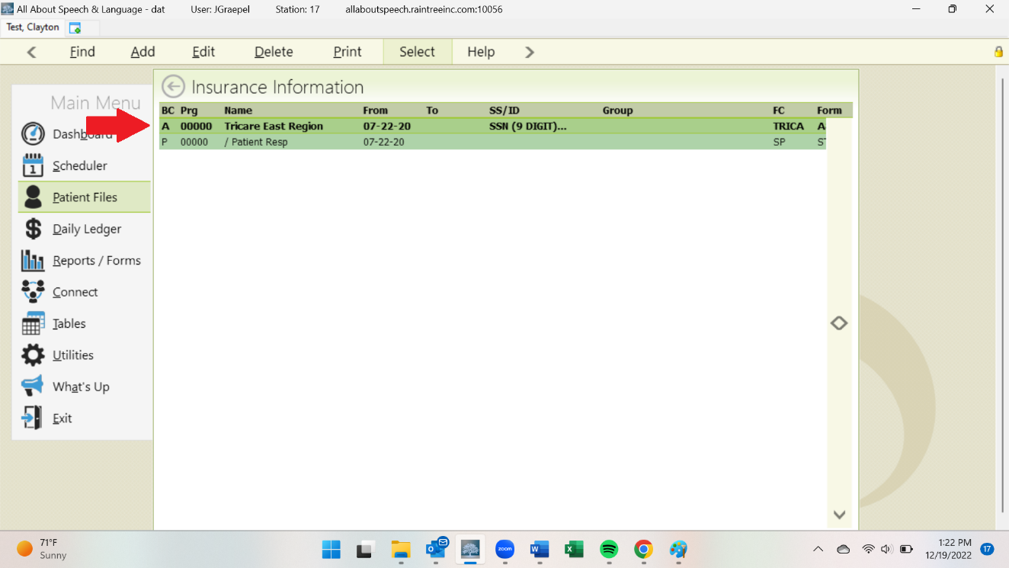
- This will open another window with all insurance information. At the bottom of the window, there is a list of “Authorizations”. This will have all expired and active Authorizations. Active will be GREEN, expired will be GRAY. Click on the most recent option to open a window with additional details. Be sure to select the appropriate case (ST001 for speech, FE001 for feeding, OT001 for occupational).

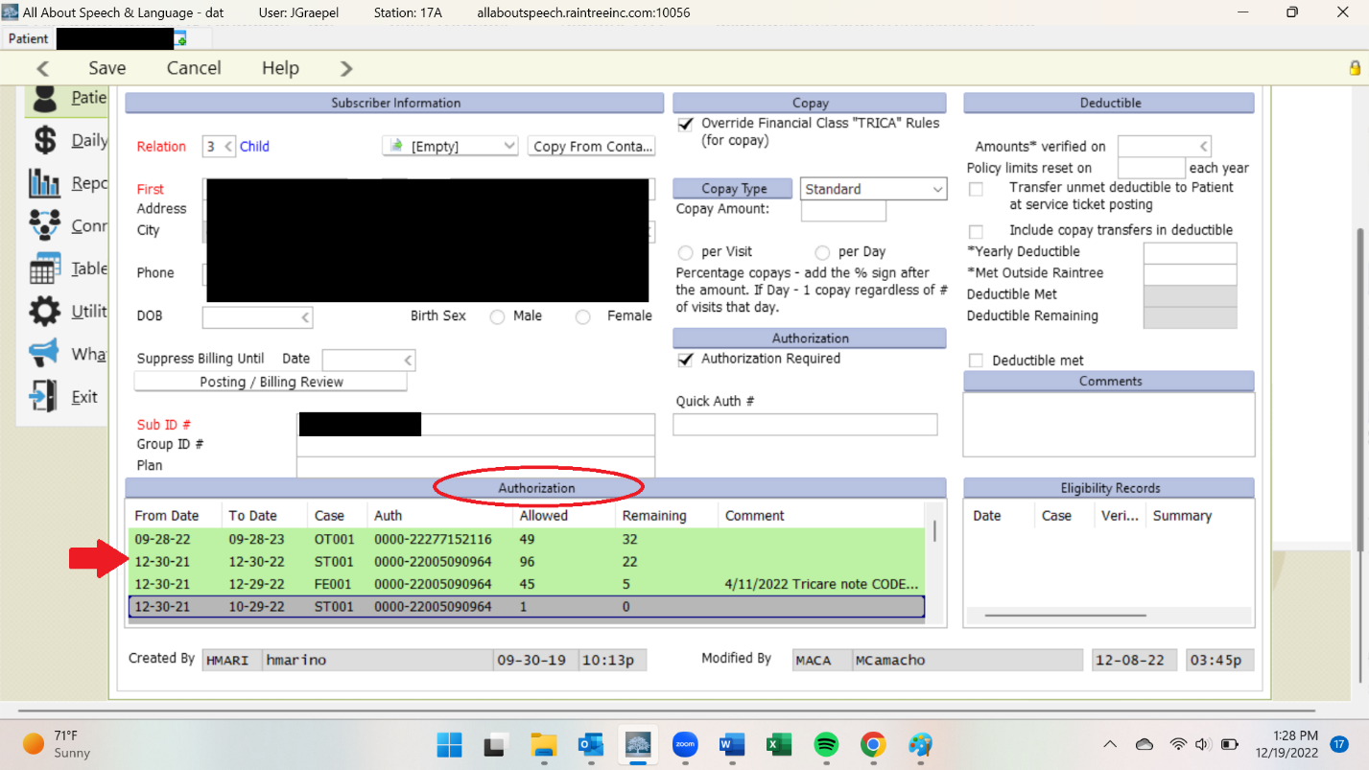
- Details will include Start/End dates, visits remaining, and status. Under “Authorization Request and Appeal”, there is sometimes an option to view the hard copy/fax of the authorization.
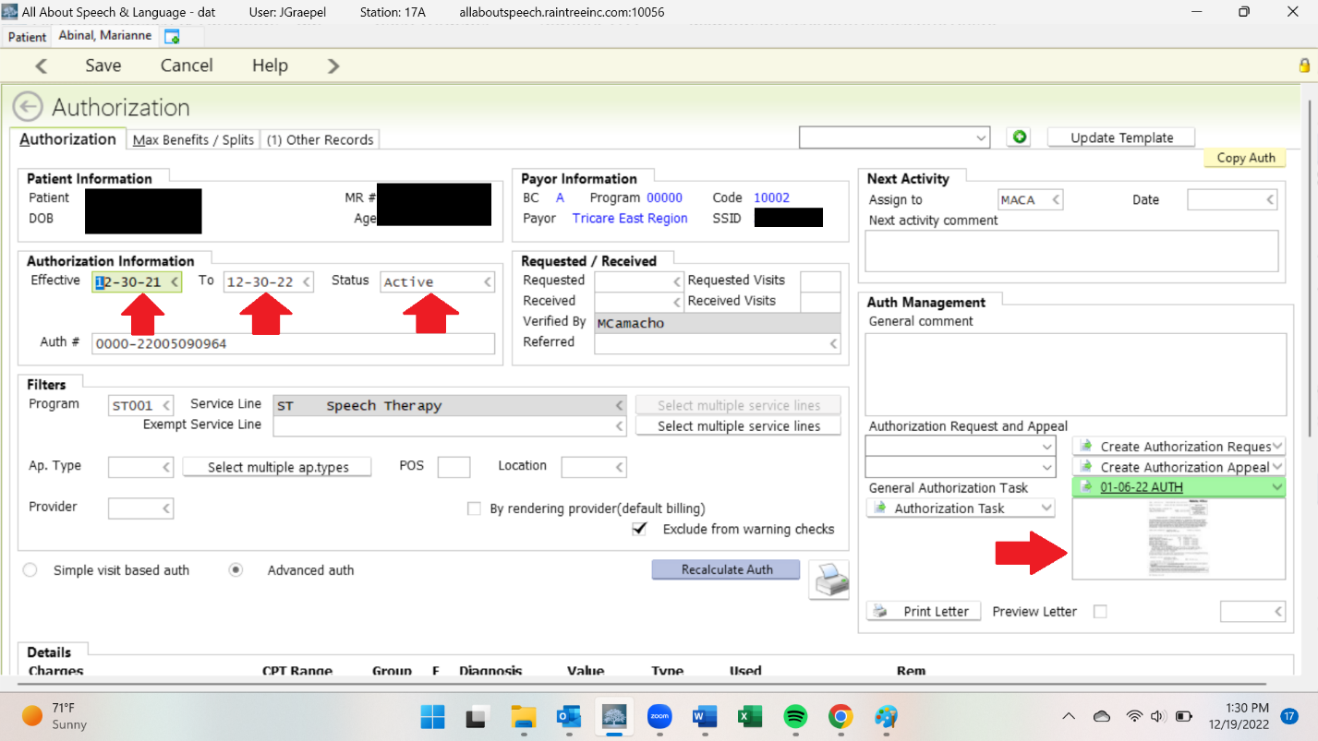
- Verify dates and status before proceeding with any re-evaluation.

Checking Out Therapy and Evaluation Measures & Preparing Protocols
At each respective office location, where evaluation materials are kept, there is a sign out sheet to check out standardized tests and manuals for use when scoring evaluations. Please follow the instructions on the sign out sheet and return as soon as you are done with the materials by checking them back in.
- Please send department wide emails for standardized tests that we only have one copy of that you may need for an evaluation/re-evaluation and plan on removing from either office location. Feel free to collaborate with other colleagues to help you get the measure you need at whatever office location is needed. Please return the standardized tests as soon as you are done using them to their appropriate office location.
- Please also include Patient Scheduler in this email so they are aware when booking evaluations so not to cause any double-booking of evaluations where the same standardized measure may be required
- For evaluations that are used frequently or there is a need for, please bring to your CM’s attention at your weekly meeting and it will be communicated to the Clinical Director for further consideration
- Please pull corresponding evaluation protocols from the designated location in each respective office to use. For any printed testing materials, please be mindful of only printing the pages/items you need.

Greeting for an Evaluation
- Warmly and enthusiastically greet the caregiver first, give your name and discipline
- Allow the caregiver to introduce you to the child OR you may introduce yourself to the child, depending on their age/comfortability with new people
- Get down to the client’s level and talk to them about what they are doing (i.e. I see you just arrived, you were playing on your mom’s phone, you brought ___, I like your _____)
- Ask three essential questions when you greet the client:
  - When you ask 1 question, it shows you are polite (i.e. How are you?)
  - When you ask 2 questions, it shows you’re genuinely interested in the other person. (i.e. How are you? Did you have a nice weekend?)
  - When you ask 3 questions, it takes that interaction to a whole new level, making the other person feel important (i.e. How are you? Did you have a nice weekend? Oh you had a birthday, what did you do for your special day?)
- Talk about where you are going to be working (i.e. Younger child: I have a room with games/fun things to do with pictures and paper, do you want to play some games with me? If the child says no, ask the parent and they should then be willing to come back if their parent is willingly going to walk back with you--adjust what you talk about for clients age)
- Follow any in-office policies or procedures for check-in, if applicable
- Get the client’s permission to go to where you are going to be working (I.e. Are you ready to walk on back?)
- Determine parents wants and needs by creating:
  - Affinity: a liking for someone or something
  - Reality: something actually experienced or seen
  - Communication: exchanging of information
- Find out the child’s wants and needs, if applicable/appropriate
- Follow Steps for Conducting the Evaluation (below)

Establishing Rapport
- Your role is to become an extension of/a caring member of their family
- Be happy, cheerful, enthusiastic and personable
- Continue to reinforce affinity, reality, and communication.
- In getting to know them use open-ended question asking as a way to show you care!
- Ask 3 essential questions when you greet the Family (see above in Greetings)
- You need to understand what is going on for that family and what challenges they are dealing with (i.e. do they have working cars, work schedules, health problems, family members living with them). Understanding these things will allow you to be caring toward them and adjust whatever may be needed, within reason, so the family continues to remain committed to the therapy process (i.e. adjust the schedule to see client one time per week vs making them feel bad for stopping therapy altogether)
- When therapy is commencing, hear what their reason for coming to AASL is and make sure you address that problem/concern FIRST
- Listen to the family! Again, listen to the family! Hear what their primary concerns are!
- If they feel they are being heard and understood, they are going to be invested in therapy and build trust with you. This will then allow you to better manage “unrealistic expectations” (i.e. a parents has a 3 month old and they want their child to walk; your first goal would be to address why you aren’t going to address walking immediately in therapy and then you will share what you are going to work on skill-wise to get their child to be able to walk)
- We have to get them to understand WHY you are doing or not doing whatever it may be tied to their concerns
- Keep open lines of communication with them
- Hold them to policies and expectations we have of them in your communication with them and with the help of the Front Desk.
- It’s okay to get to know them on a deeper level outside why they are coming to AASL (i.e. find out things in common, engage in small talk) This shows you are human too and builds a bond so they continue to build their rapport and relationship/communication with you!
- Love what you do and have fun! The more they see that, the more they are going to buy into the therapy process, trust their child to you and our company, and follow through with the home program, stay committed to therapy, and complete their treatment plan with AASL!

Conducting the Evaluation
- Once you engage in establishing rapport either through conversation and/or play, administer the measures you have selected for the assessment
- Keep in mind that sometimes the measures selected are not going to be the best fit at the time of the evaluation, so use your clinical skills appropriately to be flexible in the moment and adapt as you need to. Remember you are the expert!
- Discuss what you are seeing throughout the evaluation so you can speed up the wrap up at the end, and it may be beneficial to talk about things as they happen in the moment
- At the end of the evaluation, summarize (the remaining of) your findings of the evaluation and what the treatment process will be like going forward, if that is recommended. Summarize this to the parent first.
- Feel free to give the client a toy or something to do to keep themselves busy while you talk to the family at this time. You can involve the child, where appropriate. If not, you can have them go with their other parent/caregiver etc. if more than one person accompanied them to the evaluation.
- Sometimes you will be asked direct questions from the caregiver/family about their child. Answer honestly with what’s within our scope of practice. If they flat out ask questions about Autism and if you think their child has it, which is one of the most common questions we do get asked, you can share with the parent characteristics that you see that are in line with this diagnosis and let them know that these will be monitored and you will put additional recommendations in the evaluation for further testing, should they desire that going forward. Let them know that we cannot formally diagnose Autism, but we are trained to identify characteristics and treat children accordingly. Assure parents that regardless of a diagnosis, we use the child’s strengths to bolster their areas of weakness and to make improvement developmentally! Also let them know that the observed traits/behaviors alone are not indicative of an official diagnosis and that as treatment gets underway, rapport is established with a family, and you get more eyes on the child, you will continue to make recommendations and engage in open communication with the family about their child.
- In a similar light, you may have parents that are in denial or not ready to hear about their children relative to any observations you may be seeing or delays they present with; this is ok too; use your clinical judgment during this portion of the evaluation to communicate strengths/weaknesses, and general therapy recommendations going forward. Once rapport is built and a relationship is made with the family, you can then start to slowly engage with them on this journey--baby steps. Remember, our role is to become a caring part of their family/extension of their family that is reflected in the quality of care we provide, the trust and rapport built with the family, and our communication with them. Sometimes it is going to take longer and we are often “hand-holding” the family, and guiding them along the way, representing ourselves like the expert but doing so with a softer approach.
- Then summarize for the client (I.e. I’m going to show you all the things you can do and those things that might be a little harder for you that I’m going to help you with going forward and we will play games and have some time together each week! --adjust for each child accordingly)
- Walk them back to Front Desk/Waiting room where the following will be communicated: when to expect to hear from us regarding confirmed scheduled appointments, when they will hear from Front Desk to go over new client paperwork and office policies, and anything else the client or AASL needs prior to them leaving the office, or who will follow up with them if they have particular questions (i.e. billing etc.) and then notify that person accordingly.
- Send the family off with a cheerful farewell!
- Email Patient scheduler within ONE BUSINESS DAY with recommendations for diagnosis and treatment duration/frequency (usually 1-2 days/week 30 minutes)
- Inform family that evaluation will be available in 2 weeks via the patient portal for them to review.

Scoring Protocols and Expanded Procedures for Drafting Report in EMR System:
- Written evaluations are due within 2 weeks of the initial evaluation! This is extremely important to be timely in completing your documentation according to this policy. Your CM will be following up with you on completion of your documentation each week. Appropriate follow up for problem-solving and re-training will take place if paperwork is not getting completed in a timely manner. Please be sure to have goals entered before the client’s first treatment session. As a reminder, a daily note cannot be signed off on/completed if an evaluation or progress note is open.
  - Completing reports in a timely manner is essential. At the conclusion of your evaluation, please communicate to parents that they can access their child’s report in 2 weeks via the patient portal.
- You will need to score the standardized assessments following the completion of the evaluation and check back in any standardized assessments or manuals. File protocols accordingly.
- When you are ready to begin writing the evaluation, use the EMR system.
- Use Google Drive Report Templates if needed for verbiage on specific measures when needed.
- Saving Work: As you are writing up the evaluation, hit save to save work you have done in the different sections/tabs as you are working and it will then allow you to keep moving through the evaluation to the next tabs.
  - General Notations:
    - Use IEVAL or REVAL templates in Raintree to populate narratives that will then need to be personalized for the client.
    - Anything with an open box you will have a pre-written narrative: Parent/Family Concerns, Accompanied By, Reliability (tied to behavior observations). The other boxes are check boxes that auto-fill in criteria you select: Behavior, Primary Communication, Concerns.
    - For check boxes throughout the evaluation template: click on the green + arrow, then a box will populate, select the items that pertain to your client and then hit the floppy disk drive to save it.

Checking In Appointments
On your scheduler, open up the green/tan cell for the client, coded as STEVL/STREV. Check in the client by right clicking and selecting “check-in” and then double click to open the file. The appointment will have a yellow box once it is checked in.
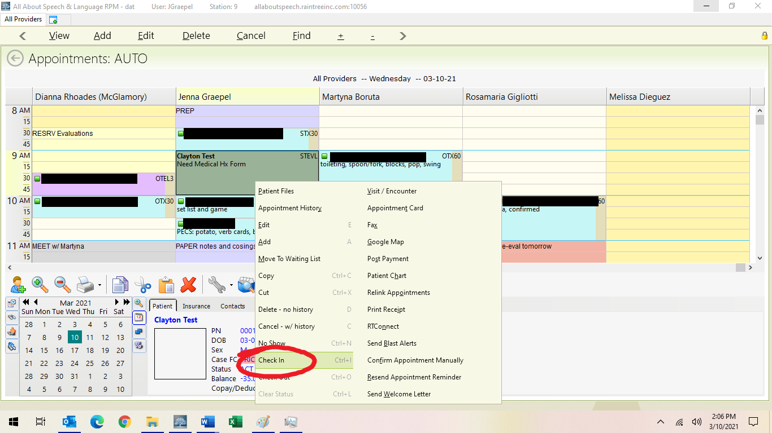

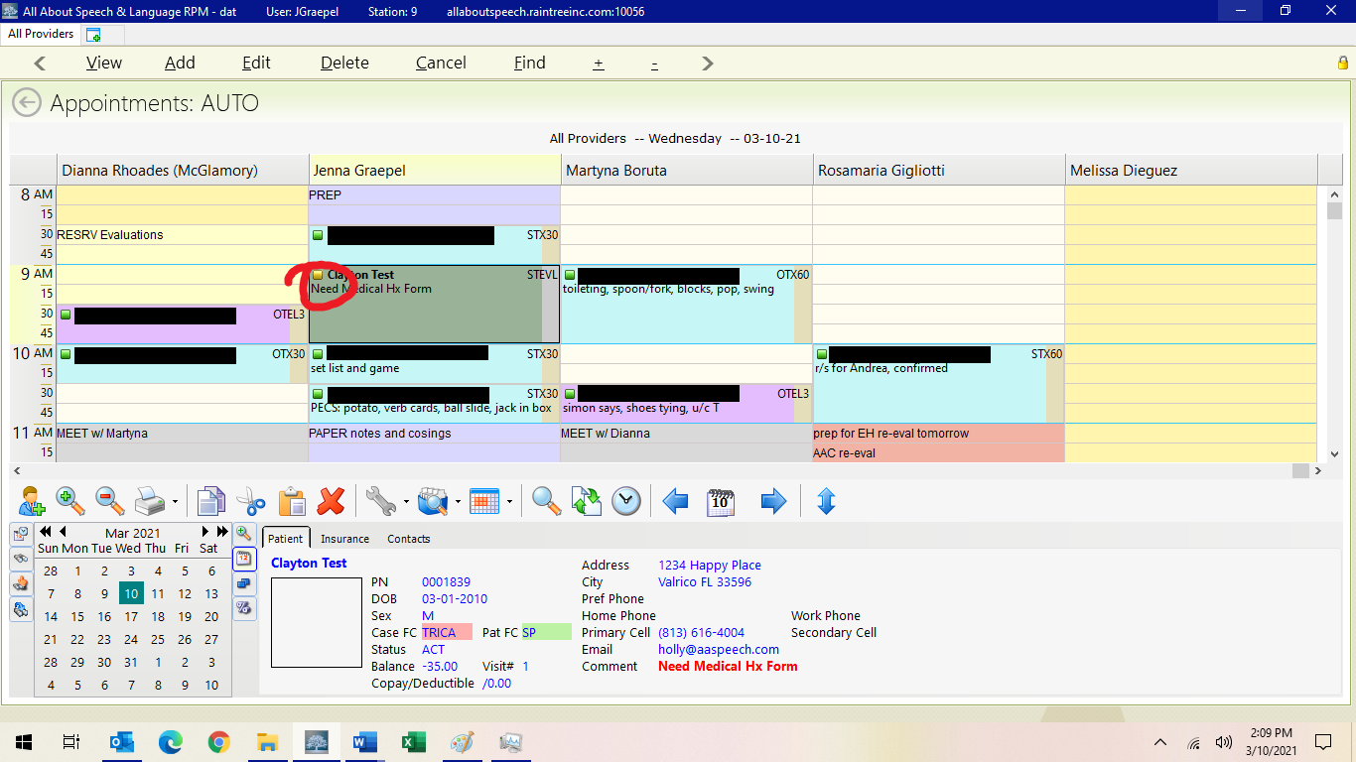
Once in the template you will see at the top: Type Initial Evaluation, Eval SLT Standard *all note types should always be in this format of SLT Standard. Remember under the Note Type is where you also can drop down to change to a progress note, discharge note, re-evaluation and daily note. EMR will also prompt you for progress notes and re-evaluations.
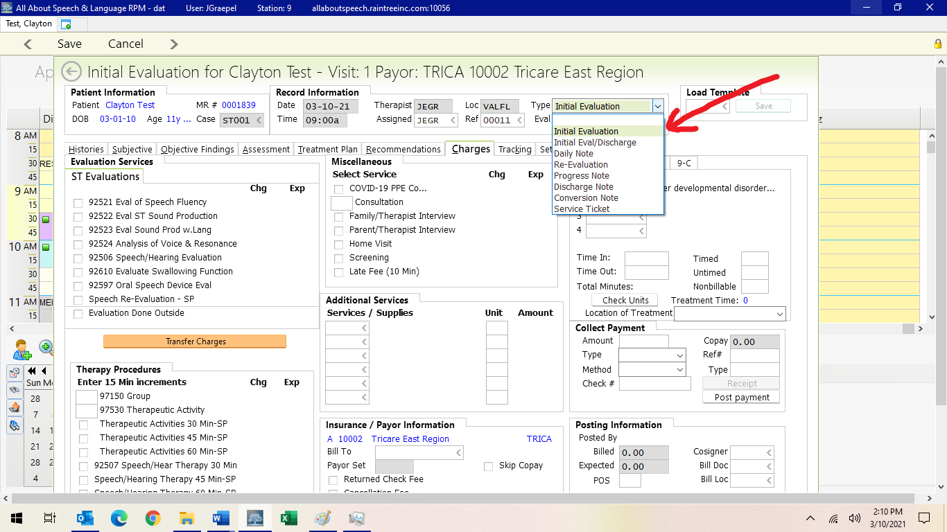

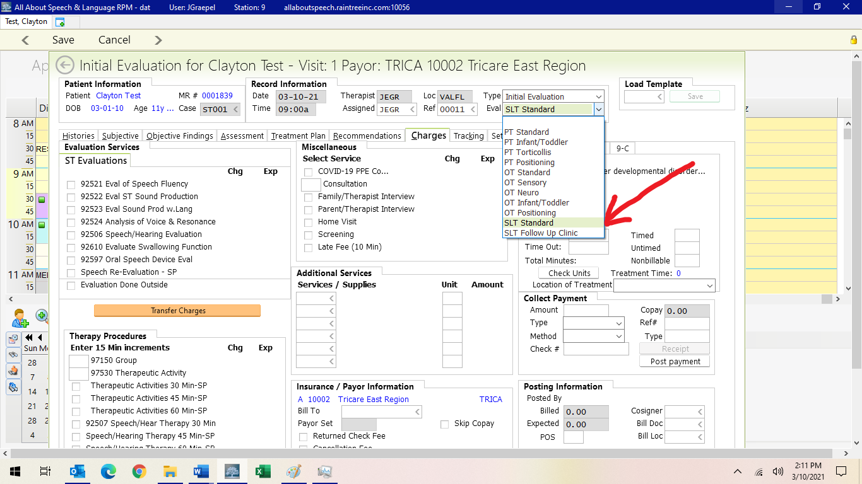

You will find the corresponding template to load, IEVAL or REVAL. Select from the drop-down list or type the code in the top right corner. This will load in all templates for you across Subjective, Objective, Assessment, Treatment Plan, and Recommendations tabs. Fill out accordingly.

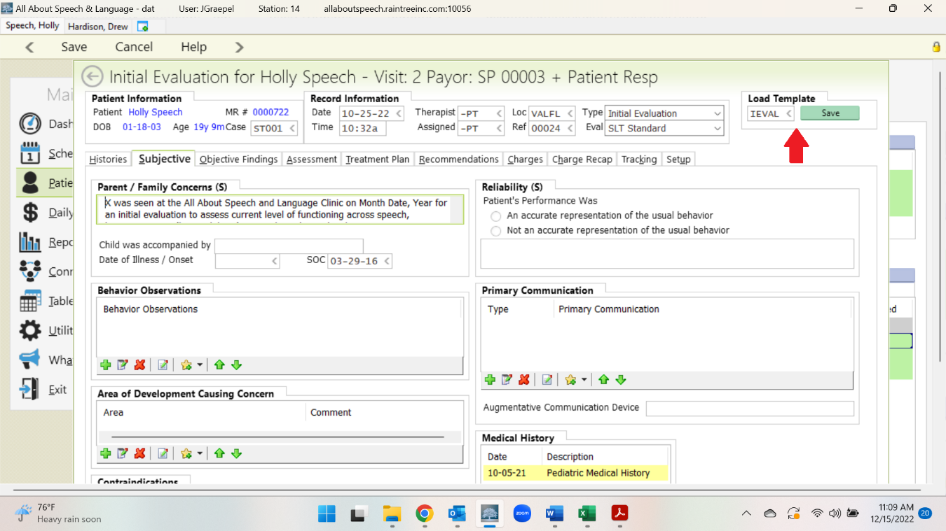
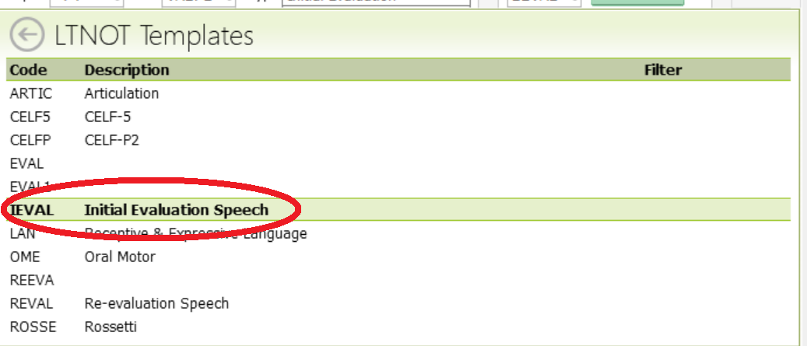

Below further outlines required information for evaluations across SOATRC Tabs (Subjective, Objective, Assessment, Treatment Plan, Recommendations, Charges)

Handling Clients Who Do Not Qualify for Therapy
Tricare:
- The evaluating therapist will score up the evaluation then email the parent CC’ing patient scheduler to notify the family that their child did not qualify
- Ensure if additional strategies/HEP are to be provided to the family, you do so in this email
- If a client who has Tricare does not qualify but parents want to start services, please reference Initial Eval- Self Pay Client steps (below) as they can pay privately for services.

Self-Pay:
- The evaluating therapist will score up the evaluation then email the parent CC’ing scheduling to notify the family that their child did not qualify
- Note that if the parent continues to express the desire to want services and you feel they would benefit, then therapist can inform family that they can initiate short term services
- Therapist will notify scheduling department of POC recommendations

Email Template

Hi,

It was a pleasure meeting your family. I wanted to inform you that ____ (child’s name) does not qualify for Speech/Occupational Therapy services at this time. He/she scored in the average range in the areas of ______ (add in areas they did well in). Your child’s report will be accessible through the Patient Portal in two weeks.

As we discussed in the evaluation, continue to practice ______ (for example: shoe tying). Please reach back out to the office (813) 616-4004 if any additional concerns arise over the next 6 to 12 months or if you have any questions.

Reminder, the evaluating therapist needs to notify patient scheduler of their recommendations within 24 hours.

Subjective Tab:

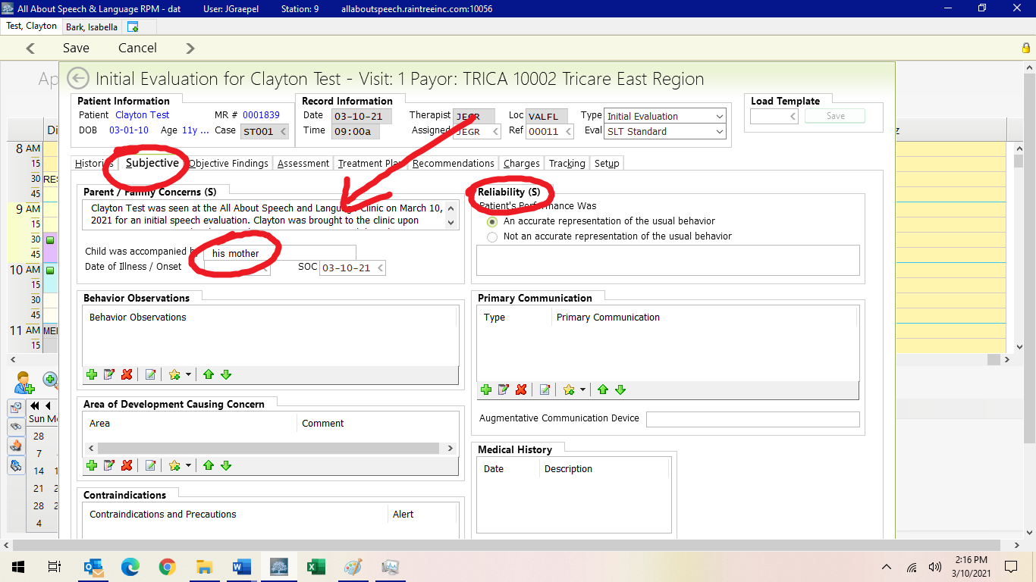

Parent/Family Concerns (top left of the Subjective Tab, already in for you)
X was seen at the All About Speech and Language Clinic on Month Date, Year for an initial evaluation to assess current level of functioning across speech, language _____ (list modalities). X was brought to the clinic upon parental/doctor concerns surrounding ______.

Please see medical history on file for information pertaining to birth, developmental, medicinal, academic, and other medical information. All information provided in the medical history and developmental subsections was completed and directly reported by the parent. -OR-The medical history was reported by the parent directly and filled out accordingly across developmental sections.
Medical history significant for ______ (frequent ear infections, surgeries, diagnoses) -OR- Medical history remains rather unremarkable.

X presented as a ____ (playful, guarded) boy/girl. X readily participated in the evaluation/was reticent to participate in the evaluation, and required little to no/occasional/frequent redirection from the clinician/parent.

MEDICAL HISTORY WILL BE DELETED ON WHITE PAGE BY COSIGNER/RIGHT BEFORE SIGN OFF

Behavior Observations
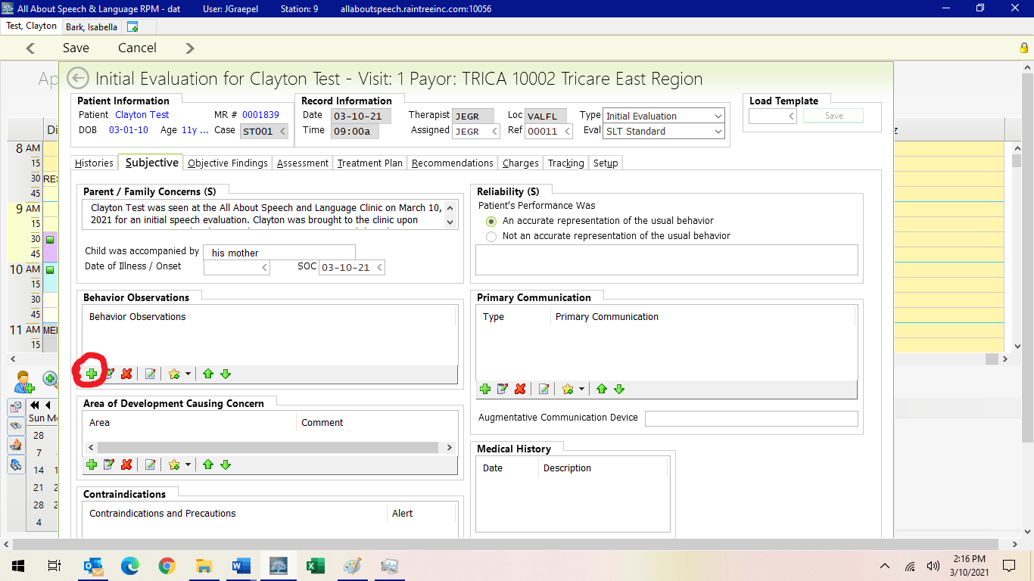

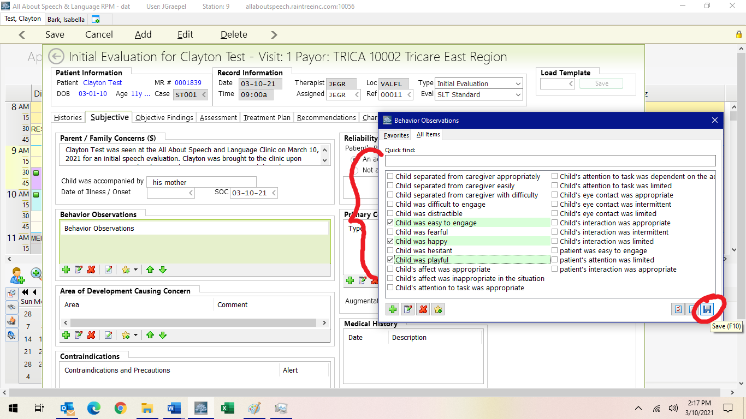

Areas of Development Causing Concern
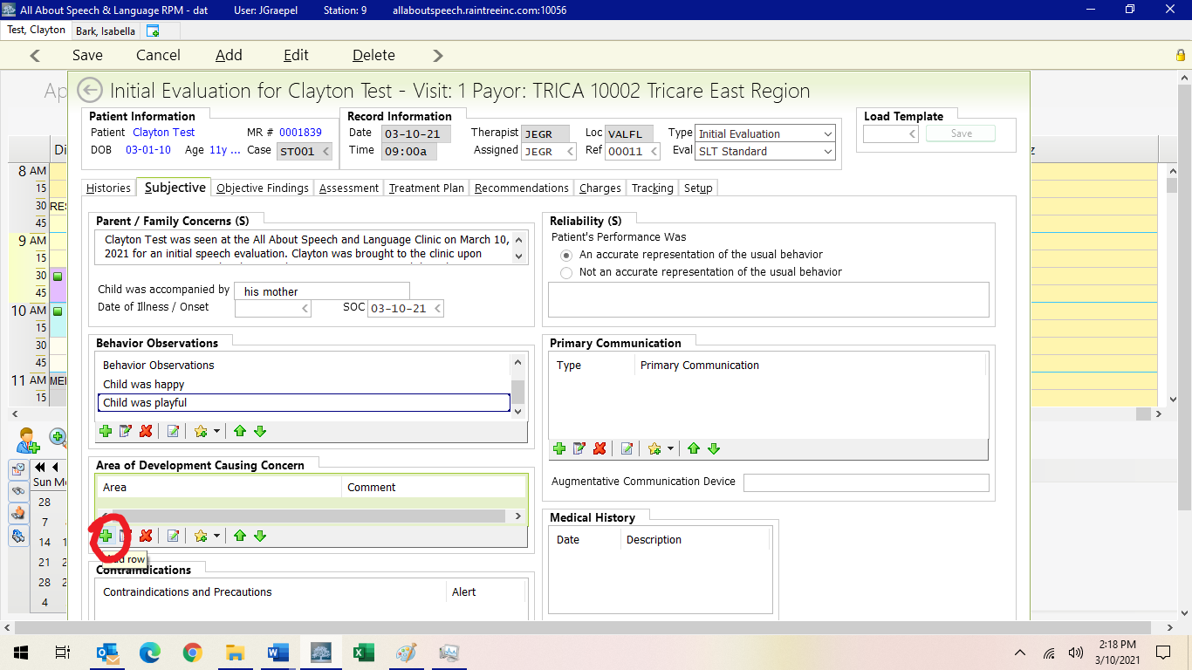

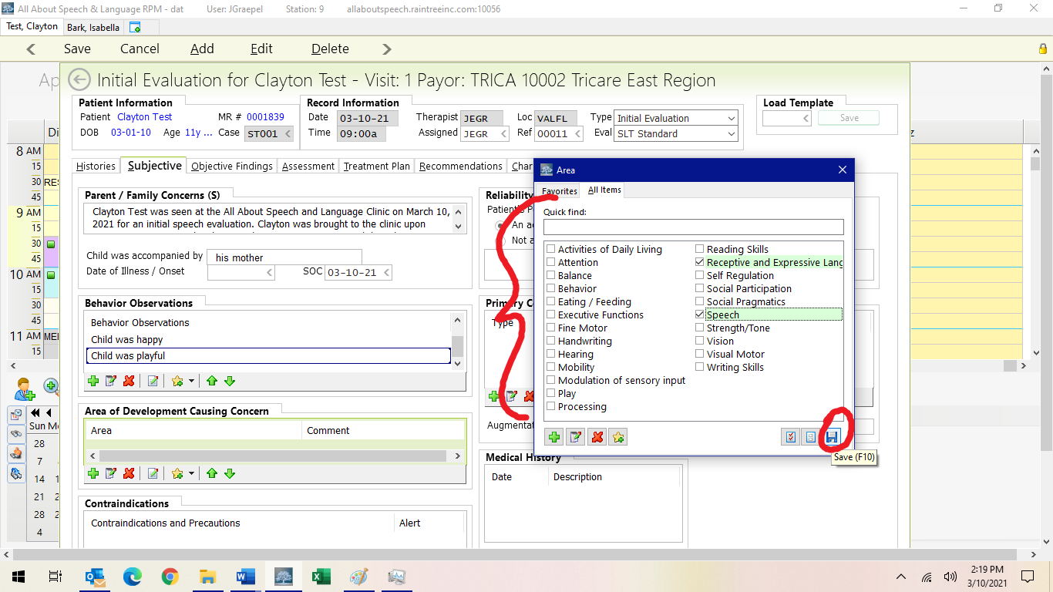

Primary Communication

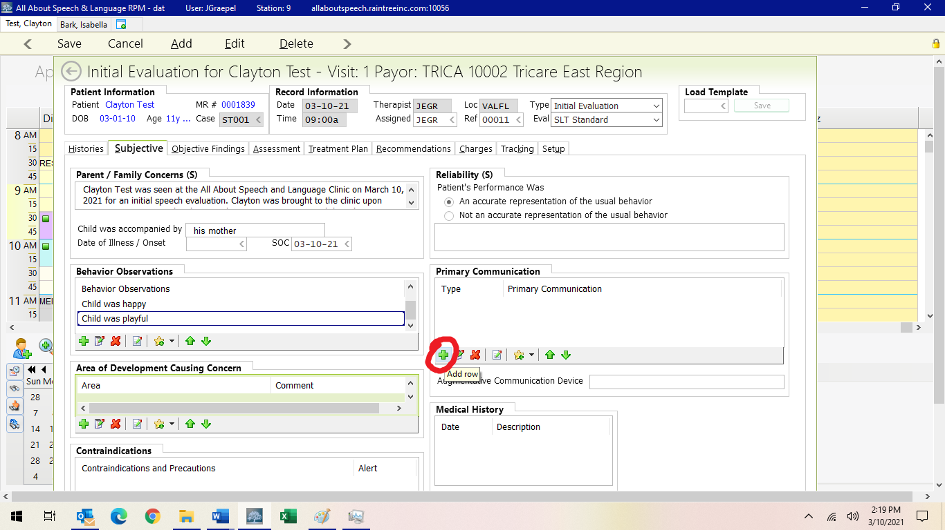
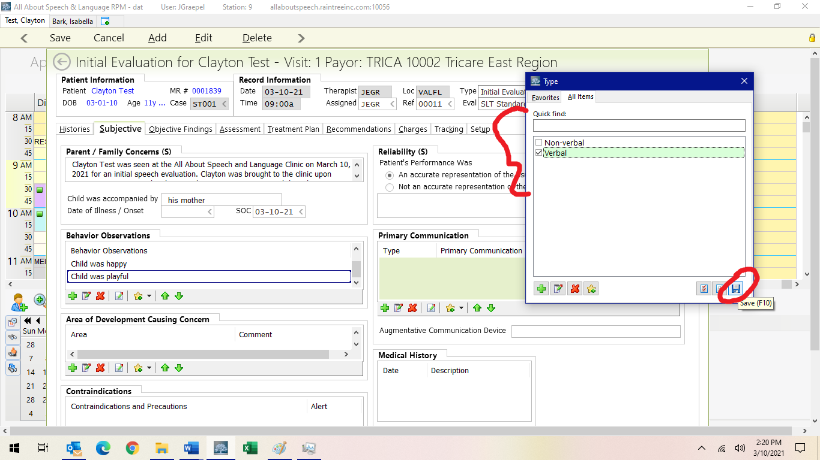

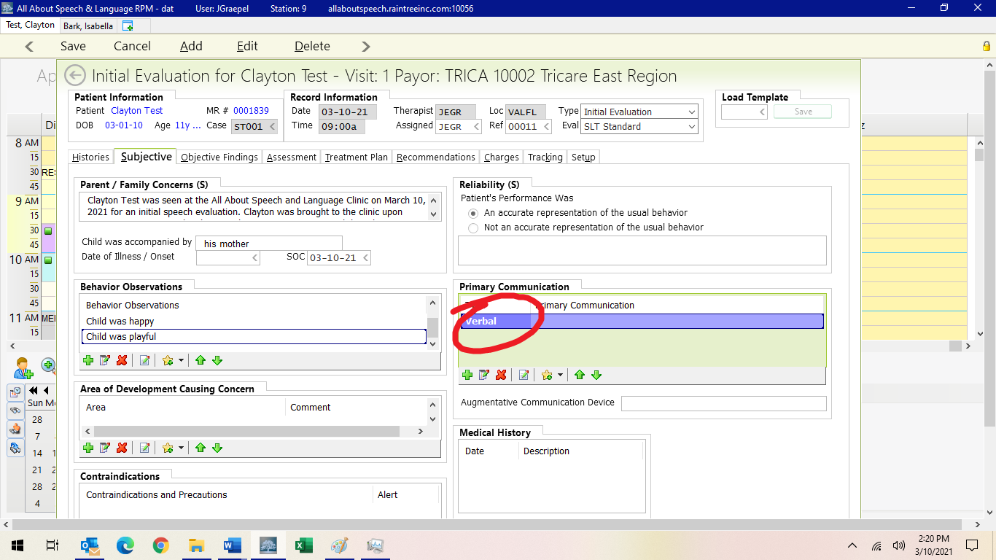

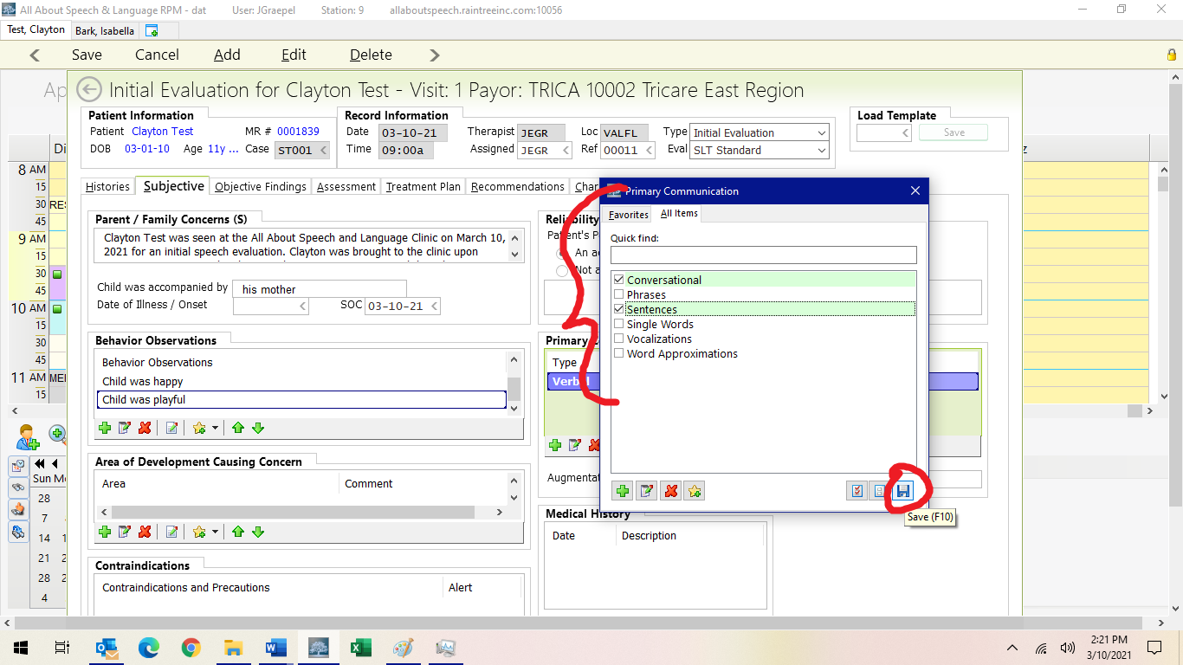

Objective Tab:
In Objective Findings: Templates should already be preloaded. There are templates available for each communication domain, should you need to load them in separately (codes below). Clinicians are to assess ALL areas, even if qualitatively assessed/subjective judgment. Please review sections, remove inaccurate information, and add client specific details. DO NOT use the drop-down lists in these sections; we are no longer using the word “delay” on our evaluations, and the information with severity is redundant with the templates.

ARTIC = ARTICULATION
OME = ORAL MOTOR
LAN = RECEPTIVE AND EXPRESSIVE LANGUAGE
SOCIA= PRAGMATIC/SOCIAL
VOICE= VOICE AND FLUENCY

PLEASE REVIEW THSE SECTIONS, REMOVE INACCURATE INFORMATION, AND ADD CLIENT SPECIFIC DETAILS.

Objective Findings
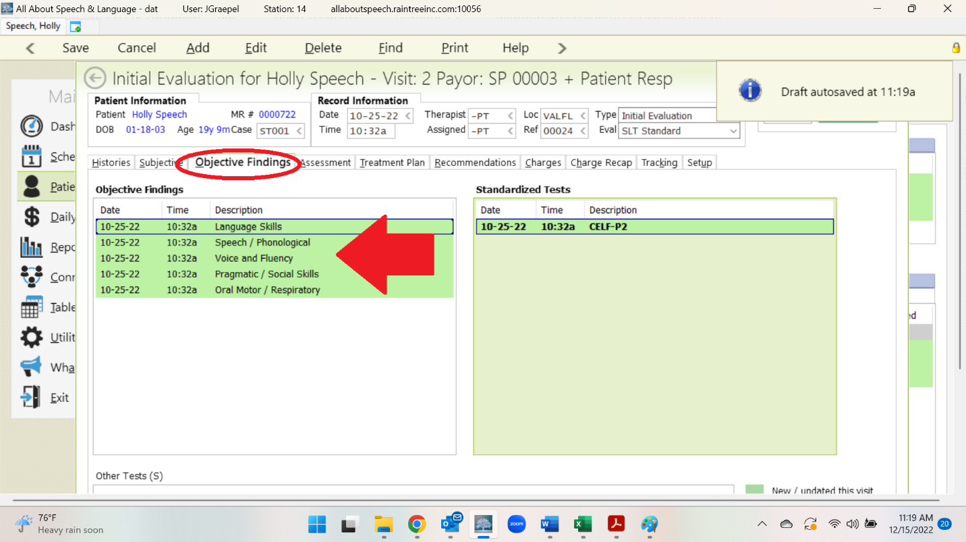

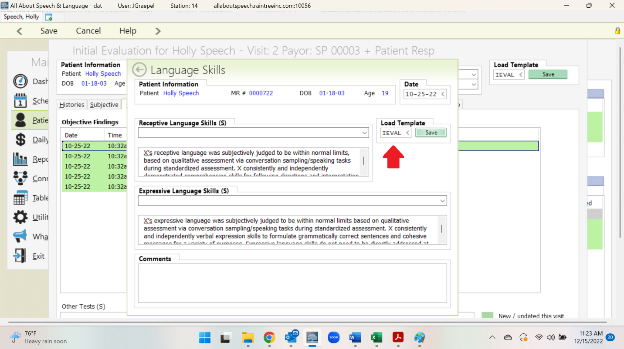

In Standardized Tests: Click A to add, you will see a long list of standardized tests pop up and select the ones you need.
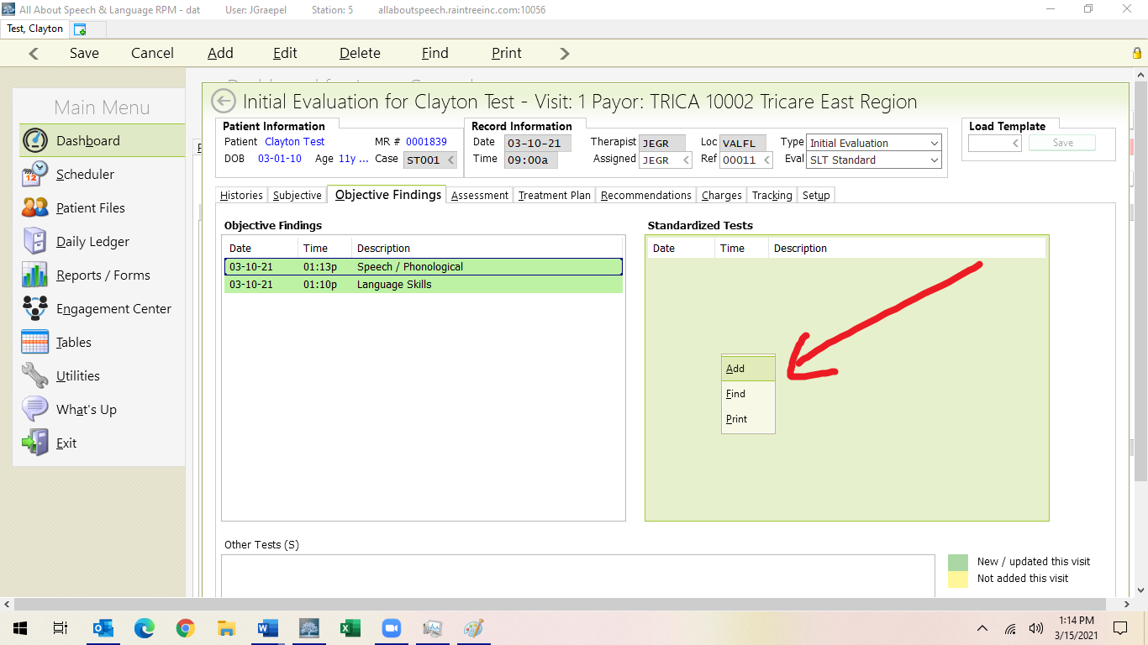

Standardized Tests
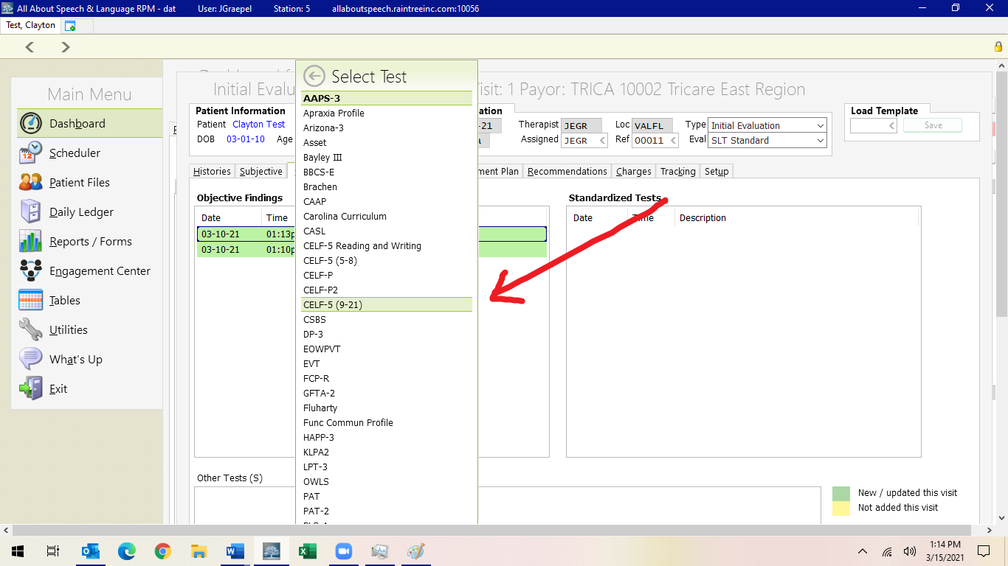
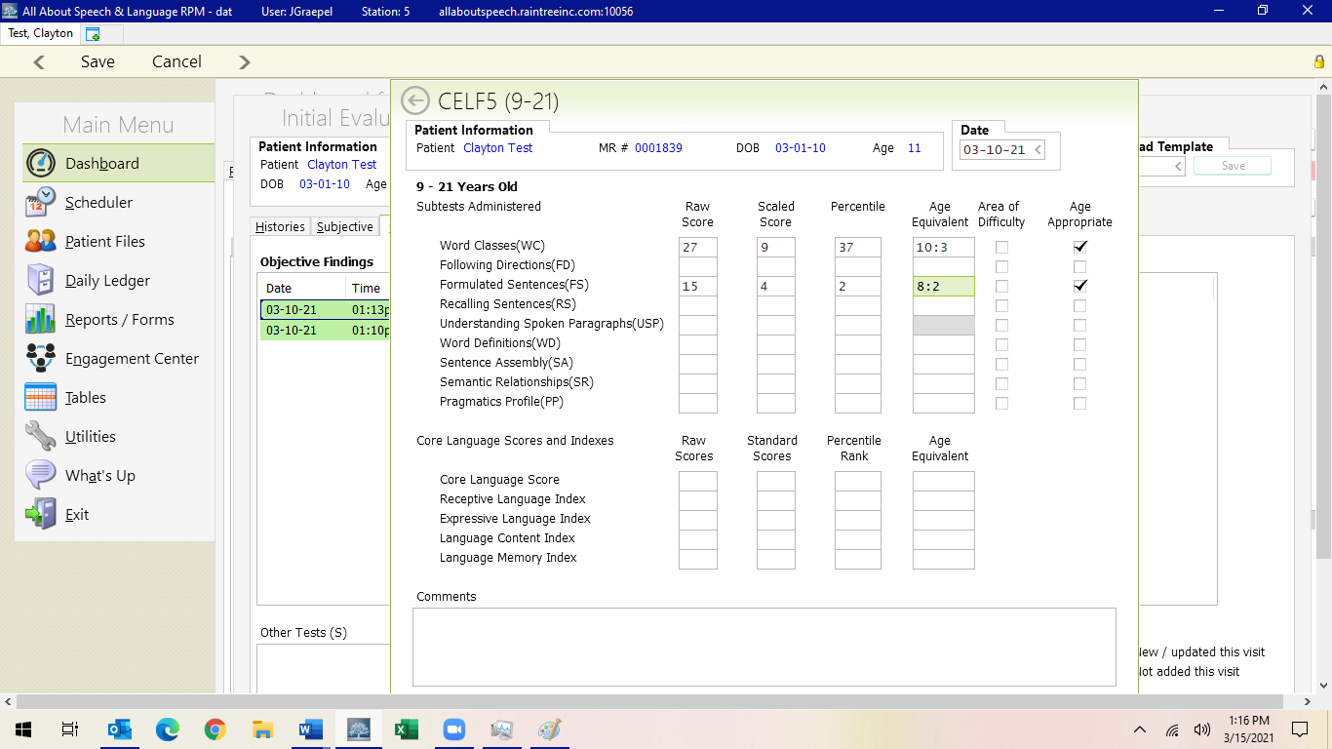

There are templates available for describing subtests for our most commonly used assessment tools (CELF-5, CELF-P, etc.). Please utilize these test descriptions for self-pay evaluations. For Tricare evaluations, simply input scores. Unless there is a one-off circumstance, there should be no need to edit these templates in the narrative boxes.
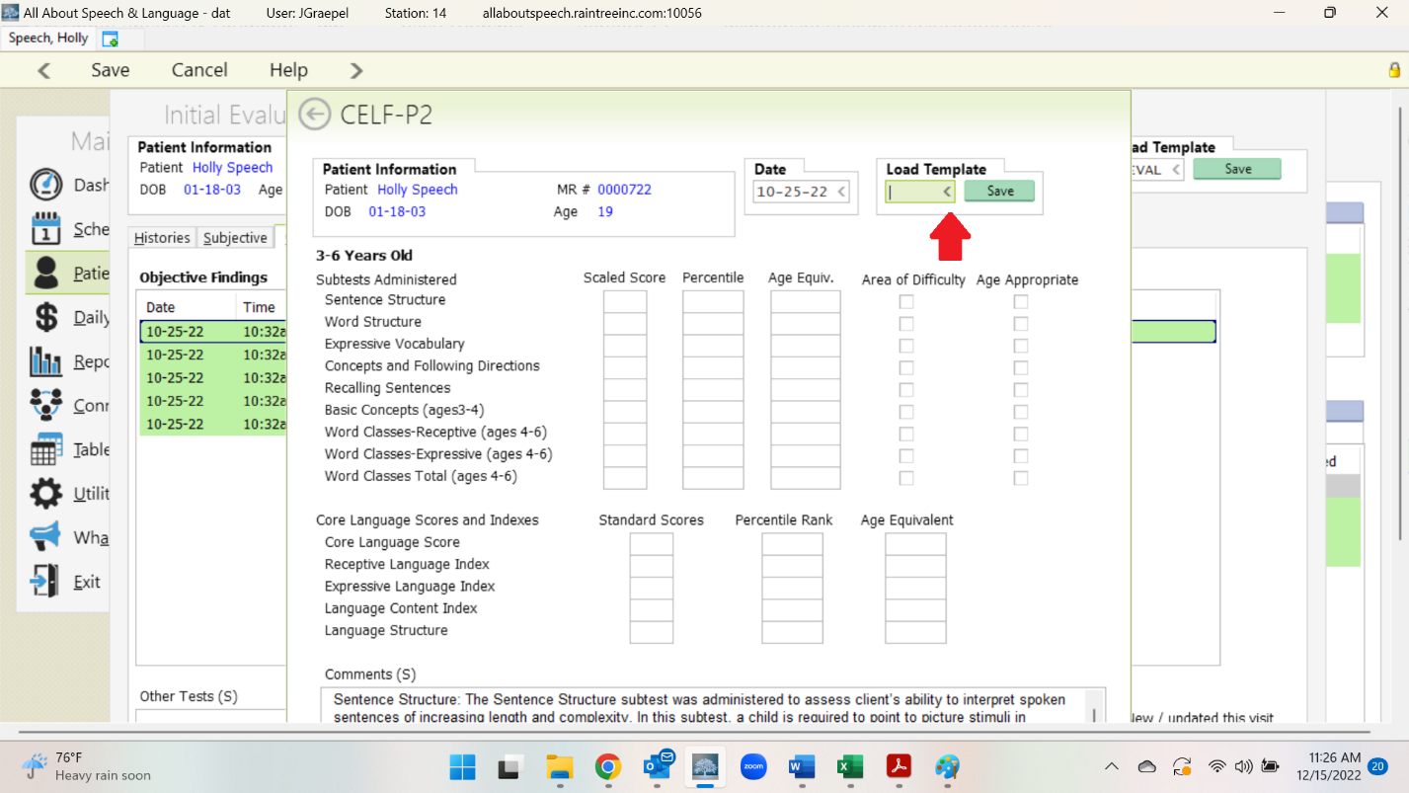
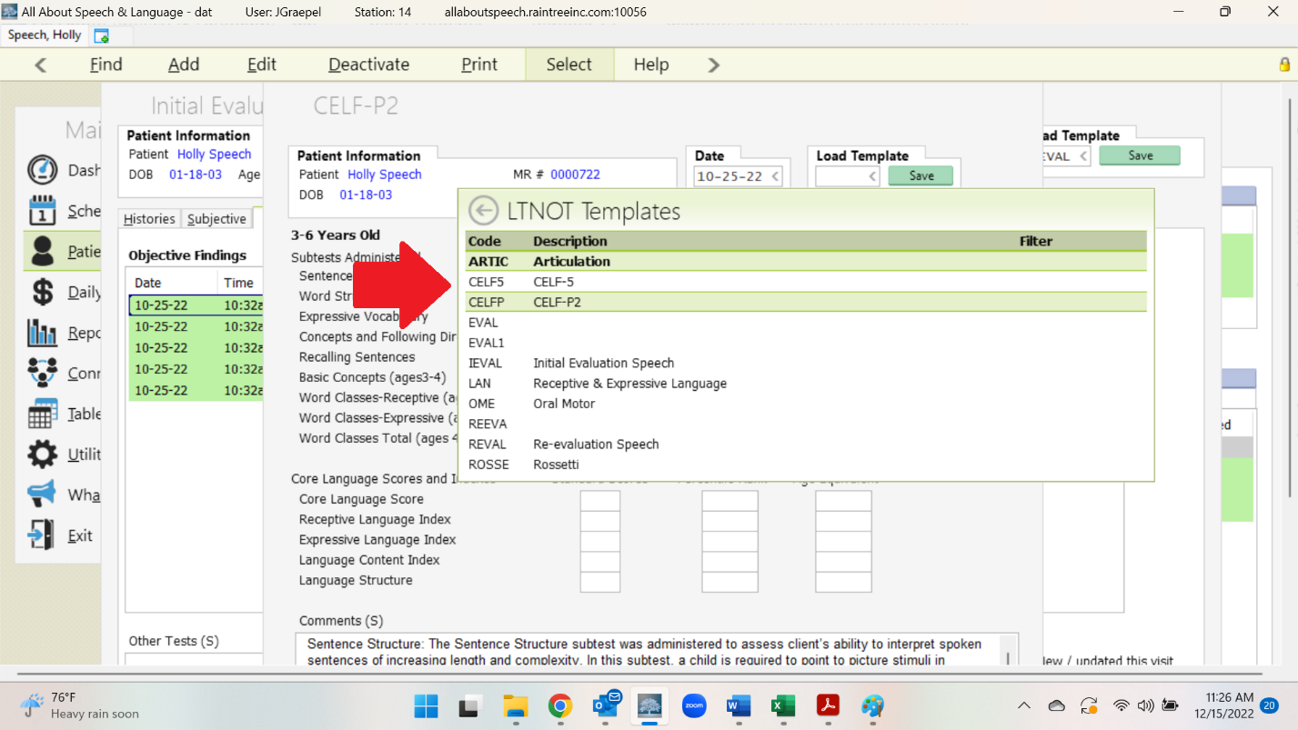
For standardized assessments that do not yet have a template in RT, we have a google-doc of running “subtest blurbs” for you to reference for quick copy and paste.
The open narrative box for “Other Tests” is mostly used for our Reading Measures, Social Tests, and any standardized tests that aren’t currently in RT.
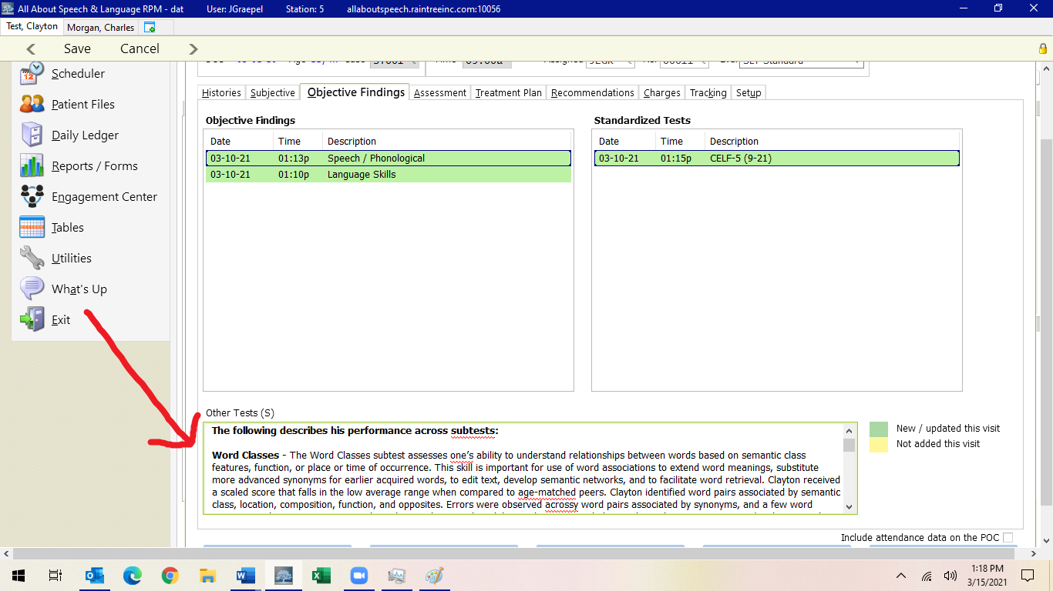

Certain assessments with pick lists (GFTA, PLS-5), do not have templates. Pick lists are updated. See example
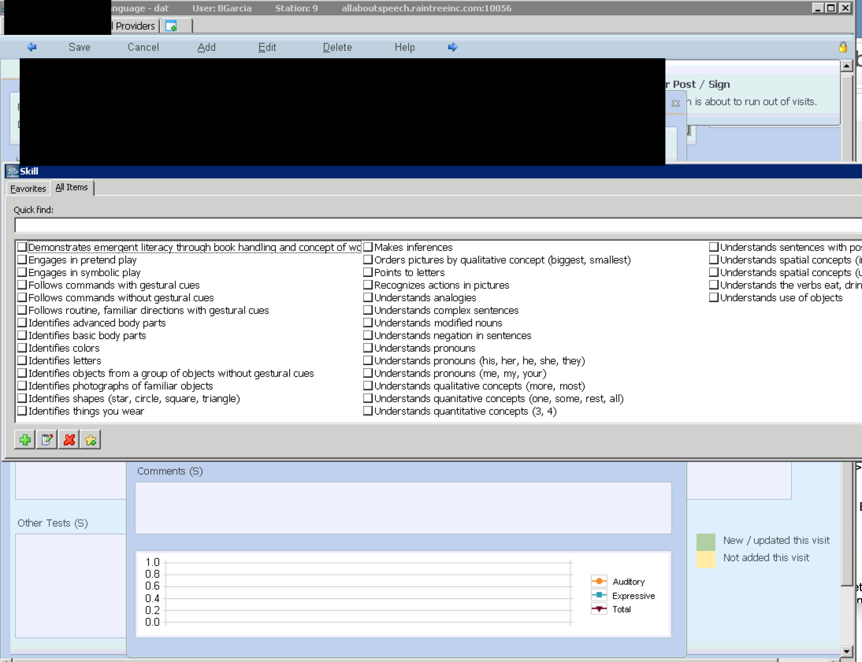

In the final sign off page, the following manual edits are to be made (cosigners will do for cosignee)
- Change GFTA-2 to GFTA-3, CELF-P2 to CELF-P3
- Delete out the sentence regarding percentile rank for GFTA, because it’s just wrong: “A percentile rank indicates the percentage of children who earned either the same, lower, or better score or on the test.” This is not an accurate definition. (on cosigns, cosigner will do).
- Remove any auto-populated descriptions of subtests/performance (should be just the CELF-P2)

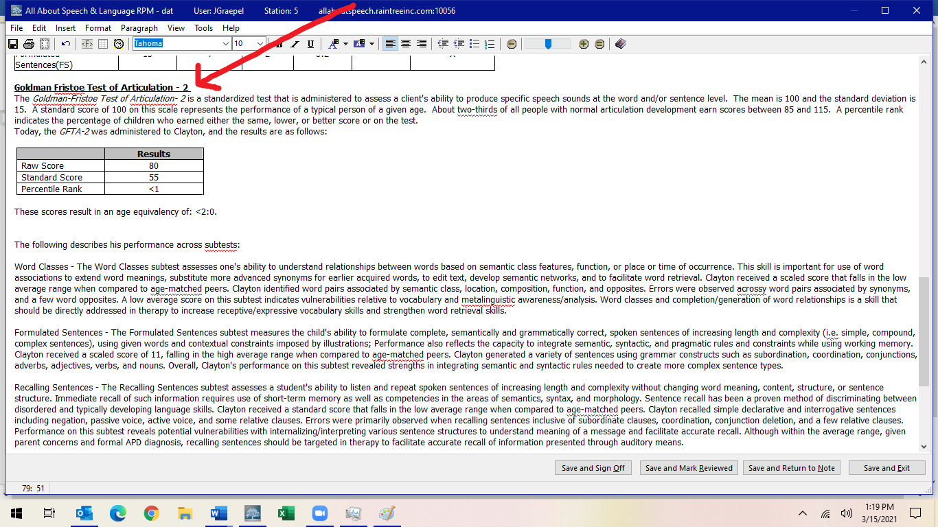

Treatment Plan Tab and Pick Lists for Short-term Goals:
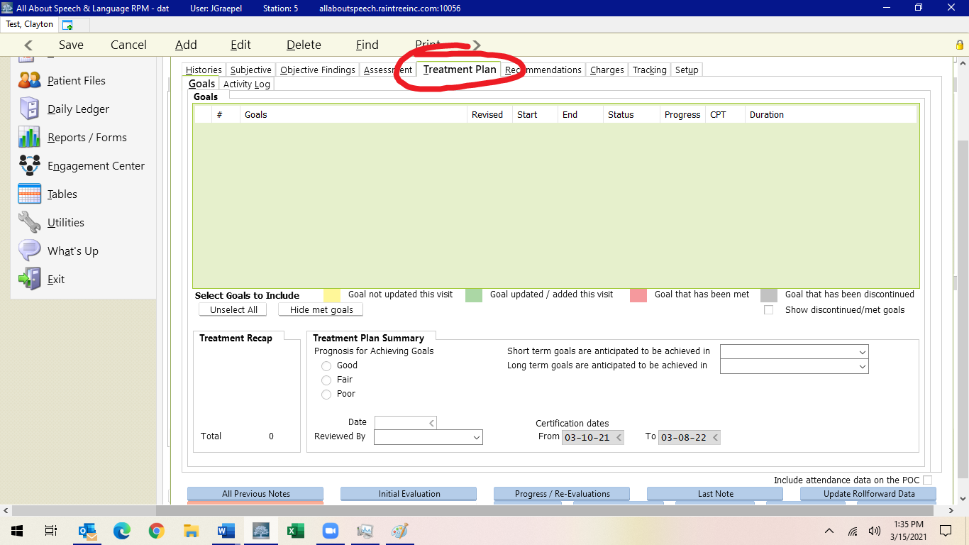

Under Goals, you are going to hit A to add.
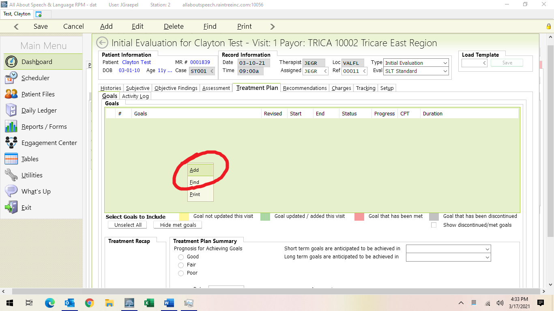
Under Category select your long-term goal area from the drop-down arrow. Then you write your long-term goal. Please see google drive for updated pick list goals that include LTG with the STG by goal area to help you in writing appropriate long-term goals.

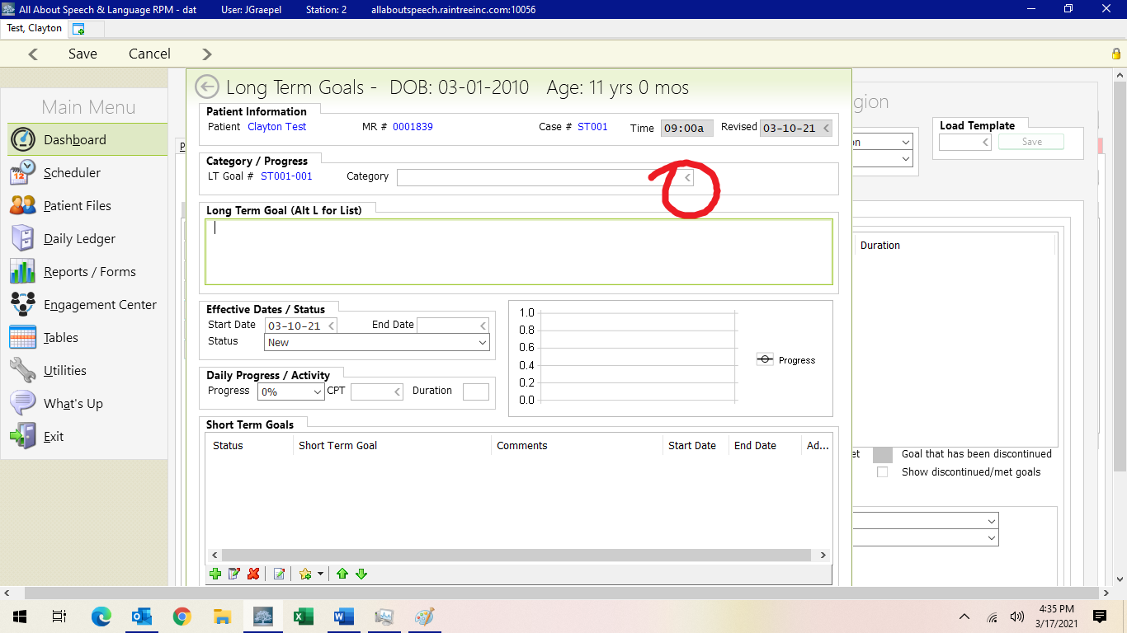
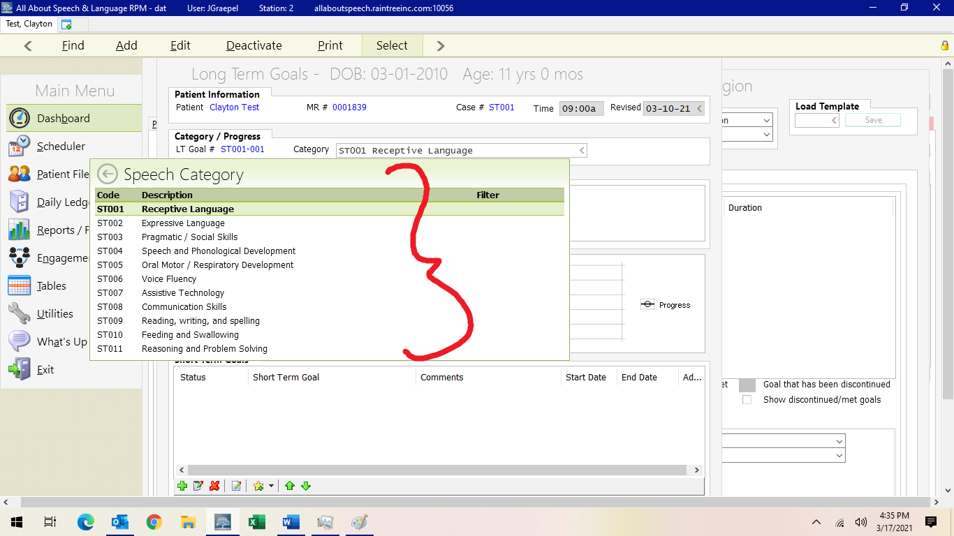

You do not need to fill in progress on initial evaluations.

Under Short-Term Goal, you are going to go down to the toolbar where you see the star with the + and drop-down arrow box next to it. When you click this, you will hit Load Template.

Then all the templates that we have current “pick lists” for across STG areas will populate here. Select the ones that apply to your LTG objective then the entire template will load. You can toggle over the goal area to see the entire goal. If you have to edit the goal, click on the goal to highlight it in purple, then right click and edit the goal.
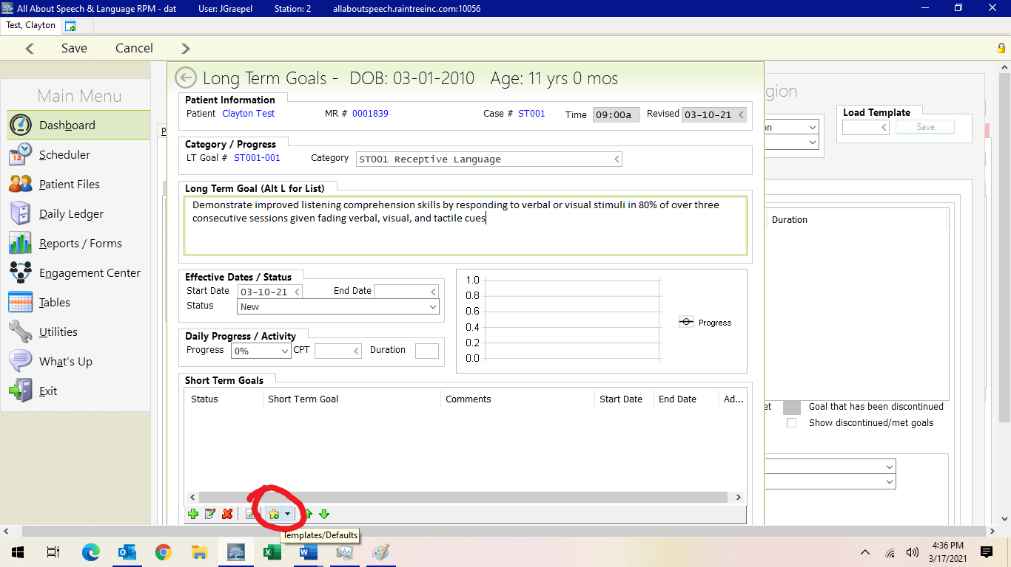

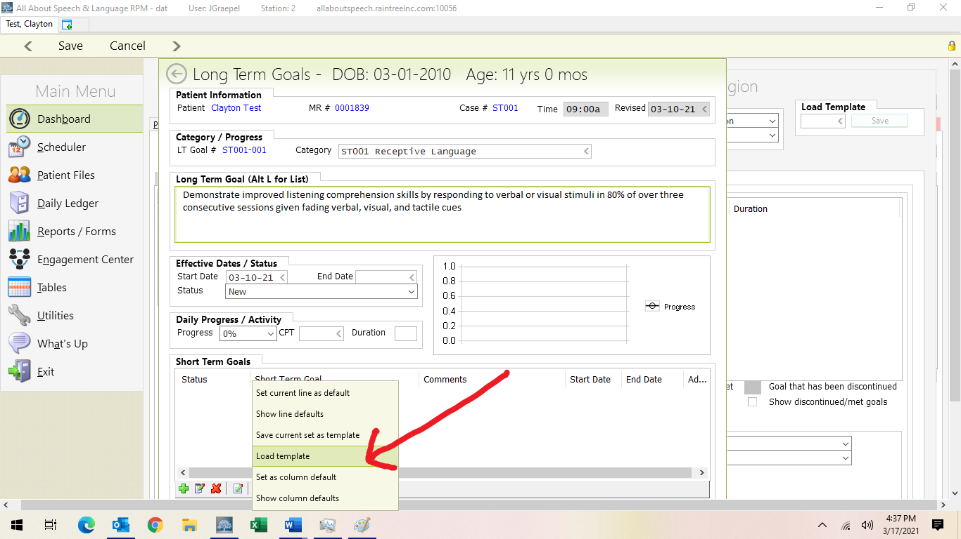

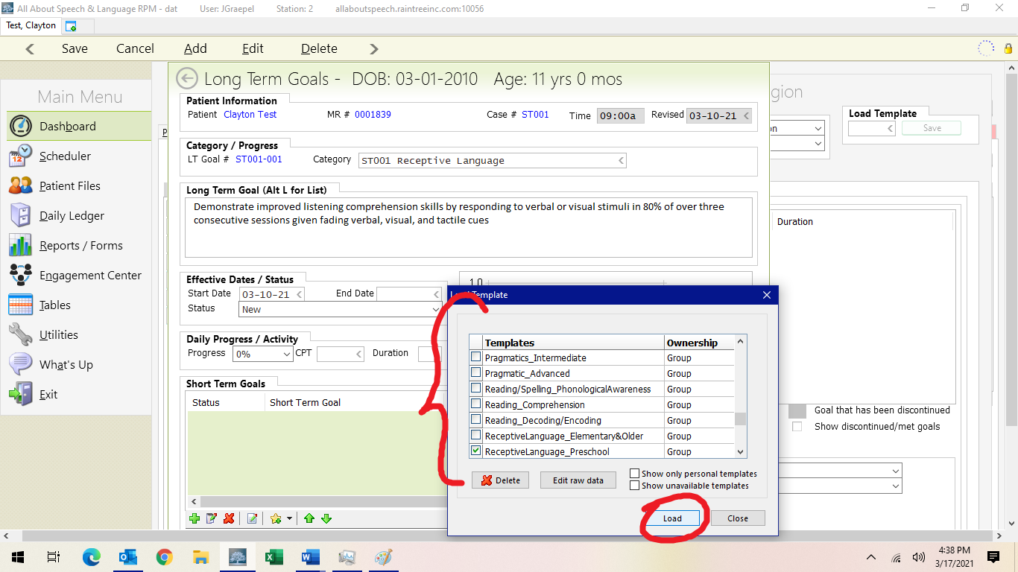

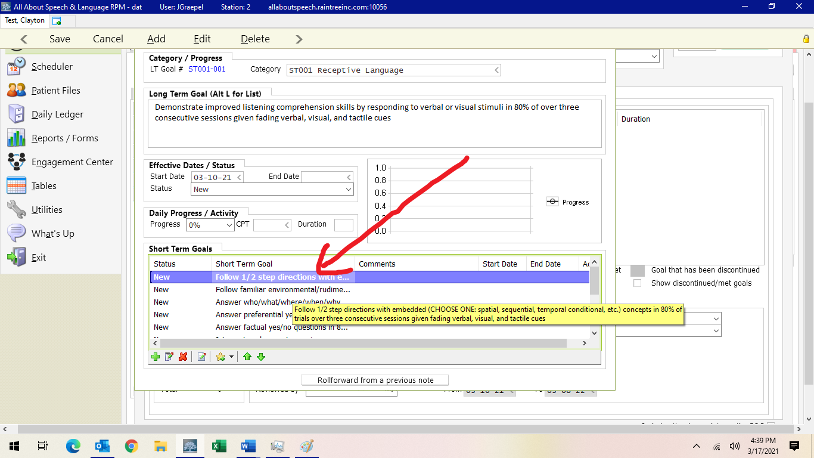
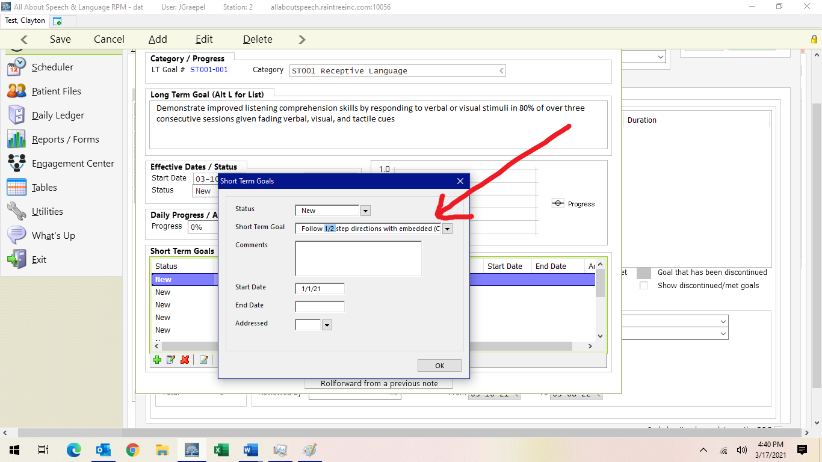
This will mostly be necessary for articulation goals when you are inputting the specific sounds that need to be addressed in treatment.

You will then go through and delete out with the red X button the short- term goals that are not needed to start this plan of care. We usually select no more than 4-5 short-term goal objectives as these can be updated at the time of the progress note, 6 months going forward from the date of the initial evaluation OR if short-term goals are being met and new goals need to get added sooner than this. Be sure to put the date in each STG as well
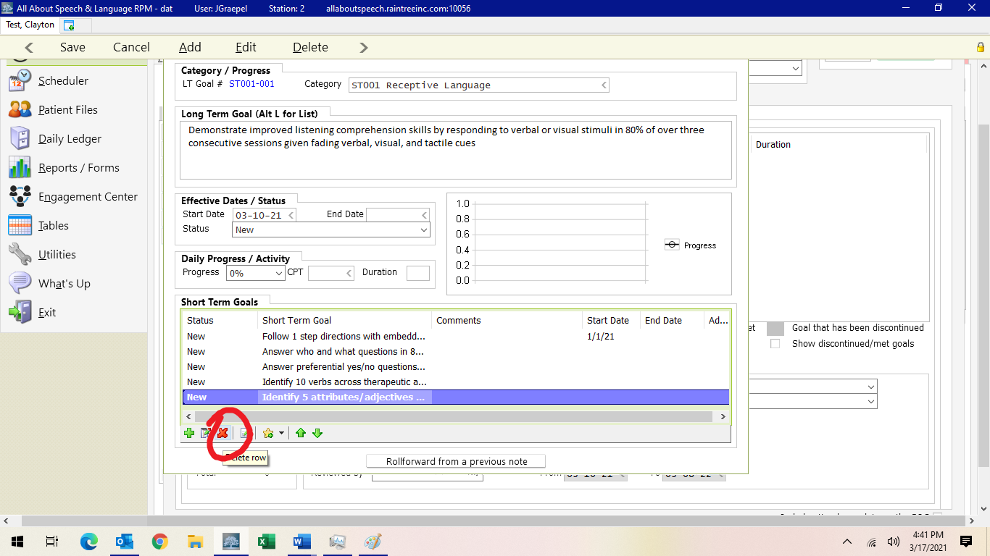

Then you hit save.
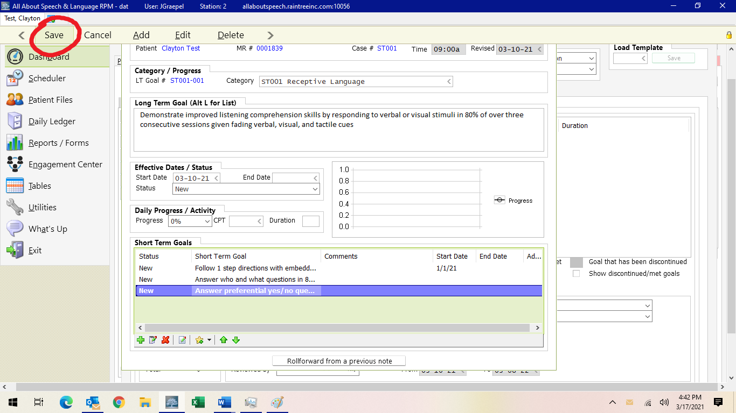
You will repeat this process for as many LTG areas you have with STG area objectives. Use the google drive Pick List/Updated Goals Document to help you as a reference

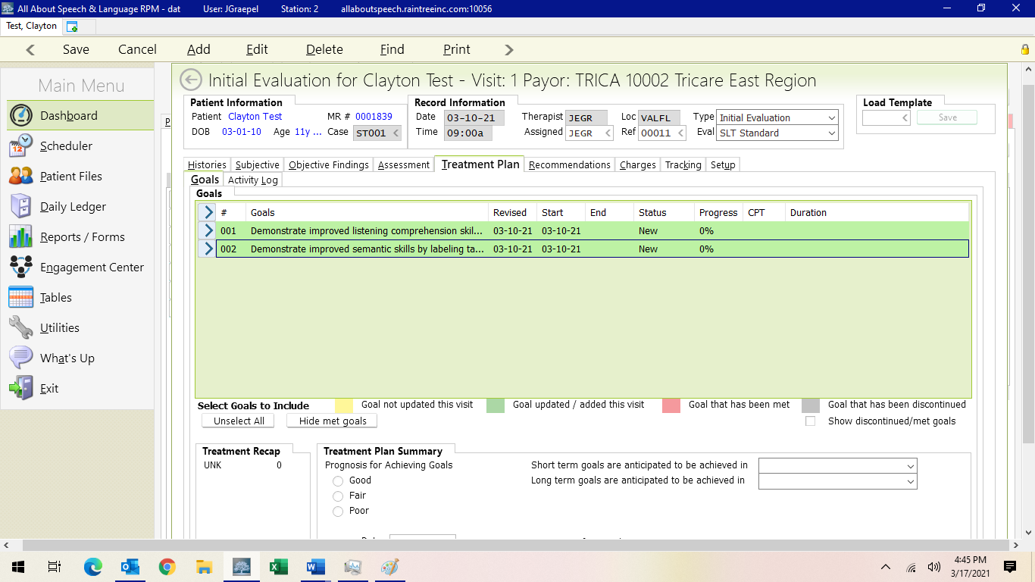

Updating, Meeting, Discontinuing Goals for Re-evaluations

Update and/or add any new goals, if warranted, or change the status of the goal per the drop down in this section. WE ONLY USE New, Ongoing, Discontinued, or Met. Once a goal has been addressed in a therapy session, it changes from “New” to “Ongoing.” To Update goals, do the following:

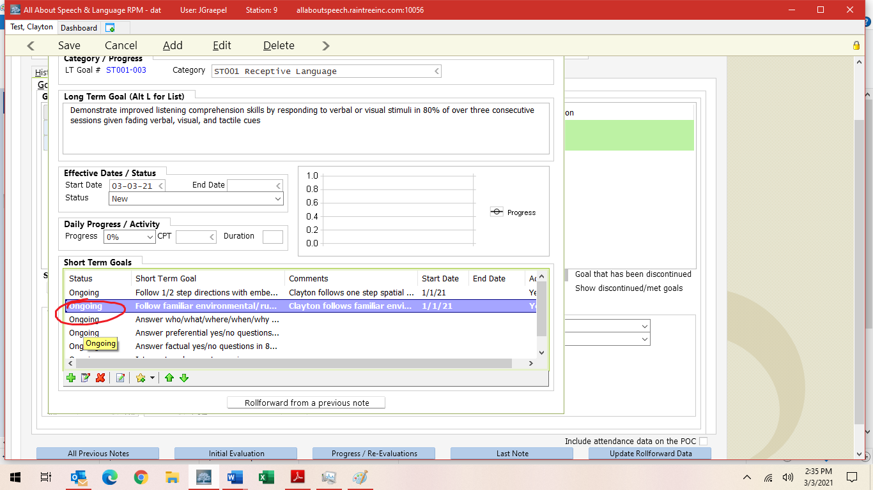
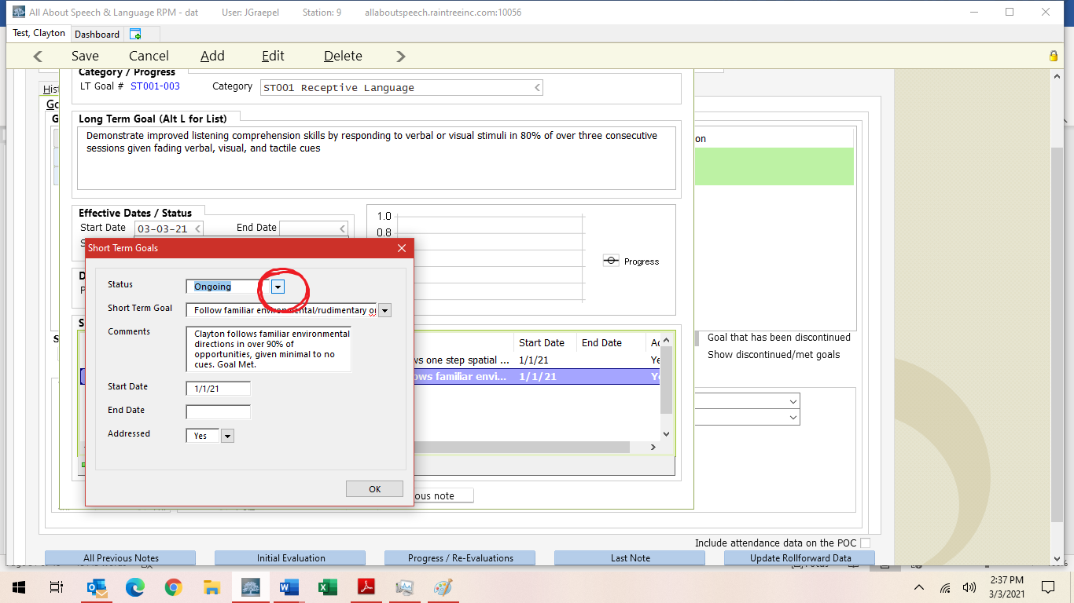

*IF A STG IS DISCONTINUED OR MET, BE SURE TO PUT AN END DATE!

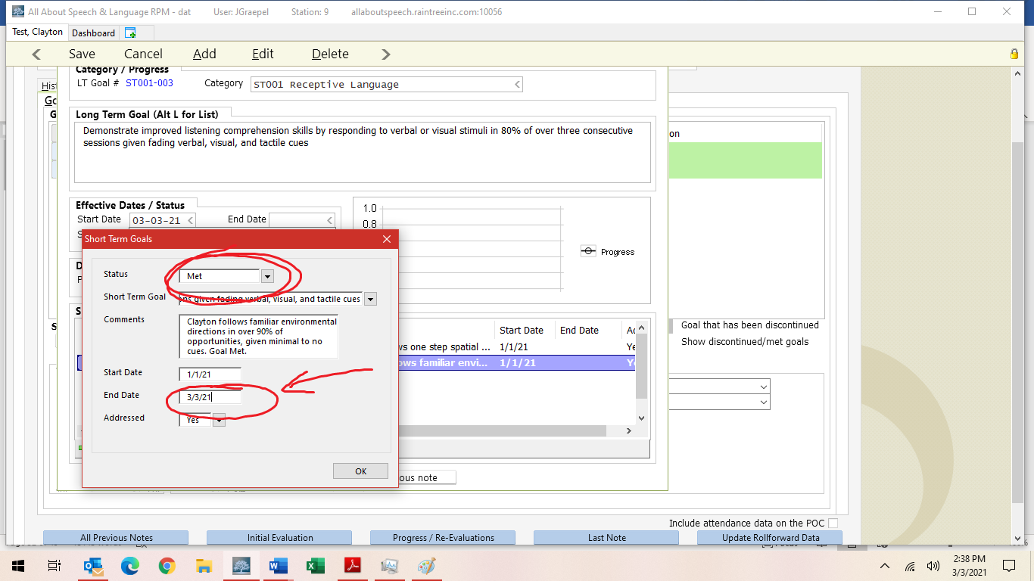
*SAME GOES FOR ANY LTG DISCONTINUED/MET (ALONG WITH STATUS CHANGE)

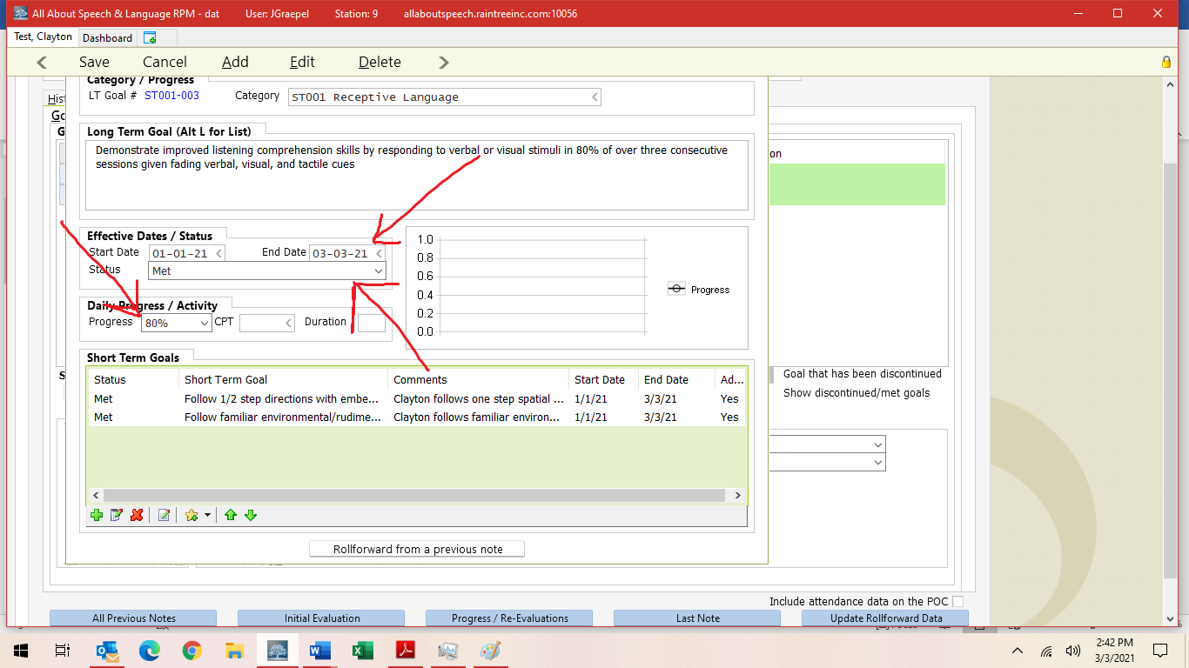

Under Treatment Plan Summary, select prognosis, then list what STG and LTG are going to be achieved. Generally, we do 6 months for STG and 12 months for LTG; But if a client has more severe deficits you can put LTG for by discharge.

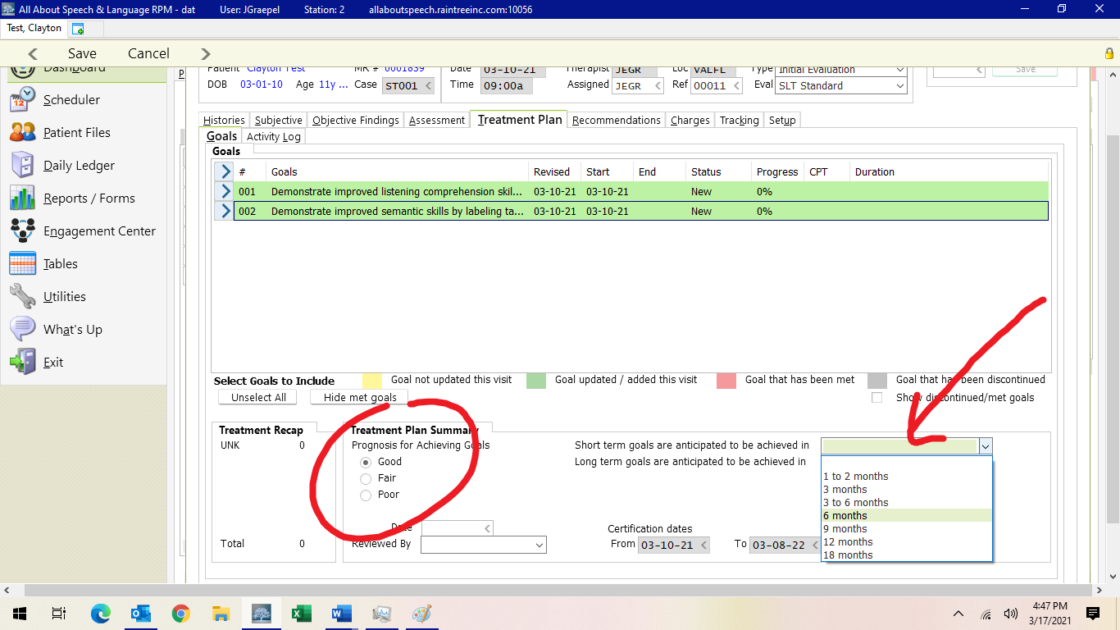

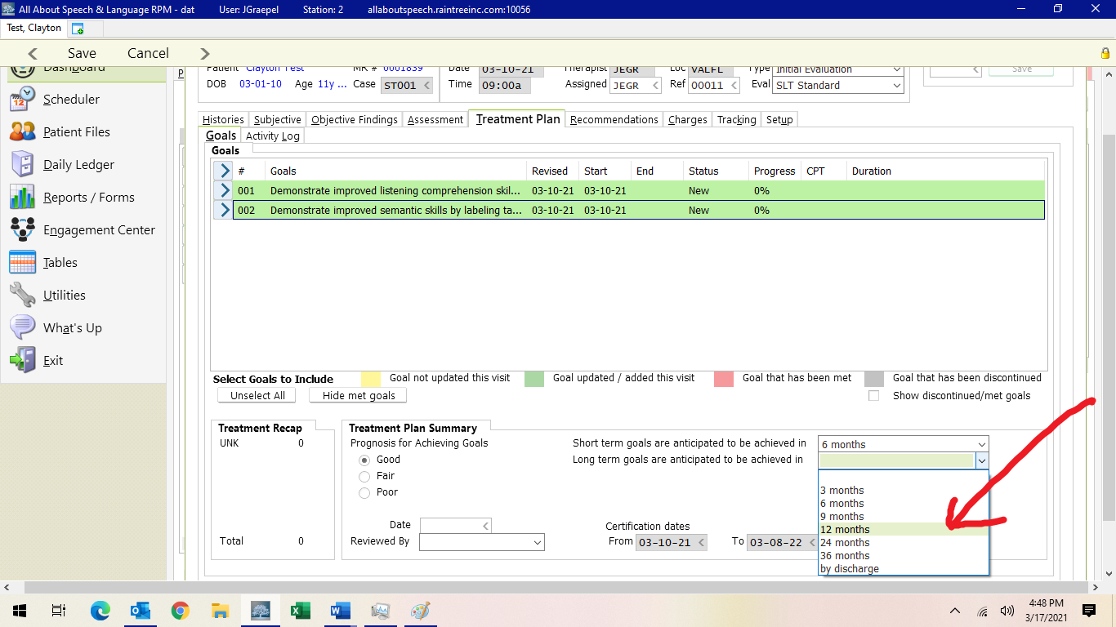

Assessment Tab:

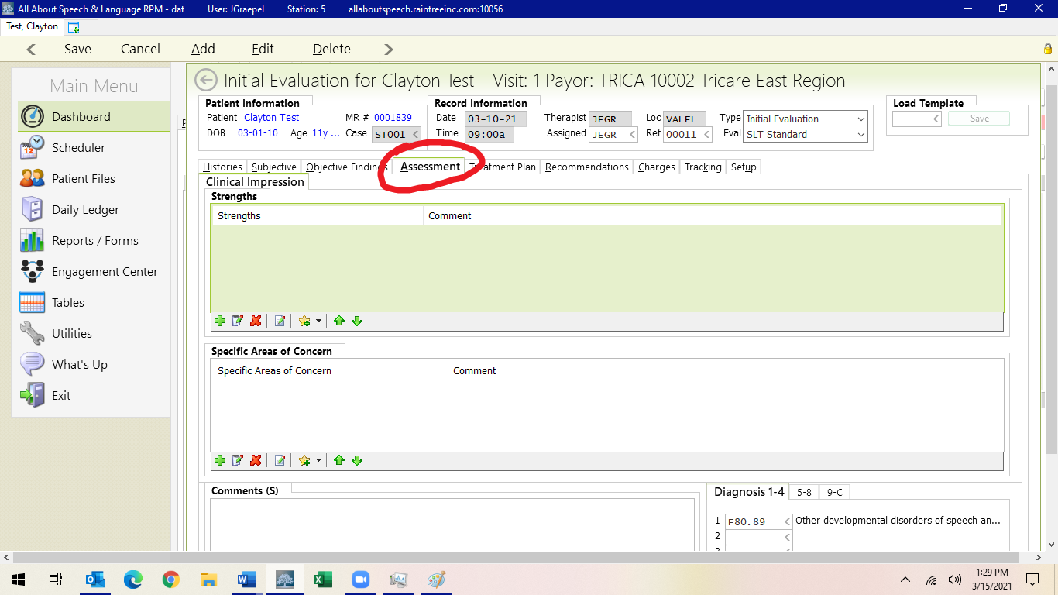
Check boxes with + of Strengths and Areas of concern. You don’t have to “comment” on areas of concern. Again, given the analysis is in the body of the report you can just select what the updated areas are and save with the floppy disk icon.

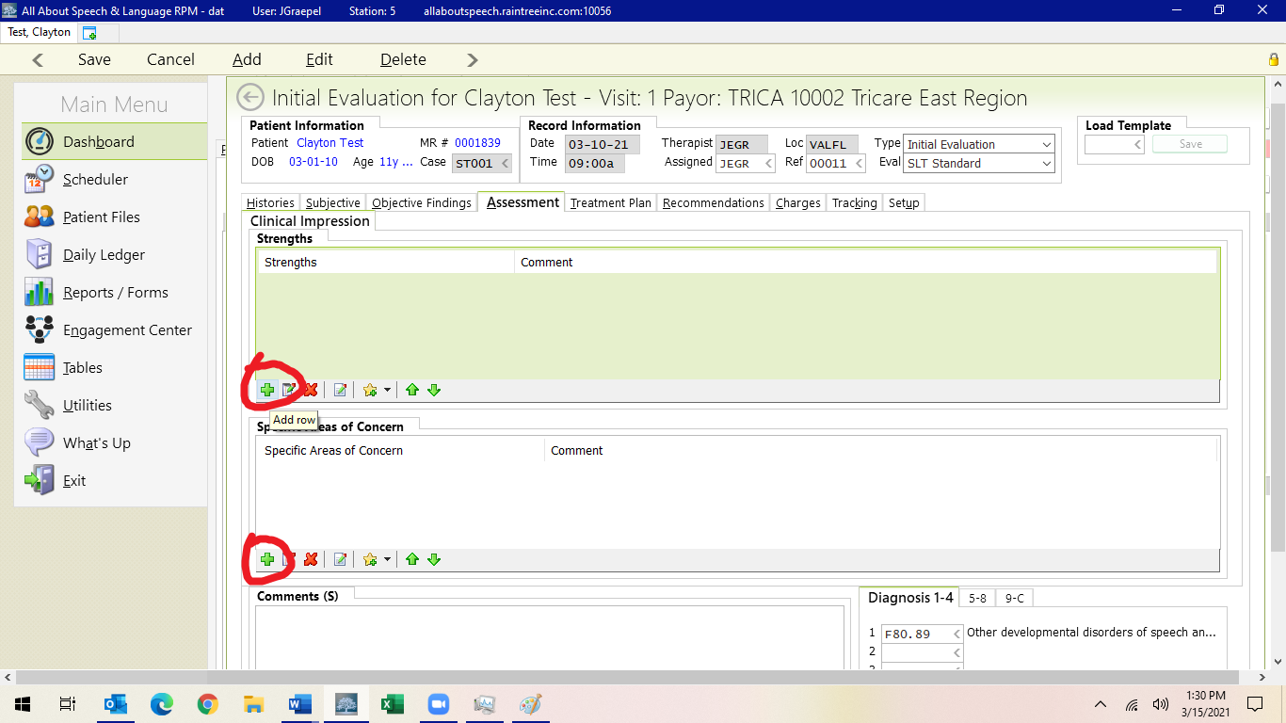
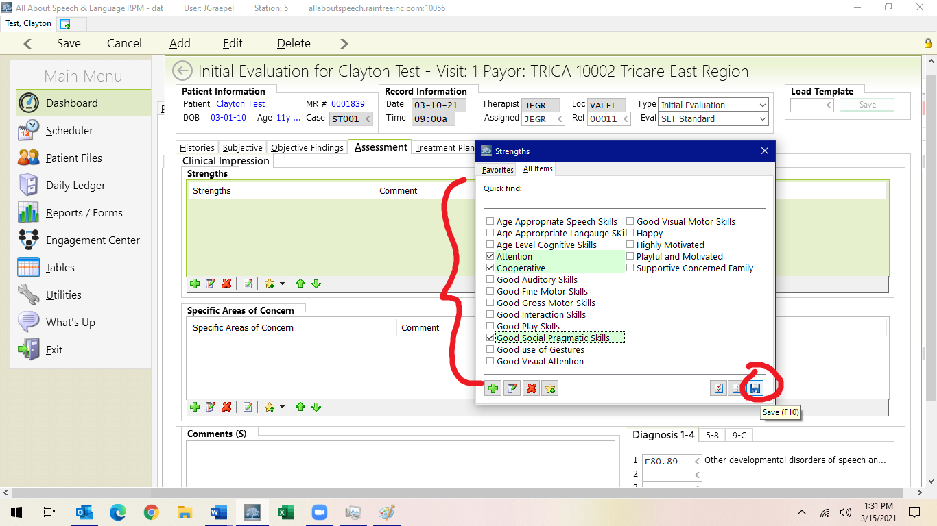

Depending upon the client and concerns identified in the evaluation, a comment may be warranted, however, this is done on a case-by-case basis as well. In this comment box, you will ALWAYS reiterate if therapy is/is not warranted. Typically, we use this verbiage:

“x, a x year x month old girl/boy, presents with impairments across __________skills. Results of standardized and qualitative assessment reveal the need for therapeutic support is warranted at this time.”

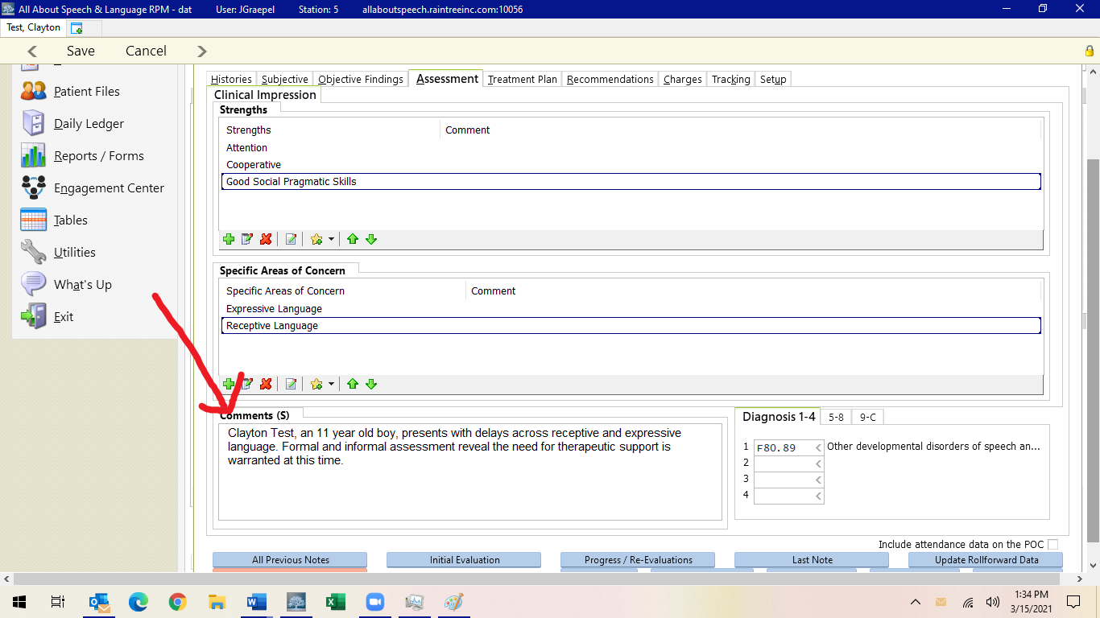

Recommendations Tab:
There is a template for this as well that will fill out for you as well. PLEASE be sure to read thoroughly and complete, remove any information that is not pertinent or accurate. It should look like this:

Based on standardized and qualitative assessment, clinical observation, and parent report of NAME’s current level of function, skilled speech language intervention is warranted at this time. X, age __;__, presents with deficits/impairments across (list domains) secondary to (diagnosis if relevant). Medical history is also relevant for _____ (anything pertinent to their development). X presents with _________ (PUT IN DISORDER); DISORDER is considered a condition that may be impacting X’s ability to functionally communicate his/her wants and needs. Research has shown skilled speech language therapy to be beneficial in treating speech and language disorders (Broomfield & Dodd, 2011). ***See various Research citations***

Social Citation= Research has shown skilled speech language therapy to be beneficial in treating social skills disorders in children and adolescents (P.G. Erwin, 2007).
Apraxia CItation=Research supports the use of a motor-planning approach incorporating integral stimulation and/or Dynamic Temporal and Tactile Cueing approach for children with [childhood apraxia of speech] CAS (Koehlinger, K. M. 2015).
Stuttering Citation= Research has shown skilled speech language therapy to be beneficial in treating stuttering disorders in children and adolescents (C. Nye, et al. 2013).
AAC Citation= Research has shown skilled speech language therapy implementing augmentative output to be beneficial in improving speech and language skills(Allen, A. A., Schlosser, R. W., et al. 2017).

RESULTS FROM TESTING: Results from the ____/qualitative assessment revealed skills to be below average. Primary areas of need include: __________. Oral motor structure/function, voice, fluency, articulation, pragmatic language/social interaction, receptive language, and expressive language skills (CHOOSE APPLICABLE), were subjectively judged/assessed to be within normal limits. LIST ANY PARTICULAR OBSERVATIONS HERE, i.e. “X was observed to whisper some of his responses during the evaluation; this is observed to be behavioral in nature and not indicative of a voice pathology/etiology. All aforementioned communication domains should continue to be monitored and directly addressed as deemed clinically necessary.

PLAN OF CARE/FOCUS OF TREATMENT: Recommendations are as follows: Initiate/Continue with Speech-Language Therapy. Based on clinical observations, evaluation results, and caregiver reports, the specified frequency/duration for speech-language treatment is recommended. Skilled, individualized therapy services are/continue to be indicated to carry out the plan of care, which requires one-on-one instruction from a skilled, trained therapist due to the need for continually updated goals and techniques that cannot be provided solely/soundly by this patient’s caregiver at home. At this time, therapeutic support is considered medically necessary and should address (LIST/DETAIL SPECIFIC AREA/DOMAINS)___________. Therapeutic techniques to help execute this plan of care will include the following: (ANY SPECIFIC SLP TREATMENT TECHNIQUES RECOMMENDATIONS TO BE ADDED HERE I.E., Augmentative/Alternative Communication (AAC), PECS, CYCLES APPROACH, Auditory Discrimination Training, Oral Stimulation and/or Exercises, Verbal Behavior Shaping, Behavior Modification, Fluency Training, Voice Therapy an/or Vocal Care Program, Feeding and/or Swallowing Therapy utilizing S.O.S method, Articulation therapy utilizing PROMPT, ETC.).

PROGNOSIS/MEDICAL NECESSITY: X’s prognosis and rehabilitation potential is positive with skilled individualized therapy. Based on parent report, clinical observations made in therapy sessions, results of administered standardized testing, areas of need are confirmed across X’s expression, understanding, and production of language (ADJUST SPECIFICS).Given these conditions, as well as X’s compliance and participation in therapy, attendance, and his supportive family, prognosis for improvement with therapy is good at this time. Recommended therapy is considered to be medically necessary to prevent more significant disability, is individualized and specific for this patient based on their symptoms or diagnosis/condition (where treatment is targeted toward specific goals), is reasonable and not in excess of the patient’s needs, will be implemented with evidence-based practices and standards and therefore are not experimental in nature, are reflective of the level of service that can be safely furnished for the patient, and for which no equally effective and more conservative or less costly treatment is available at this time. The specified medically necessary treatment requires the specific knowledge, skills, and judgment of a speech-language pathologist (SLP) and is expected to yield improvement within a reasonable amount of time. The goal of intervention is to treat X’s impairments with the purpose of remediating skills to a more normal state of function.

HOME PROGRAM BEYOND TREATMENT: Patient and caregiver will follow up with a HOME PROGRAM that is designed to aid in appropriate carryover and generalization of newly learned skills and shall include: providing caregiver training, verbal and written home exercise plans/activities following session times, and provision of treatment strategies and patient progress toward goal objectives following sessions.
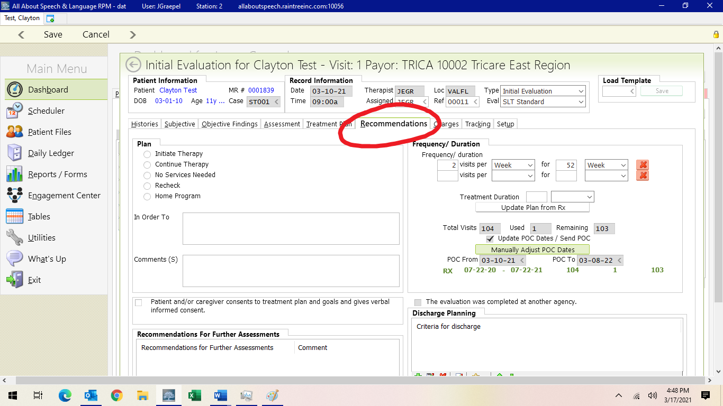

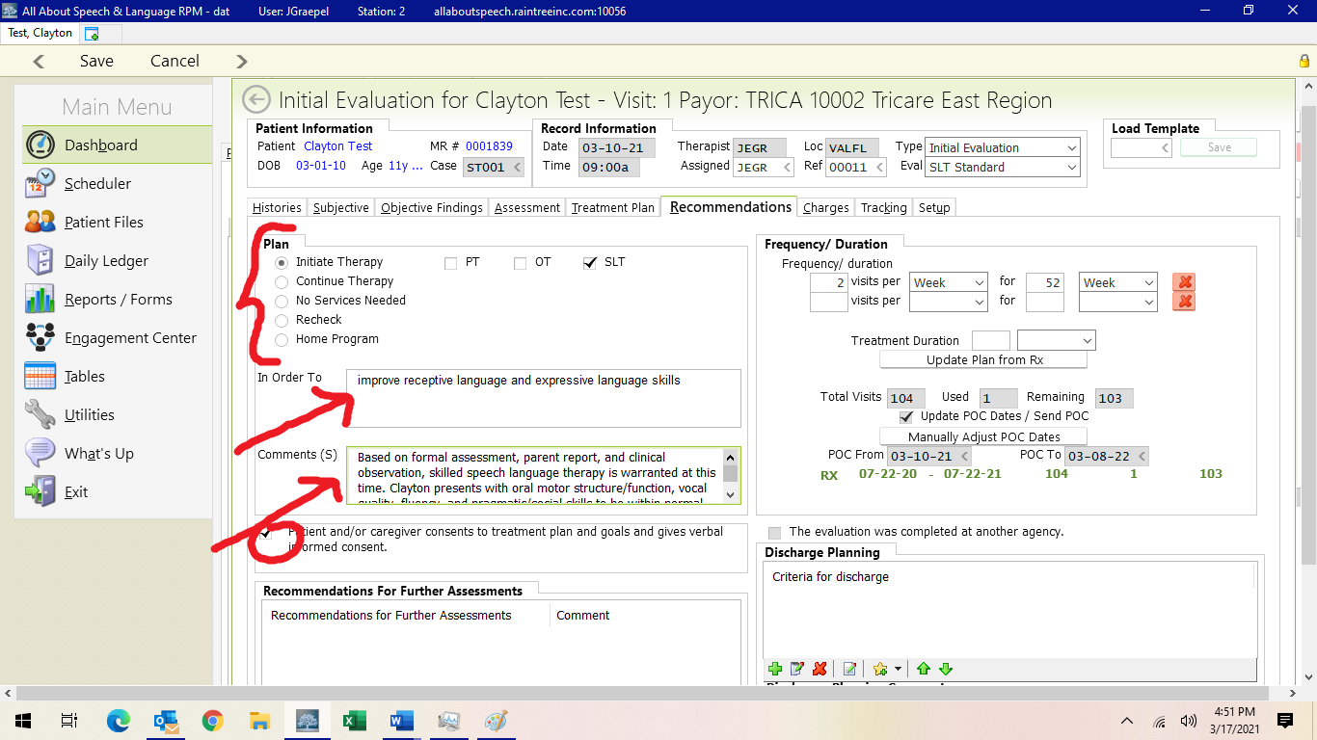
Here you will also add recommendations for further assessments if needed, again especially if have concerns for more going on with a child; can select via +.

Recommendations for further Assessments
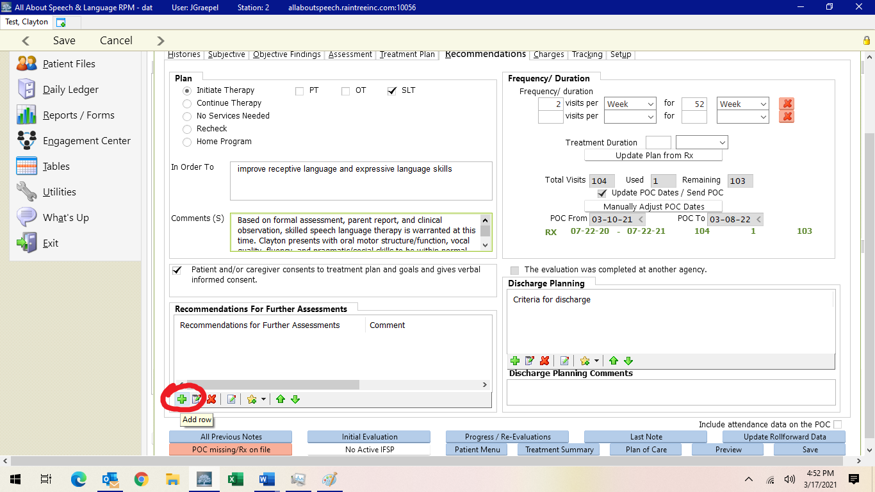

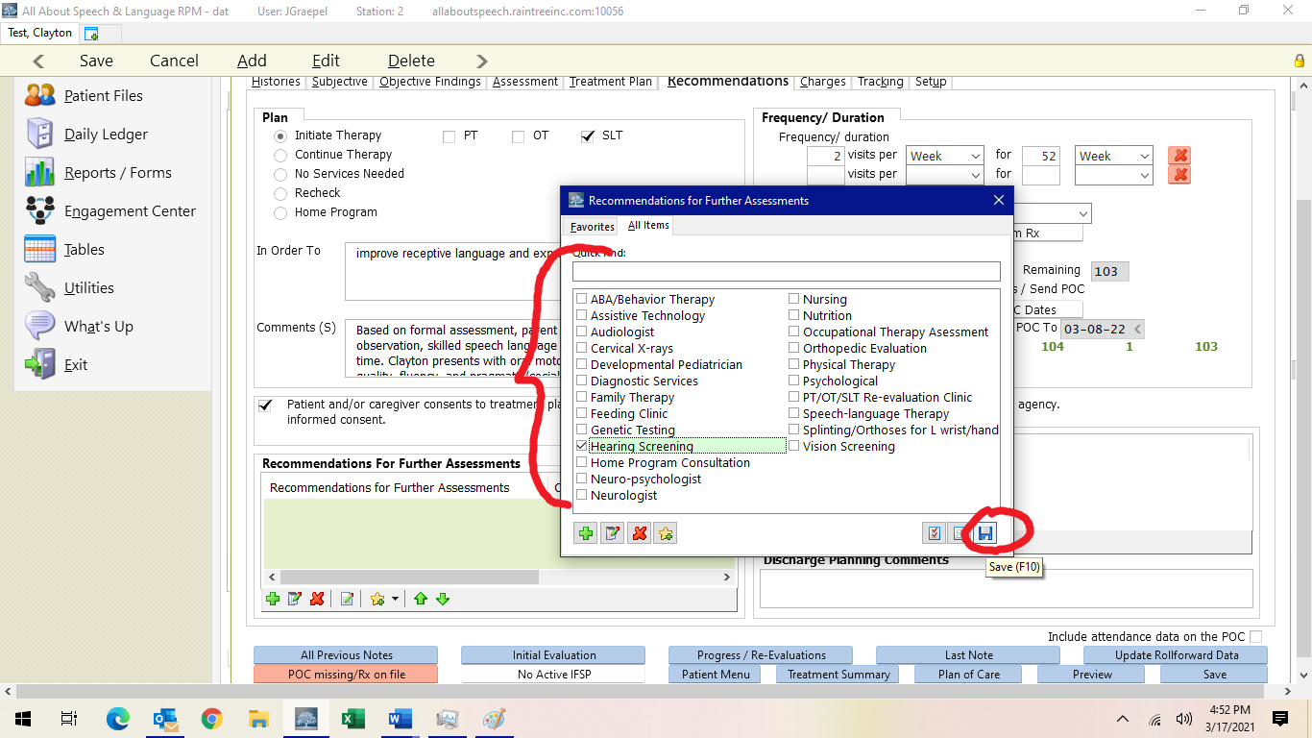

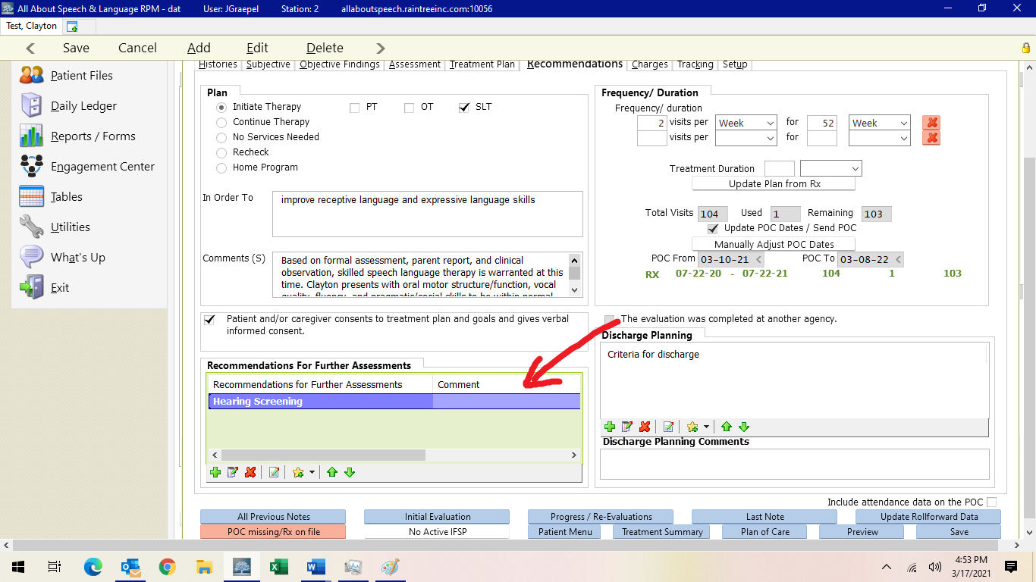

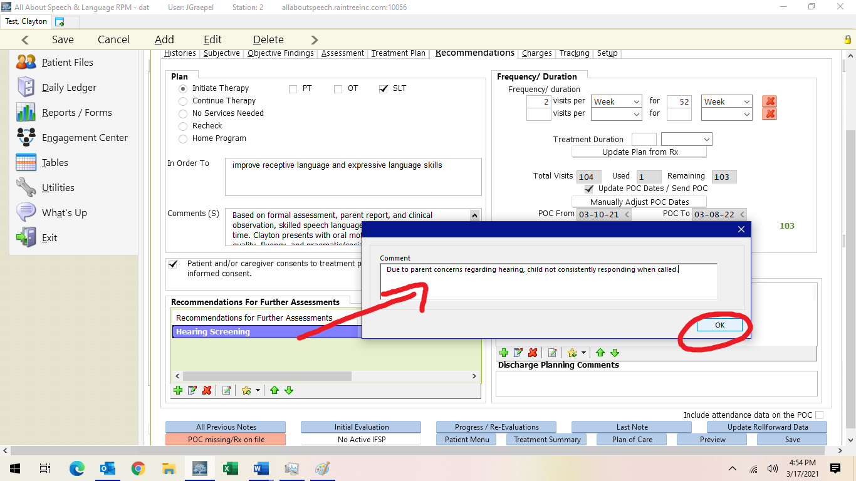
Under Frequency/Duration you will input 1-2 visits per week for 52 weeks (use clinical judgment here)

Treatment Duration is 30 minutes. Total number of visits will be 104.

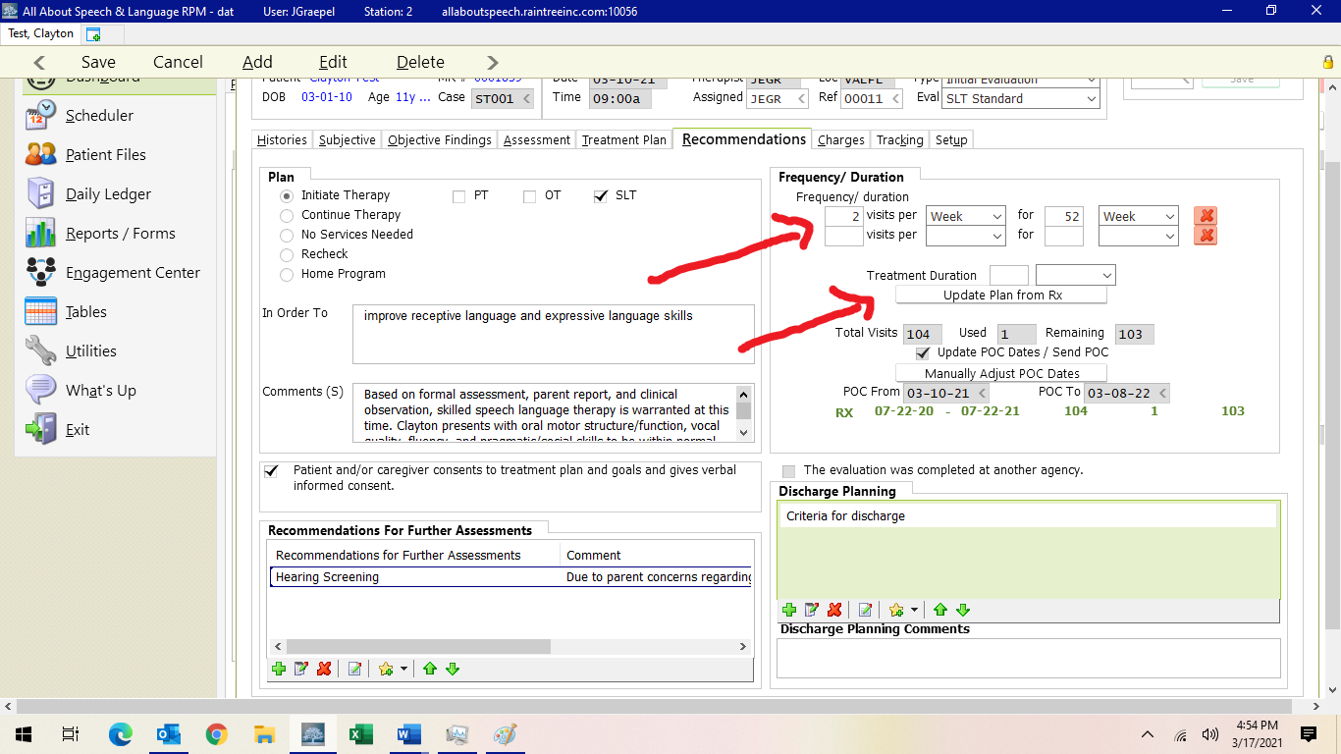
POC From and POC To Dates are in line with the initial date of the evaluation; you input the initial date of the evaluation and then put that same date but a year later denoting when it “expires” and that will warrant us to do a re-evaluation. Sometimes the numbers autofill in for you as well. If there is ever an error, it won’t let you sign off on the report without fixing it so can always ask CM/Operations Director about this

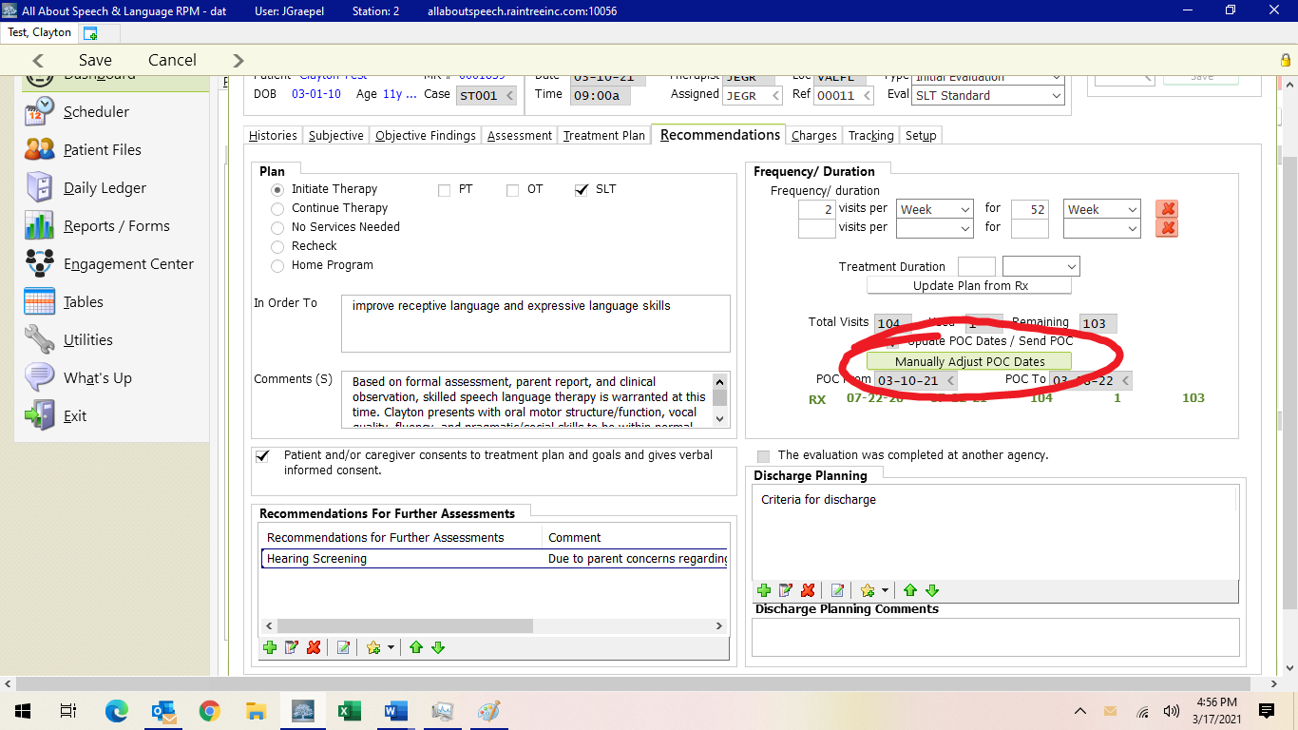

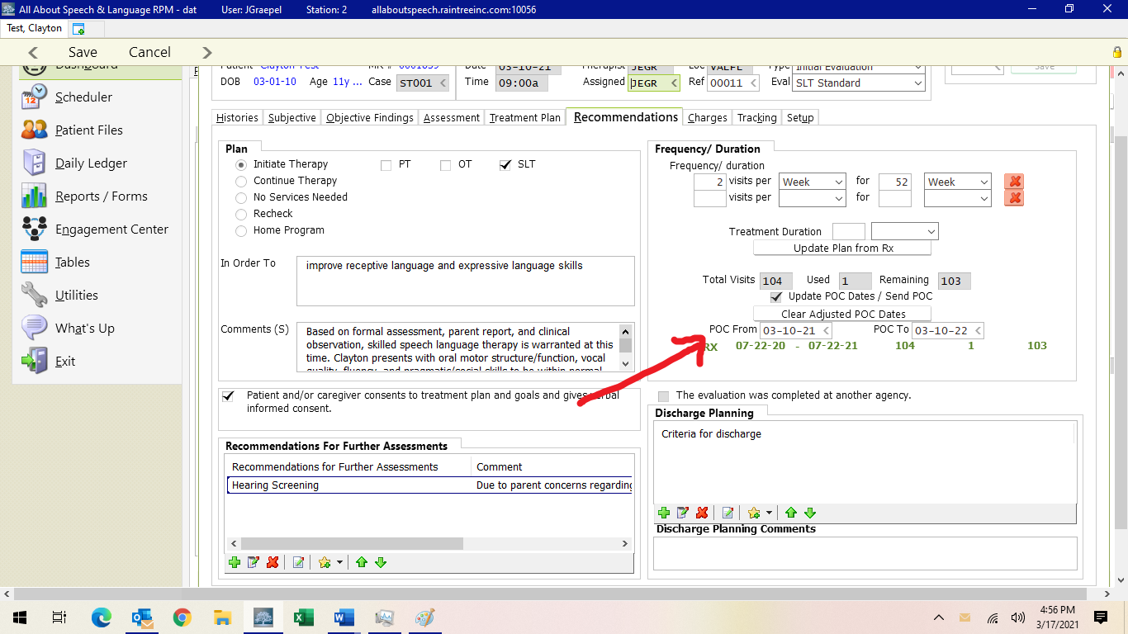

Discharge Planning: Again, case by case if you fill this out per family and can add via +.

Criteria for Discharge
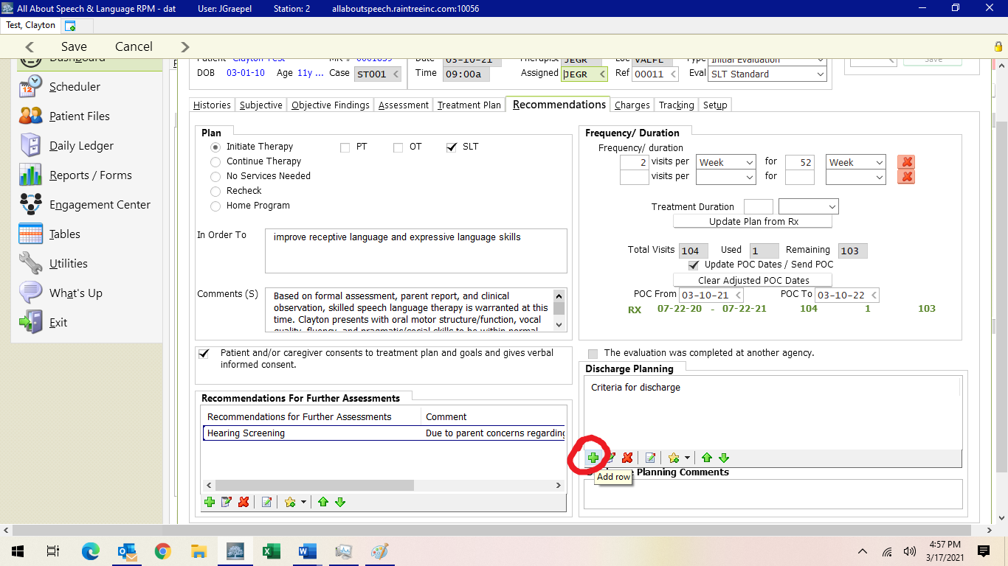

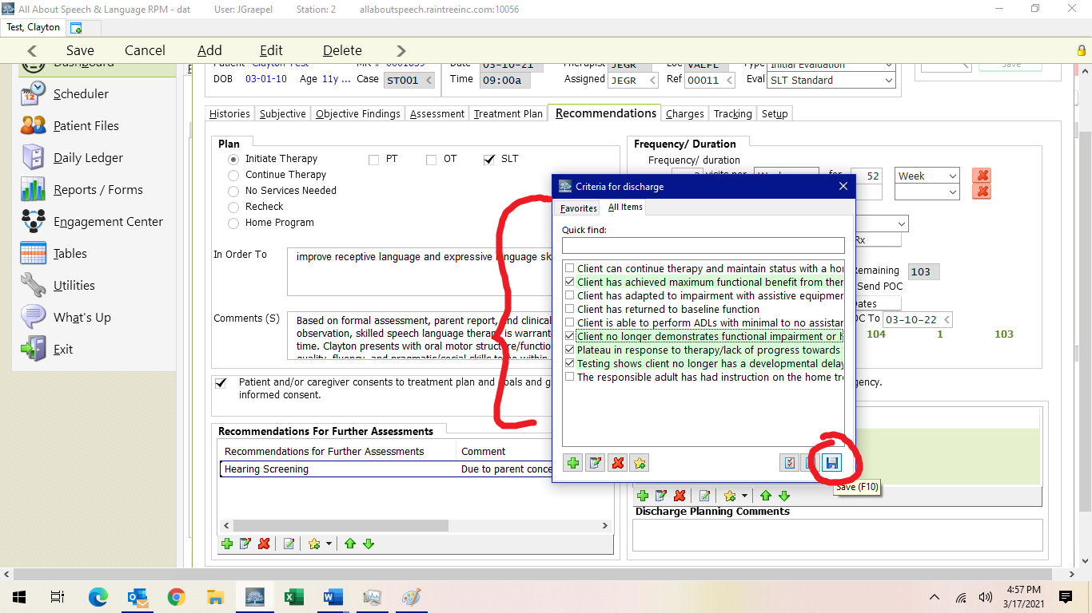

Charges:
Most evaluations are 92523 (In some cases, you will use 92522 if you are NOT assessing language. Typically, you are at least informally assessing); for SP and TRICARE
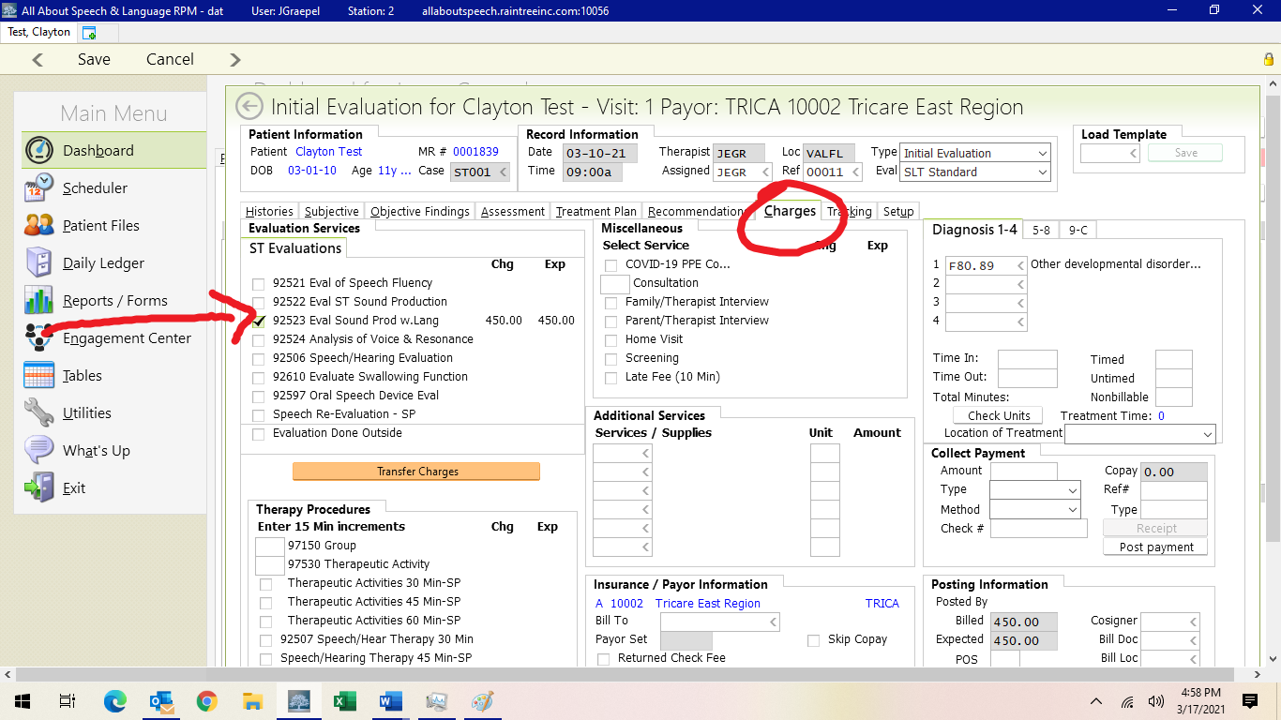

If there is another evaluation code that is warranted you can use the list in the charges tab or it will be communicated to you at the time of the evaluation, or you can communicate with your CM prior to the evaluation.

Reminder: if a re-evaluation is split into 2 30-minute sessions, please communicate with your CM for handling Tricare clients and communicate with Front Desk for Self-Pay (self-pay clients’ second appointment is deleted but reserved so testing can be completed).

Adding Diagnoses Codes
- TRICARE insurance requires that we have in our possession authorizations (Prime) or referrals (Select) as documentation supporting the medical necessity of the therapy services provided by AASL. These documents have listed a diagnosis code which was determined by the client’s medical doctor. There may be a list of more than one diagnoses. Upon receipt of this documentation, Patient Scheduler enters the applicable codes in Raintree consistent with the authorization or referral. SELF-PAY clients may elect to request a script or referral from the Primary Care Physician if they are planning to submit paid invoices in hopes of acquiring reimbursement from their private commercial insurance company. If we are provided a script, Patient Scheduler, will enter such diagnosis code as their primary diagnosis in their chart.
- The primary diagnosis provided by the medical doctor should remain diagnosis code #1 in the client’s chart. Do not remove the original code from the doctor; this is required for reimbursement. If a therapist determines after testing that additional diagnosis codes are applicable for the client, they should send an email to Client Service Manager to add the codes, listing them in the order to be added and the effective date. Client Services Manager will then enter this information in all the applicable areas on Raintree.
- If a primary diagnosis code is changed by the Primary Care Physician at the time of the new authorization or referral, the Client Services employee handling TRICARE will update Raintree accordingly for TRICARE families, and the Client Services Manager, will update for SELF-PAY clients.
- If a therapist believes that a diagnosis code needs to be updated as it is not applicable to the child, the therapist will email the Client Services Manager requesting such change.
- If a parent brings in a report to share with our clinic from another professional with added diagnoses that you, the therapist, believe should be added to their chart, please email the Client Services Manager to make this addition. In addition, share the supporting document from the professional with the Front Desk Receptionist to upload to Raintree.

F84.0 Autistic Disorder | Q90-Q90.9 Down Syndrome (Trisomy 21)
F80.0 Phonological Disorder | F80.1 Expressive Language Disorder
F80.2 Mixed Receptive/Expressive | R63.30 Feeding Difficulties, Unspecified
F80.81 Child Onset Fluency Disorder | F81.0 Specific Reading Disorder *
F80.9 Developmental Disorder of Speech and Language, Unspecified | F80.89 Other Developmental Disorders of Speech and Language
R62.0 Delayed Milestone in Childhood | F80.82 Social Pragmatic Communication Disorder (NOT combined with ASD)
R48.2 Apraxia | R13.11 Dysphagia, Oral Phase
- F84.0 ASD you DO NOT add Social Pragmatic Disorder F80.2 code
- R62.0 you DO add secondary codes (F80.1, F80.2, etc.)
- ANY F80 codes cancel each other out (you cannot have more than one) i.e., if it is a speech and language kid, you don’t do F80.0 Phonological Disorder and F80.1 Expressive Language Disorder, you choose the F80.1
- F80.9 you DO NOT add codes (see above)

*This is not an exhaustive list, but includes the codes we are most commonly seeing in current caseloads, please continue to forward the referrals so that the evaluating therapist can determine whether or not a code is appropriate and reimbursable* For further reference, please view list from ASHA 2022 ICD-10-CM Diagnosis Codes Related to Speech, Language, and Swallowing Disorders (asha.org)

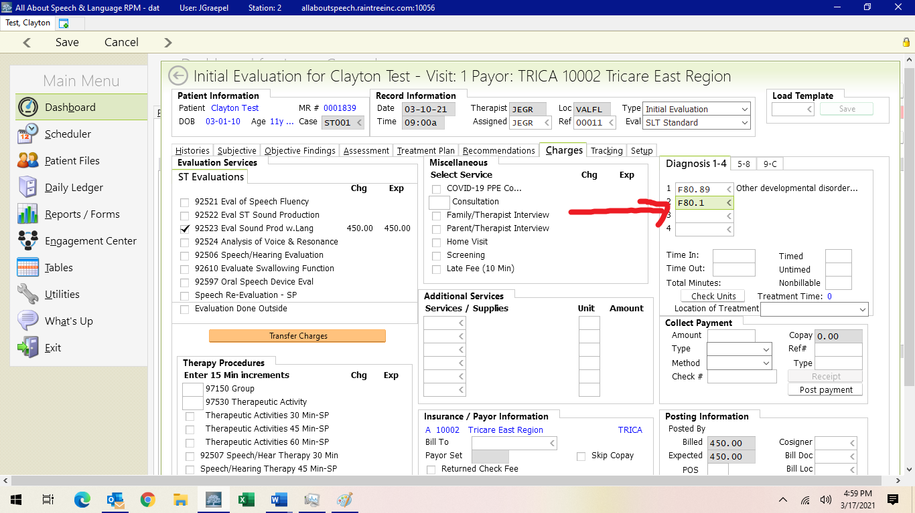

Signing off/Saving Report:
- If you don’t complete the evaluation in one sitting, you hit save and exit. If you are ready to save and sign off, hit save, then you will be directed to what looks like a white document, much like when you save and sign off on daily notes. Here is where you check for grammatical edits, and do minor changes like the GFTA-2 making it say GFTA-3 and any other formatting type changes. You cannot edit big elements of the report in here (i.e. specific data, goals etc.) as they won’t save into the report. So if you catch changes that need to be made you will have to go back to the edit detail when you click on the evaluation in the client’s chart.
- If you are requiring co-signs, DO NOT make changes in the final sign off screen (cosigner will do this for you). Your report will be sent to your co-signer for review before it is finalized so be sure to communicate with them when you signed off on it accordingly.
- If you are required to have your evaluations reviewed prior to being signed off and NOT on cosigns, you will just “save and exit” the report until it is reviewed. Be sure to communicate completion of the evaluation and request for review accordingly, and in a timely manner, with your CM
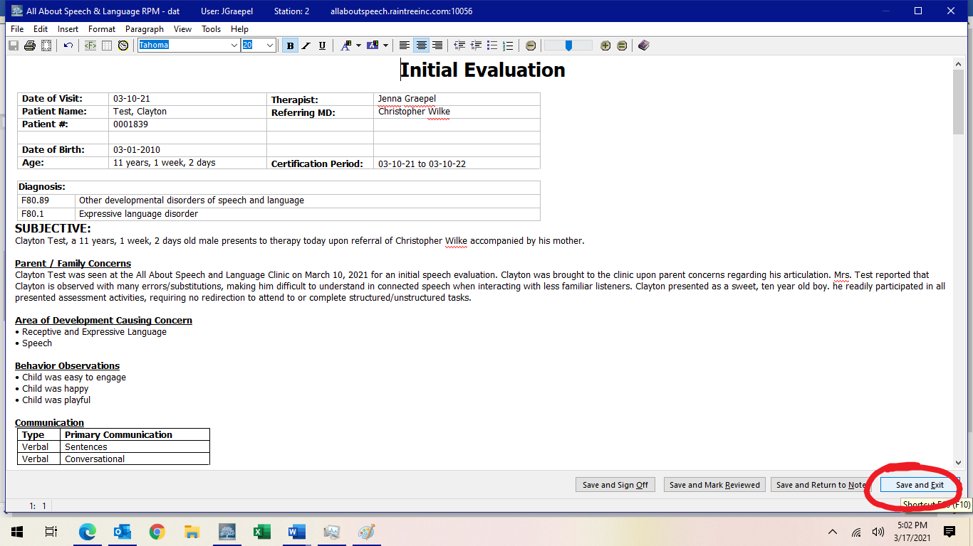
- If you are wanting a second set of eyes or opinion on a certain part of your evaluation, just “save and exit” the report until it is reviewed. Be sure to communicate completion of the evaluation and request for review accordingly, and in a timely manner, with your CM
- Be sure to give the evaluation a read-through to ensure no glaring typos or errors before signing off on the document. This is a last impression a doctor, family, or insurance reviewer will be seeing from us, so take care in your review.
- Do not sign off on a client's daily note if they have an open evaluation. When you see a client for a daily treatment session who has a re-evaluation open, do not address or comment on ANY goals in the daily note until the re-evaluation is signed off. This causes issues for NEW, MET, or DISCONTINUED goals not to be able to roll forward automatically. While the re-evaluation is “open,” please input your data into the assessment portion. Once the re-evaluation has been signed off, you can then address the goals and add your data to the short- or long-term goals and comment boxes and sign off on the note.
- If a parent/caregiver requests to have the evaluation sent to them or another professional, please inform the Front Desk. Please do so by providing client name, parent name, and specific request. They will send documentation to parents or other professionals as requested, ensuring necessary releases of information are on file.

Cosigns:
- When starting as a clinician here at AASL, all documentation will require a cosign. Upon your completion/sign off of a note, it will be sent to someone in Quality Division for review.
- Cosigns are required for the purposes of ensuring consistency of documentation across the team. Additionally, TRICARE does require a cosign until a clinician becomes an approved provider.
- Once a note is signed, it will be removed from the Cosignee’s Dashboard onto the Cosigner’s dashboard. Daily notes should be completed within two business days, progress notes or discharge notes within 2-4 business days, and evaluations/reevaluations within two weeks.
- If there are any edits that need to be made to documentation, the Cosigner will send an email outlining specific feedback. The cosigner will also designate a time which within these edits need to be made. If no time frame is specified, changes must be made within 48 hours of receiving this feedback to ensure timely completion of documentation.
- Please do all edits within the note template/detail. Do not edit the final draft page. Edits made in the final draft page result in a change to the note that prevents billing from adding charges. Billing will not be able to post charges until signed by cosigner if this occurs. It will look like this:
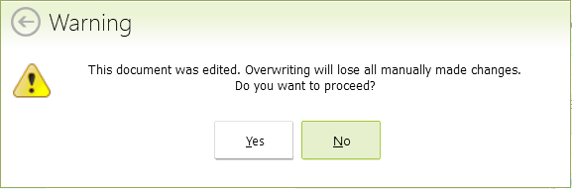
- Tips for optimizing the cosign routine:
- Familiarizing yourself with procedures as outlined in the Therapist Hat Pack
- Being proactive about seeking feedback may help reduce the time it takes for editing/completing documentation
- If you want feedback prior to signing a note, please communicate this to the Quality Division in a timely fashion so there is ample time for review.

Shared Clients:
Often time clinicians will “share” a client (i.e Billy is seen by Ms. A Monday and Ms.B Wednesday). Please be sure to consult with the other treating clinician regarding data collection for continuity of care purposes.

Further information regarding Literacy Only Evaluations:
- A literacy ONLY evaluation may be warranted when:
- A family will express concerns regarding literacy following a speech-language evaluation
  - TRICARE family expresses concern regarding literacy to Patient Schedule (we will first assess language through a comprehensive evaluation covered by TRICARE to identify the need for additional testing)
  - The SLP discovers/notices concerns regarding literacy following a speech-language evaluation
  - In these cases, you will do the following:
    - Contact Patient Scheduling to schedule a second evaluation appointment. This appointment will be devoted to reading, writing, and spelling assessments only and will be scheduled for 60 minutes unless the evaluating therapist requests otherwise.
    - Ensure the Payor is set to patient “P” when completing this evaluation. Then use the charge labeled “Reading Eval (No Language)”. This applies for ALL families, TRICARE, Self-Pay, Family Empowerment Scholarship, etc.

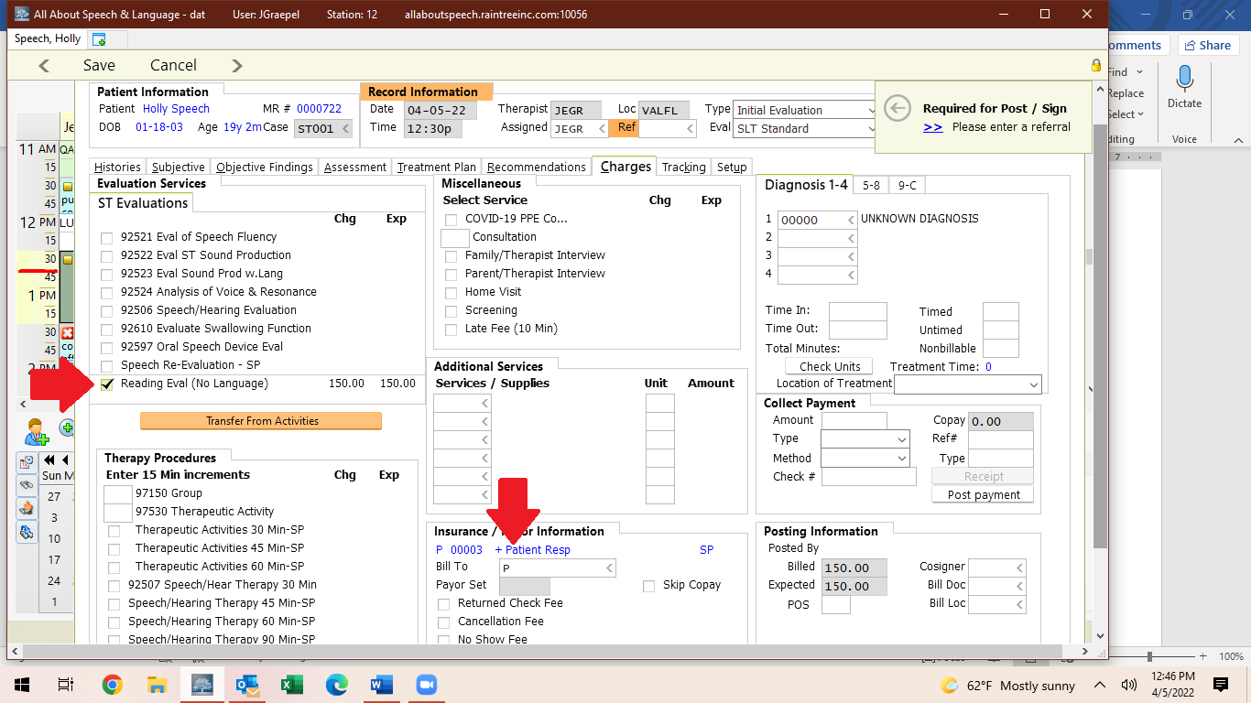**Should you feel that the evaluation should be further prorated due to outside testing and information already provided, please contact Finance Division accordingly.

BOTTOM LINE/NEW CLIENT ACQUISITION FULL LOOP
- Evaluation is scheduled; New Patient Welcome Email with Medical History link sent
- Raintree automatically sends Patient Demographics and Consent forms found in the Admin Tab of the Chart.
- New Patient added to EMR with initial clinic notes to review
- Reminders sent with Medical History Link if not completed 5 days prior to the scheduled Evaluation
- Pediatric Medical History can be found in the Chart under Therapy Tracking in the Medical History box.
- If Medical History is not received prior to the Evaluation, the patient receives a hard copy to fill out at the time of the Evaluation (by Front Desk or Therapist)
- Evaluation is conducted and initial treatment recommendations are formulated; ADD DIAGNOSIS CODE!
- Evaluating clinician sends email to Front Desk AND Patient Scheduler with treatment recommendations (usually within a business day).
- Patient Scheduler will reach out to the family to schedule new patient welcome meeting to review schedule and policies so there are no misunderstandings
- After the welcome meeting, Patient Scheduler sends an email to the family with the patient’s confirmed start date and calendar of scheduled appointments, copying all therapists involved.

Updated Jan 2023

