Initial Evaluation Procedure for AASL Occupational Therapists

Table of Contents
Preparing for the Evaluation 2
Scoring/Writing Up the Report Using EMR System: 6
Handling Clients Who Do Not Qualify for Therapy 8
Subjective Tab: 9
Objective Tab: 13
Assessment Tab: 17
Assessment Complexity: 18
Treatment Plan Tab 20
Recommendations Tab: 25
Charges: 28

Preparing for the Evaluation
- Once you are notified by Scheduling of your scheduled evaluation, you will select suitable assessment measures after reviewing notes provided in the client’s chart under the communication tab.
- You are able to locate the client’s documents and intake info in our EMR system. Under each client when you click on their name you can pull up Patient Files by right clicking on the appointment, selecting patient files, then chart. You will see “Therapy Tracking”, “Documentation/Task”, “Communication. The Communication tab, is where information from the intake call will be provided as additional notes/communication (i.e. email/phone). Medical history can be found under therapy tracking tab.

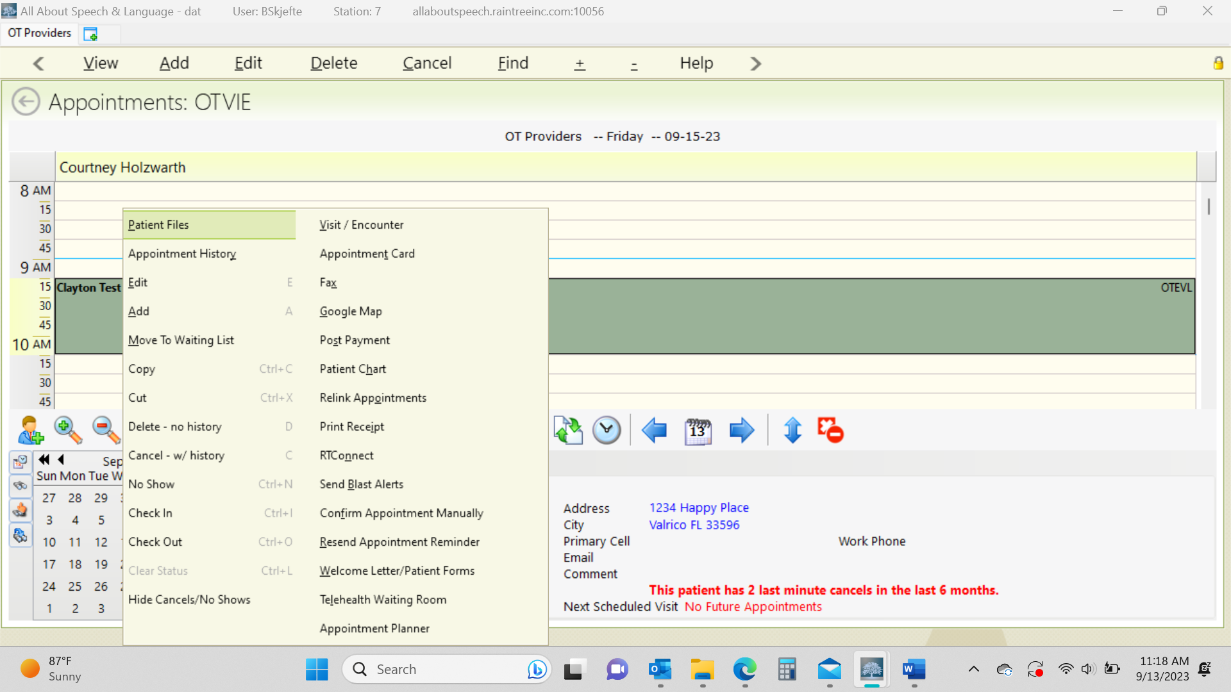
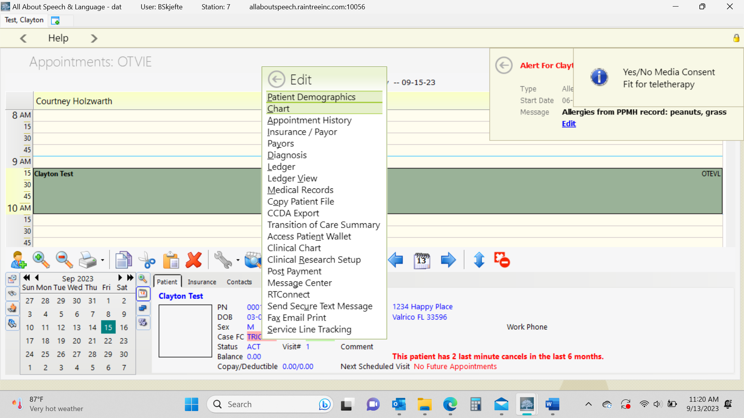
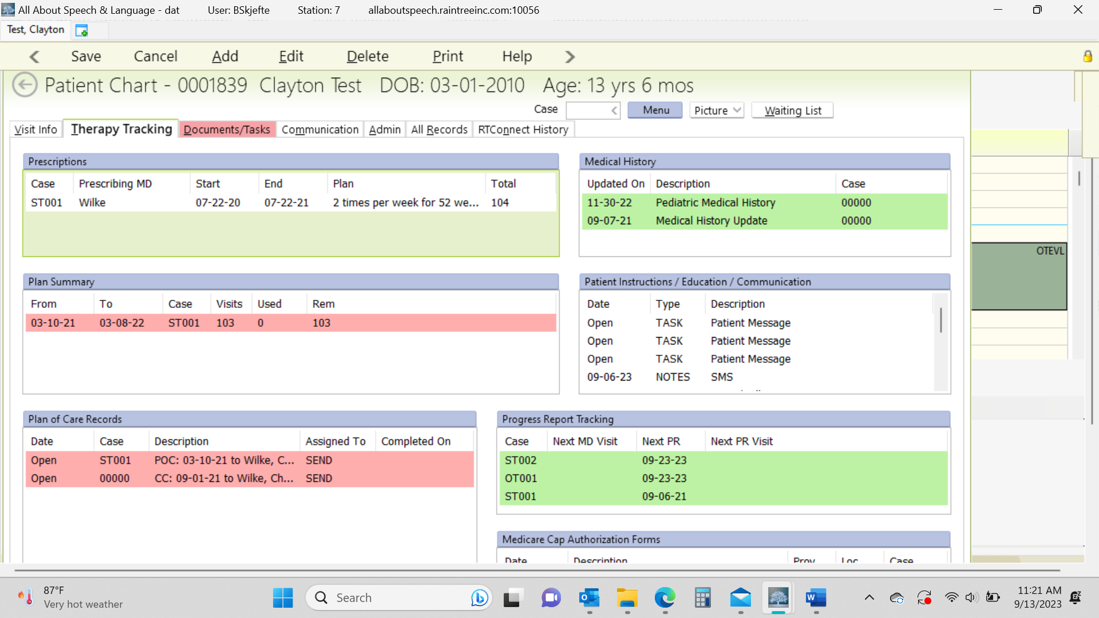

- If any additional information needs to be communicated, it can also get added directly to the client’s appointment on the scheduler by right clicking and hitting Edit and then noting any relevant notes in the Edit Box directly (i.e. see communication tab, please ask mom ____, need paperwork, copy X for evaluation etc.)
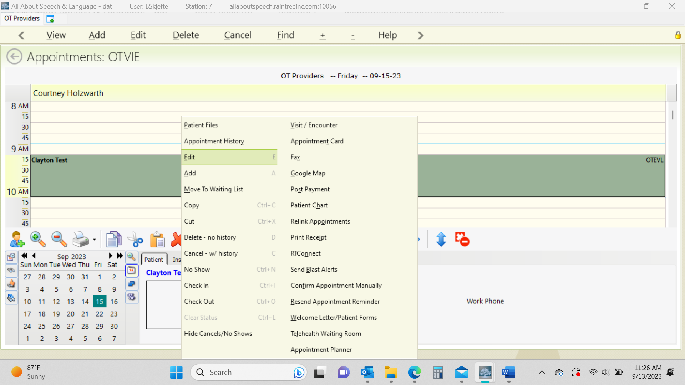

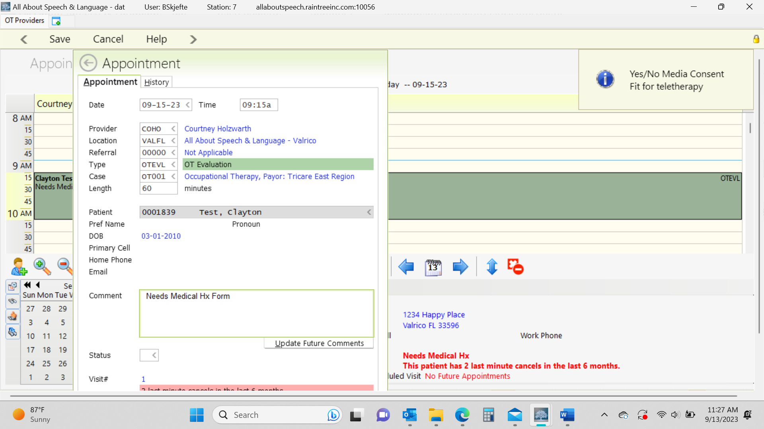
- If you need to learn about administration of a new standardized test, you will need to prepare accordingly as well and have any follow up discussions with your CM, as warranted
- The following steps will help close the loop in the process of our new client acquisition:
    - Patient Scheduler (PS) will schedule the evaluation and send the parents the new client Intake form and Medical History sent.
    - (PS) will add the new client into our EMR with initial clinic notes to review.
    - New Client Intake Form and Medical History paperwork received.
    - PS will also upload the medical history uploaded for review prior to the evaluation.
    - Evaluation is conducted and initial treatment recommendations are formulated. The evaluating therapist will then send and email to PS with treatment recommendations (the recommendation have to be to FDR and PS within 24 hours of the eval for the good faith estimate).
    - FDR provides the family with our policies at the first appointment.
    - On the date of the evaluation, greet the client warmly and enthusiastically.
    - When you start the evaluation, focus on establishing great rapport with the client and caregivers/family, with emphasis on asking open-ended questions, and engaging in: 1. Affinity: a liking for someone or something 2. Reality: something actually experienced or seen 3. Communication: exchanging of information
    - Once you engage in establishing rapport either through conversation and/or play, administer the measures you have selected for the assessment
    - At the end of the evaluation, summarize (the remaining of) your findings of the evaluation and what the treatment process will be like going forward, if that is recommended. Summarize this to the parent first.
    - Sometimes you will be asked direct questions from the caregiver/family about their child. Answer honestly with what’s within our scope of practice. If they flat out ask questions about Autism and if you think their child has it, which is one of the most common questions we do get asked, you can share with the parent red flags that you see that are concerning and let them know that these will be monitored and you will put additional recommendations in the evaluation for further testing, should they desire that going forward. Let them know that we cannot formally diagnose but we are trained to identify red flags and treat children accordingly. Assure parents that regardless of a diagnosis, we use the child’s strengths to bolster their weaknesses and to make improvement developmentally! Also let them know that red flags alone are not indicative of an official diagnosis and that as treatment gets underway, rapport is established with a family, and you get more eyes on the child, you will continue to make recommendations and engage in open communication with the family about their child.
    - In a similar light, you may have parents that are in denial or not ready to hear about their children relative to red flags you may be seeing or delays they present with; this is ok too; use your clinical judgment during this portion of the evaluation to communicate strengths/weaknesses, and general therapy recommendations going forward. Once rapport is built and a relationship is made with the family, you can then start to slowly engage with them on this journey--baby steps. Remember, our role is to become a caring part of their family/extension of their family that is reflected in the quality of care we provide, the trust and rapport built with the family, and our communication with them. Sometimes it is going to take longer, and we are often “hand-holding” the family, and guiding them along the way, representing ourselves like the expert but doing so with a softer approach.
    - Then summarize for the client (I.e. I’m going to show you all the things you can do and those things that might be a little harder for you that I’m going to help you with going forward and we will play games and have some time together each week! --adjust for each child accordingly)
    - After Evaluation is completed, communicate “Our documentation process typically takes 2 weeks. You will be able to access the evaluation in their child’s portal. FD will be reaching out in regard to scheduling

Scoring/Writing Up the Report Using EMR System:
- Written evaluations are due within 2 weeks of the initial evaluation! This is extremely important to be timely in completing your documentation according to this policy. Your CM will be followed up with you on completion of your documentation each week. Appropriate follow-up for problem-solving and re-training will take place if paperwork is not getting completed in a timely manner.
  - You will need to score the standardized assessments following the completion of the evaluation and check back in any standardized assessments or manuals
  - When you are ready to begin writing the evaluation, use the EMR system.
  - We will share current client evaluations with you as examples to get a sense for how they are written given ages/diagnoses/standardized tests administered.
  - Saving Work: As you are writing up the evaluation, hit save to save work you have done in the different sections/tabs as you are working, and it will then allow you to keep moving through the evaluation to the next tabs.
  - General Notations:
    - Anything with an open box you fill in with narrative: Parent/Family Concerns, Accompanied By, Reliability (tied to behavior observations). The other boxes are check boxes that auto-fill in criteria you select: Behavior, Primary Communication, Concerns.
    - For check boxes throughout the evaluation template: click on the green + arrow, then a box will populate, select the items that pertain to your client and then hit the floppy disk drive to save it.
  - On your scheduler, open up the dark green cell for the client, coded as OTEVL
  - Check in the client by right clicking and selecting “check-in” and then double click to open the evaluation
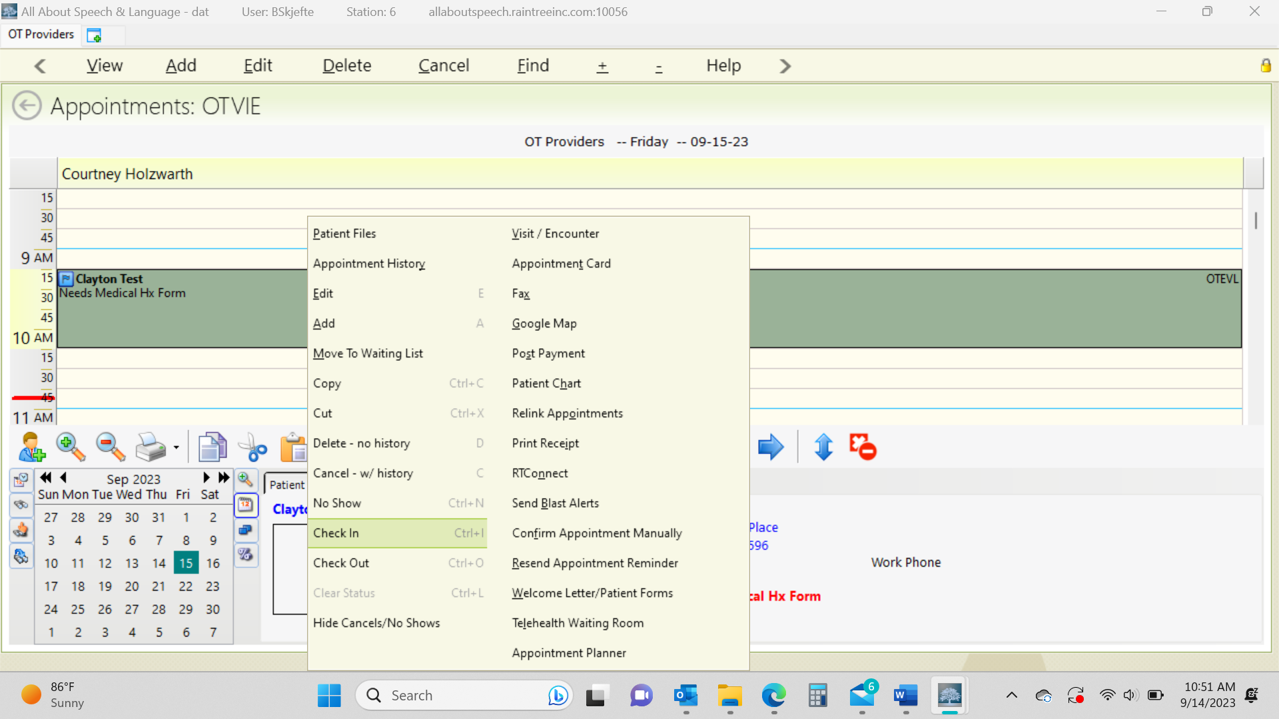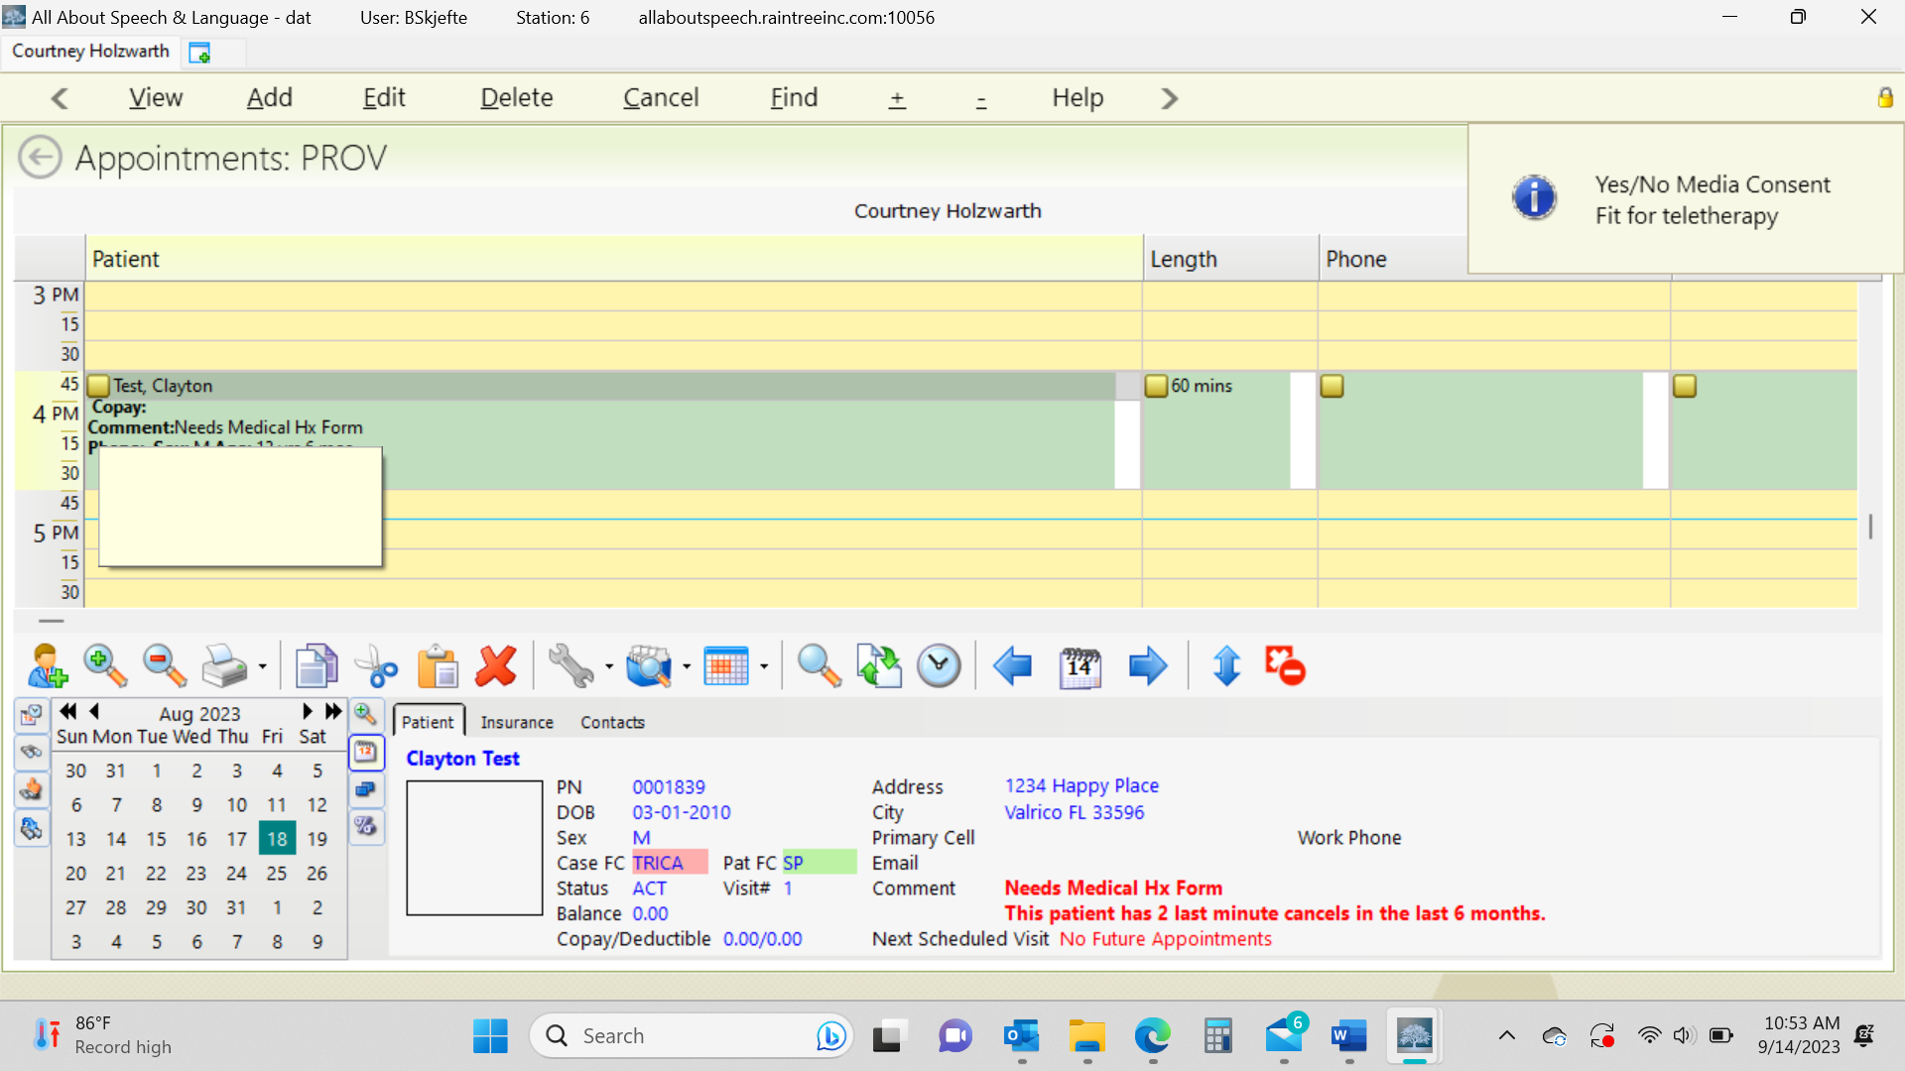
  - To open the client’s appointment after you check then in, double click on the appointment
  - Once in the client’s chart, you will see at the top: Type Initial Evaluation, Eval OT Standard *all note types should always be in this format of OT Standard.
  - Below the patient information you will see you’re the following tabs: Subjective, Objective, Assessment, Treatment Plan, Recommendations, Charges
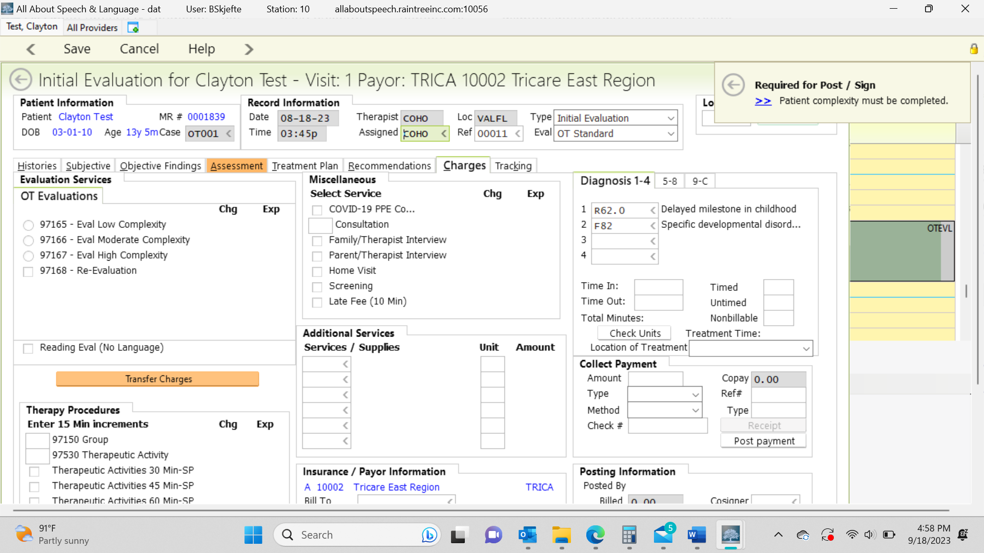

Handling Clients Who Do Not Qualify for Therapy
Tricare:
- The evaluating therapist will score up the evaluation then email the parent CC’ing patient scheduler to notify the family that their child did not qualify
- Ensure if additional strategies/HEP are to be provided to the family, you do so in this email
- If a client who has Tricare does not qualify but parents want to start services, please reference Initial Eval- Self Pay Client steps (below) as they can pay privately for services.

Self-Pay:
- The evaluating therapist will score up the evaluation then email the parent CC’ing scheduling to notify the family that their child did not qualify
- Note that if the parent continues to express the desire to want services and you feel they would benefit, then therapist can inform family that they can initiate short term services
- Therapist will notify scheduling department of POC recommendations

Email Template

Hi,

It was a pleasure meeting your family. I wanted to inform you that ____ (child’s name) does not qualify for Speech/Occupational Therapy services at this time. He/she scored in the average range in the areas of ______ (add in areas they did well in). Your child’s report will be accessible through the Patient Portal in two weeks.

As we discussed in the evaluation, continue to practice ______ (for example: shoe tying). Please reach back out to the office (813) 616-4004 if any additional concerns arise over the next 6 to 12 months or if you have any questions.

Reminder, the evaluating therapist needs to notify patient scheduler of their recommendations within 24 hours.

Subjective Tab:
- Select Load Templet then OT initial Evaluation
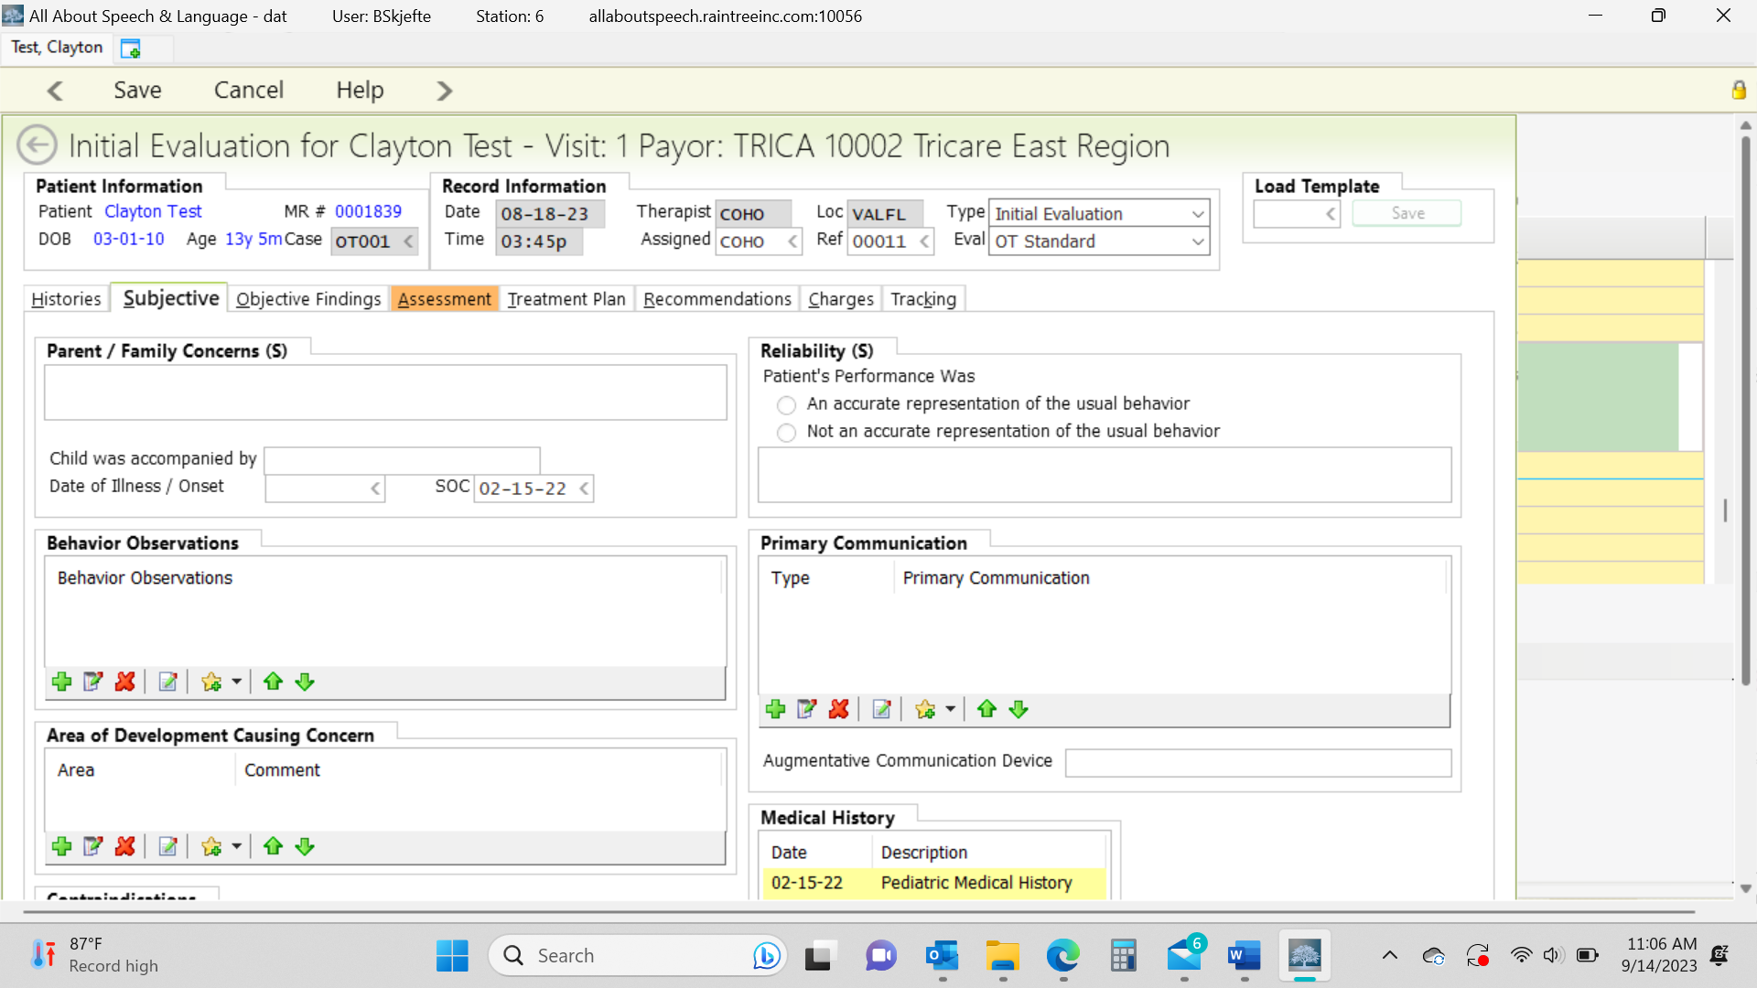
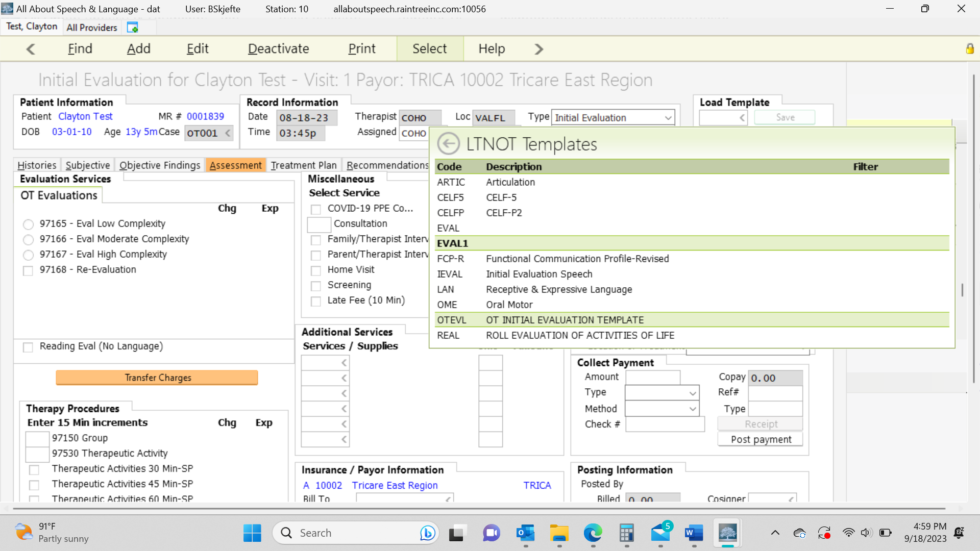

- Parent/Family concern: These sections will be in summary form. Most of the time the PCM will typically look at this section and the Recommendations section only, so we want to be sure to have details here. You can provide the full name, subjective information, and parent concerns. You can right click and select edit to open the text box to a larger screen
- Behavior Observations and Areas Causing Concern:
  - click the green plus sign and select appropriate areas based on your specific client.
- Primary Communication:
  - Click the green plus button and select verbal/non-verbal and then when you double click on the Primary Communication, you will be able to select all criteria pertaining to the client being verbal/non-verbal and they will populate in the drop down.

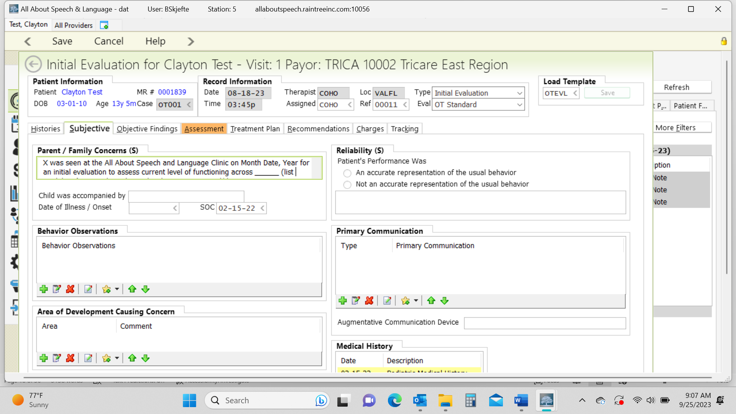

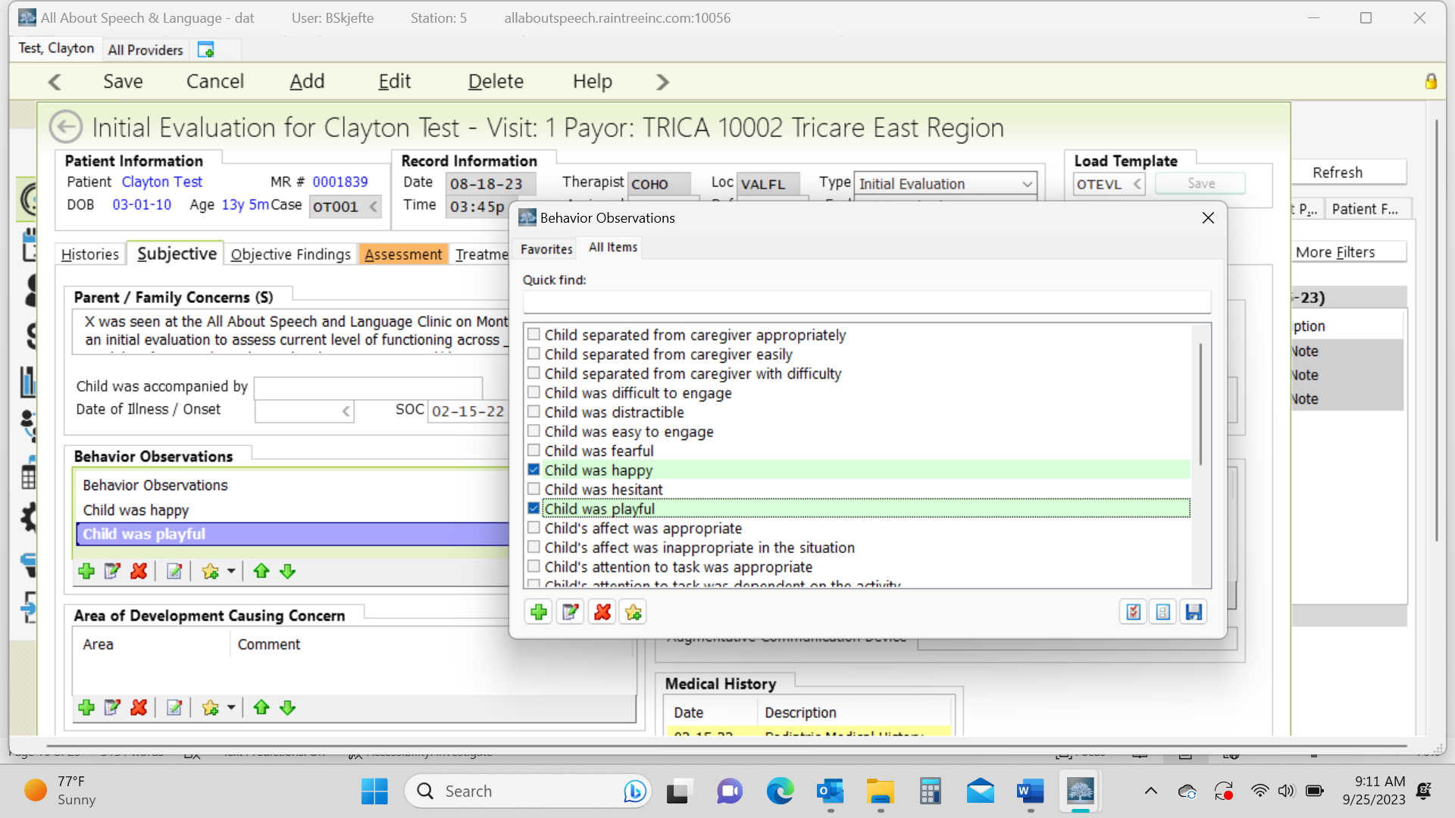
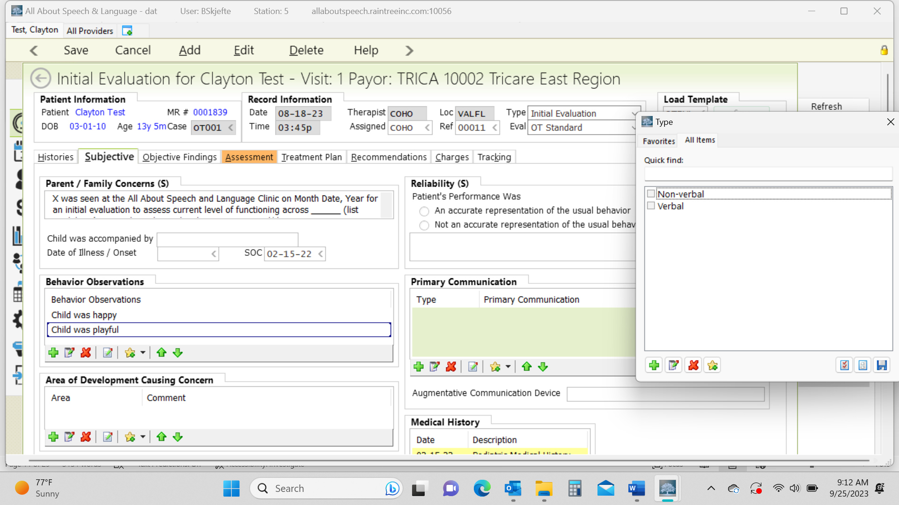
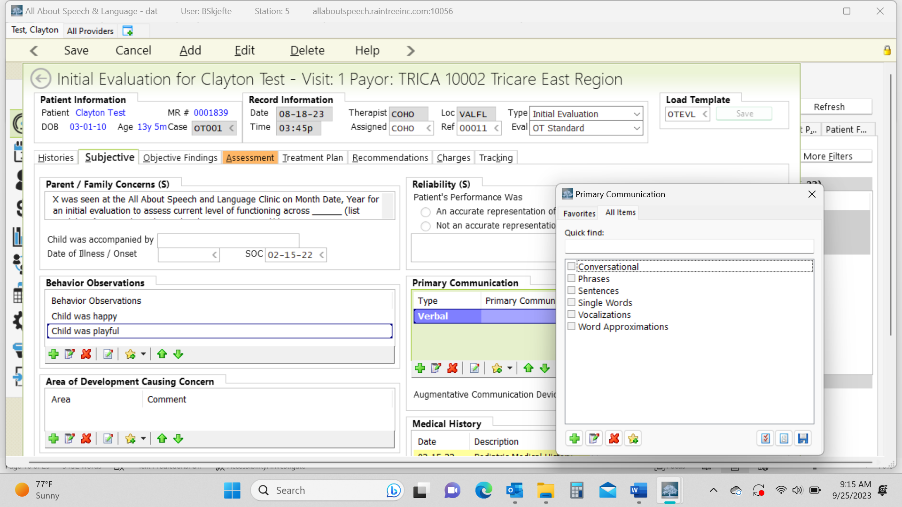

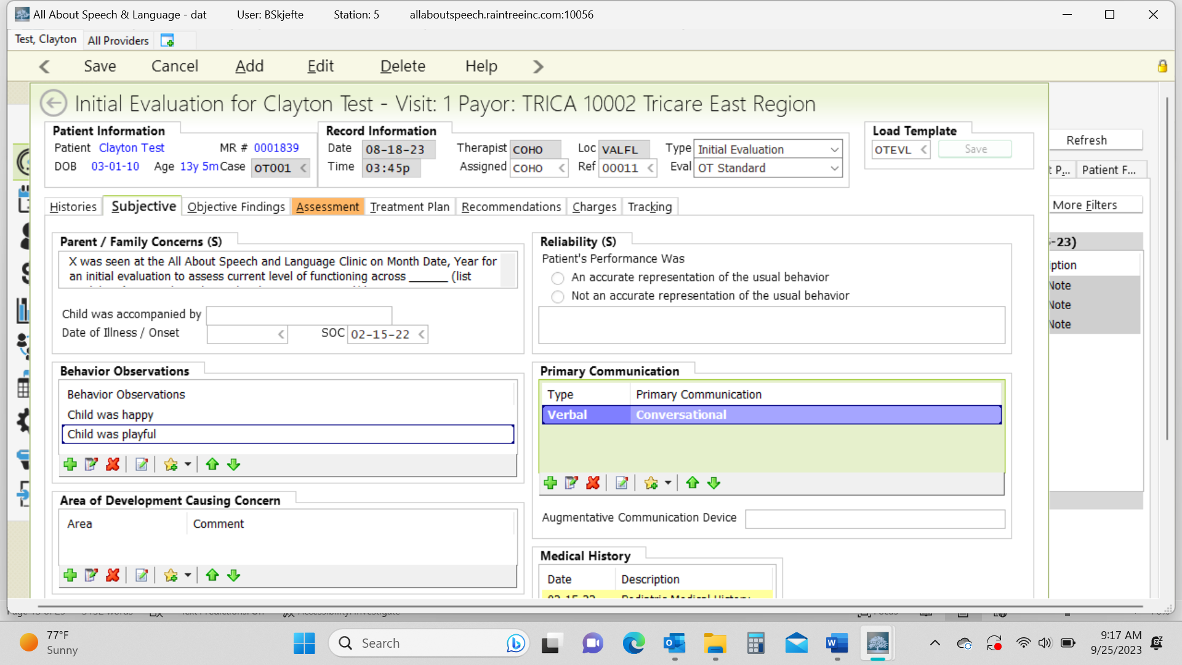

Objective Tab:
- This is where you input all the standardized tests and the REAL if administered.
- Right click in the Standardized Tests box and select "Add" and locate appropriate test. Fill in data accordingly.
- To add the REAL right click on Shared Tests Box and select “Add”. If REAL blurb does not populate type “REAL” into template to load the description of the assessment.
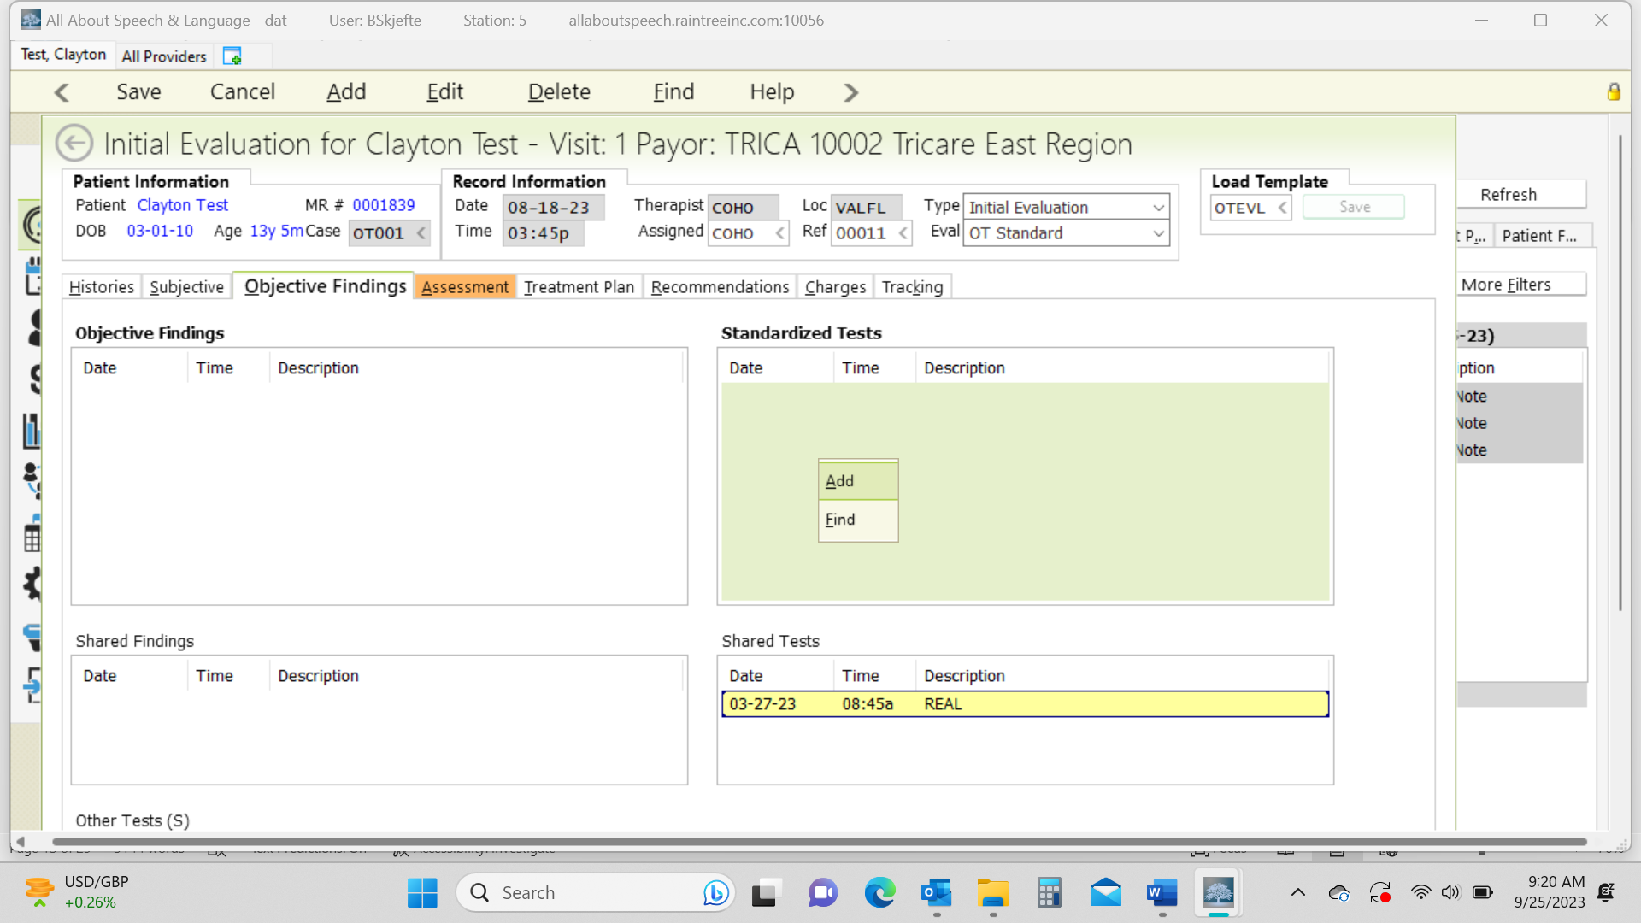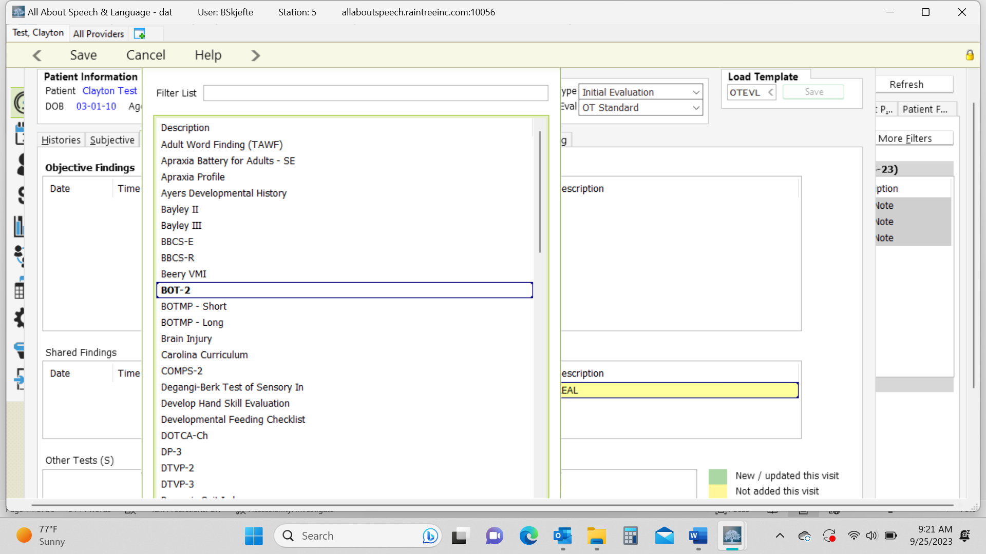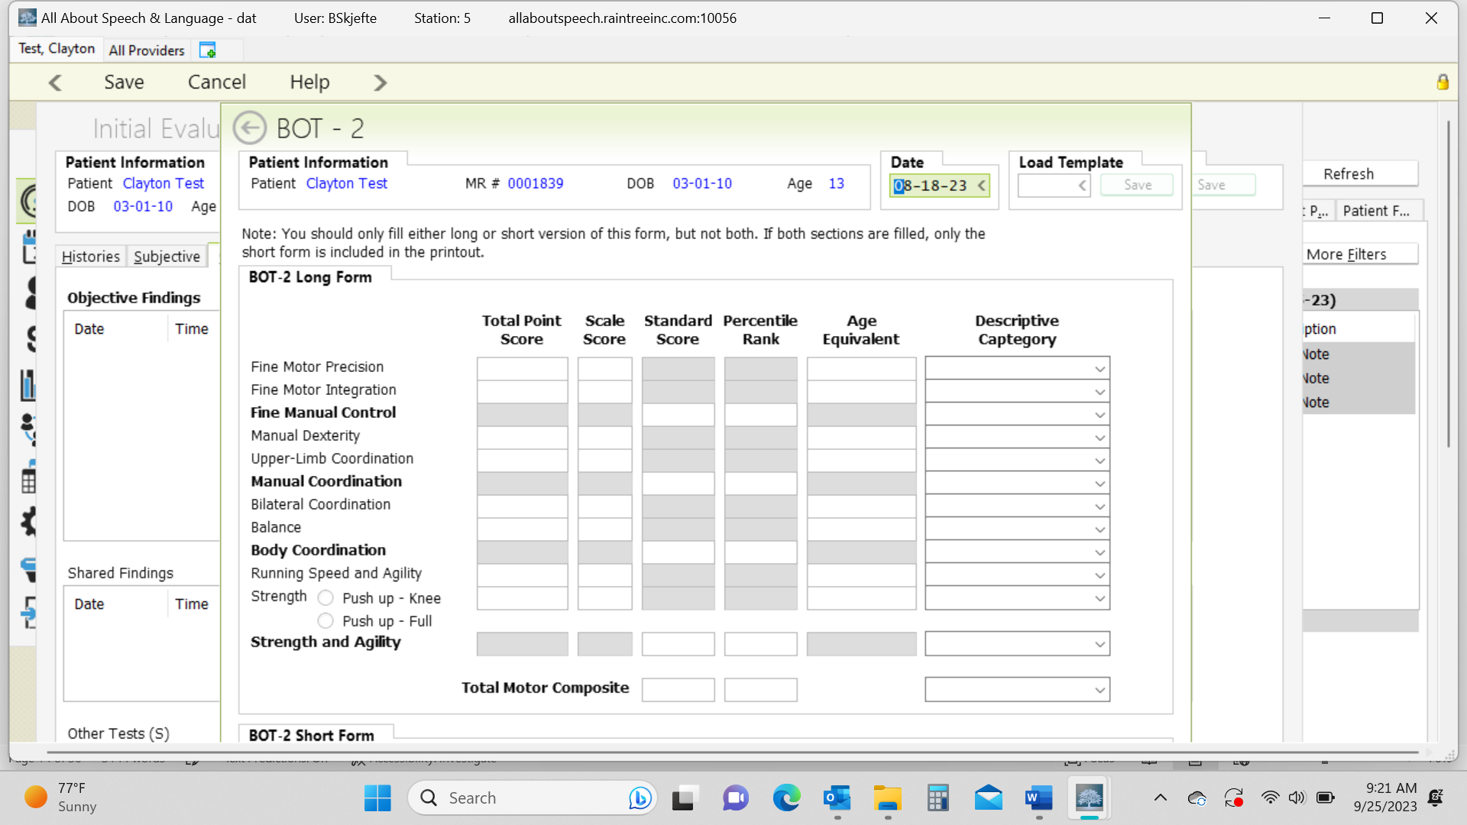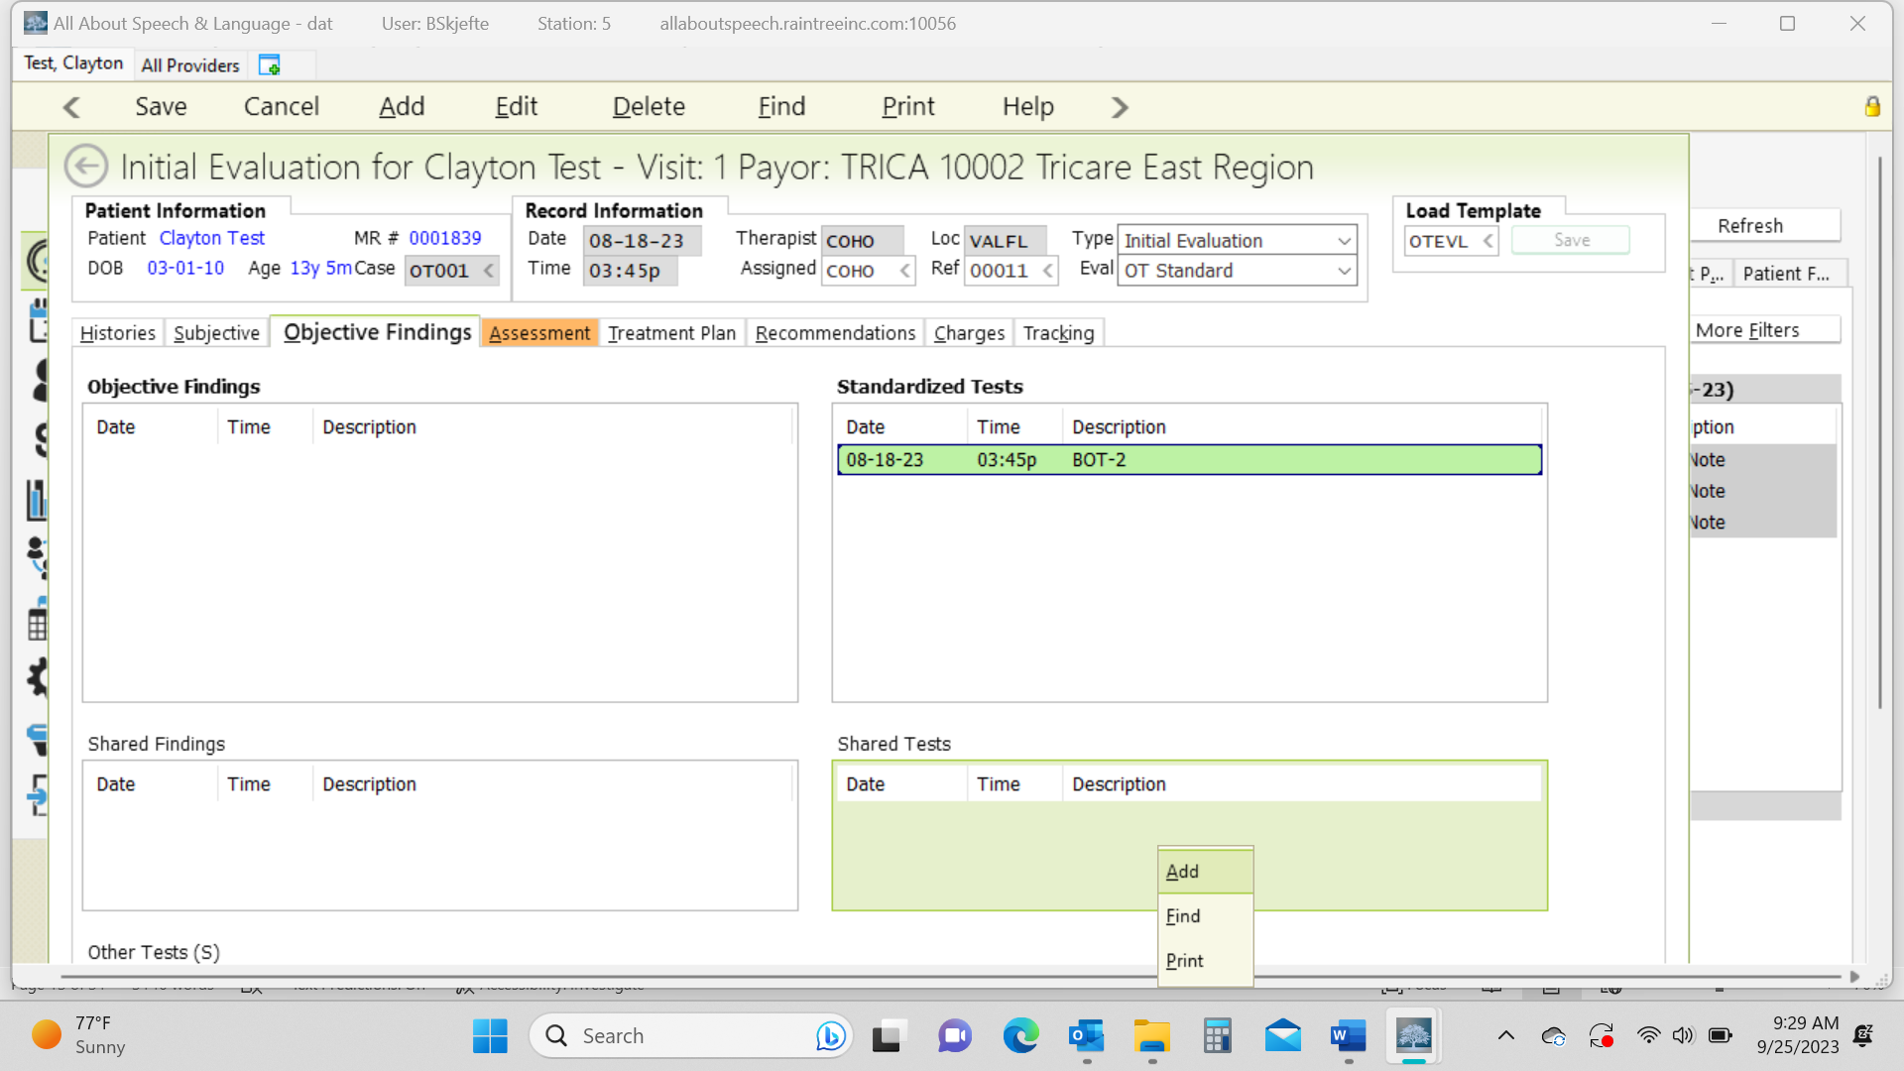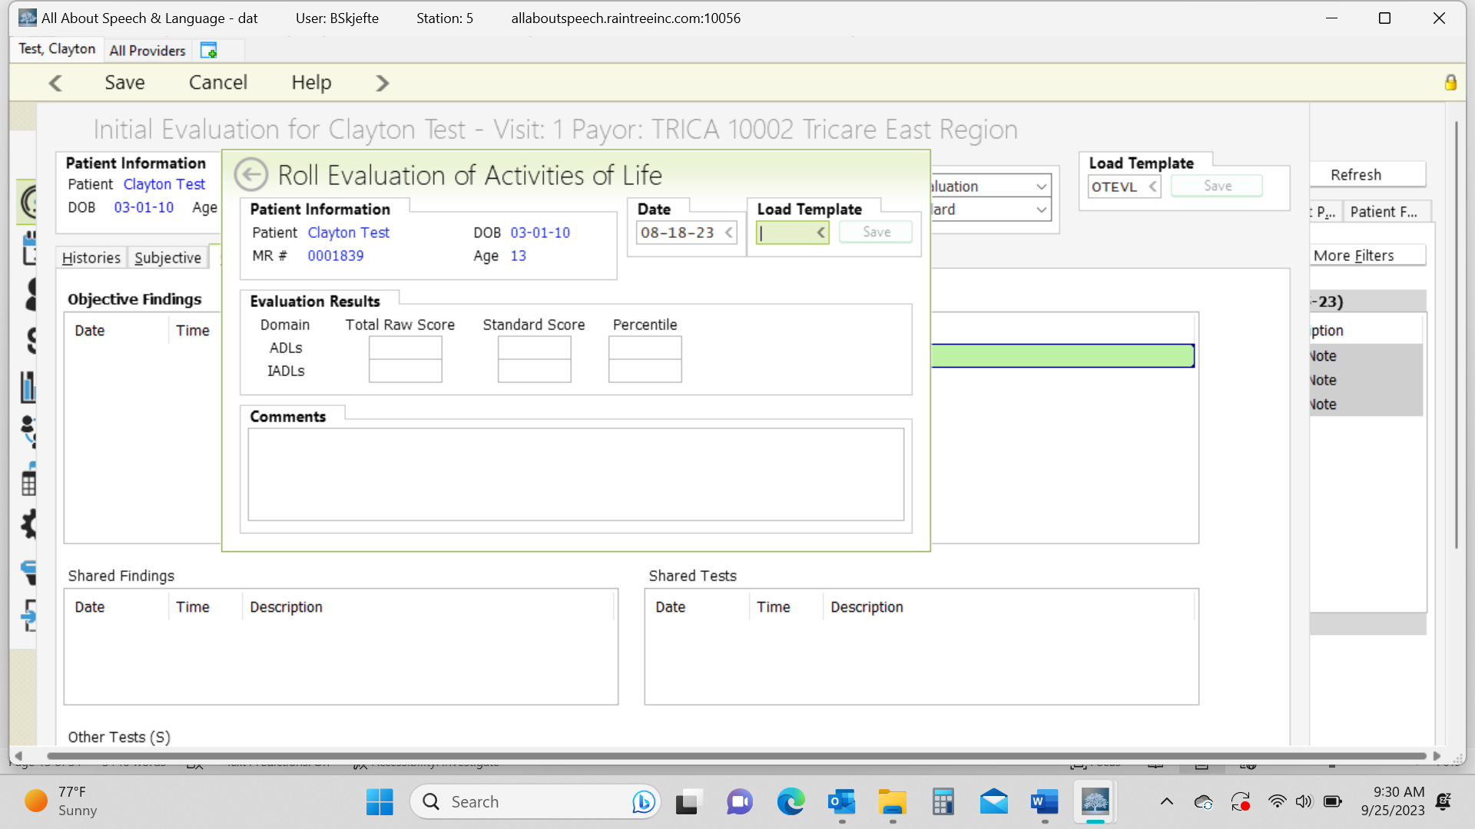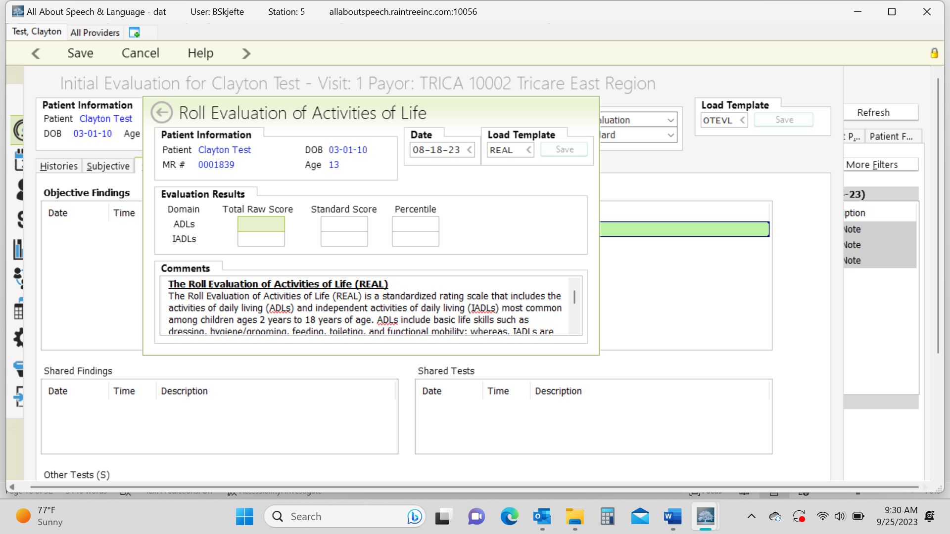

Assessment Tab:
- Click on the green + to add the clients Strengths and Areas of concern. You don’t have to “comment” on areas of concern. Again, given the analysis is in the body of the report you can just select what the updated areas are and save with the floppy disk icon.
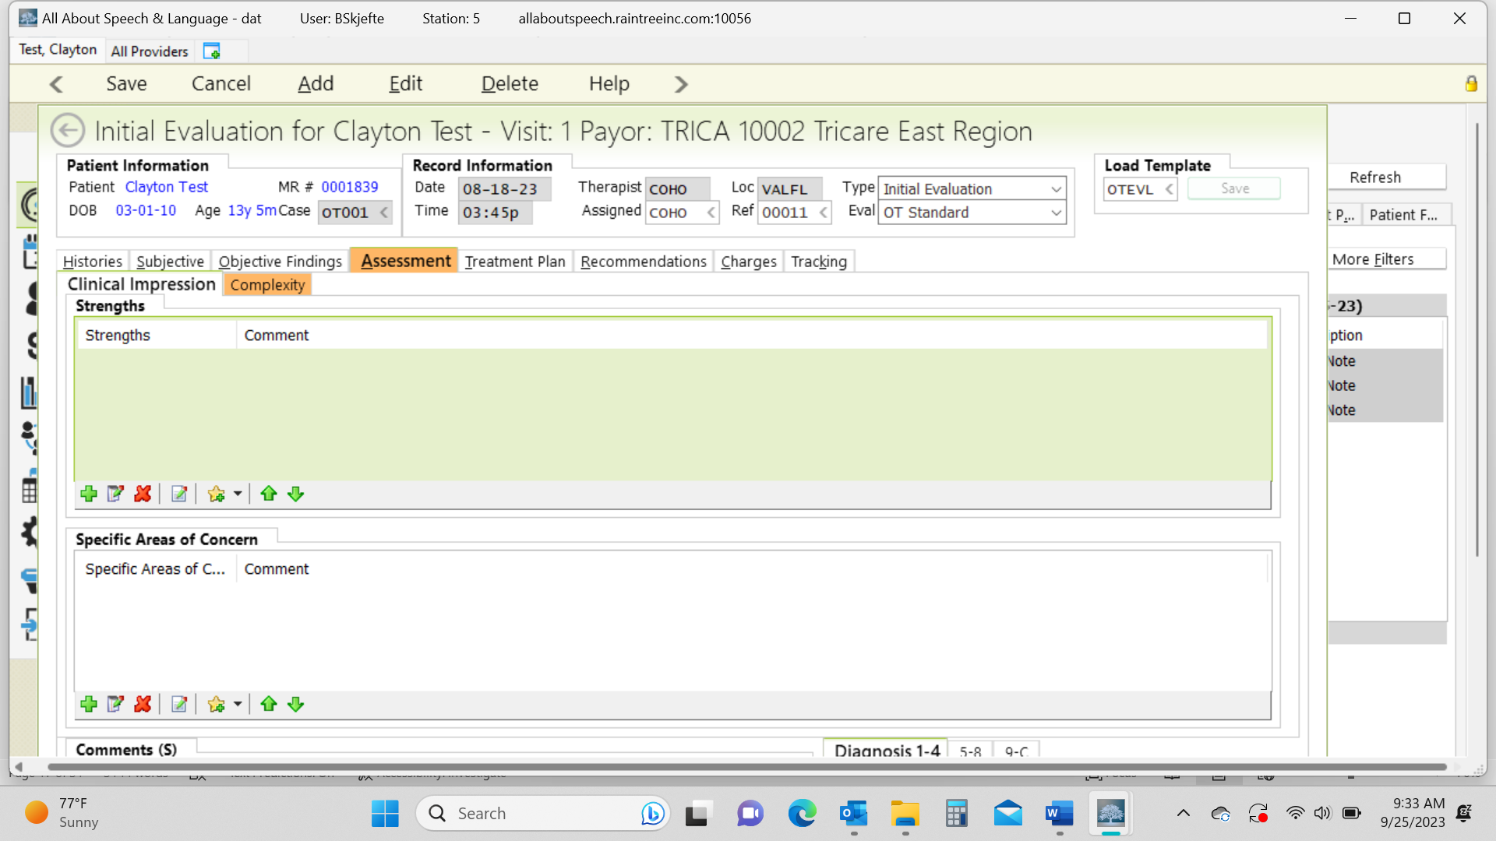
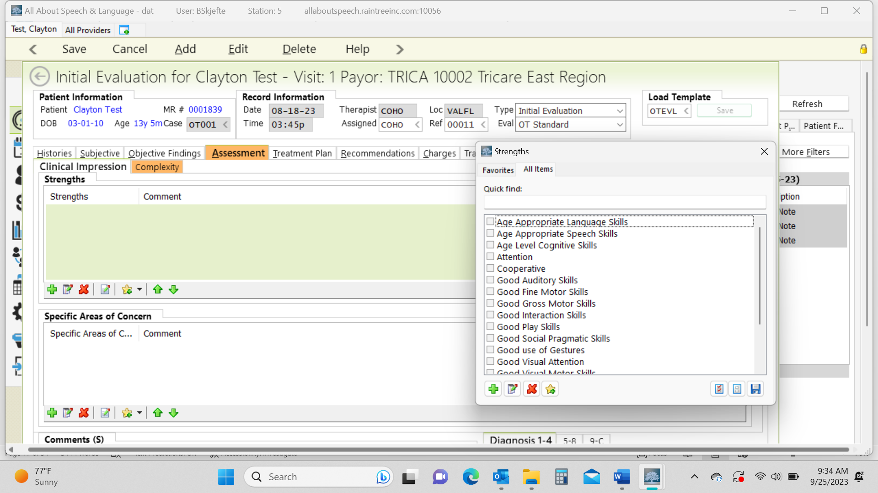
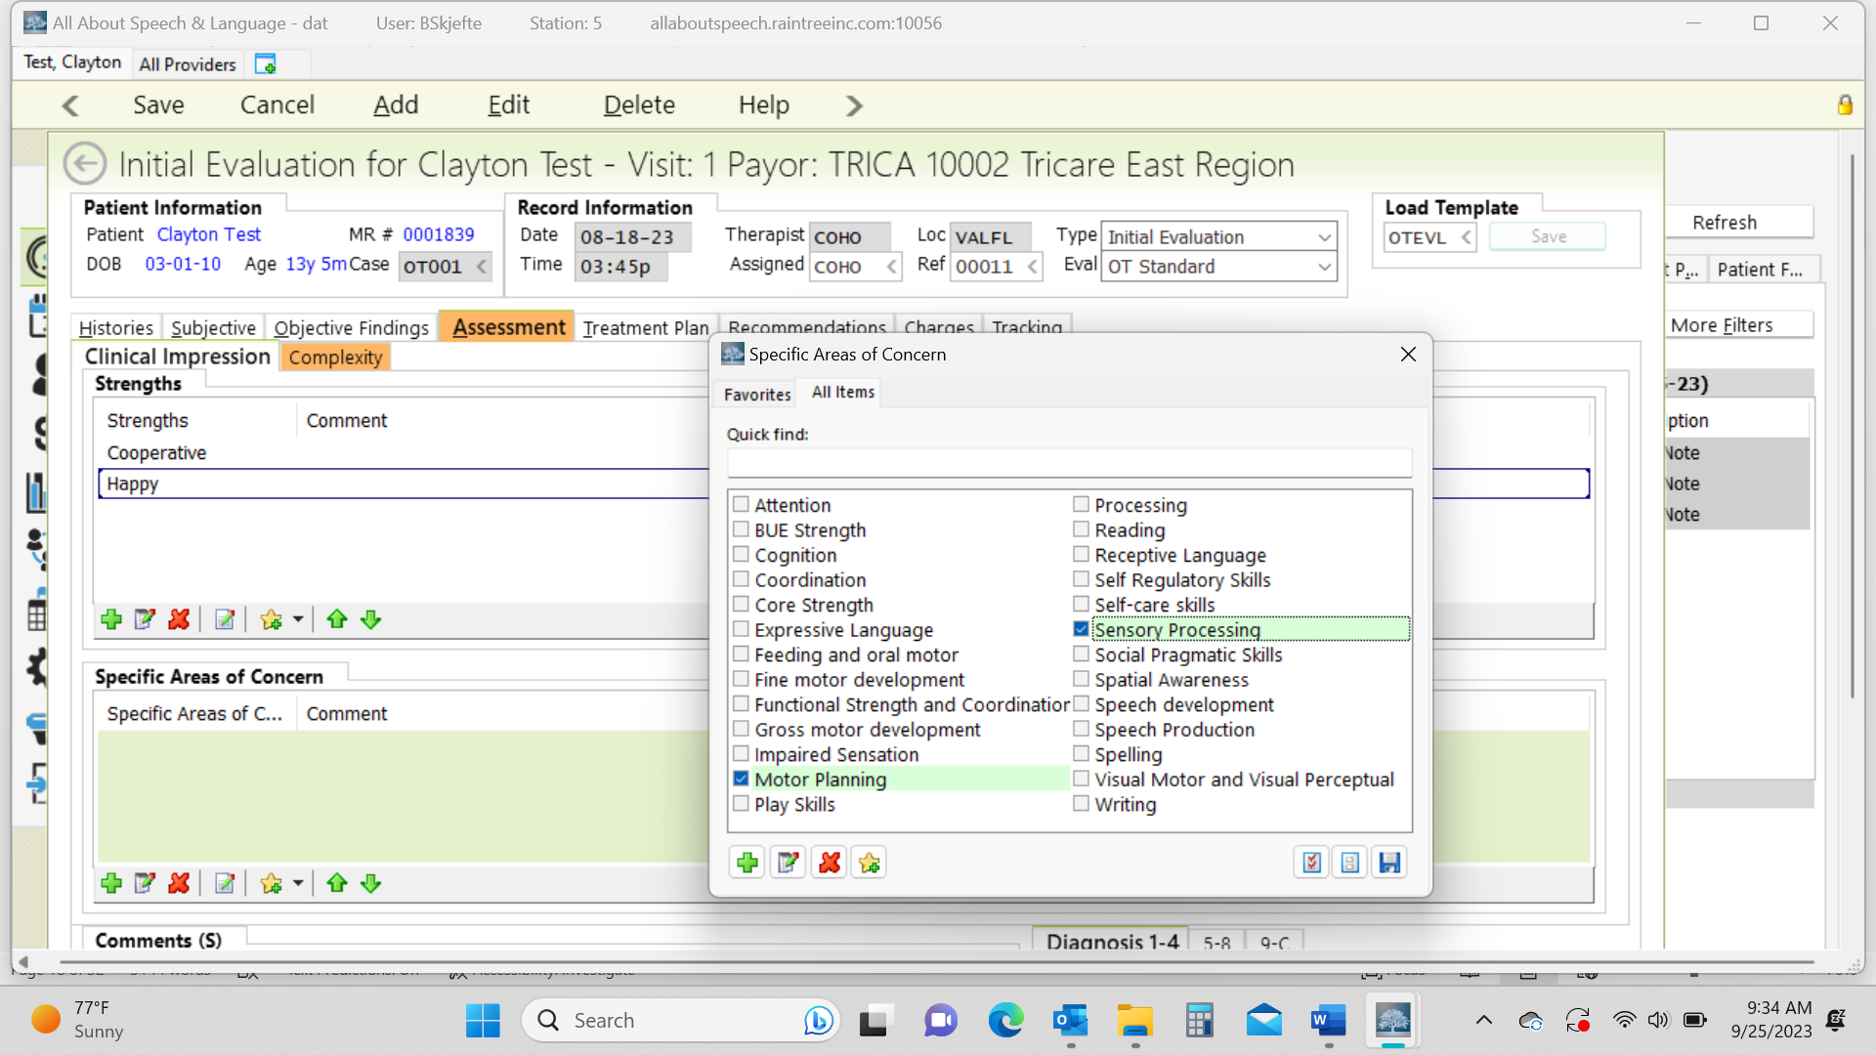

- Depending upon the client and concerns identified in the evaluation, a comment may be warranted, however, this is done on a case-by-case basis as well. In this comment box, you are able to provide your assessment of the client's strengths and weaknesses. Break down findings into categories such as Play/Interactive/Behavior Observations, Gross Motor Skills, Fine Motor & Visual-Motor Skills, Self-Care Skills. You will ALWAYS reiterate if therapy is/is not warranted.

Assessment Complexity:
- Click on the Complexity tab. You will then fill out the following information in accordance with AOTA guidelines to determine the complexity of the evaluation: Occupational Profile/Medical & Therapy History, Patient Assessment, and Clinical Decision Making. Be sure that the complexity level determined under this section matches the complexity level on the charges tab.
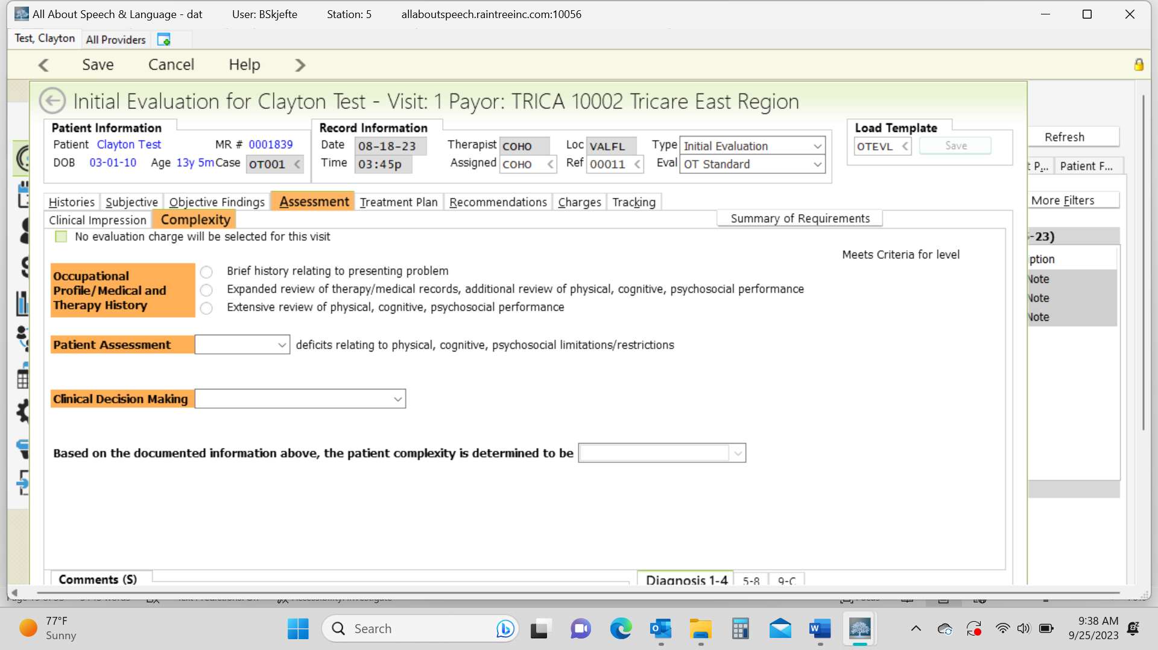

How to Determine Medical Complexity (low, moderate, high) - moved to recommendations/charges/assessment
Explanations from AOTA’s “New Occupational Therapy Evaluation Coding Overview” document.

Client Medical History The client’s history, both medical and therapy, is reviewed and considered to identify aspects such as the prior level of function and presenting diagnosis that is causing the client to seek occupational therapy services. How much of the history is necessary depends on what the client is seeking services for and what the occupational therapist needs to know to continue with assessment and development of the plan of care. The referral for therapy may also provide additional information. It can also come from medical records of past and current care.

Occupational Profile The occupational profile provides an understanding of the client’s occupational history and experiences, patterns of daily living, interests, values, and needs. The client’s problems and concerns about performing occupations and daily life activities are identified. The client’s priorities for outcomes are determined. To determine the level of occupational profile that must be completed, the therapist must consider the presenting problem(s), the reason(s) for referral, and the client’s goals. Although a client may have multiple diagnoses, and be very complex, if he or she is in a stable state and wants one small or targeted issue addressed by the occupational therapy intervention, then this component should be coded as low complexity

https://www.aota.org/~/media/Corporate/Files/Practice/Manage/Documentation/AOTA-Occupational-Profile-Template.pdf

Consider the following things when determining level of medical complexity
Past Medical History
Current status (current services, specialists, medication, equipment, procedures)
Education (school, type of classroom, any services in school)
Barriers to occupational engagement:
Low:1-3
Moderate:3-5
High: 5 or more

physical: type of home, share a bedroom, parks or playgrounds
social: people that live in the home, family/friends in proximity, ability to engage with peers/siblings, opportunities for social participation, behaviors that may affect the family's activities, communication
cultural: sense of love/support, religion, parent's expectations to be as independent as possible, parent's sense of community scrutiny, beliefs
personal: age, who they receive support from, any difference with interactions with different family members, primary caregiver, socio-economic status
temporal: who they receive support from, weather or time of year affecting regular activities may have a negative impact on the child
virtual: Do they engage in video chats with family? How much screen time do they get and what happens if that is disrupted?

Areas of values/interests of the child or the family
- ADLs
- Cognition
- Fine motor
- Social skills/play skills
- Physical skills (strength, balance, coordination
- Visual skills
- Sensory

Treatment Plan Tab
- Under Goals, you are going to hit A to add.
- Under Category select your long-term goal area from the drop down arrow. Then you write your long-term goal.
- Under Short Term Goals, click the green + to add goals. Be sure to select the status is New and enter the start date under all STGs. Then you hit save.
- You will repeat this process for as many LTG areas you have with STG area objectives.
- Under Treatment Plan Summary, select prognosis, then list what STG and LTG are going to be achieved. Generally, we do 6 months for STG and 12 months For LTG.
- Add date as initial evaluation date and “Reviewed By:” select appropriate response from drop down box.

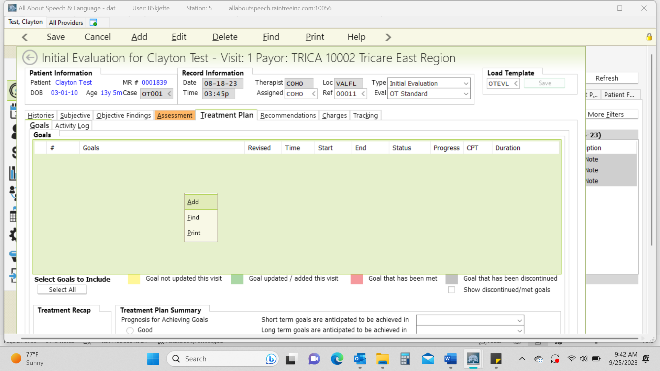

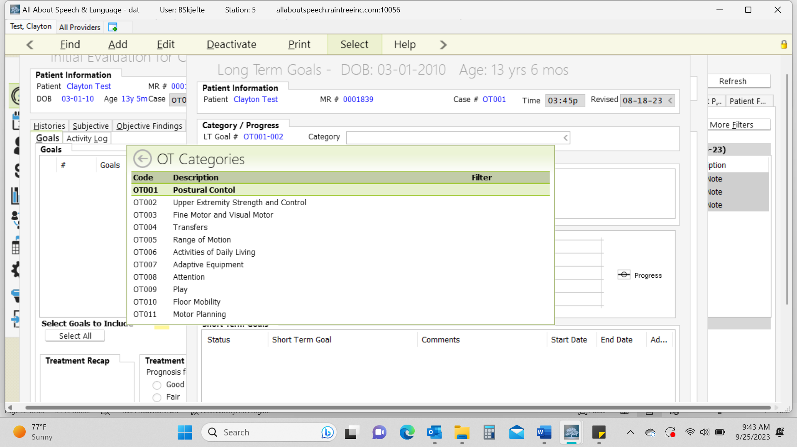
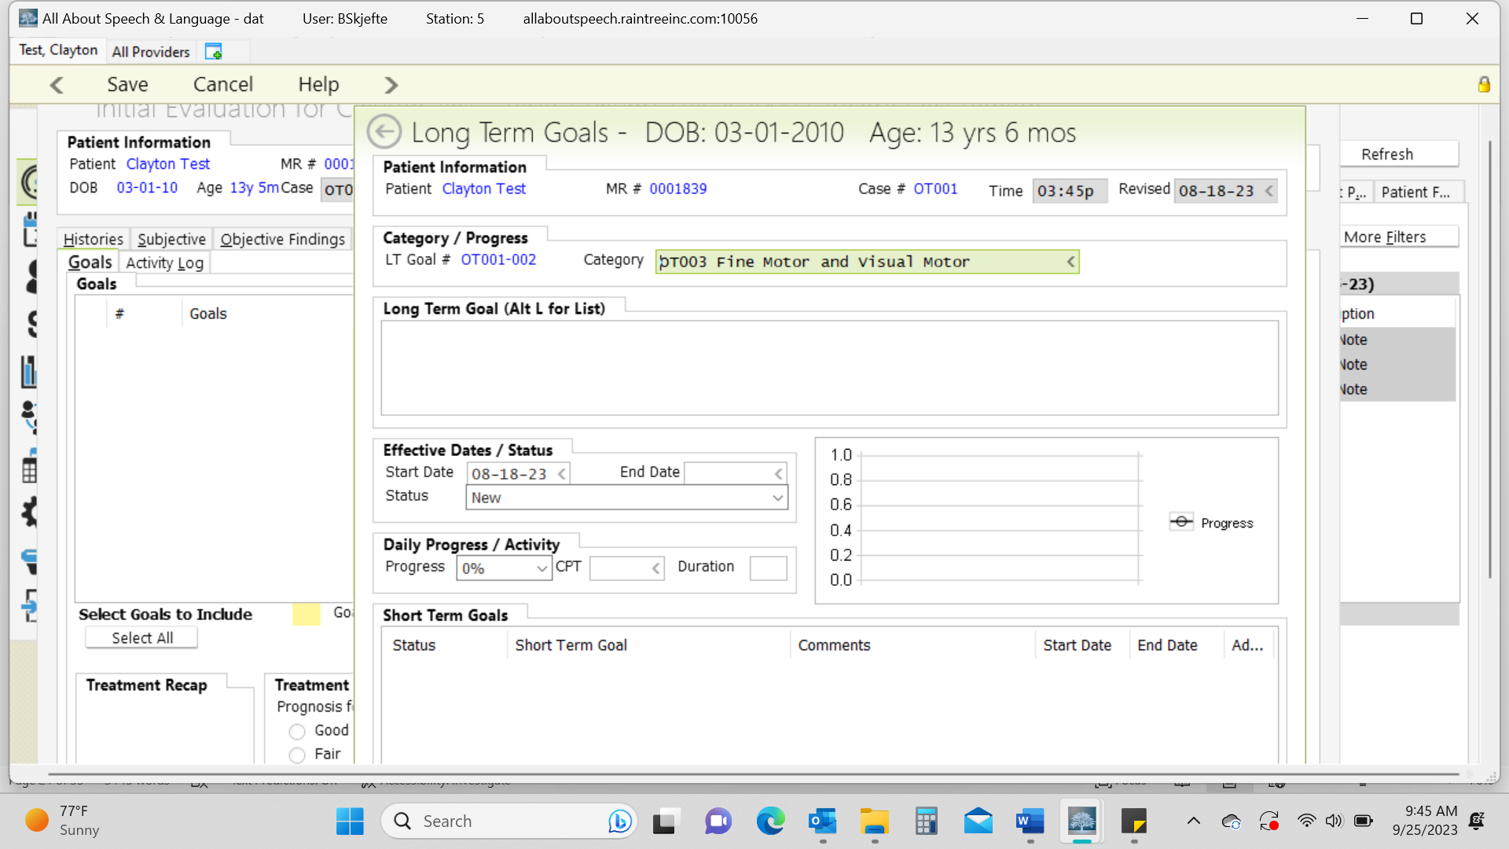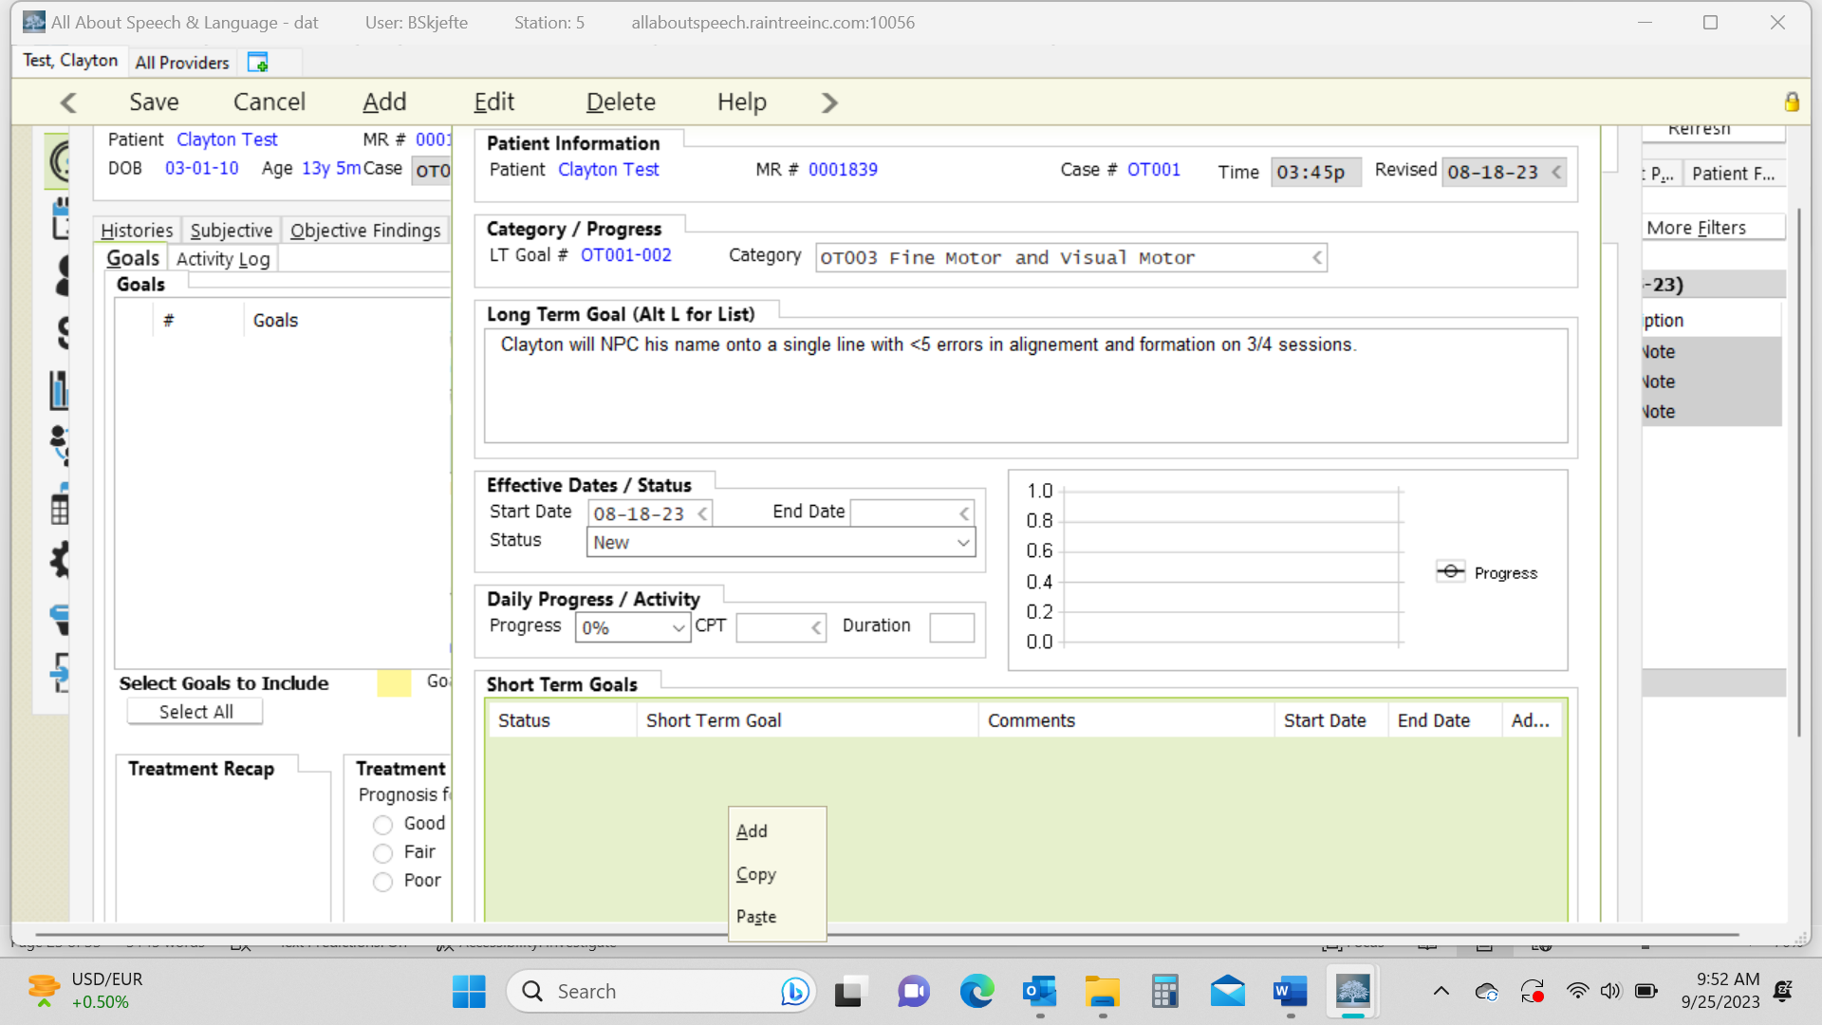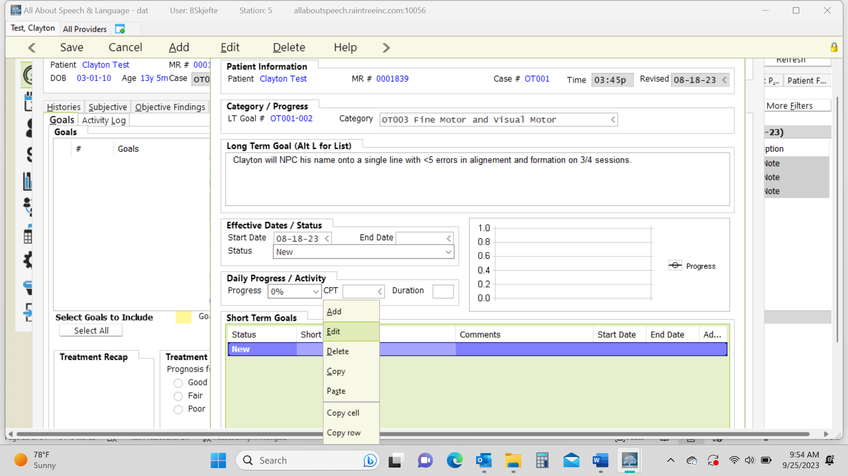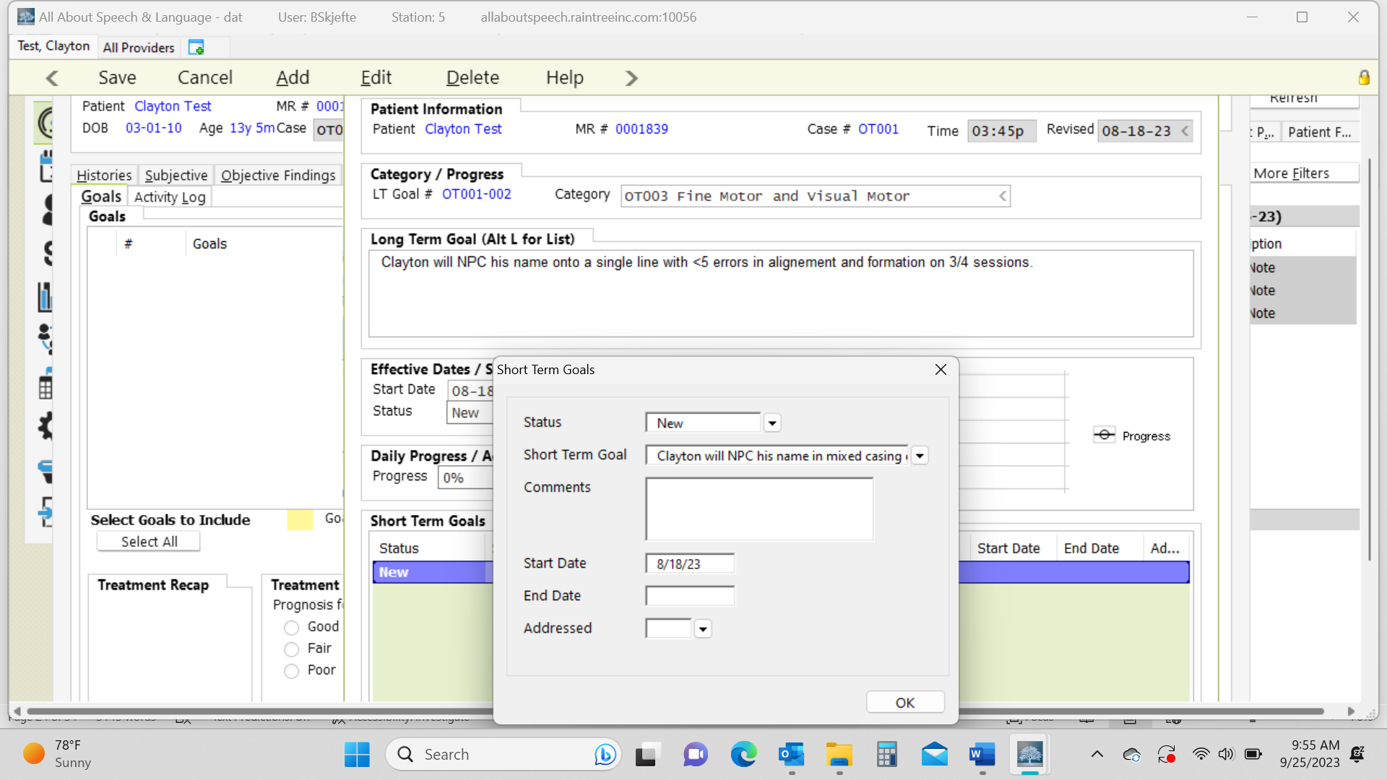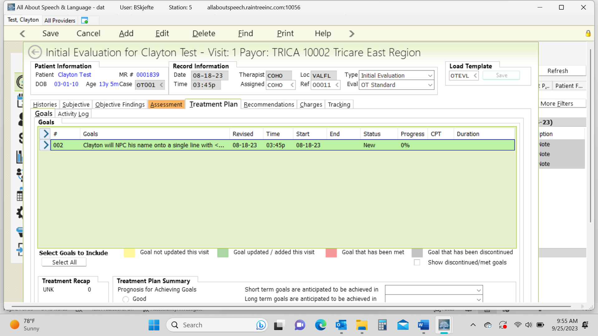

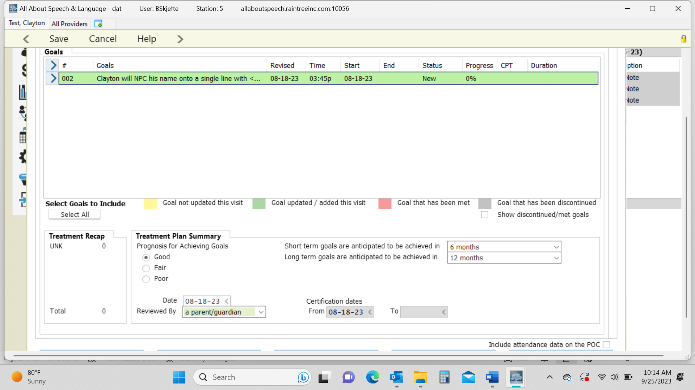

Recommendations Tab:
- You will select what is appropriate (initiate therapy etc.) and fill in the “in order to box” where we do a quick summary of strengths/weaknesses and what will be addressed going forward. Here is where we also will identify red flags again (if not already included in appropriate sections of the report) if they are present for a child given how they presented throughout the evaluation, as well as given the family dynamics (i.e. some families know something is wrong and come in asking lots of questions and some have no idea what is going on and we are going to have to gently educate them, start planting seeds, and we will be walking with them on their journey with their child going forward—can always speak more about this with your CM if you have questions before your sign off on your report, as it is a case by case scenario given each family is different.
- In the comments box, identify assessment complexity level and add performance deficits. Below are areas based on the OTPF-4.
  - Physical skills refer to body structure or body function (e.g., balance, mobility, strength, endurance, fine or gross motor coordination, sensation, dexterity).
  - Cognitive skills: ability to attend, perceive, think, understand, problem solve, mentally sequence, learn, and remember, resulting in the ability to organize occupational performance in a timely and safe manner. These skills are observed when a person (1) attends to and selects, interacts with, and uses task tools and materials; (2) carries out individual actions and steps; and (3) modifies performance when problems are encountered.
  - Psychosocial skills: interpersonal interactions, habits, routines and behaviors; active use of coping strategies; and/or environmental adaptations to develop skills necessary to successfully and appropriately participate in everyday tasks and social situations.
- Here you will also add recommendations for further assessments if needed, again especially if you have concerns for more going on with a child; can select via +.
- Under Frequency/Duration you will input X visits per week for 52 weeks (use clinical judgment here)
- Enter Treatment Duration (typically 30 or 60 minutes)
- Total number of visits will be 104.
- POC From and POC To Dates are in line with the initial date of the evaluation; so you input the initial date of the evaluation and then put that same date but a year later denoting when it “expires” and that will warrant us to do a re-evaluation. Sometimes the numbers autofill in for you as well. If there is ever an error, it won’t let you sign off on the report without fixing it so you can always ask the CM/Operations Director about this.
- Discharge Planning: This is a case by case if you fill this out per family and can add via +.

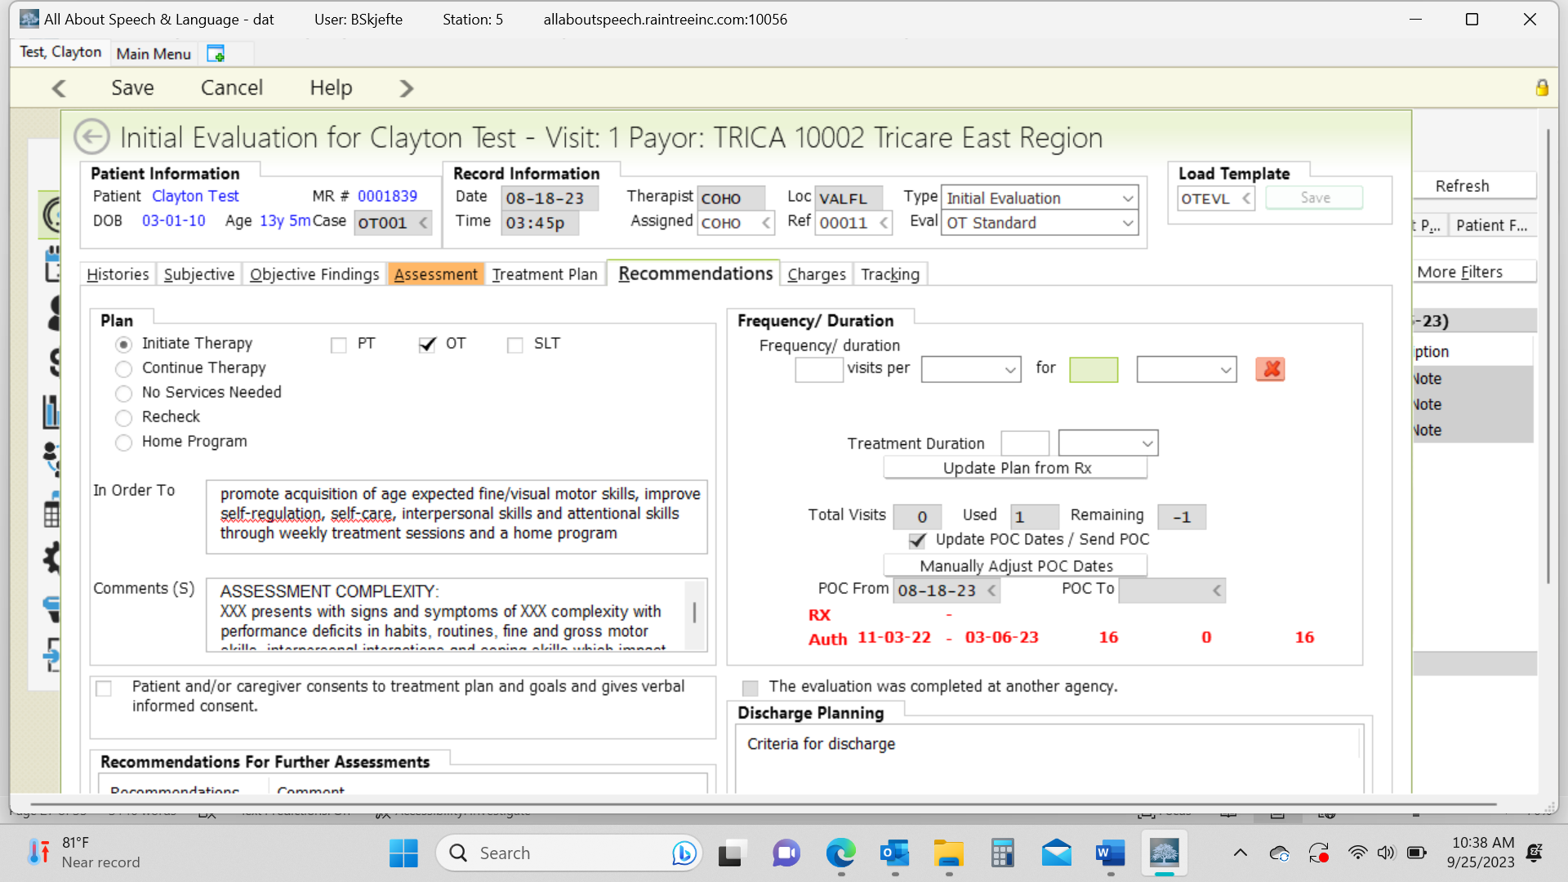
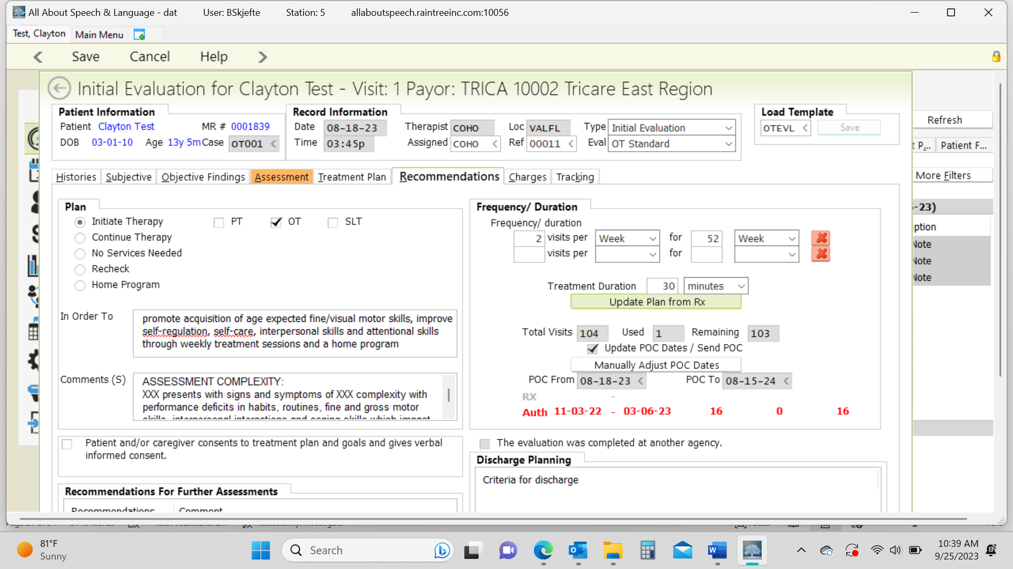

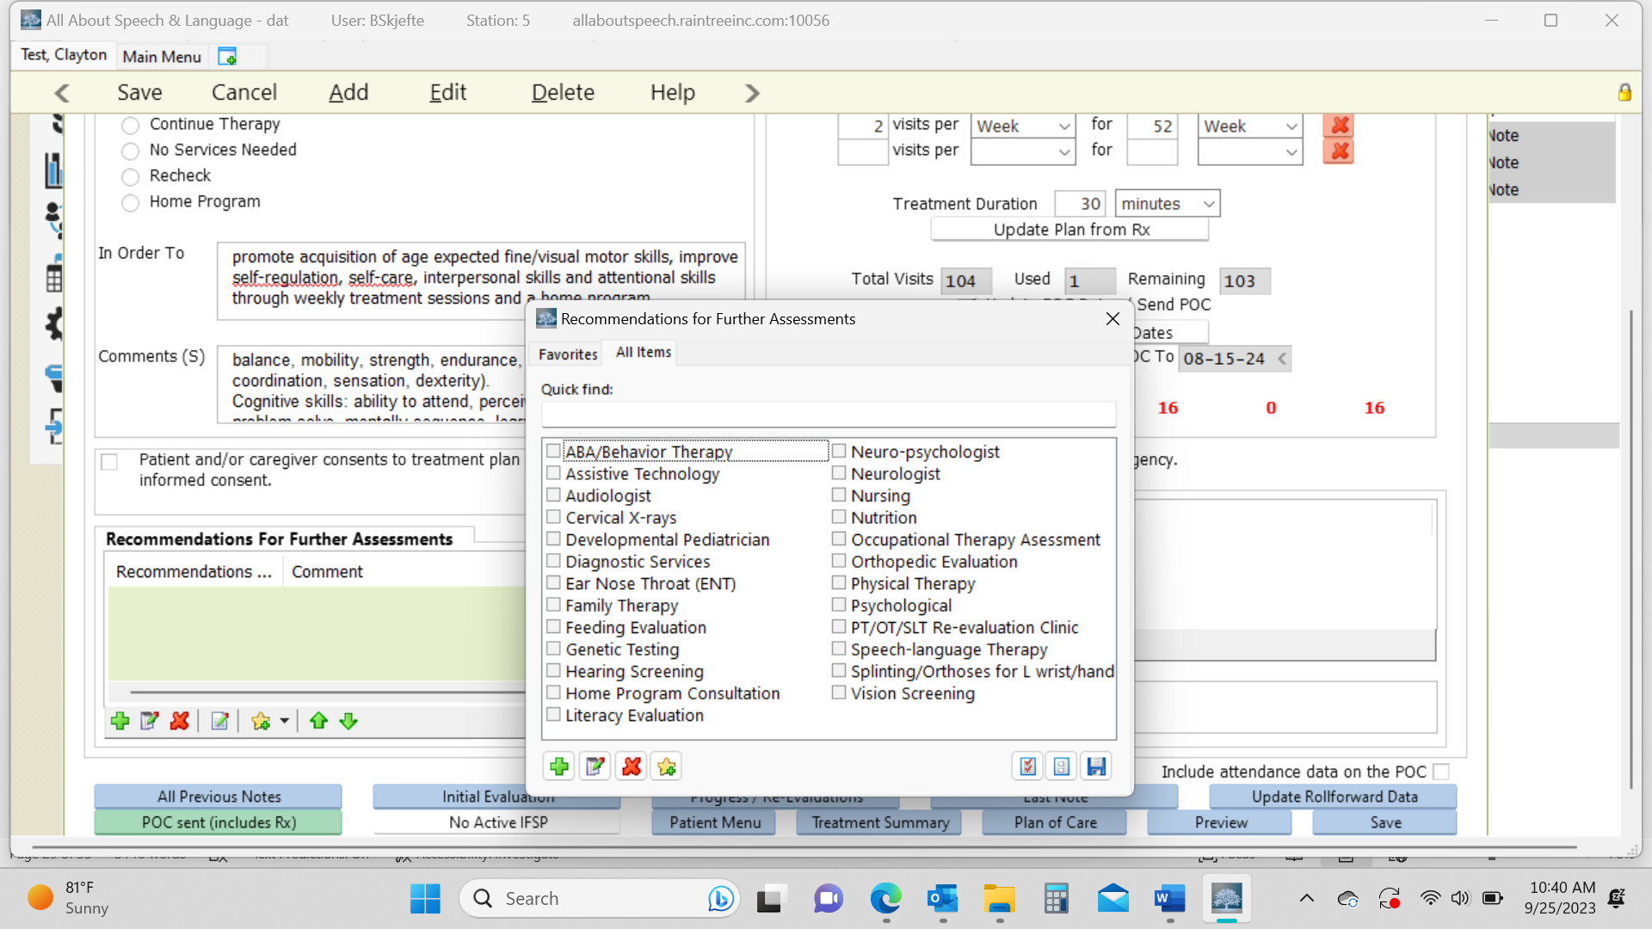

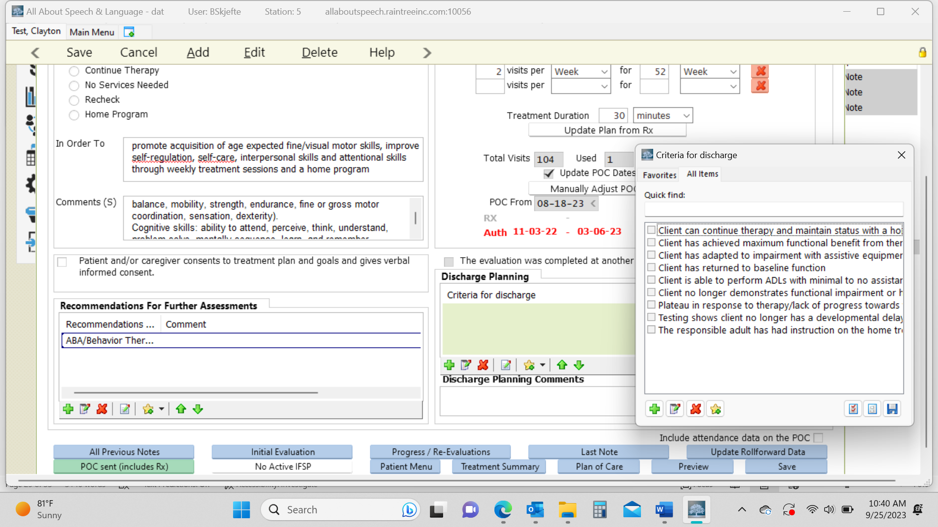

Charges:
- For Tricare, select Eval Low/Moderate/High Complexity & input add’l # of units under 97530 Therapeutic Activity. Ex. If you saw the client for a 60-minute Low complexity eval, you would select Eval Low complexity and enter 3 additional treatment units
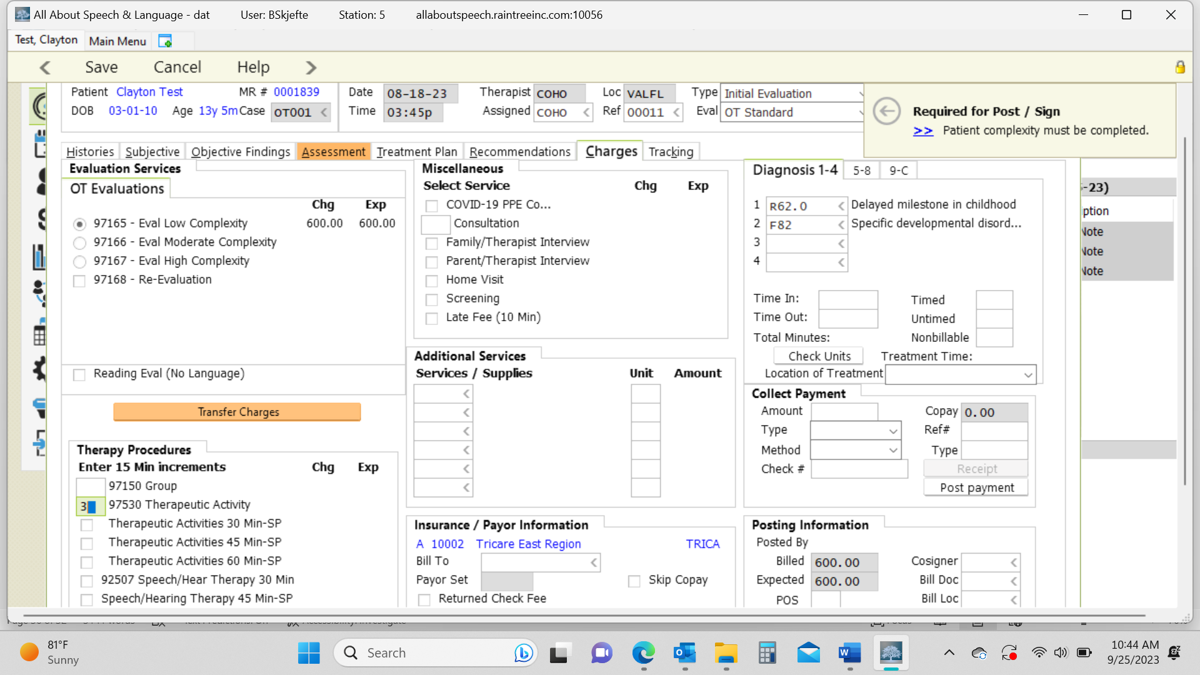
- Self-Pay families you will select only the Eval complexity which attaches the $250 charge
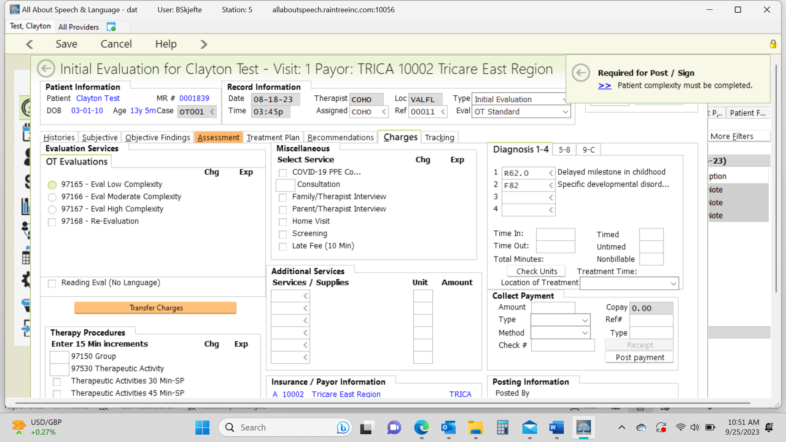

Diagnoses:
- Make sure diagnoses are accurate and/or are added to what has already been provided from the referring physician before you assign charges; otherwise, we cannot fix it going forward when saving and signing off on the report. The initial diagnosis, as it was originally indicated per the insurance authorization, is input to make sure we get reimbursed as that code comes from the Doctor and then we add additional codes as necessary
- If a client’s authorization/script does not come in with a diagnosis code, it is up to the evaluating therapist to apply the one of following Diagnosis Codes: Specific Developmental Disorder of Motor Function (F82) or Delayed milestones in childhood (R62.0).
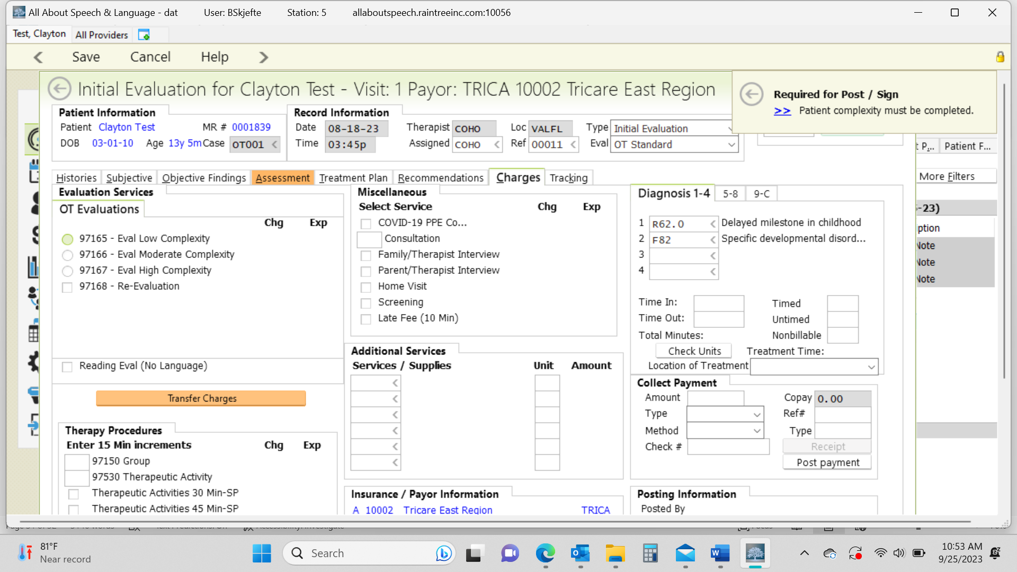

Signing off/Saving Report:
- If you don’t complete the evaluation in one sitting, you hit save and exit. If you are ready to save and sign off, hit save, then you will be directed to what looks like a white document, much like when you save and sign off on daily notes. Here is where you check for grammatical edits, and do minor changes and any other formatting type changes. You cannot edit big elements of the report in here (i.e. specific data, goals etc.) as they won’t save into the report. If you catch changes that need to be made you will have to go back to the edit detail when you click on the evaluation in the client’s chart.
- If you require a co-signs, your report will be sent to your co-signer for review before it is finalized so be sure to communicate with them when you signed off on it accordingly.
- If you are required to have your evaluations reviewed prior to being signed off you will just “save and exit” the report until it is reviewed. Be sure to communicate completion of the evaluation and request for review accordingly, and in a timely manner, with your CM
- If you want a second set of eyes or opinion on a certain part of your evaluation, just “save and exit” the report until it is reviewed. Be sure to communicate completion of the evaluation and request for review accordingly, and in a timely manner, with your CM.
- Be sure to give the evaluation a read-through to ensure no glaring typos or errors before signing off on the document. This is the last impression a doctor, family, or insurance reviewer will be seeing from us, so take care in your review.
- If a parent/caregiver requests to have the evaluation sent to them or another professional, please inform the Front Desk. Please do so by providing the client’s name, parent name, and specific request. They will send documentation to parents or other professionals as requested, ensuring necessary releases of information are on file.

