Re-Evaluation Procedure for Occupational Therapists

Contents
Updating Caseload Tab 2
Tracking Upcoming Re-Evaluations 4
History Tab 7
Subjective Tab 9
Objective Tab 12
Assessment Tab 15
Treatment Tab 16
Recommendations Tab 21
How to Determine Medical Complexity (low, moderate, high)……………………………………..22
Handling Clients Who Do Not Qualify for Therapy 23
Charges Tab 24

Updating Caseload Tab
- It is the responsibility of the treating therapist(s) to:
- track due dates for re-evaluations/progress notes
- keep their dashboard up-to-date (i.e., remove discharged or covered clients)
- ensure due dates are accurate (i.e., conversion note clients require manual updates)
- To update your Caseload tab, log into Raintree and go to your respective Dashboard, locating the tab titled “Case Load”:
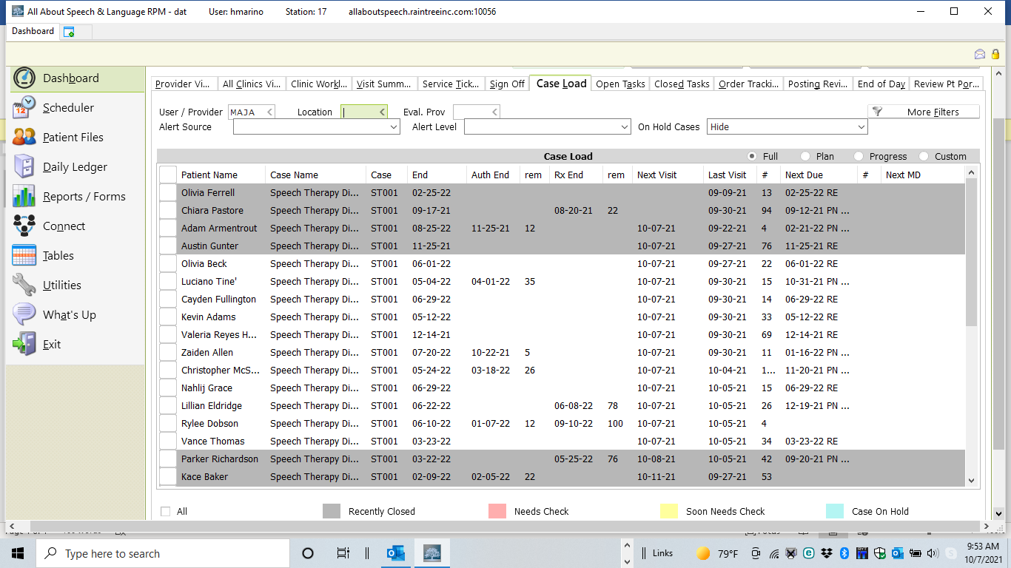

3. Remove clients seen for coverage, or clients no longer on your caseload by doing the following:
  - Select the client by checking the box next to their name
  - Select the Remove from Active Caseload button, located at the bottom of the screen. This will remove this client from your caseload list.
  - If the client dropped out or was discharged, please be sure to complete a discharge note prior to removing them from your caseload.
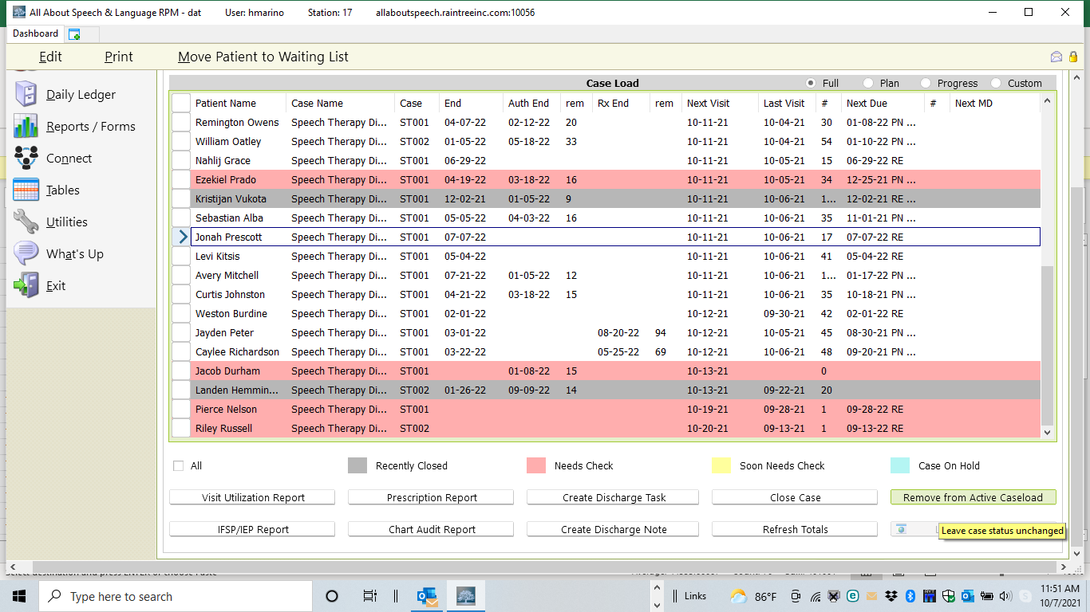
To manually update re-evaluation and progress note due dates, do the following:
- Select the name with your mouse:

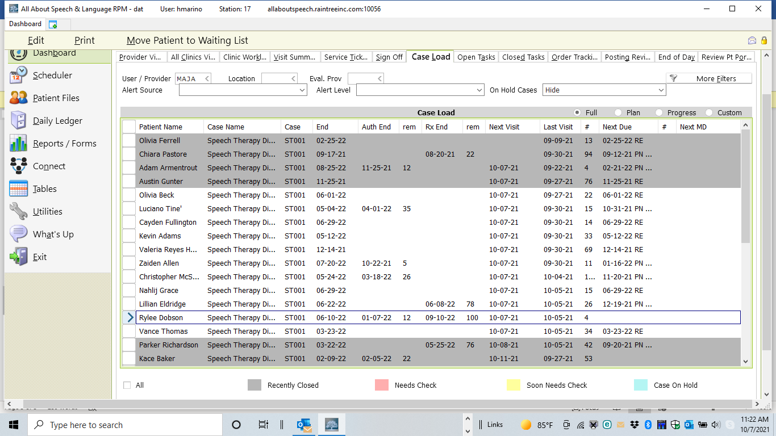

- Select Edit.
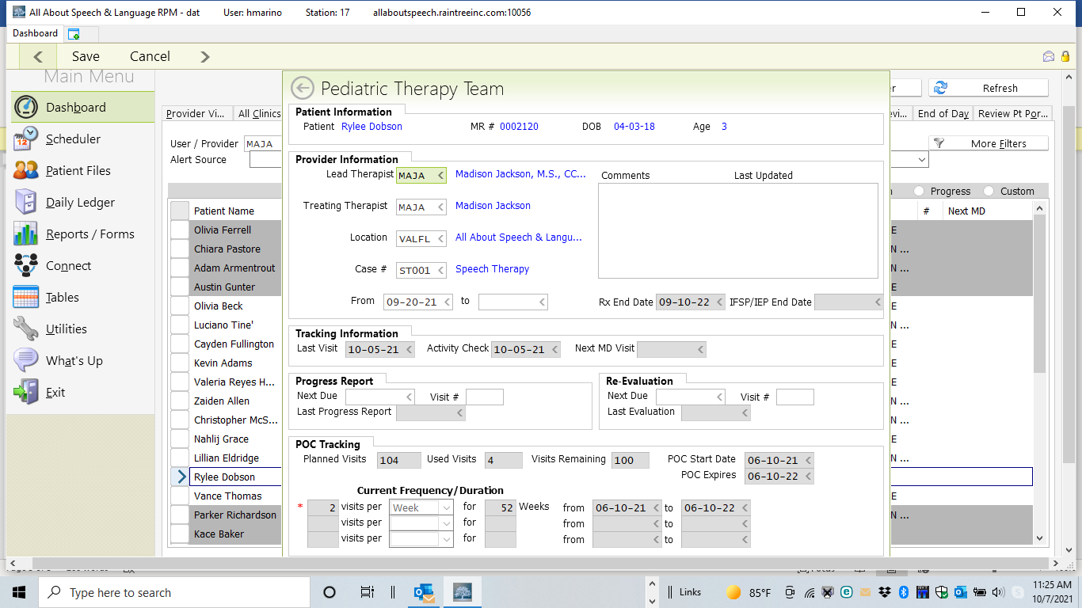
- Enter the Progress Report/Re-Evaluation Next Due date: 12-10-21, based on the POC dates: 06-10-21 to 06-10-22. And enter the Re Evaluation Next Due date: 06/10/22.

Tracking Upcoming Re-Evaluations
- Use the Case Load tab under Dashboard to determine what re-evaluations are upcoming. Of note, OTRs are also responsible for their assigned COTA’s caseload if applicable.
- Date to send List | Upcoming Re-eval Dates
End of January | March and April
End of February | April and May
End of March | May and June
End of April | June and July
End of May | July and August
End of June | August and September
End of July | September and October
End of August | October and November
End of September | November and December
End of October | December and January
End of November | January and February
End of December | February and March
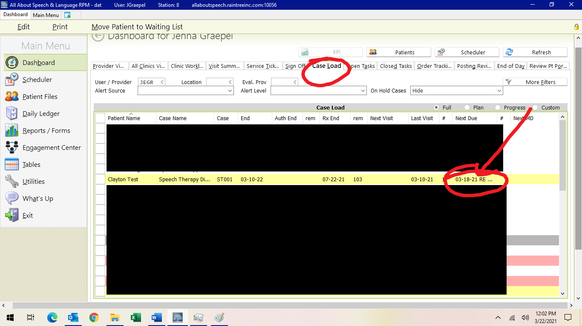

2. EMR system will also auto-prompt you when you log into daily notes when re-evaluations are due and will auto-change the note type for you if you initiate it during a treatment session (it should be scheduled before this notification), OR you can go in and change the note type under TYPE to Re-evaluation with OT Standard.
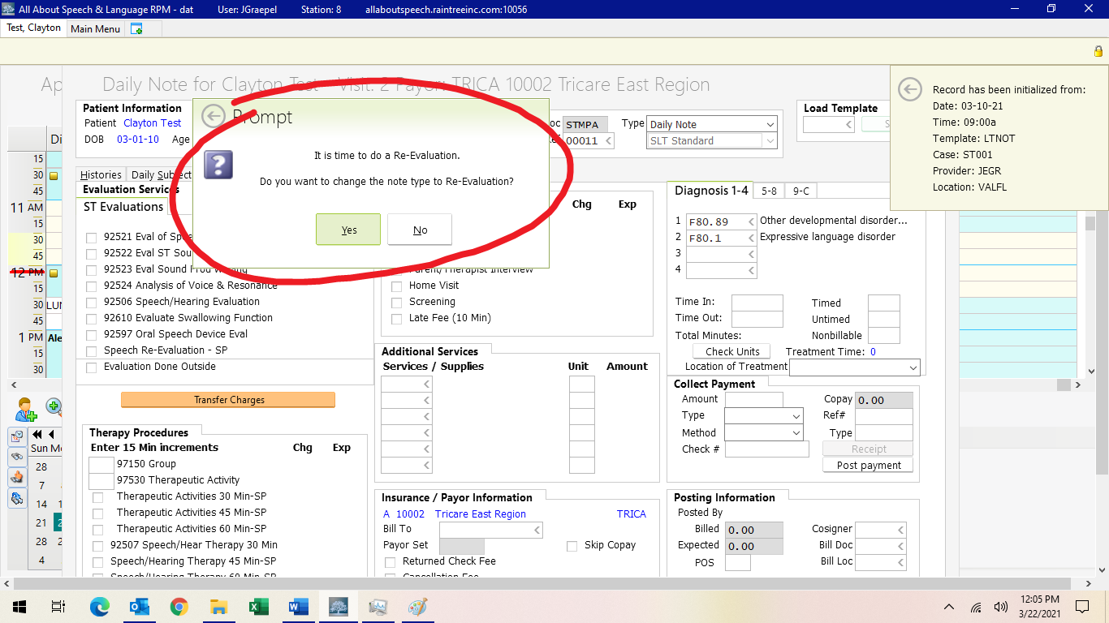
- Or if you are initiating the re-eval prior to the POC expiring, you create the re-eval note type by selecting the drop-down box by “Type” and selecting re-eval.
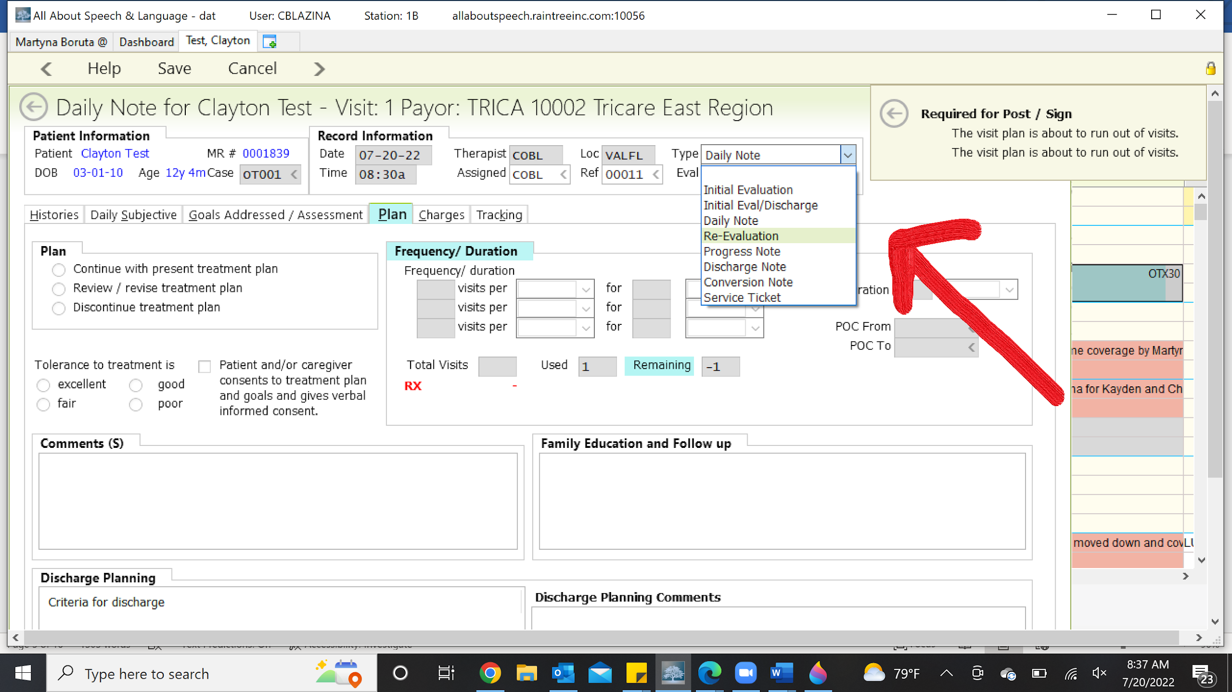

- If applicable, COTAs are responsible for communicating to the OTR upcoming re-evals for the next two months on their caseload 2 months in advance to allow for time to schedule the reevaluation on the OTRs schedule. These lists are to be sent at the end of every month. The supervising OTR is responsible for overseeing this process and coordinating with the family and COTAs a time for the re-evaluation.

- Following the email sent by the COTA, the OTR is now responsible for providing the COTA the proposed days and time to complete the re-evaluation. The COTA will then coordinate with family on proposed re-evaluation date AT LEAST one month out from when the POC expires. The re-evaluation is to be scheduled 2 weeks from the POC expiration date.
- After coordinating with the parent, the treating therapist will email the date of the reevaluation to Front Desk Receptionist, copying Lily, Patient Scheduler, and the OTR. Lily will be reaching out to the families regarding current authorization for re-evaluation 4 weeks prior to the POC expiration. OTRs are to ensure the client’s authorization is current prior to completing the re-evaluation.

- OTR will lead any necessary schedule changes to accommodate the re-eval and will change appointment in RT accordingly.

- Once confirmed, change the appointment type on your schedule to “OTREV”; adjust time if needed. Notify Front Desk of scheduled re-evaluation.

- Front Desk Receptionist will send an email to the family to confirm the re-evaluation date, CC’ing the OTR and/or the COTA if applicable, attaching the Re-evaluation Parent Questionnaire form asking to receive back at least two-weeks prior to scheduled re-evaluation.

- Once the Parent Questionnaire is received, the Front Desk Receptionist will notify the treating therapist that pertinent documents are uploaded to RT and ready for review.

- If we do not have the medical history update prior to the time of the re-evaluation, Front Desk Receptionist will either hand deliver to family, or request that the treating therapist do so. It will then be scanned into the chart (in the documents tab) and emailed to the evaluating therapist.

- Front Desk will provide the family the AASL Quality Assurance Form at time of check-in for the re-evaluation, asking them to fill out and return before they leave. Front Desk will scan and email the form to the Clinic Manager, and upload the form to the client’s chart upon receipt.
- Treating therapist will also administer the REAL to the parents. The parents are to complete the REAL at the time of the session. NOTE- do not send this home with the parents. Look in OT filling cabinet to determine if a new REAL is needed (they can be used twice). *

- Select appropriate standardized test and prepare for parent interview as well as clinical observations. Talk with your CM about re-evaluation preparation, if you have questions.

History Tab
- Click on "Pediatric Medical History" on the right side of the screen. Click on "Update" in the top left corner of the screen. Scroll down to the bottom left corner and select "Merge". Scroll down to the bottom and select "Exclude Medical History on report". Click "Save and Complete Later".

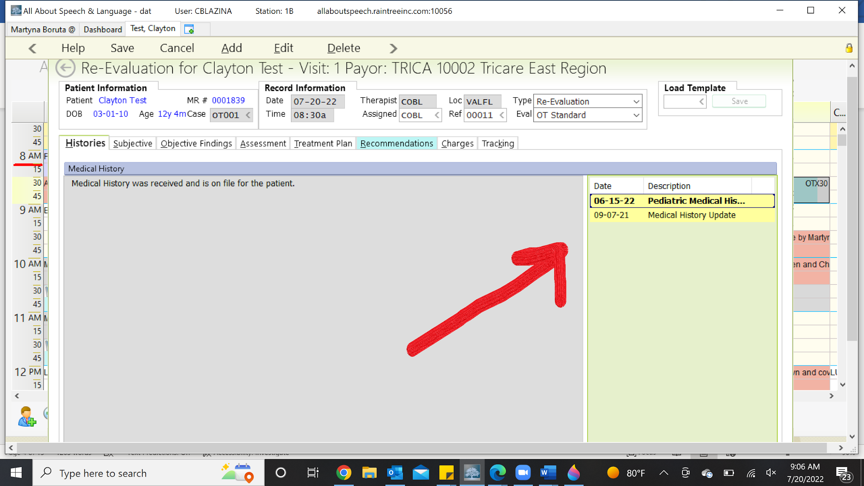

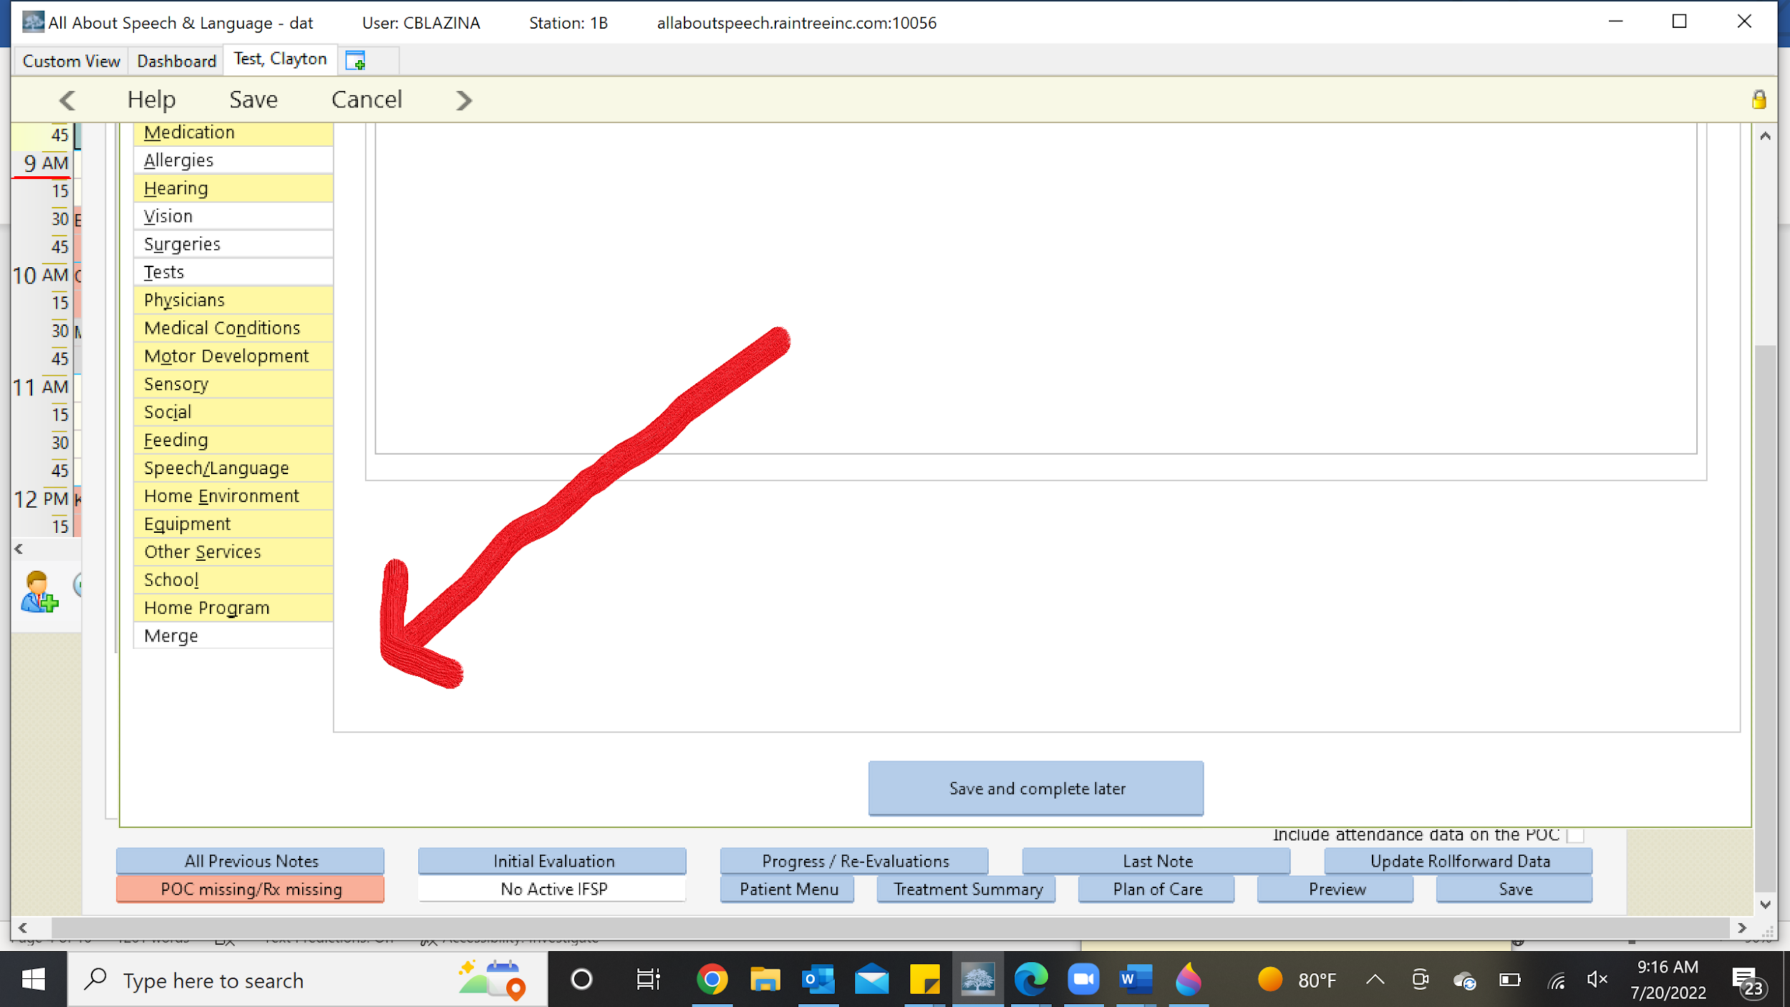

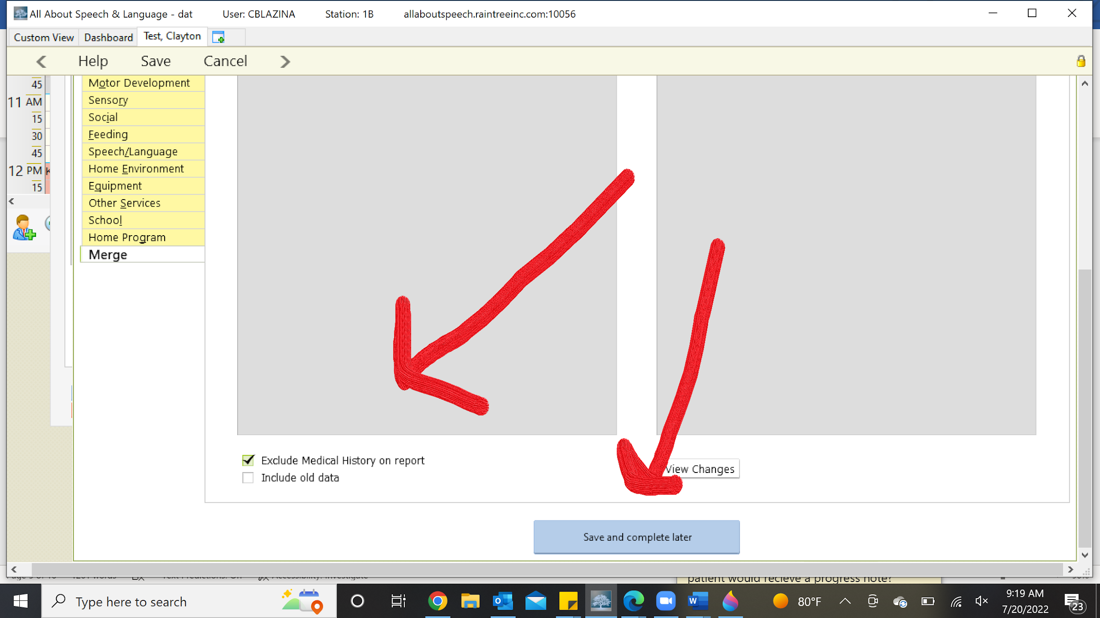

Subjective Tab
- Update with any pertinent medical history (ie. new diagnosis, starting a new medication ect) and add current parent/family concerns.
- Right click in the "Parent/Family Concerns" box and select "Edit". Use the following template for recording medical history information. Click "Close Editor" to complete. Ask your CM for the Guideline/checklist for Medical History.
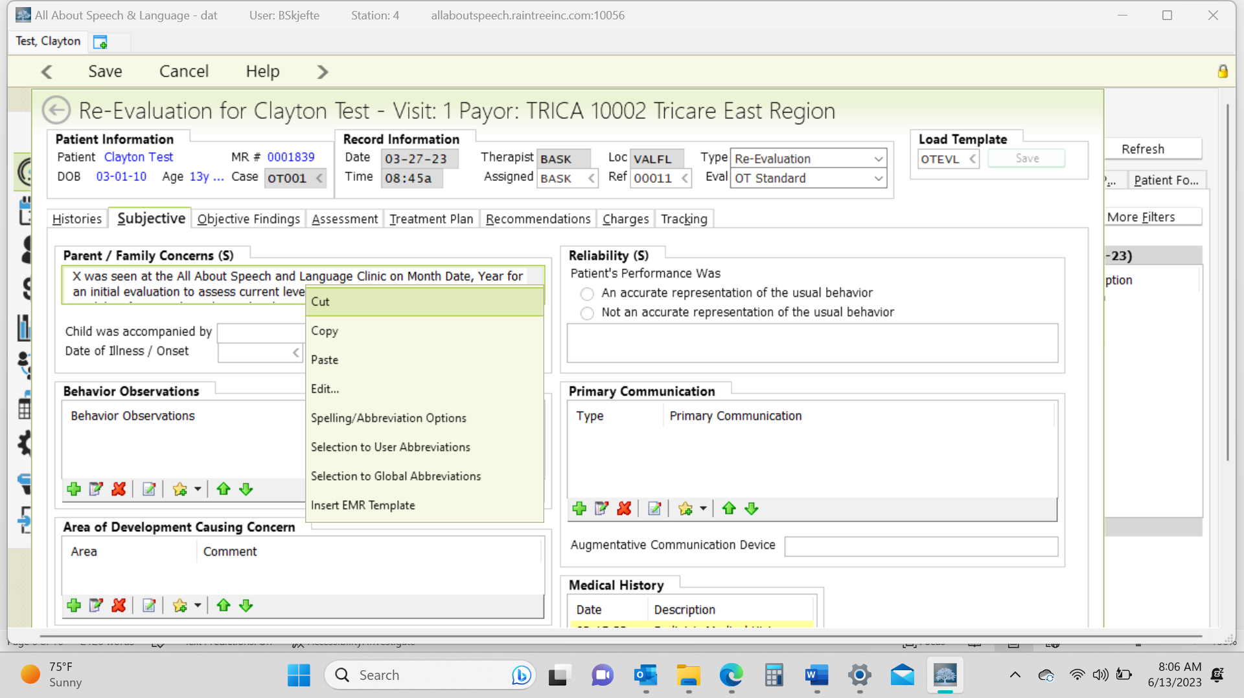

- Comment on the following sections: Reliability, Primary Communication, Behavioral Observations, Area of Development Causing Concern (these are parent's concerns). Use the green plus sign to view checklist options in these categories and click the "save" button in the bottom right corner.
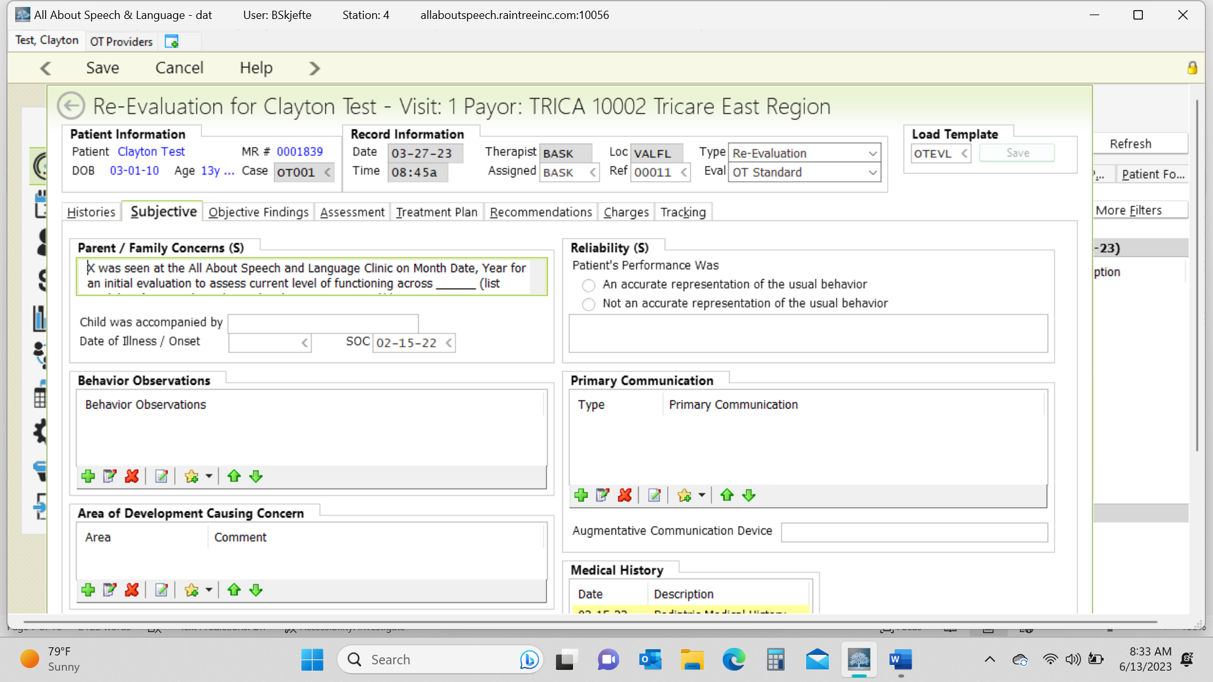
- Select "Medications and allergies reviewed"
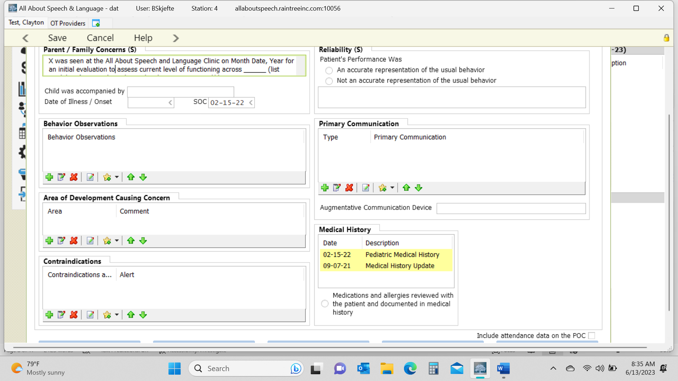

Objective Tab

- This is where you input all the standardized tests and the REAL if administered. There is an Update button that you can click on that will keep the same narrative comments from the previous year, which makes it easier for updating and commenting on progress to date. This way you will not have to come up with entirely new narrative and you can save some time accordingly! Be sure you are commenting on performance on standardized tests as compared to prior year performance and justifying the need for continued skilled OT intervention.

- Right click in the Standardized Tests box and select "Add" and locate appropriate test. Fill in data accordingly.

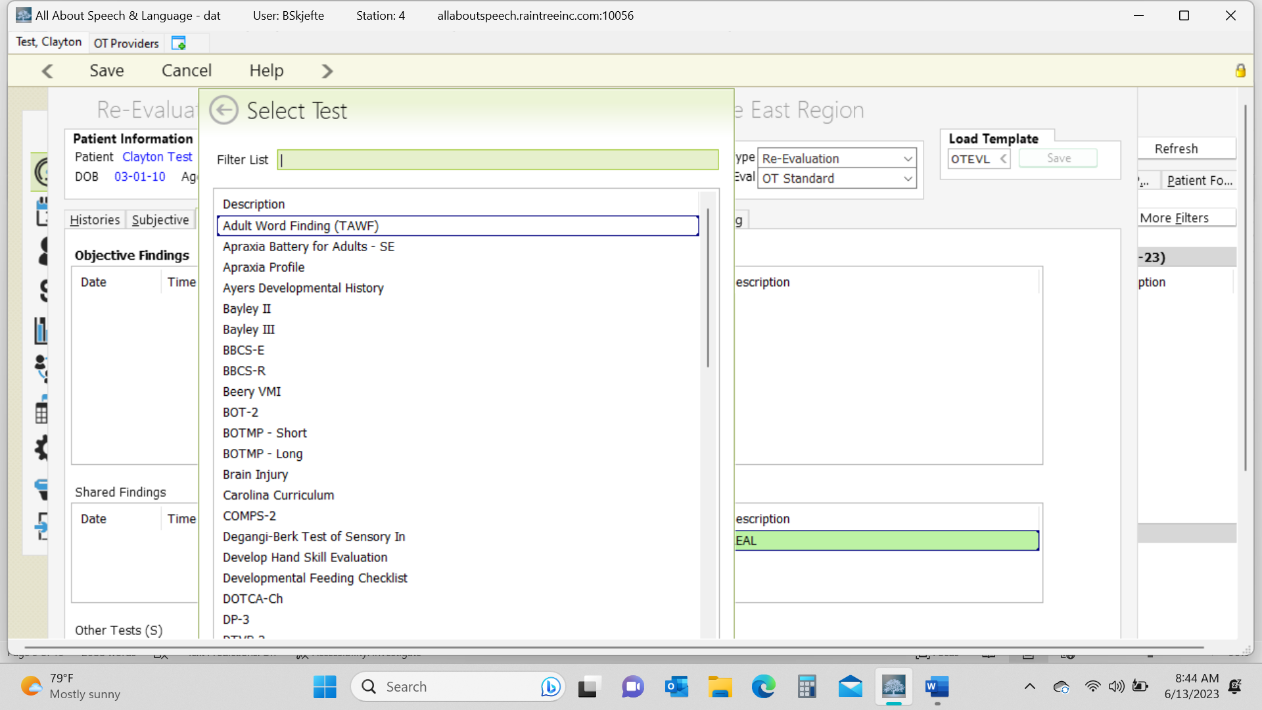

- To add the REAL right click on Shared Tests Box and select “Add”. If REAL blurb does not populate type “REAL” then “enter” into template to load the description of the assessment.
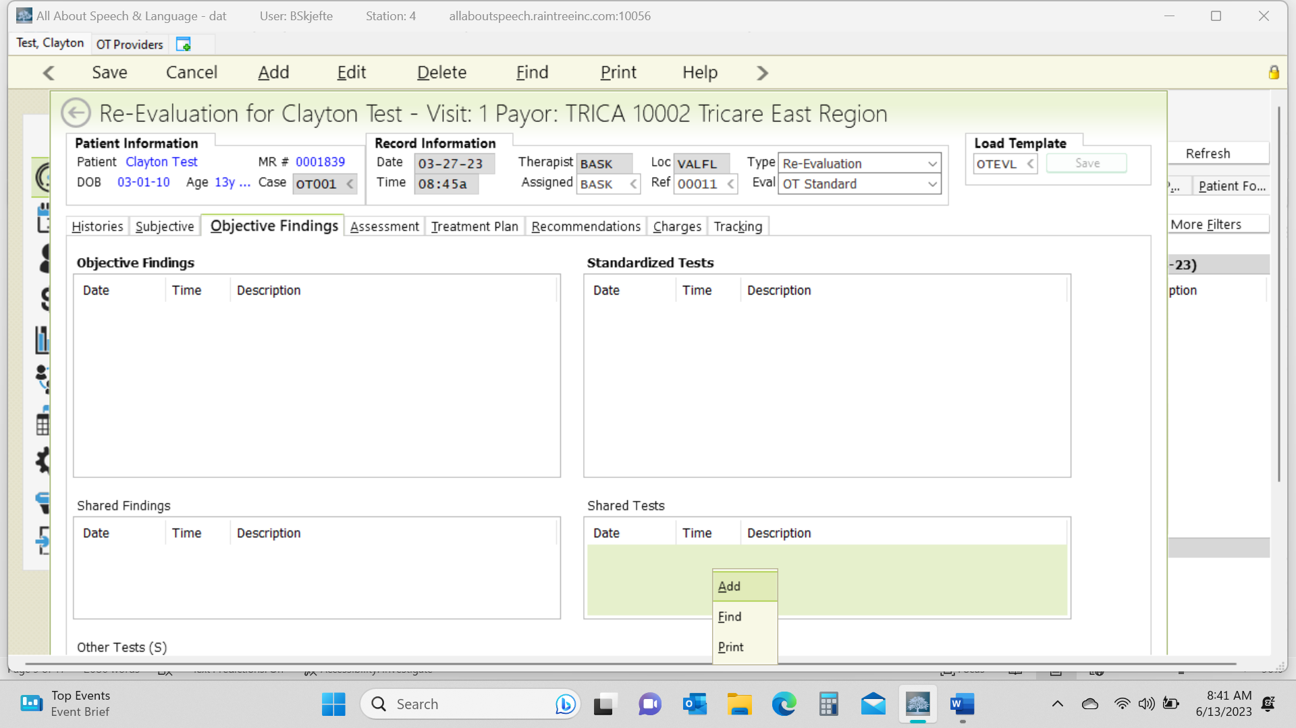
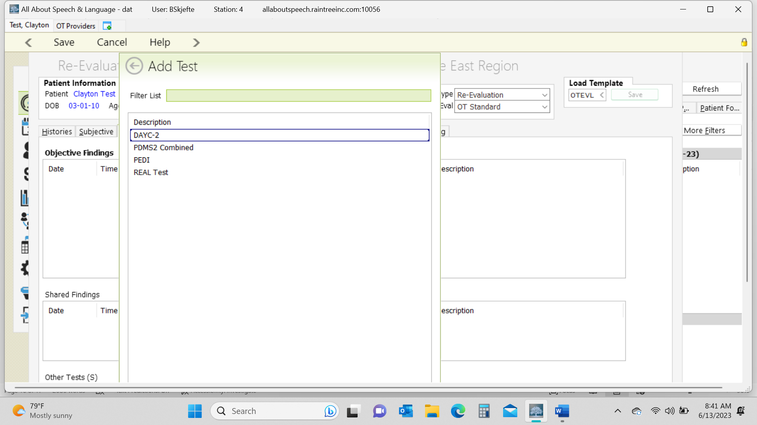
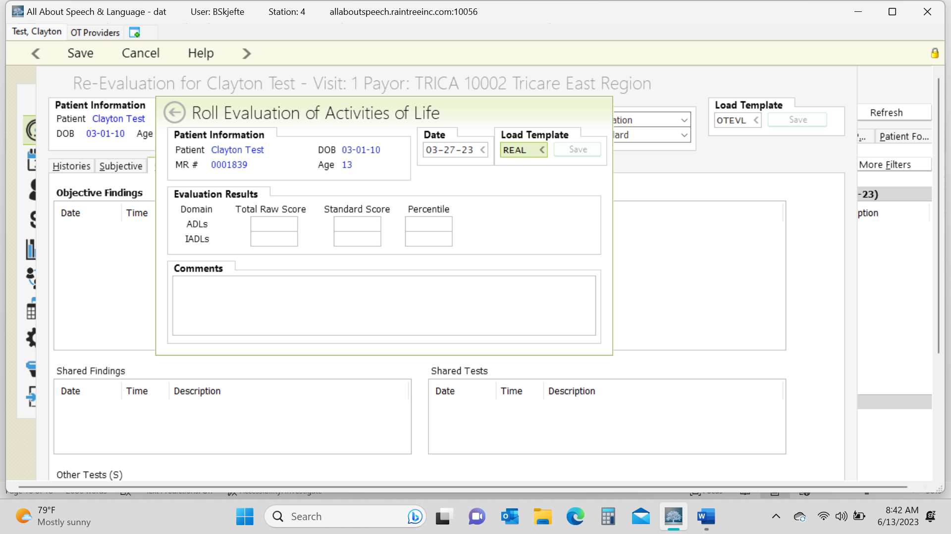
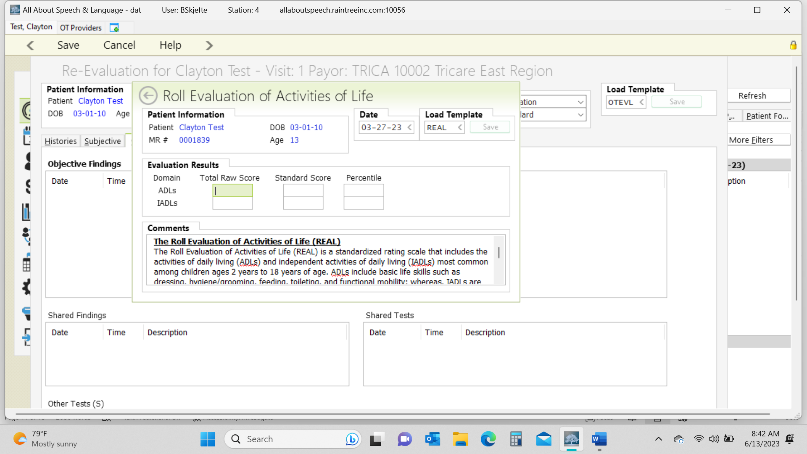

Assessment Tab

- Fill in the following areas
  - Strengths- Select the green plus sign and select appropriate items the select the "save" button in the bottom right corner of that screen.
  - Specific Areas of Concern- These are deficits or impairments that you have determined.
  - Comments- Use this box for your narrative portion of the re-evaluation. This should show the picture of where the child currently is. You do NOT have to compare to previous evaluation. See initial evaluation template. Areas to include: ADLs/IADLs, psychosocial/behavior/cognition skills, fine motor & visual motor, and gross motor skills.
  - Diagnosis- The primary diagnosis will be the medical diagnosis from the doctor. The secondary diagnosis comes from the OTR to determine what we are treating for, examples include F82 Specific developmental disorder of motor function, R63.3 Feeding Difficulties, F81.9 Developmental disorder of scholastic skills, unspecified, M62.81 Muscle weakness (generalized), R62.0 Delayed milestones in childhood. At the time of the re-eval, make changes to the treating diagnosis if necessary.

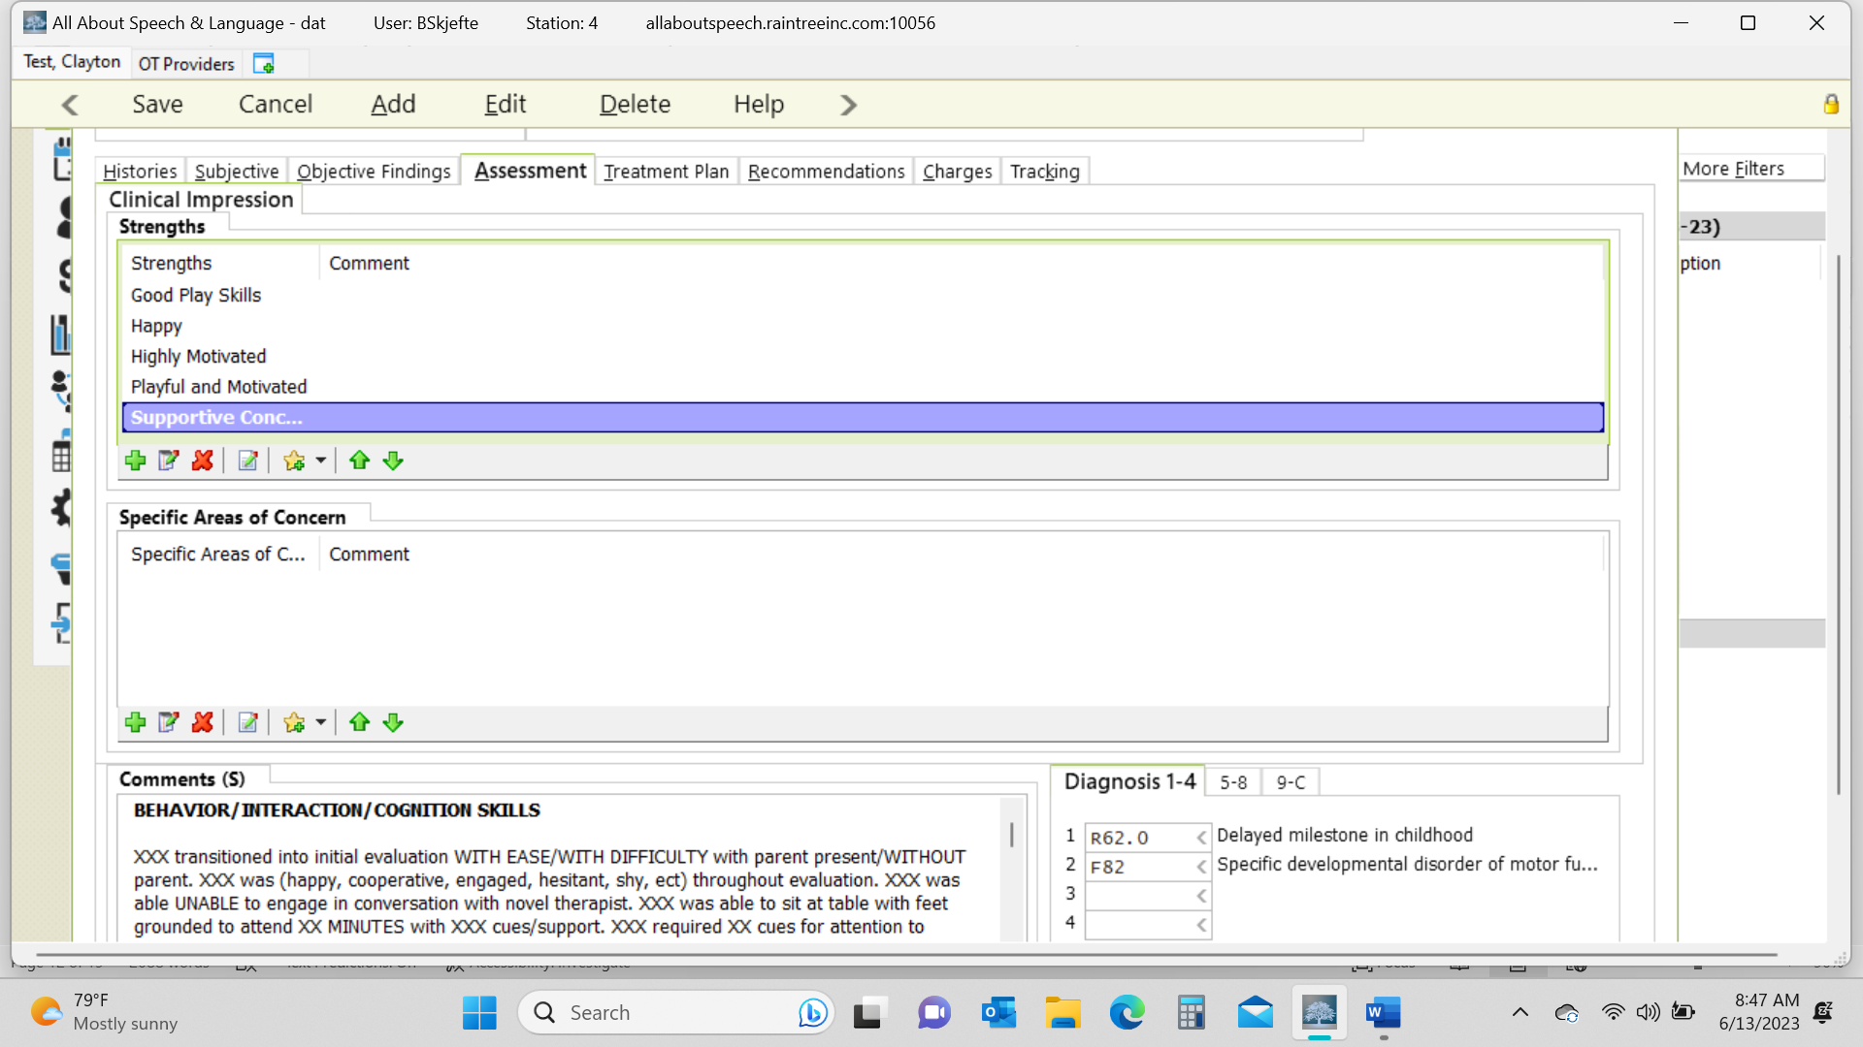

Make sure you are including a summary of progress toward goals from the previous plan of care. At the end of the narrative in the first example above:

“XXXX has met X/X short term goals and X/X long term goals during this plan of care. New goals reflect current status and caregiver concerns.“

Treatment Tab
- Click on each LTG and then hit address goal. Enter the end date for each LTG as the date of the re-eval and change status as either “Met” or “Discontinue” using the drop-down menu (* Each goal has to be met or discontinues at re-eval time) Provide a reason to why the goal was discontinued in the comments i.e., “Goal is no longer applicable during this POC, goal not addressed during this plan of care, discontinued due to safety concerns, or see new short-term goal to reflect current status. Even if you plan to use the same goal in the new plan of care, mark as “Discontinue”, and you may add as a new goal with a new start date. Change the progress from 0% to blank.
- Repeat with each STG, change status as either “Met” or “Discontinue” and enter an end date for each STG. Provide given reason in comments for discontinued goal (see above). You may select “Met” via drop down menu, however you need to manually type “Discontinue” into the status bar of STG. Click SAVE in the top left corner.

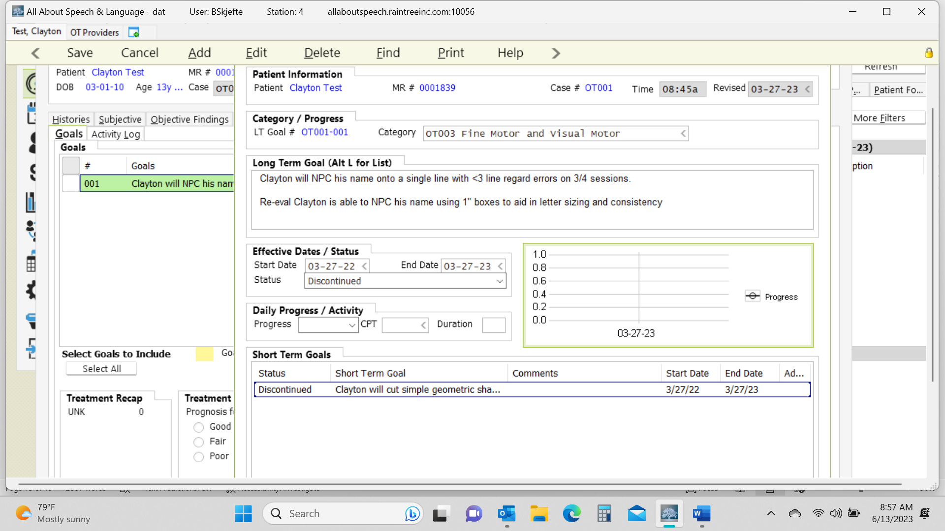

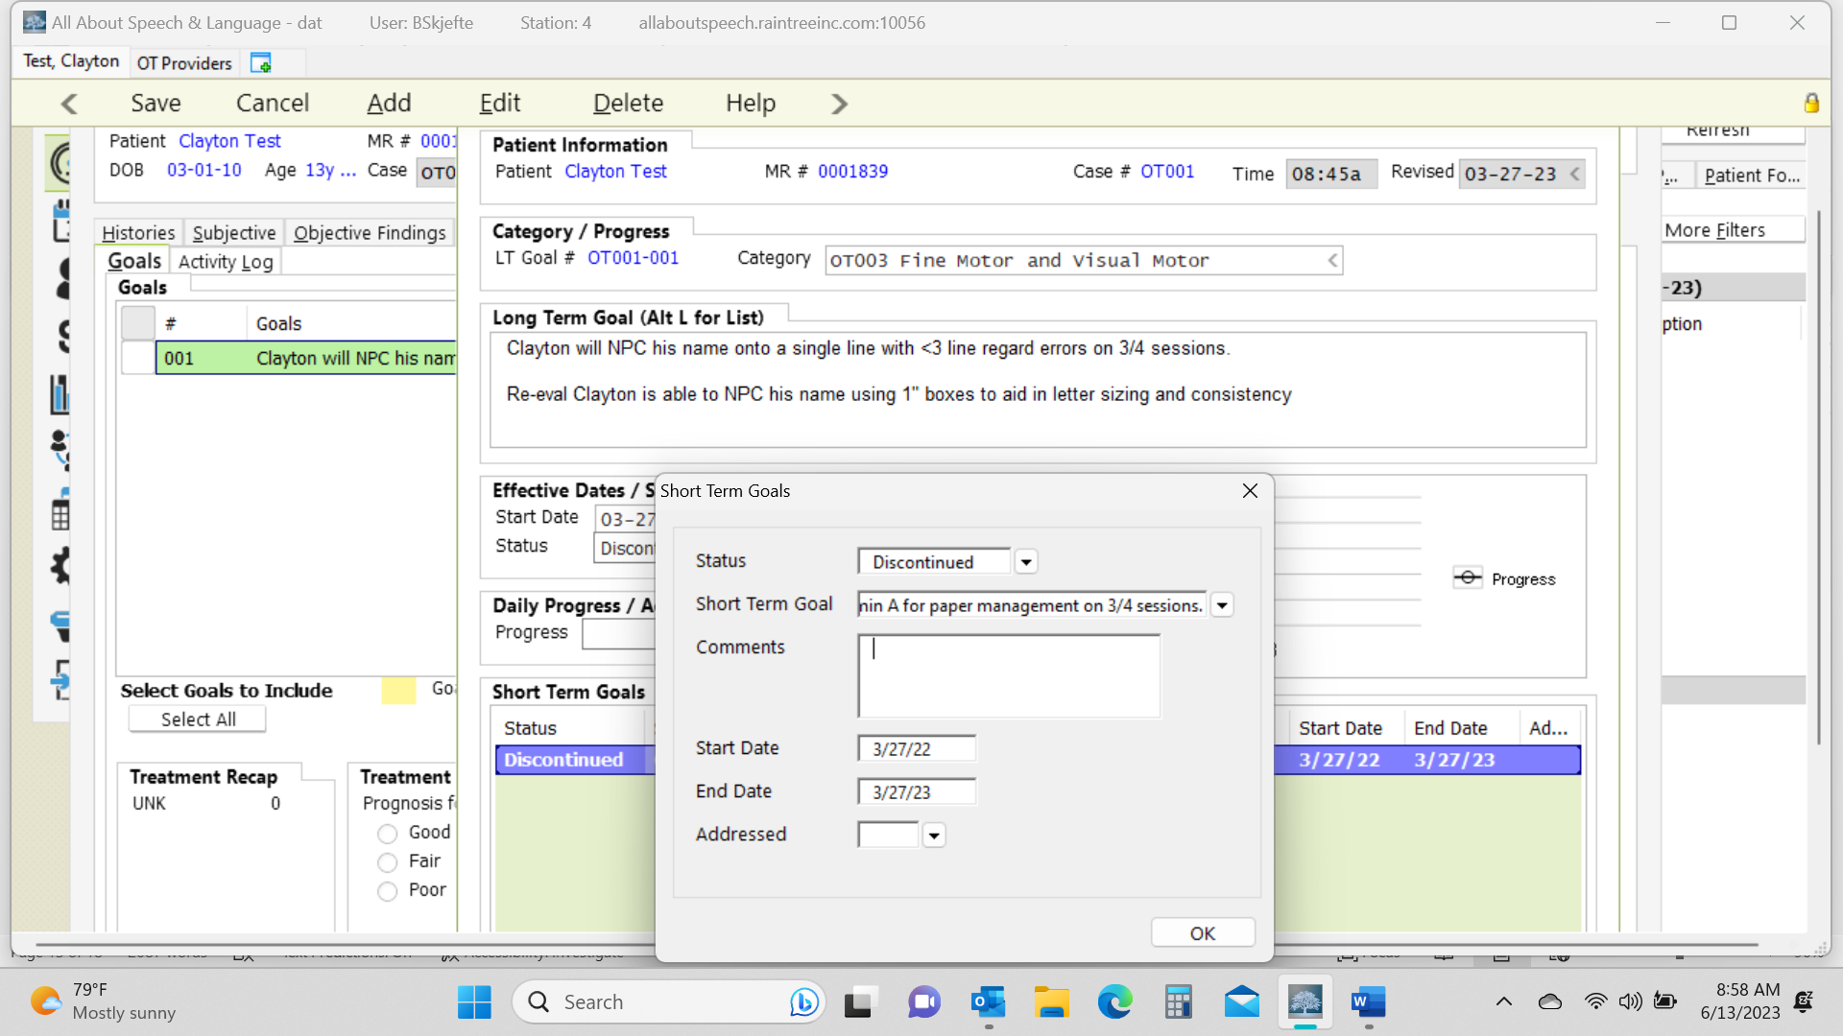

- Right click Add in the green box to create new LTGs and STGs. Select a Category for the goal. Include LTG in open box. Change progress from 0% to blank. Click on the green plus sign and select New. Click the Save button. Right click on that purple line and select Edit
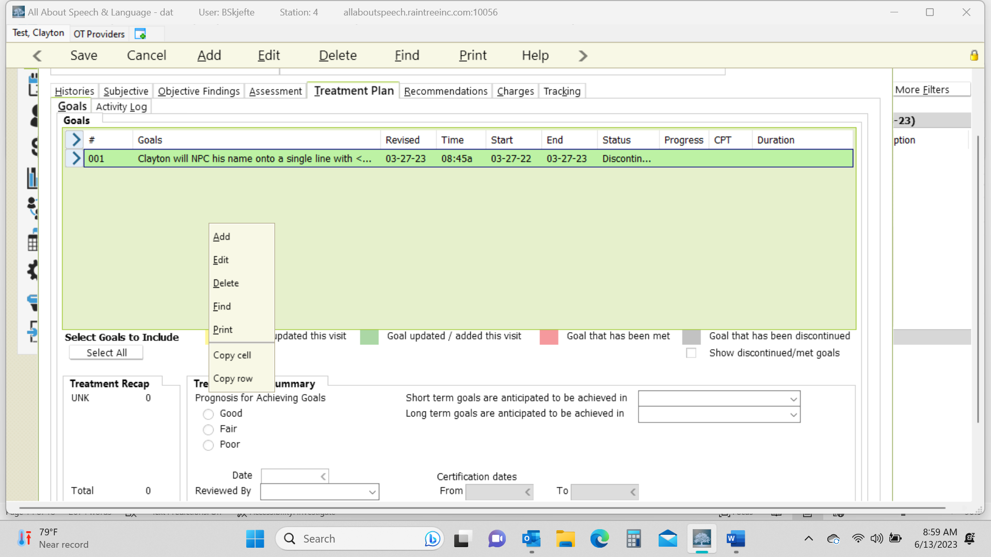
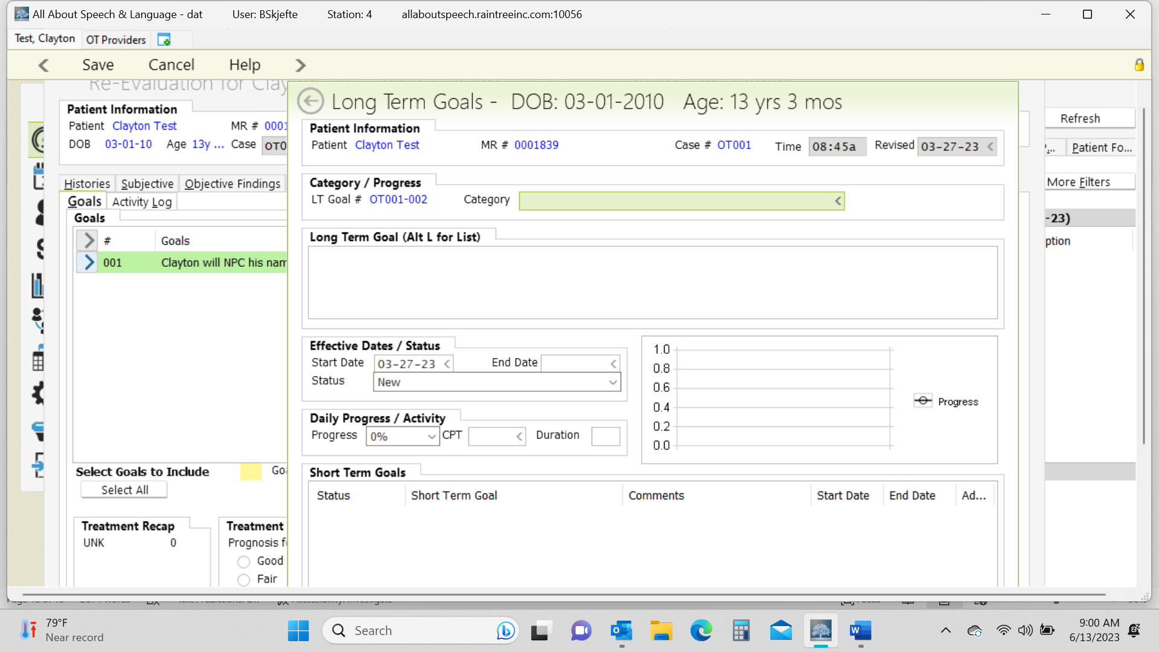
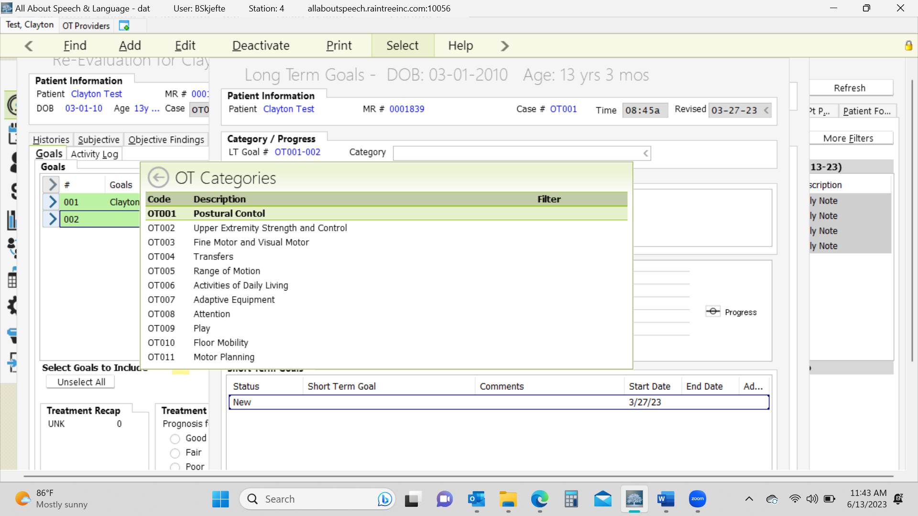
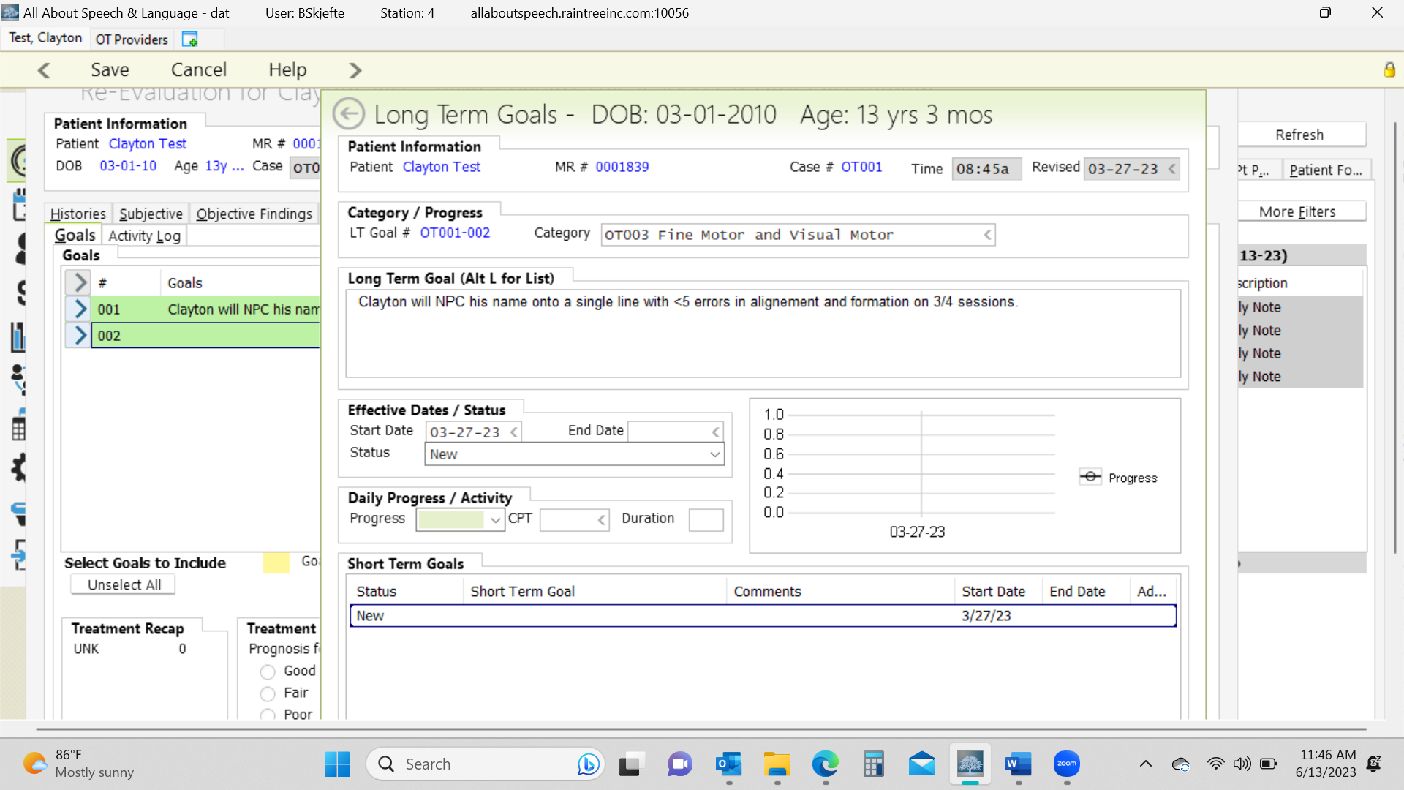
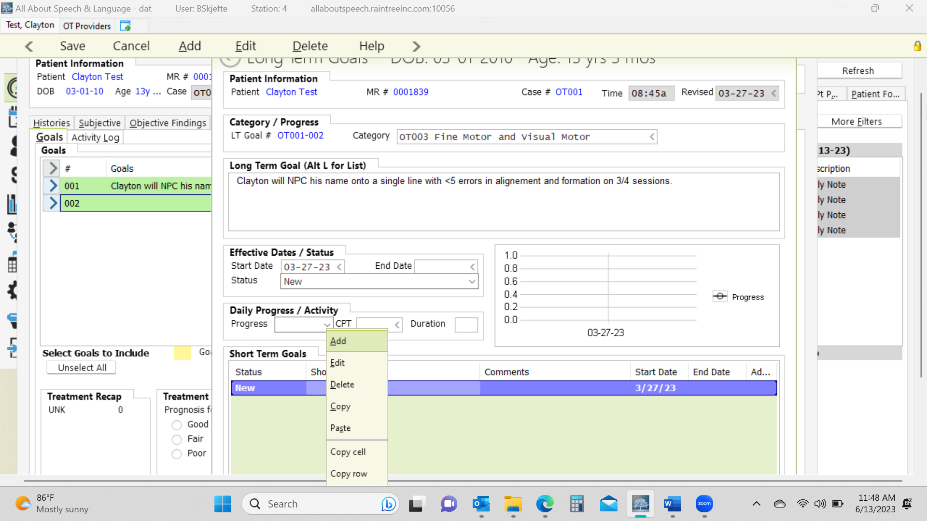
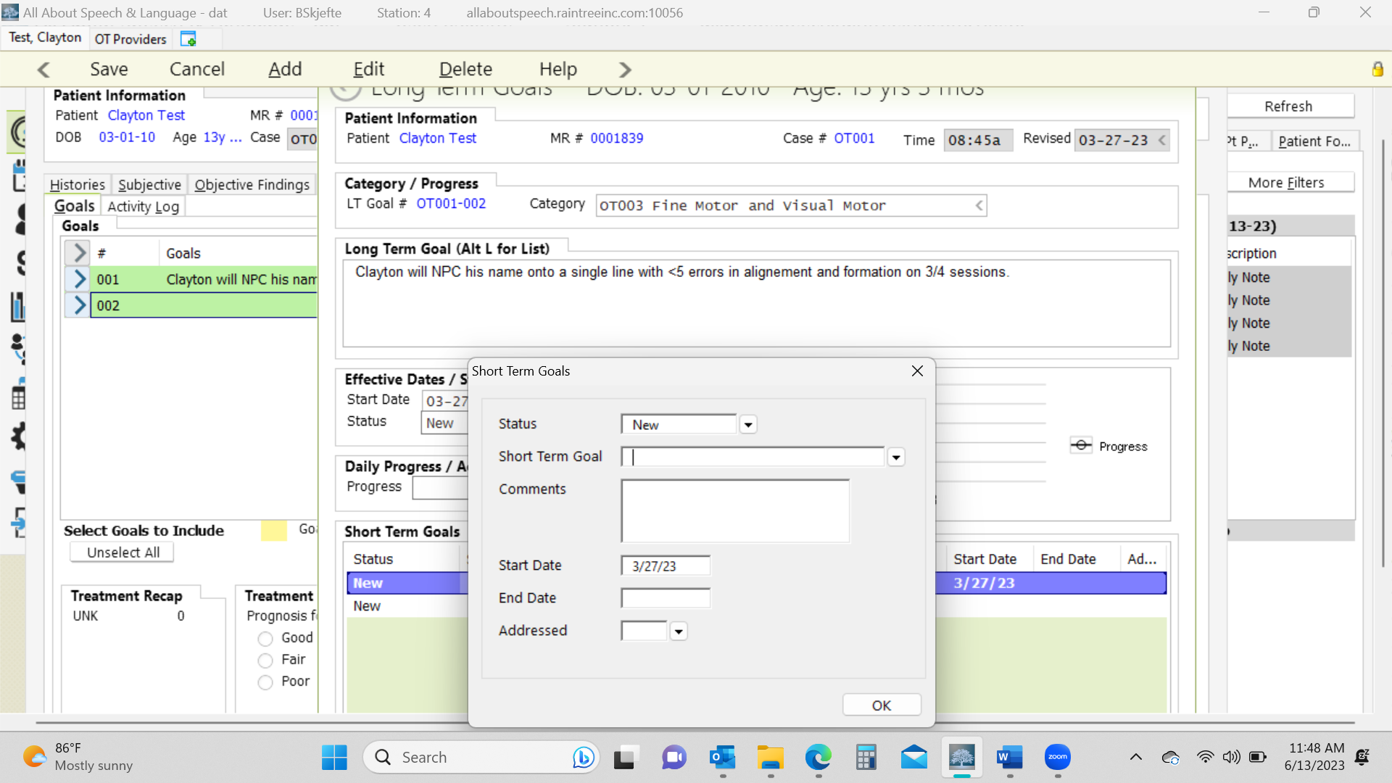
- Finally, complete the items circled below. Use the date of the report and reviewed by “parent/guardian”. Typically STG are set for 6 months and LTG for 12 months.

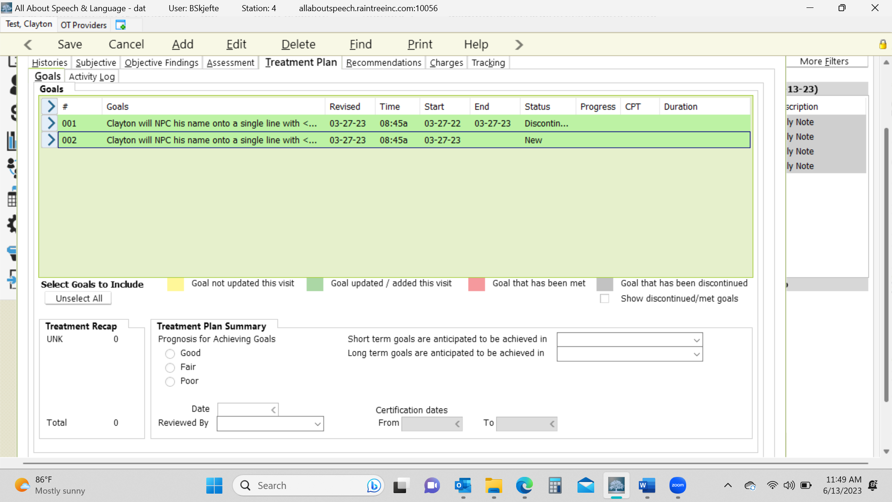

Recommendations Tab
- Select Continue Therapy and include rationale and medical necessity for services. See example. Update frequency/duration if needed. Be sure to manually adjust POC dates from the date of re-eval to one year later. Select criteria for discharge. Consider the ones provided in the example below due to the nature of the population of our clients.
- In the comments section add “ASSESSMENT COMPLEXITY: XXX presents with signs and symptoms of low/moderate/high complexity with performance deficits in XXX. Skilled occupational therapy is deemed medically necessary to address these deficits and maximize engagement in daily tasks.” Modify the deficit areas specific to your client.
  - Physical skills refer to body structure or body function (e.g., balance, mobility, strength, endurance, fine or gross motor coordination, sensation, dexterity).
  - Cognitive skills: ability to attend, perceive, think, understand, problem solve, mentally sequence, learn, and remember, resulting in the ability to organize occupational performance in a timely and safe manner. These skills are observed when a person (1) attends to and selects, interacts with, and uses task tools and materials; (2) carries out individual actions and steps; and (3) modifies performance when problems are encountered.
  - Psychosocial skills: interpersonal interactions, habits, routines and behaviors; active use of coping strategies; and/or environmental adaptations to develop skills necessary to successfully and appropriately participate in everyday tasks and social situations.

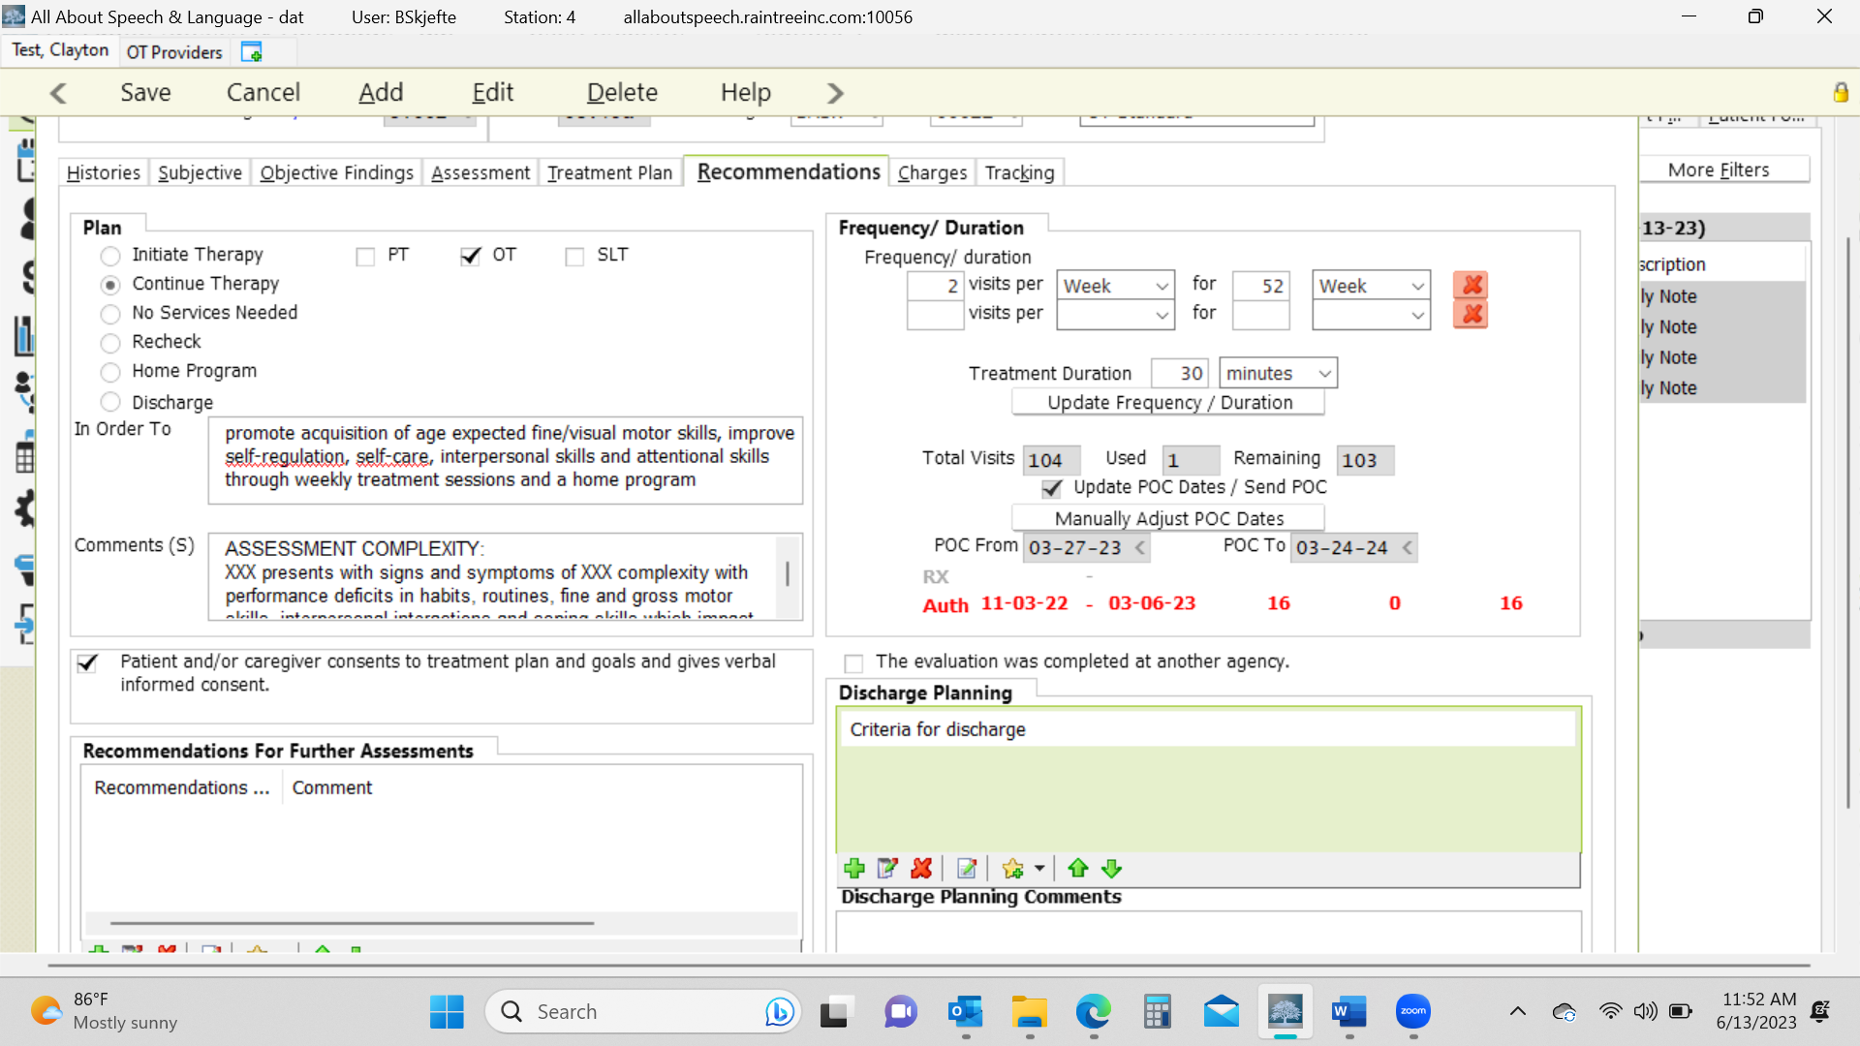

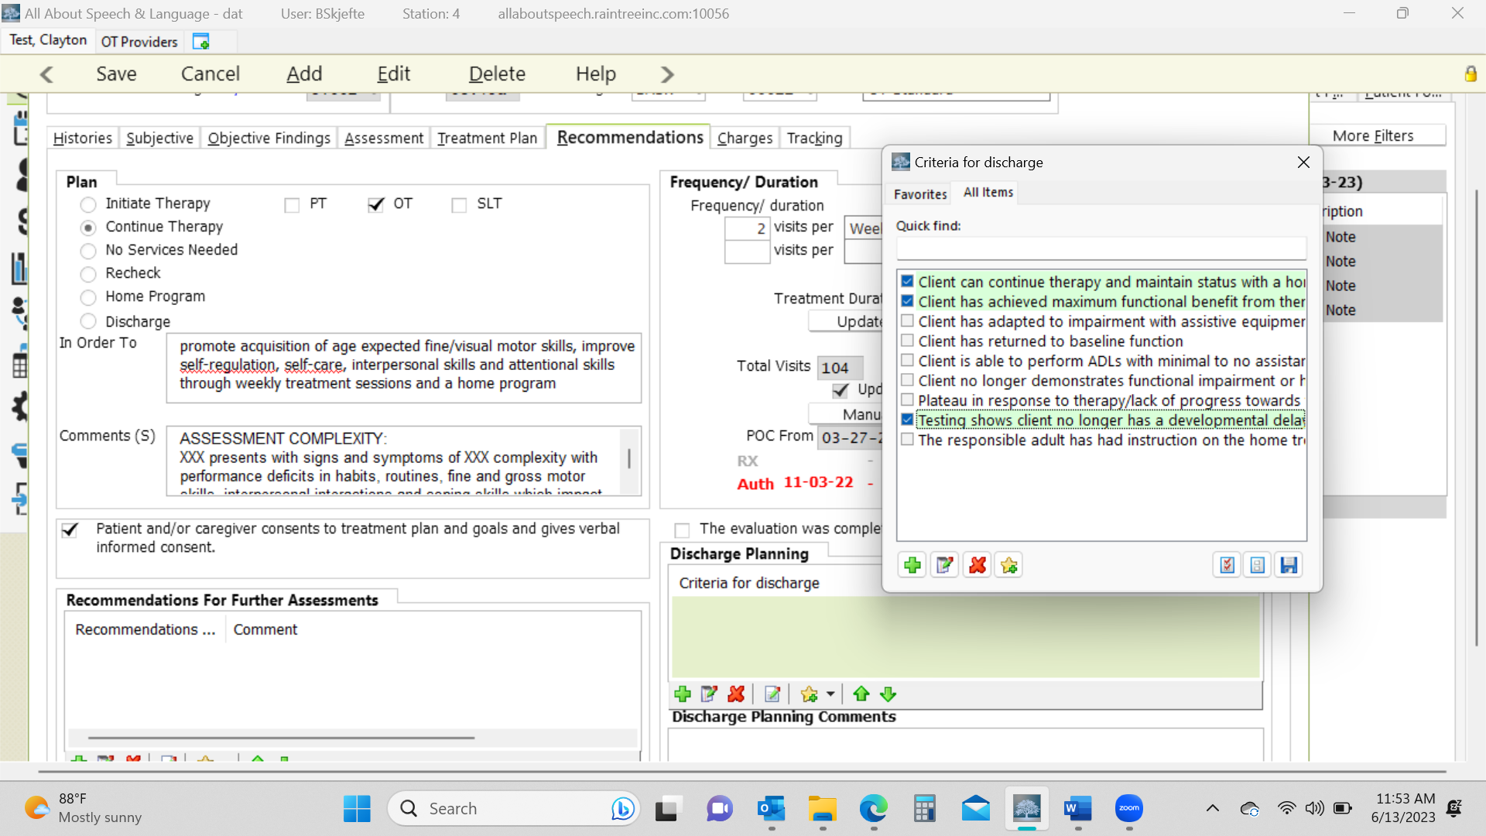

How to Determine Medical Complexity (low, moderate, high) - moved to recommendations/charges/assessment
Explanations from AOTA’s “New Occupational Therapy Evaluation Coding Overview” document.

- Client Medical History The client’s history, both medical and therapy, is reviewed and considered to identify aspects such as the prior level of function and presenting diagnosis that is causing the client to seek occupational therapy services. How much of the history is necessary depends on what the client is seeking services for and what the occupational therapist needs to know to continue with assessment and development of the plan of care. The referral for therapy may also provide additional information. It can also come from medical records of past and current care.

- Occupational Profile The occupational profile provides an understanding of the client’s occupational history and experiences, patterns of daily living, interests, values, and needs. The client’s problems and concerns about performing occupations and daily life activities are identified. The client’s priorities for outcomes are determined. To determine the level of occupational profile that must be completed, the therapist must consider the presenting problem(s), the reason(s) for referral, and the client’s goals. Although a client may have multiple diagnoses, and be very complex, if he or she is in a stable state and wants one small or targeted issue addressed by the occupational therapy intervention, then this component should be coded as low complexity

- https://www.aota.org/~/media/Corporate/Files/Practice/Manage/Documentation/AOTA-Occupational-Profile-Template.pdf

- Consider the following things when determining level of medical complexity
- Past Medical History
- Current status (current services, specialists, medication, equipment, procedures)
- Education (school, type of classroom, any services in school)
- Barriers to occupational engagement:
  - Low:1-3
  - Moderate:3-5
  - High: 5 or more

- Physical: type of home, share a bedroom, parks or playgrounds
- Social: people that live in the home, family/friends in proximity, ability to engage with peers/siblings, opportunities for social participation, behaviors that may affect the family's activities, communication
- Cultural: sense of love/support, religion, parent's expectations to be as independent as possible, parent's sense of community scrutiny, beliefs
- Personal: age, who they receive support from, any difference with interactions with different family members, primary caregiver, socio-economic status
- Temporal: who they receive support from, weather or time of year affecting regular activities may have a negative impact on the child
- Virtual: Do they engage in video chats with family? How much screen time do they get and what happens if that is disrupted?

Handling Clients Who Do Not Qualify for Therapy
Tricare:
- The evaluating therapist will score up the evaluation then email the parent CC’ing patient scheduler to notify the family that their child did not qualify
- Ensure if additional strategies/HEP are to be provided to the family, you do so in this email
- If a client who has Tricare does not qualify but parents want to start services, please reference Initial Eval- Self Pay Client steps (below) as they can pay privately for services.

Self-Pay:
- The evaluating therapist will score up the evaluation then email the parent CC’ing scheduling to notify the family that their child did not qualify
- Note that if the parent continues to express the desire to want services and you feel they would benefit, then therapist can inform family that they can initiate short term services
- Therapist will notify scheduling department of POC recommendations

Email Template

Hi,

It was a pleasure meeting your family. I wanted to inform you that ____ (child’s name) does not qualify for Speech/Occupational Therapy services at this time. He/she scored in the average range in the areas of ______ (add in areas they did well in). Your child’s report will be accessible through the Patient Portal in two weeks.

As we discussed in the evaluation, continue to practice ______ (for example: shoe tying). Please reach back out to the office (813) 616-4004 if any additional concerns arise over the next 6 to 12 months or if you have any questions.

Reminder, the evaluating therapist needs to notify patient scheduler of their recommendations within 24 hours.

Charges Tab
- Billing: Self-Pay
- Re-Evaluation: Select 97168 Re-Evaluation. This will apply the $190 re-evaluation charge. **Only use the Re-Evaluation charge for self-pay clients
TRICARE
- Re-Evaluation: same procedure as billing for an initial evaluation DO NOT USE RE-EVALUATION 97168 charge- this is for self-pay clients only
NOTE: If you are completing/splitting the evaluation in 2 30-minute sessions:
    - In the first session:
      - Check the initial eval box
      - Instead of 3 units, change it to 1 unit
    - The next session if continuing to do testing:
      - Keep it as a daily note and select 2 units if you saw the client for 30 minutes

*************************PRIVATE PAY EXAMPLE*********************************
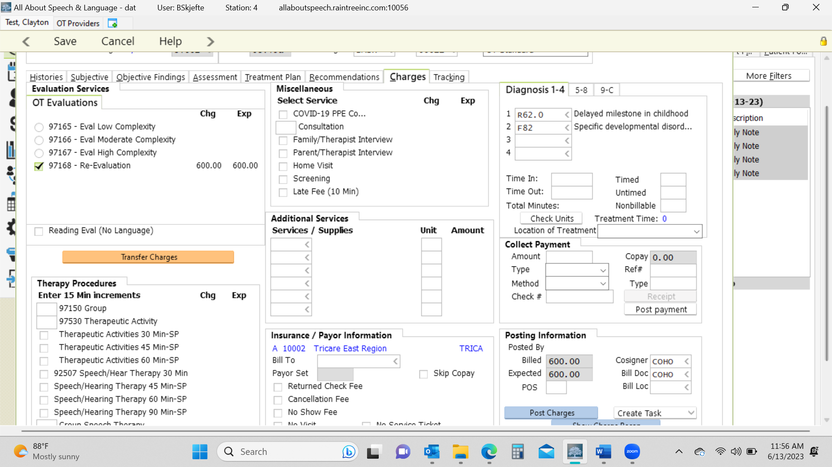

*****************************TRICARE EXAMPLE*******************************************
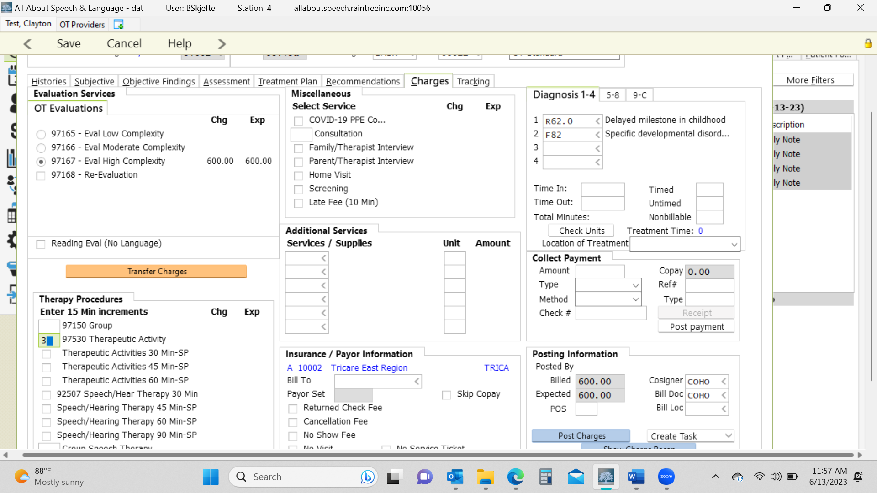

- Be sure to give the evaluation a read-through to ensure no glaring typos or errors before signing off on the document. This is a last impression a doctor, family, or insurance reviewer will be seeing from us, so take care in your review.
- Charges for Re-eval MUST be posted that day.

Updated Jan 2024

