Progress Notes AASL Procedure for Occupational Therapists

Table of Contents
Tracking Progress Note Due Dates 2
Caseload Tab 3
Progress Note Tab 7
Treatment Plan Tab 11
Recommendation/Plan Tab 22
Discharge Planning 23
Charges 25

1. Tracking Progress Note Due Dates
- It is the responsibility of the treating therapist(s) to:
  - track due dates for re-evaluations/progress notes
  - keep their dashboard up-to-date (i.e., remove discharged or covered clients)
  - ensure due dates are accurate (i.e., conversion note clients require manual updates)
- To track upcoming Progress Notes and Re-evaluations, use the chart below:

Raintree is a tool that should be utilized to efficiently track these due dates and this document contains the procedure for utilizing the Caseload Tab in a therapist’s Dashboard to do so. Login to Raintree and go to your respective Dashboard, locating your Caseload Tab. See chart below for tracking to ensure no progress notes are missed. Change appointment type in Raintree to PNOT3 or PNOT6 accordingly for the appointment with the date closest to when the Progress Note is due (not after due date).

Date to start scheduling | Upcoming Re-eval/Progress Note Dates
End of January | March and April
End of February | April and May
End of March | May and June
End of April | June and July
End of May | July and August
End of June | August and September
End of July | September and October
End of August | October and November
End of September | November and December
End of October | December and January
End of November | January and February
End of December | February and March

2. Caseload Tab

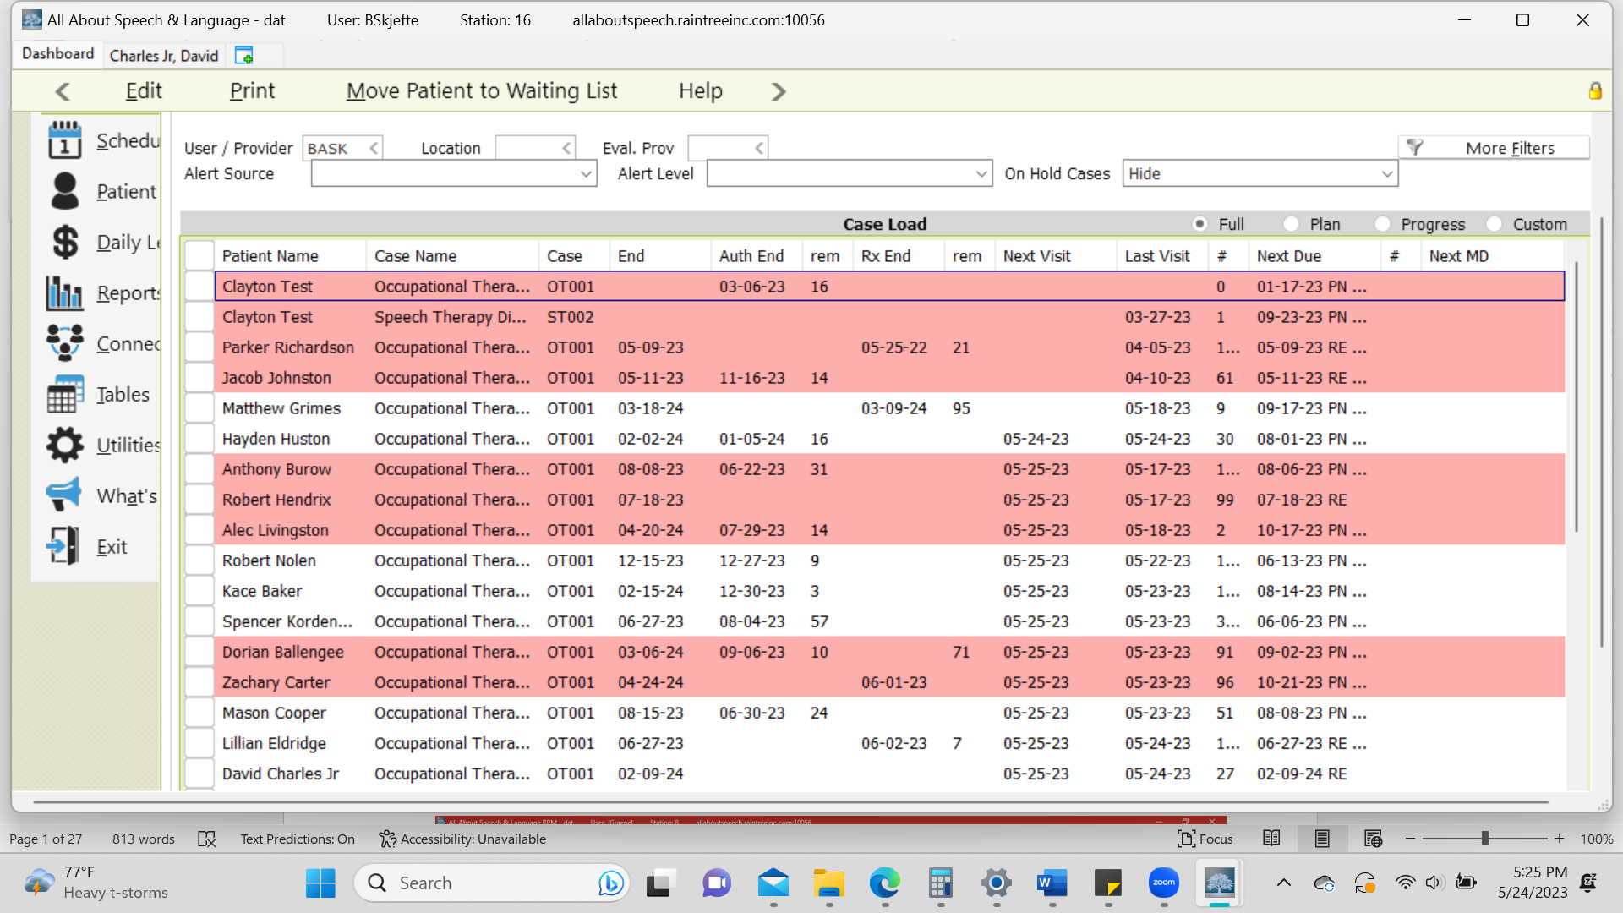

- Use dashboard to determine what progress notes are upcoming
- EMR system will also auto-prompt you when you log into daily notes when progress notes are due and will auto-change the note type for you if you complete during a treatment session OR you can go in and change the note type under TYPE to Progress note with OT Standard.
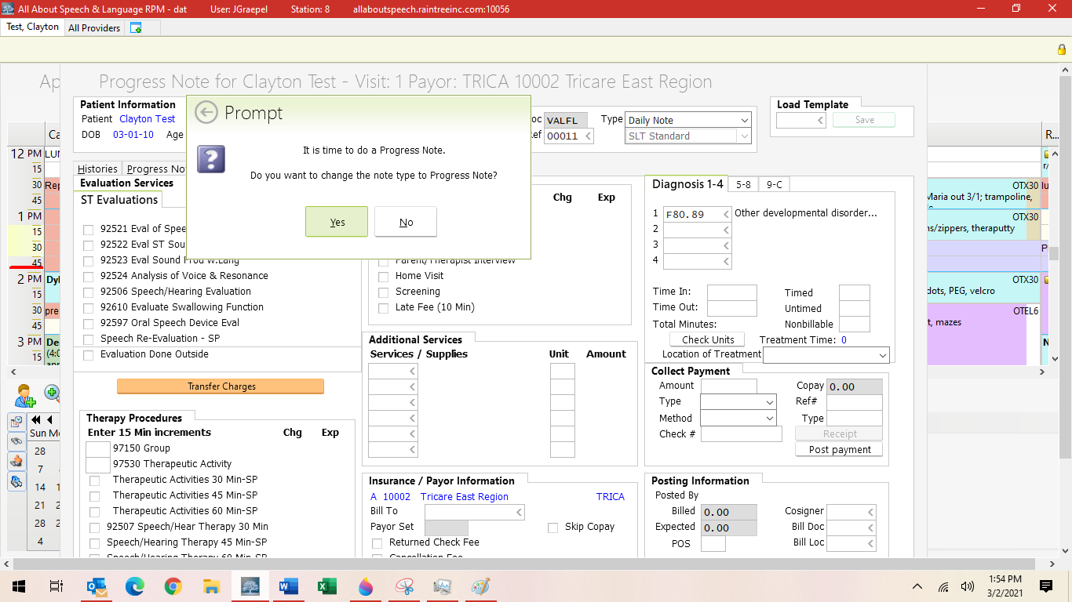
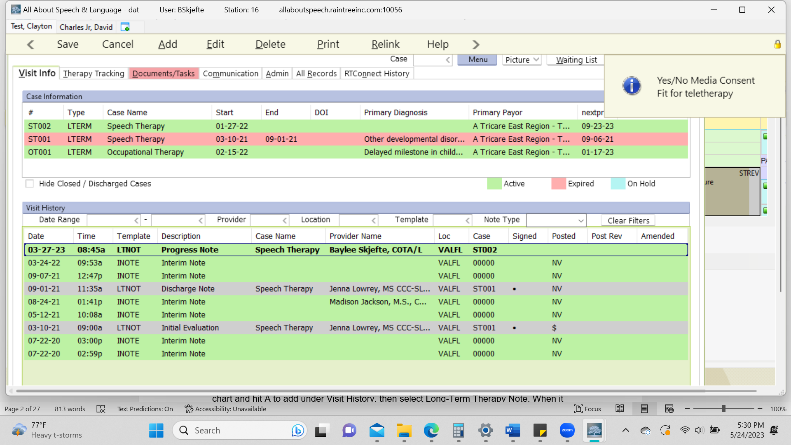

- If completing a Progress Note outside a treatment session, you can also go into the patient chart and hit A to add under Visit History, then select Long-Term Therapy Note. When it populates the note going forward on the upper right hand side you will then need to change the Note Type to Progress Note and then under that make sure you add from the dropdown
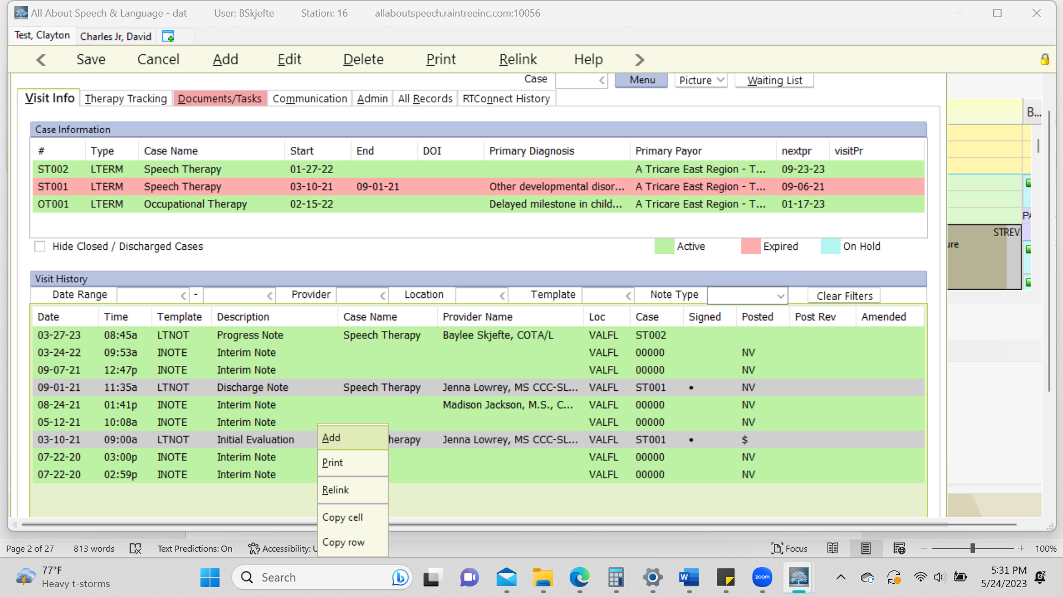
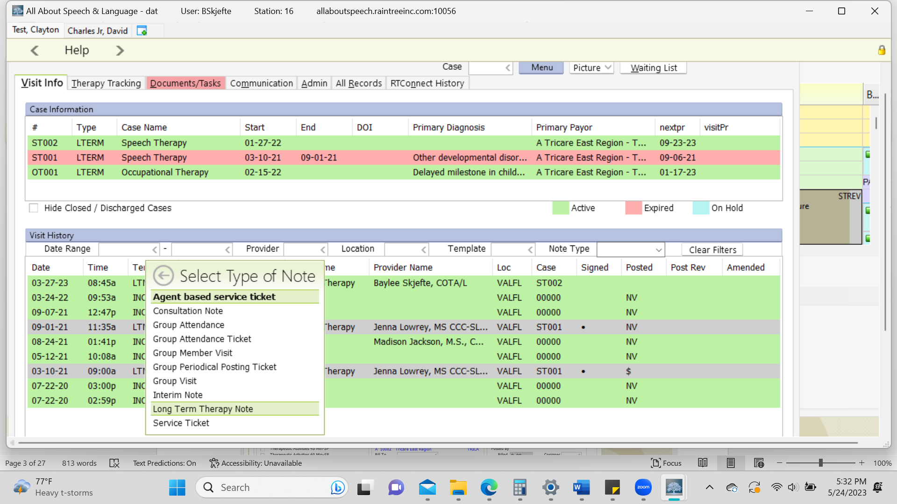

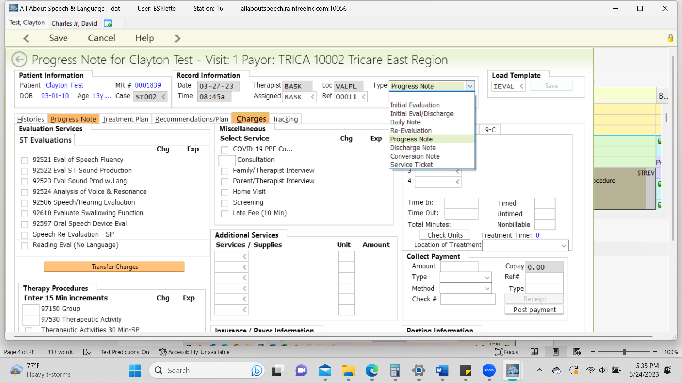
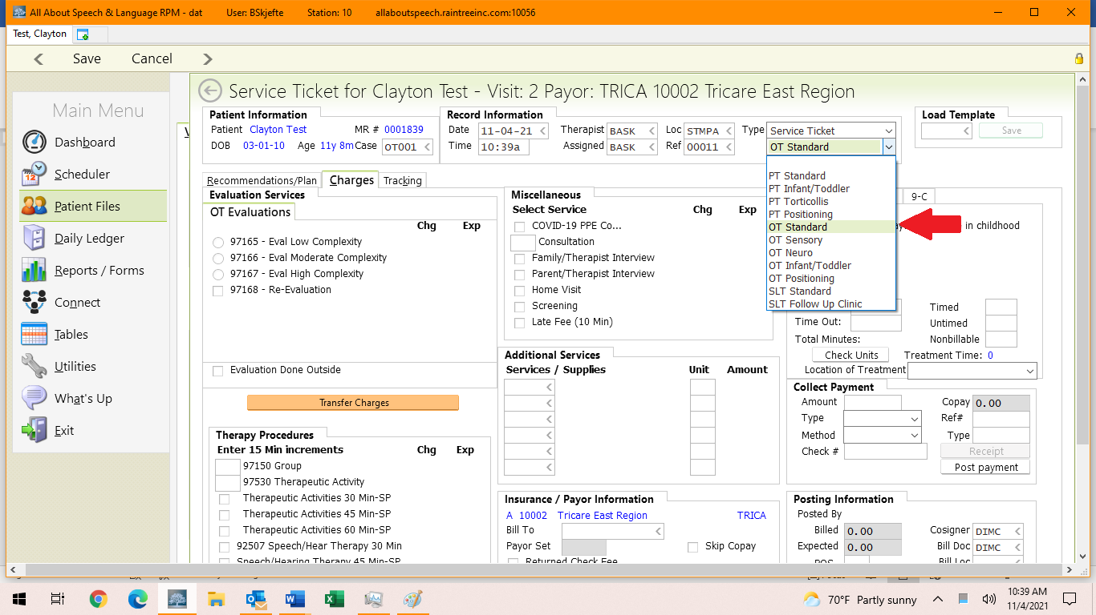

- Then go through the tabs and update across the following:
  - Progress Note
  - Treatment Plan
  - Recommendations/Plan
  - Charges

3. Progress Note Tab

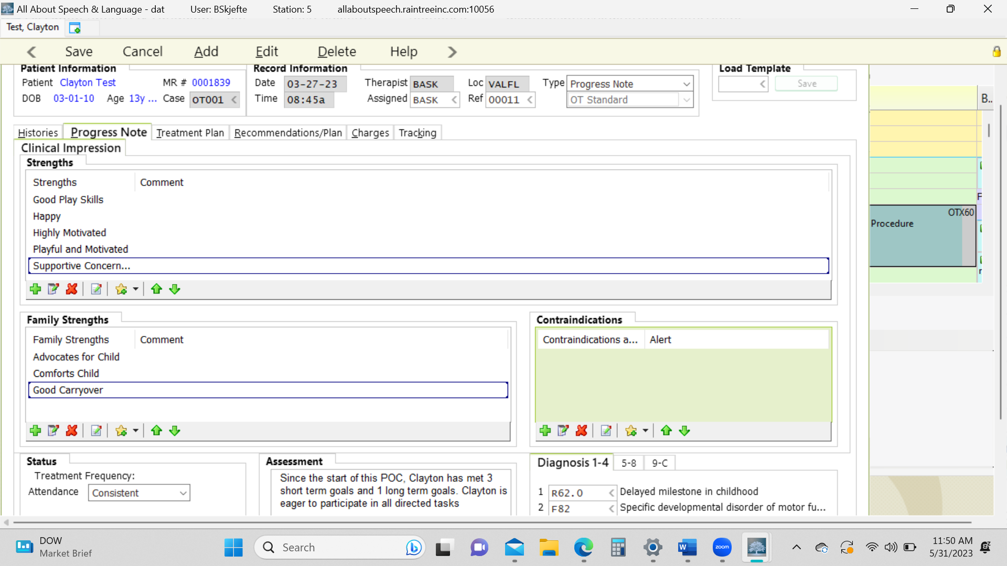

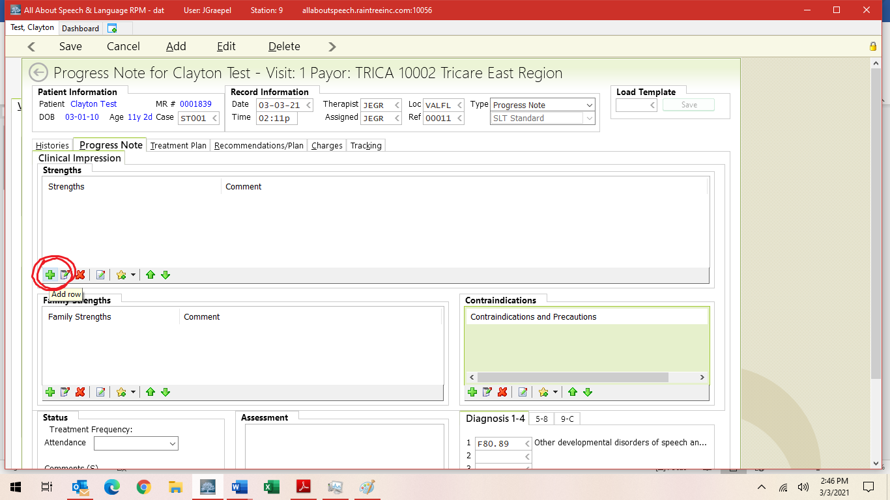
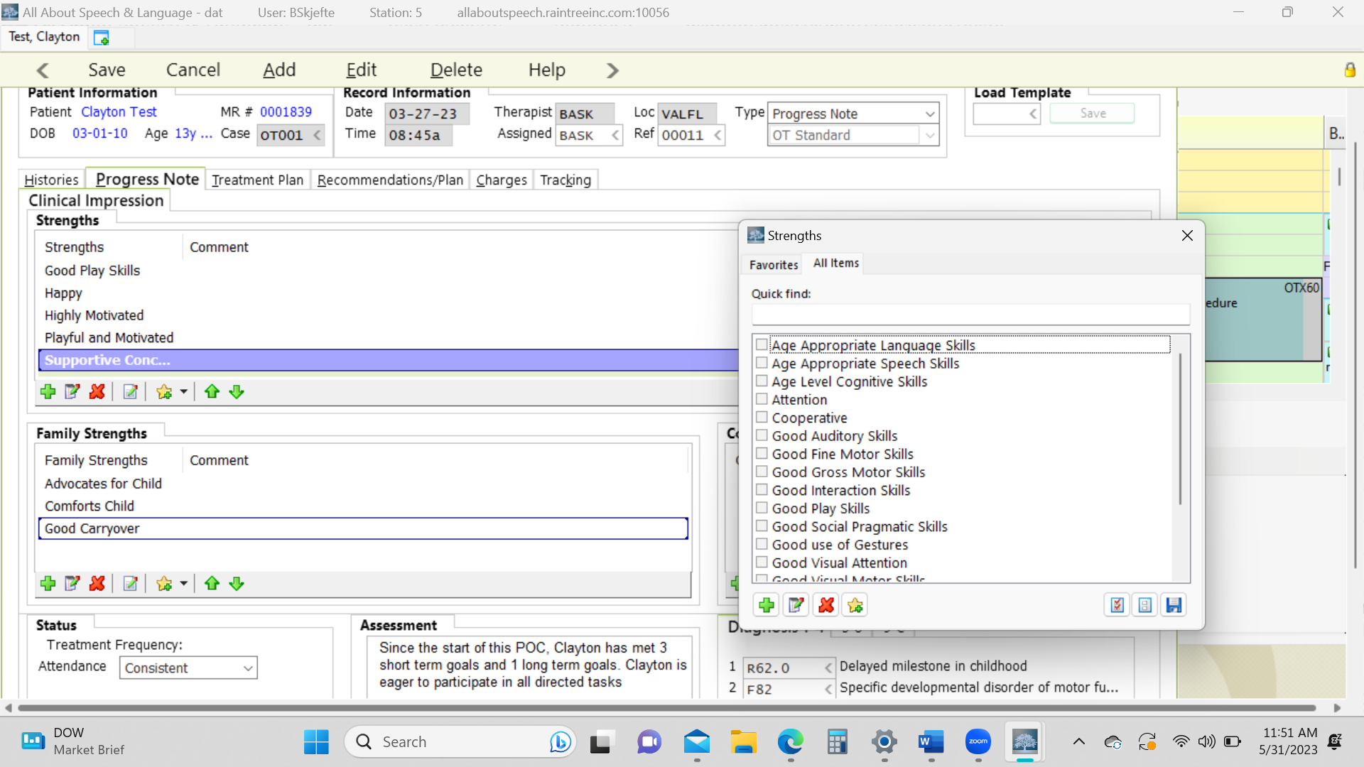

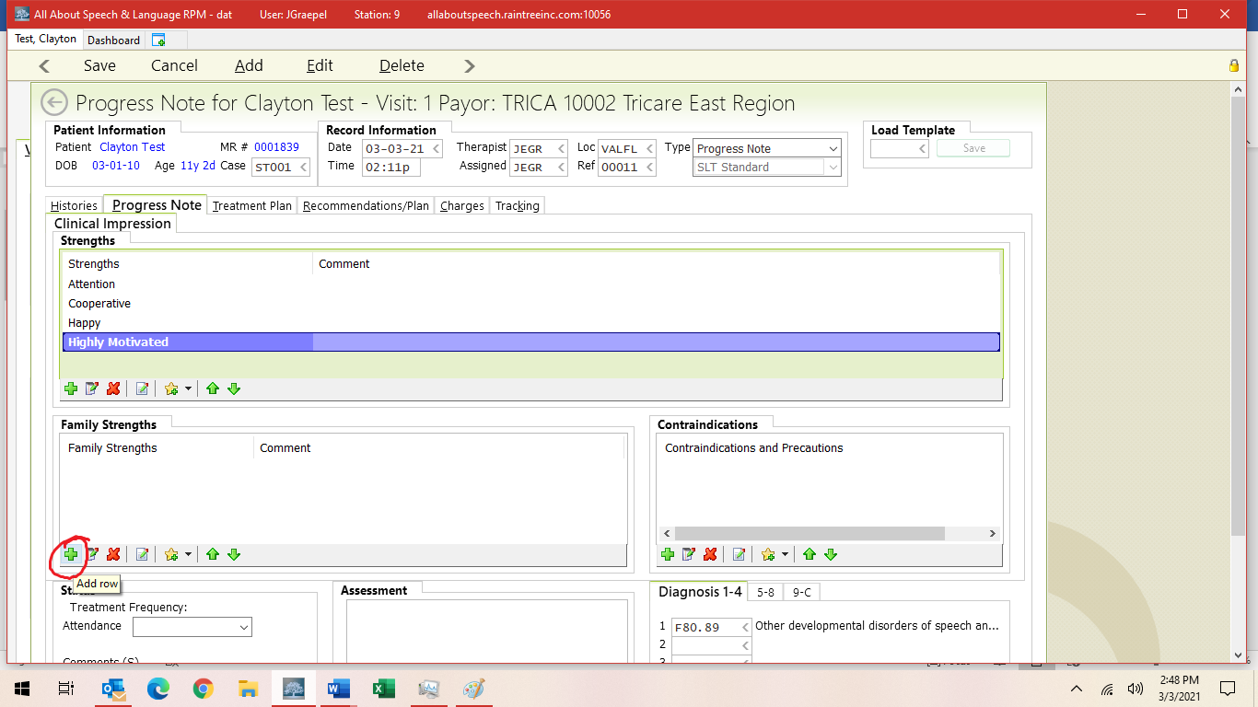

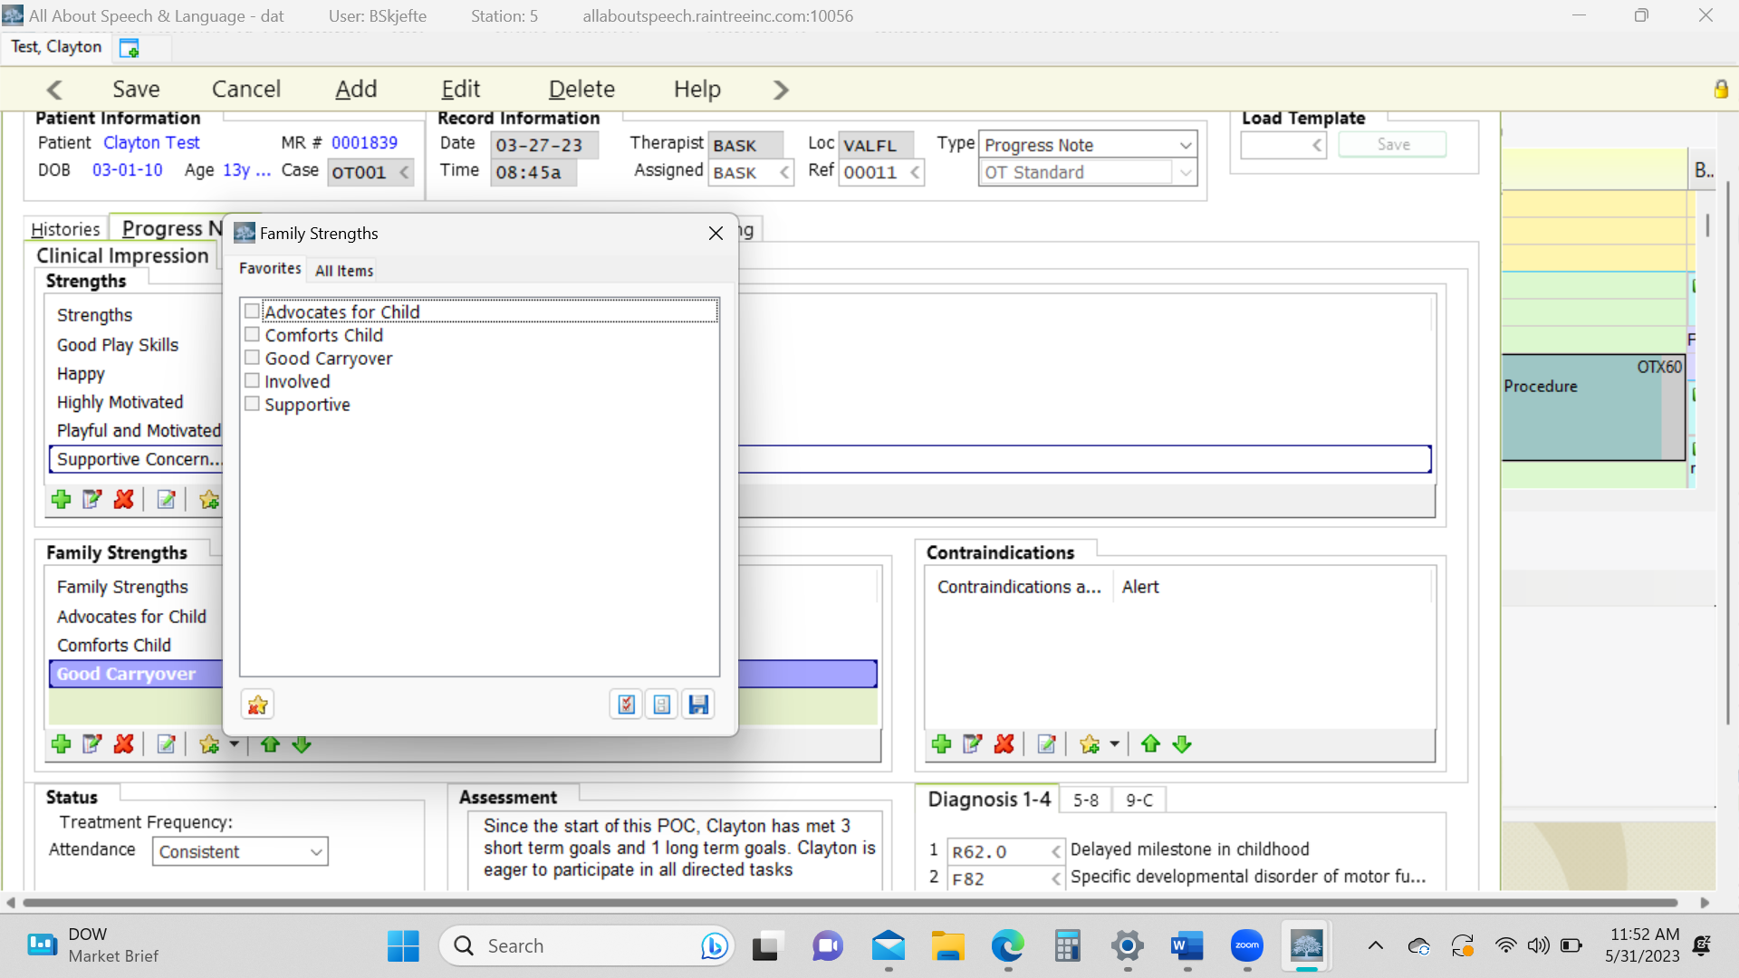

- Strength and family strengths: This will auto-populate from the evaluation. Add any additional strengths if you feel are applicable.
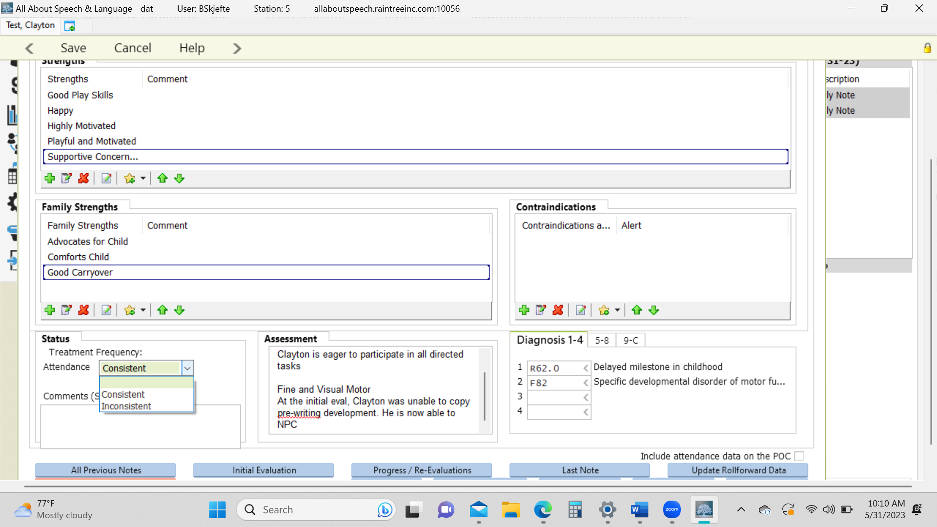

- Status:
  - Treatment Frequency- Select from the drop-down box if the client is consistent or inconsistent. In the Comment, feel free to comment on how the clients attendance is. For example, if “Limited progress towards goals 2/2 high cancellation rate”.
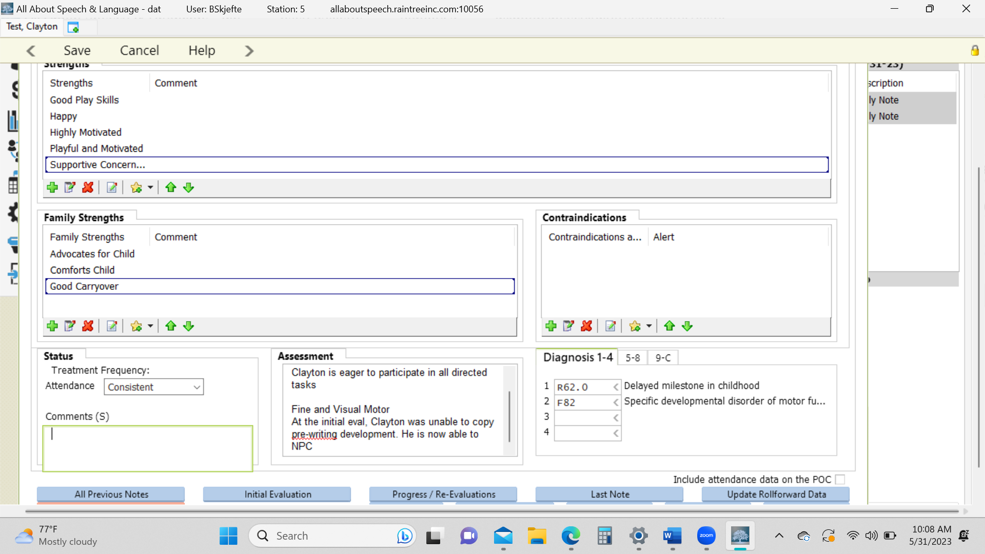

- Assessment: Right click on the box below “Assessment” and click “Edit”. This will open up the text box. Here you will write a narrative note comparing any progress made from the evaluation and current level of status on the goal areas. See your CM to provide you examples.

4. Treatment Plan Tab
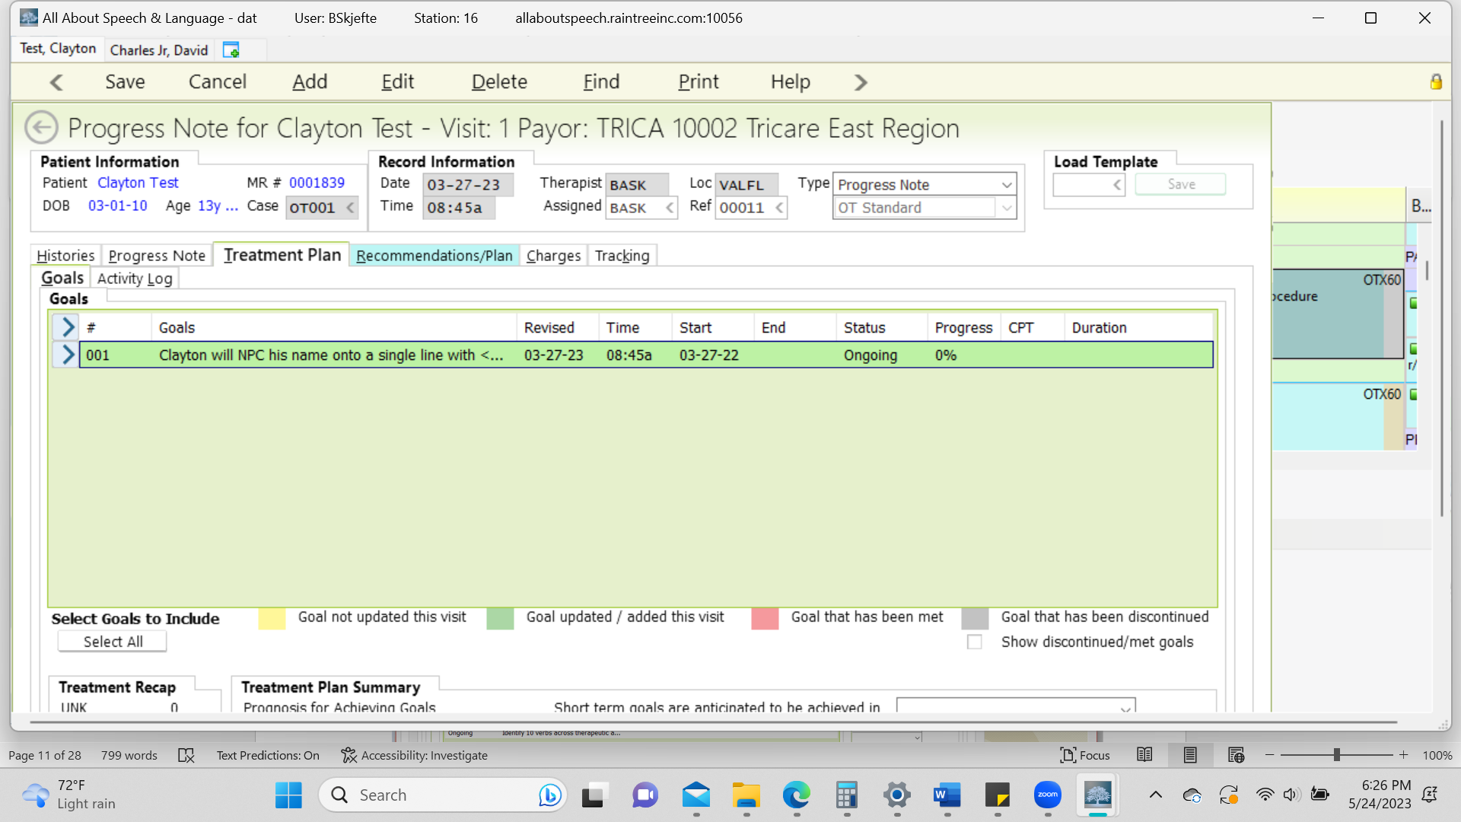

- Click on each LTG and then hit address and for each STG. Add in commentary of progress for each short and long term goal. Note the box has text limits so be to the point when commenting on each STG objective! *You must DOUBLE CLICK to edit any portion of a row for a STG

***********************REPORTING PROGRESS******************************

- Update and/or add any new goals (COTAs, check in with OTR signing off on your notes , if warranted, or change the status of the goal per the drop down in this section (i.e. Ongoing, Hold, Discontinued, Met etc.) – COTAs will meet & discuss goals w/ OTR during weekly meetings.
- Starting a month out, you MUST include the following information in your daily note:
- Date & assist level related to that goal (example below)
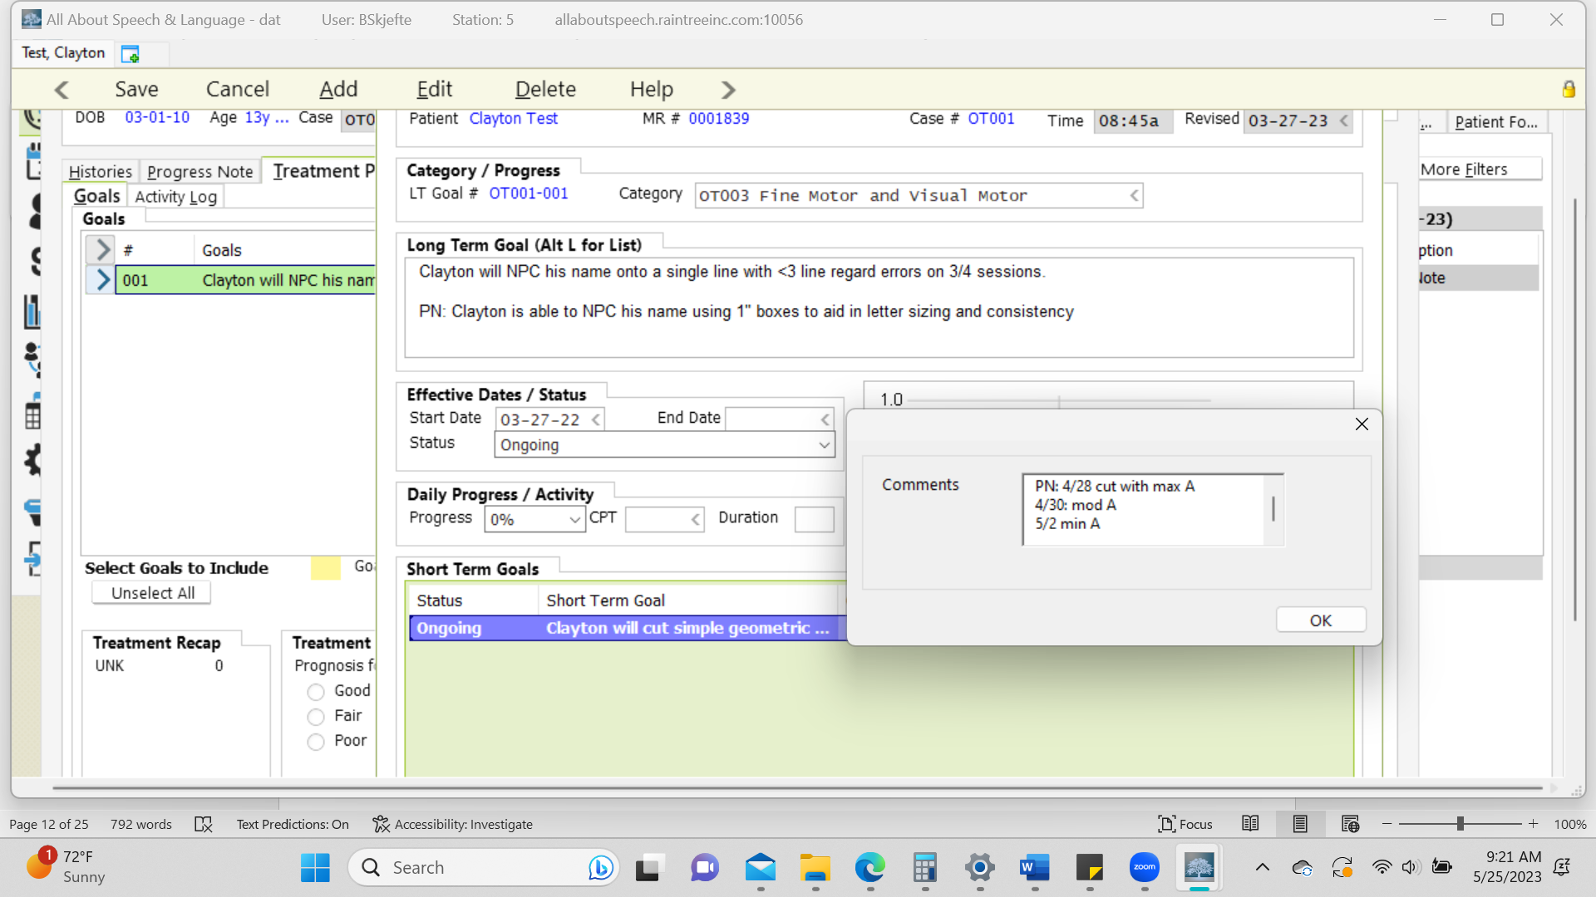

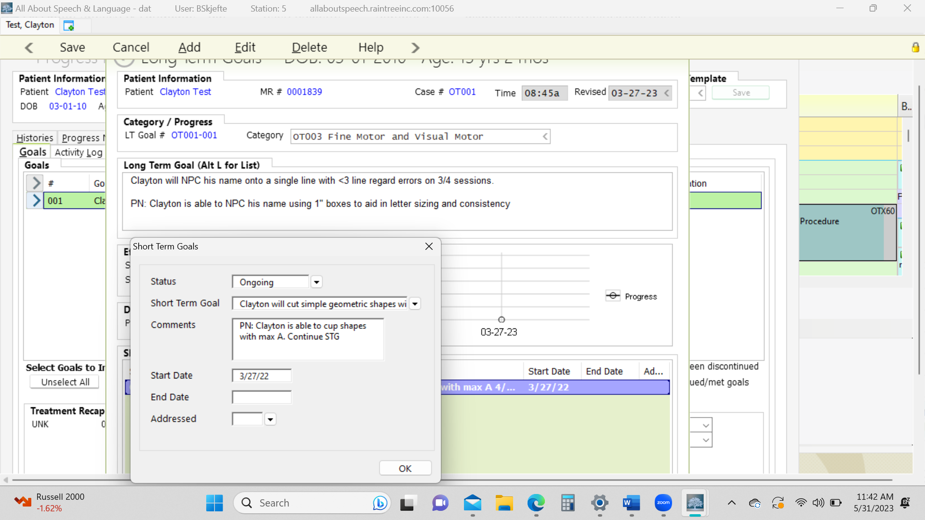

- Upon the date of the progress note, this prior information will be used to report most recent progress. At this time, you will remove these comments (located in the short term goal comment box, they should be populating from the previous month’s daily notes) and provide data for an accurate goal measure.

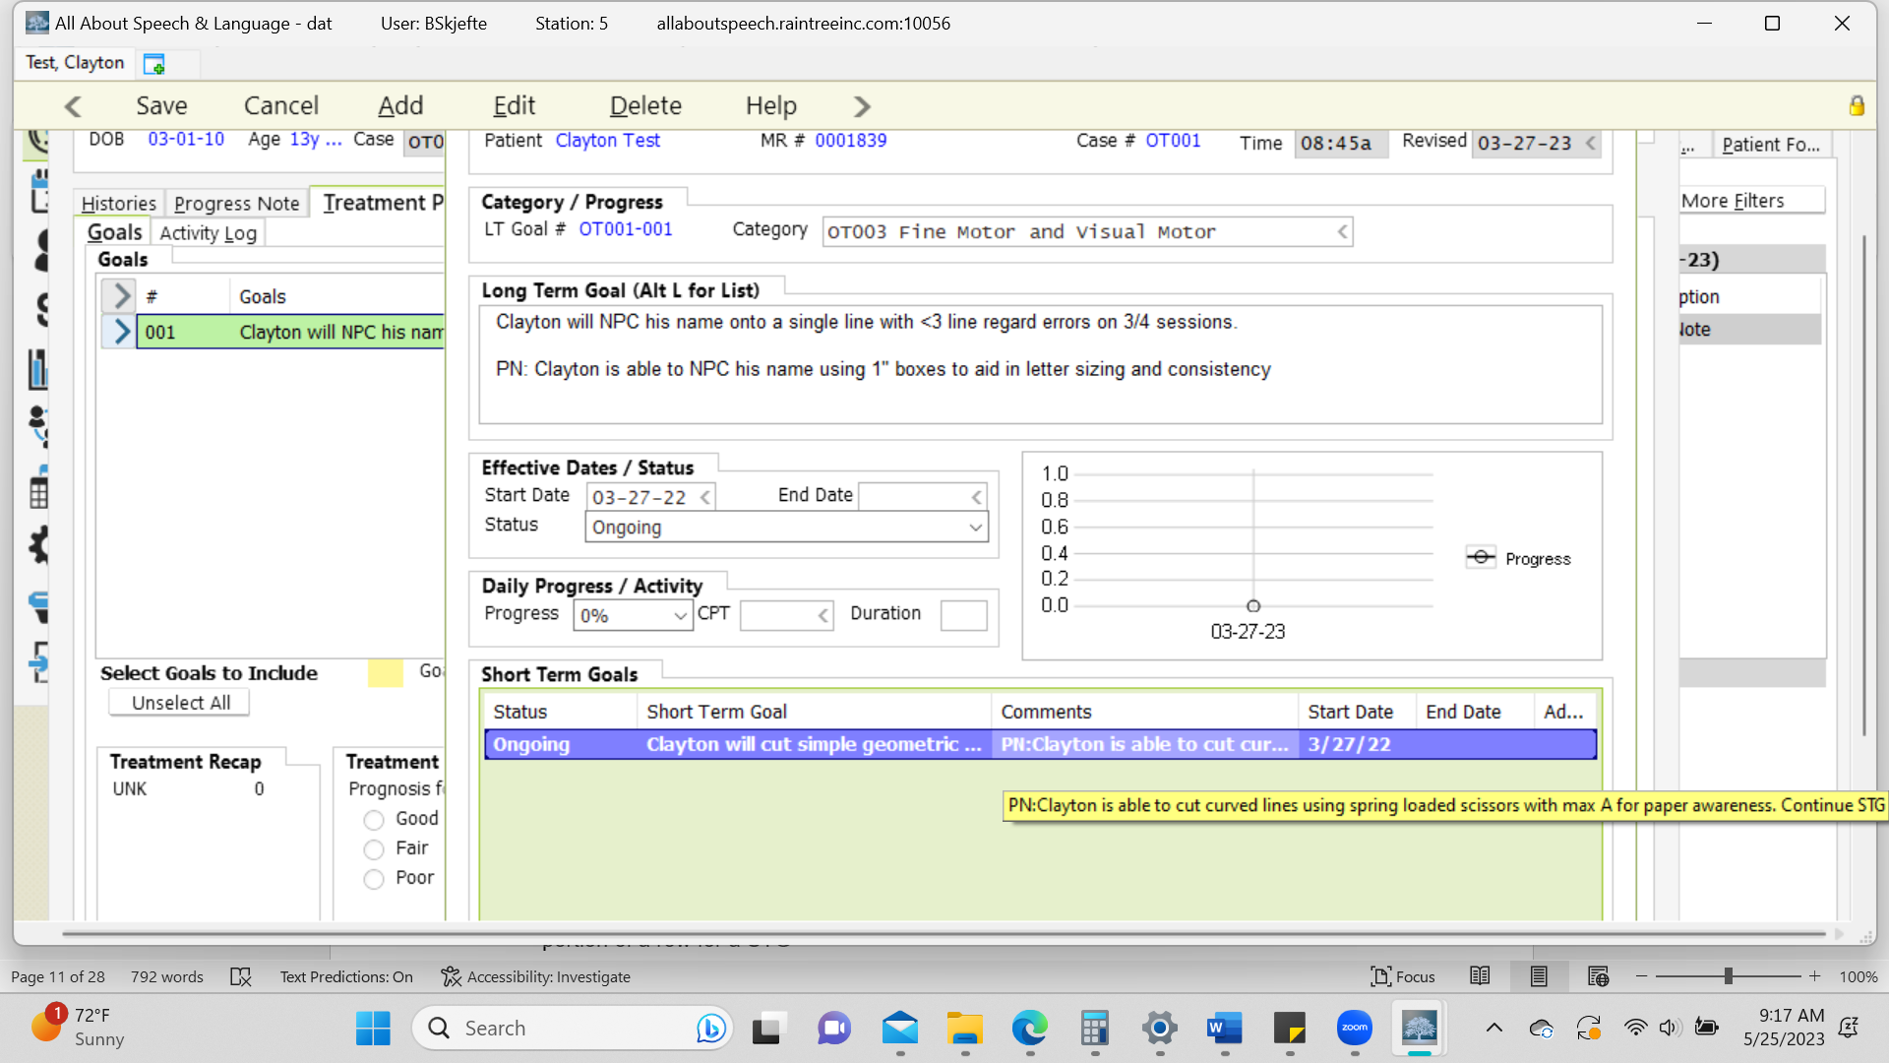

***********************Commenting on going for Ongoing *****************************

**************************CHANGING A GOAL TO MET**************************************

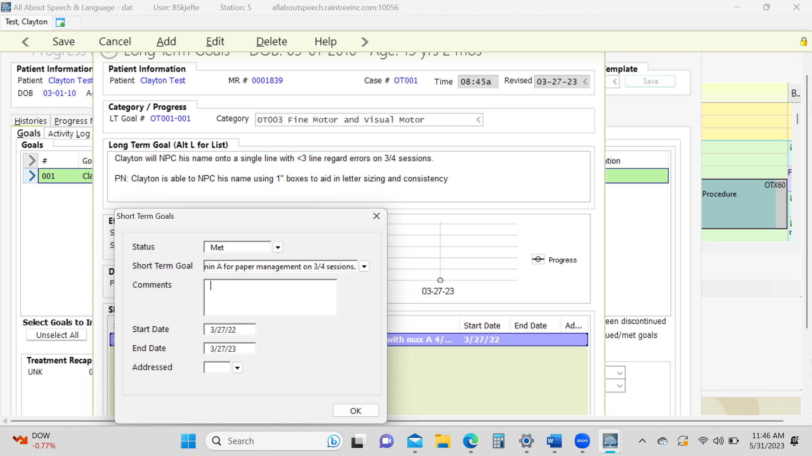
- If a short- or long-term goal is being discontinued or met, be sure to add an end date.

***********************COMMENTING ON LTGS***********************************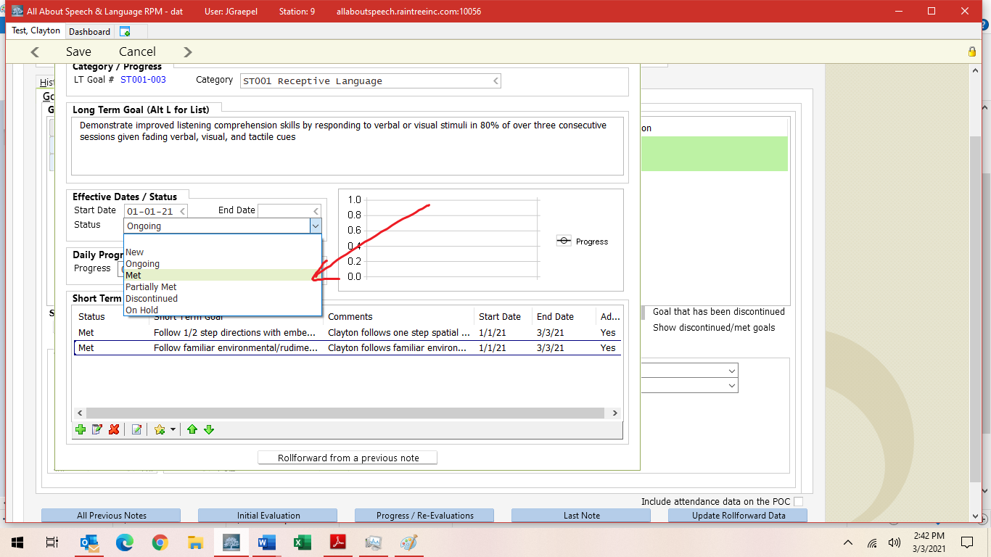

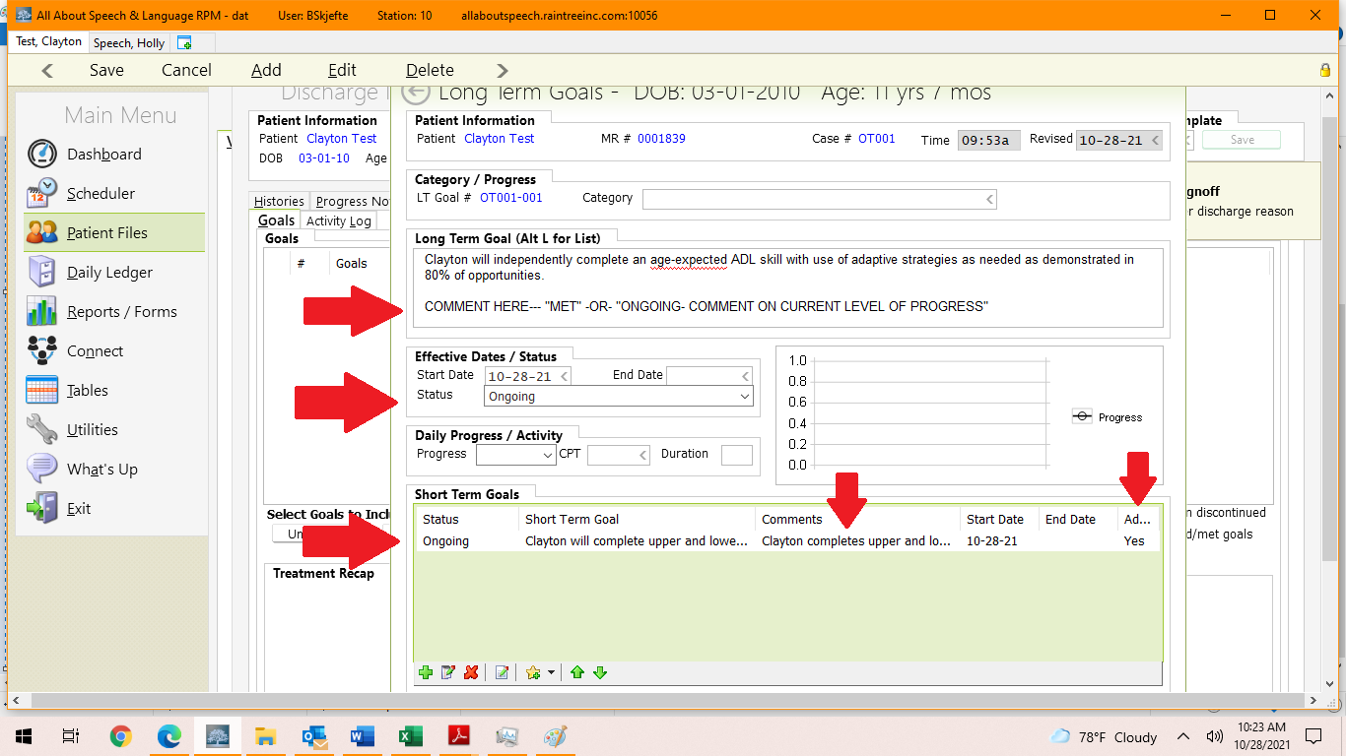

- DO NOT select any percentage for the LTG
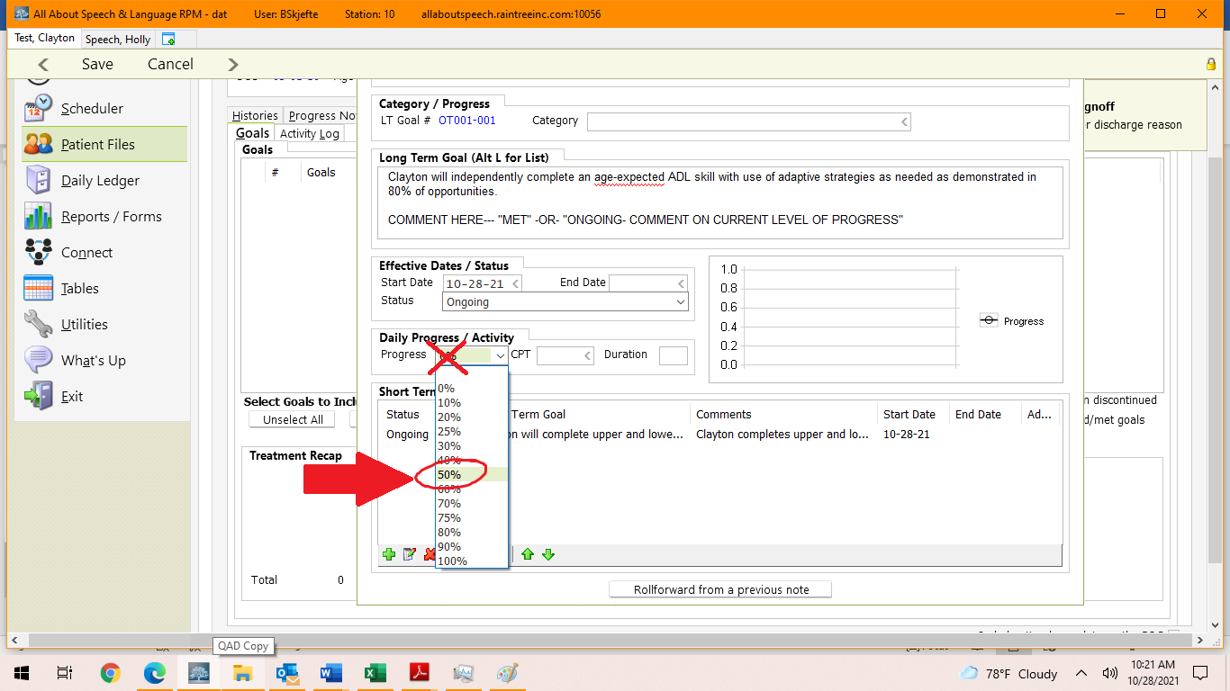

***********************ADDING GOAL*********************************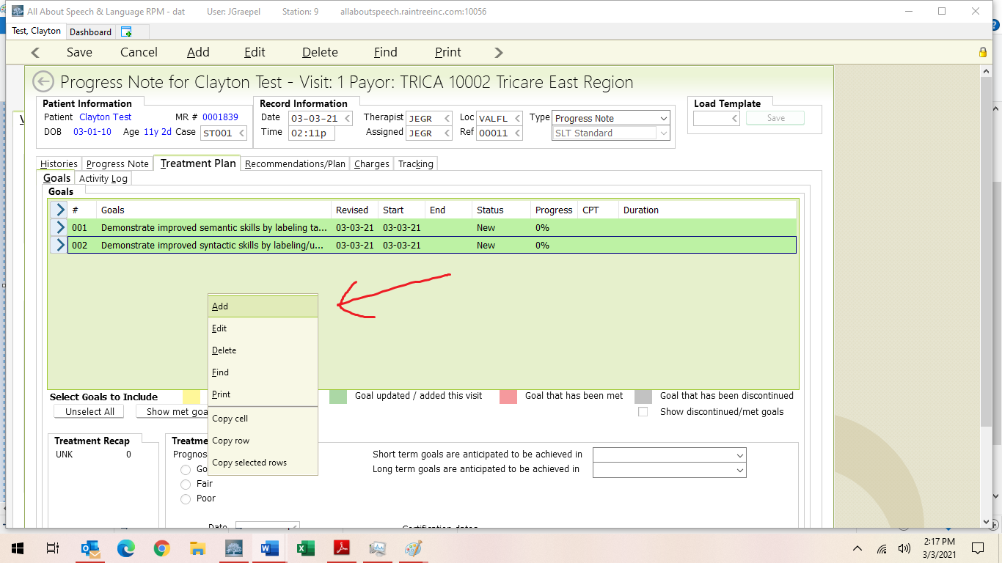

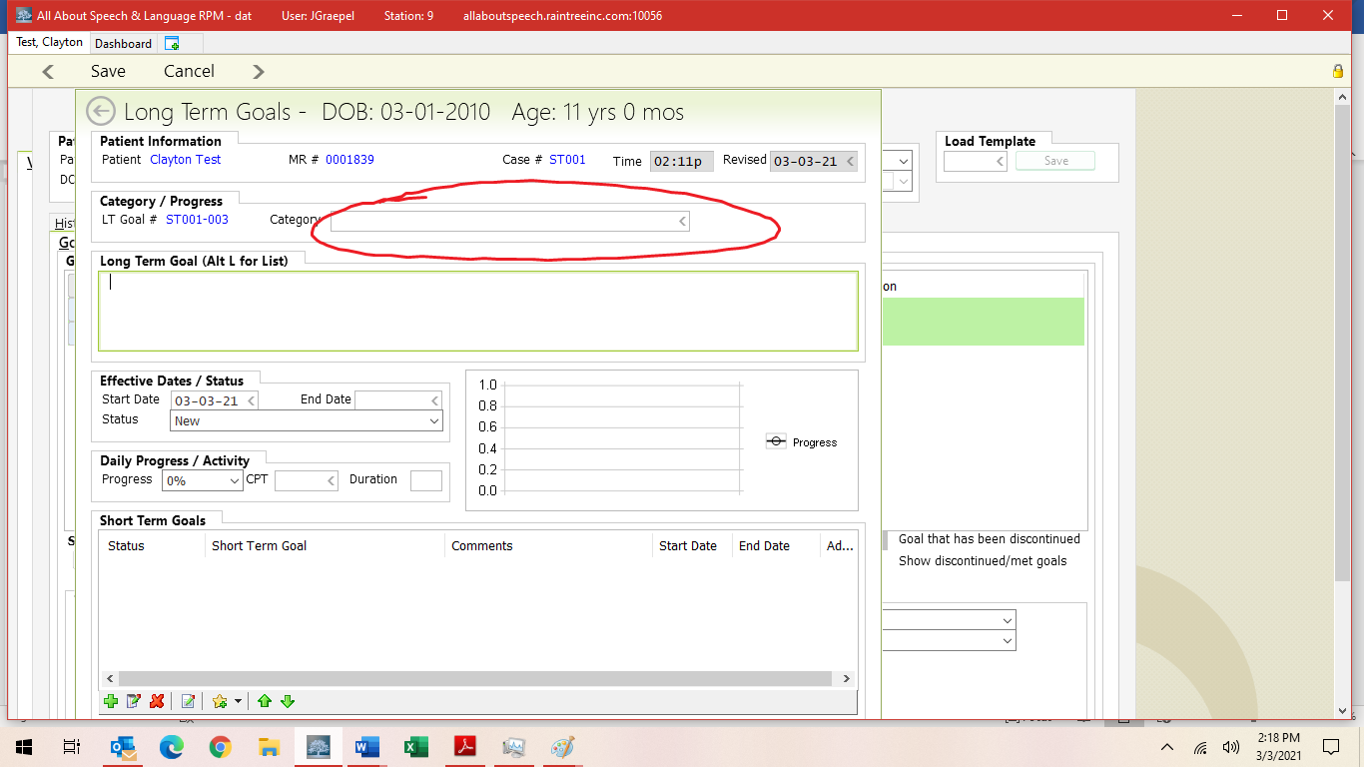

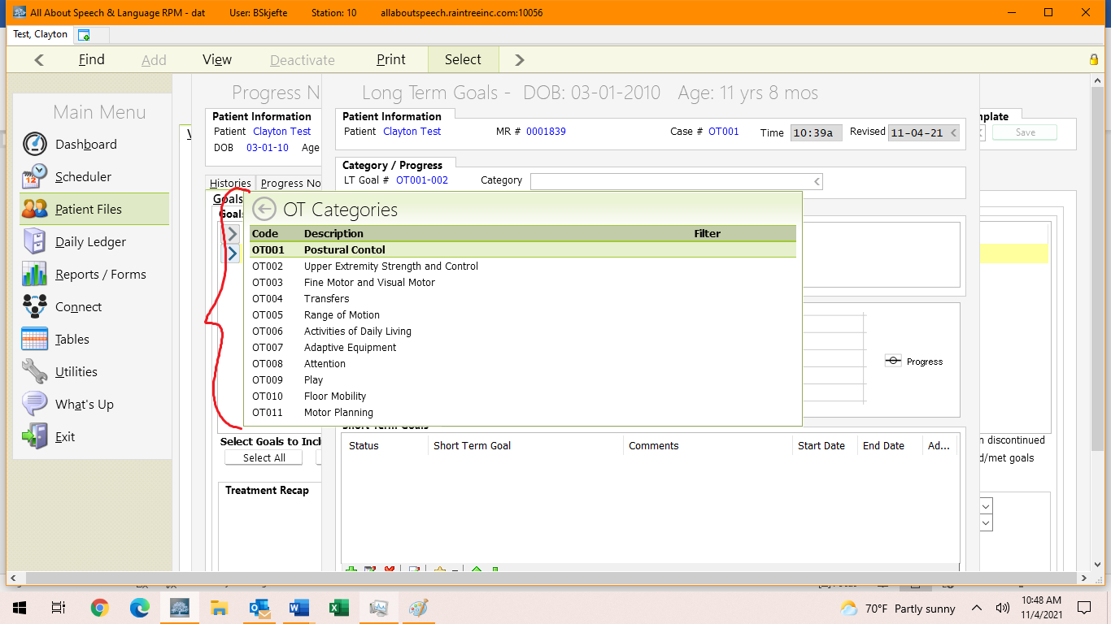
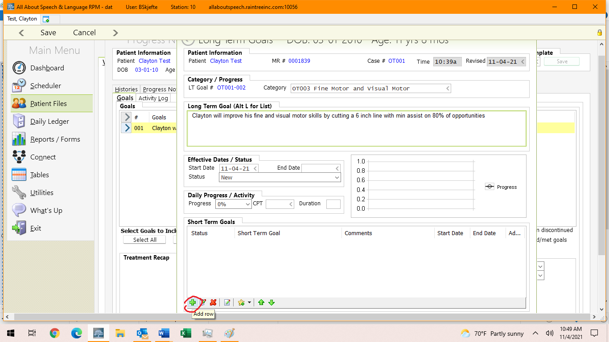

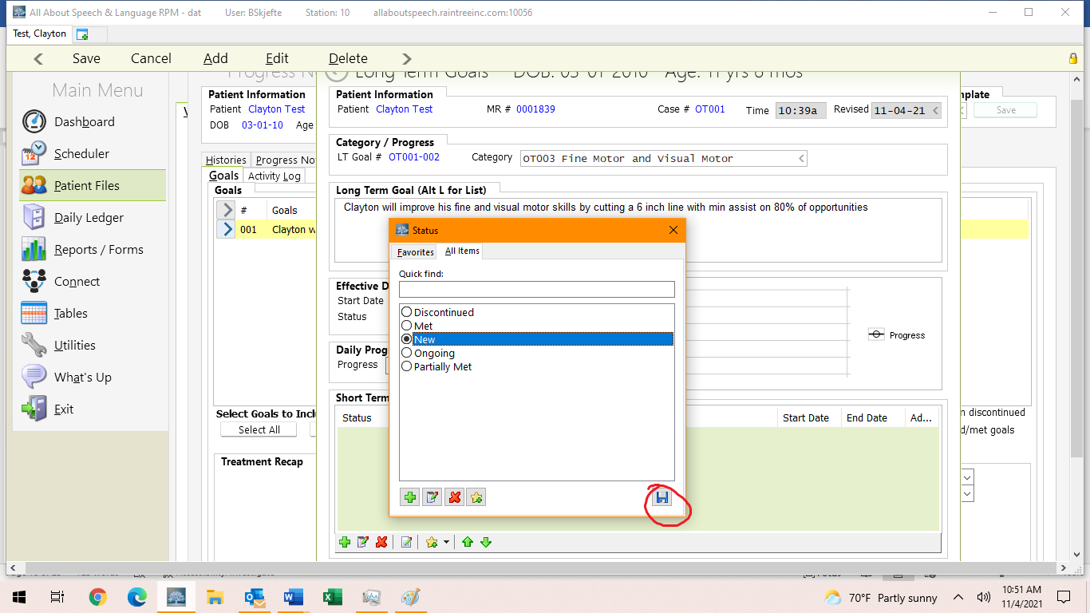

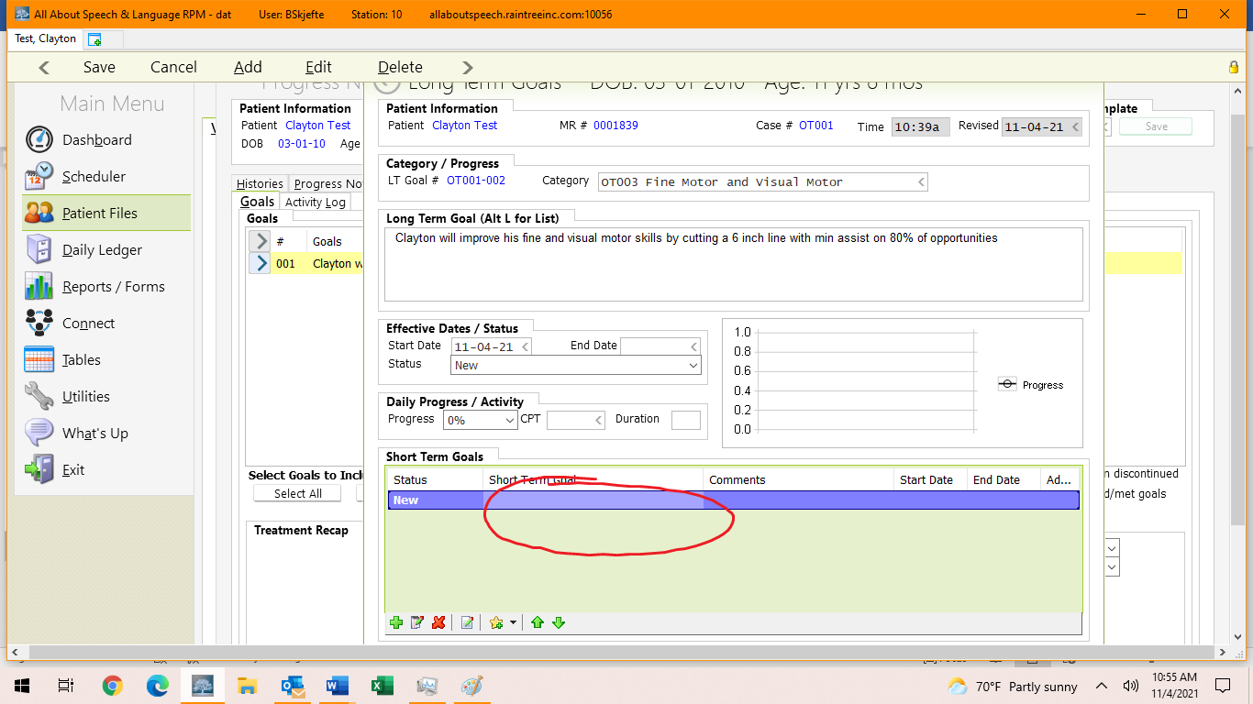

**Right click to edit and type in the goal

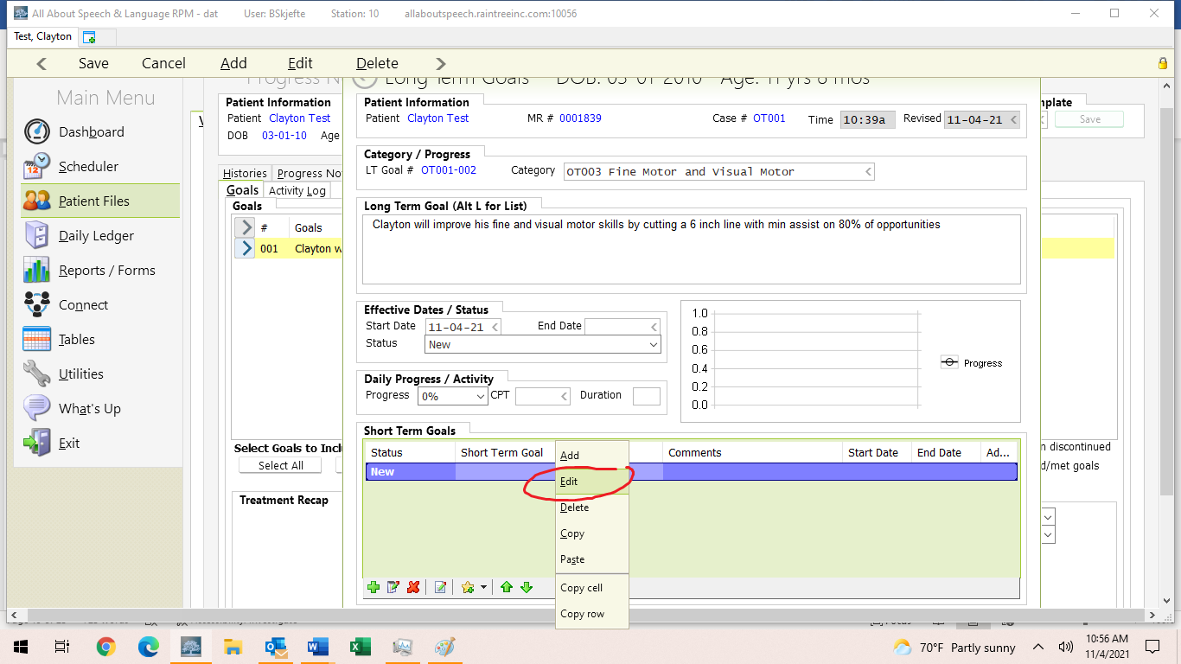
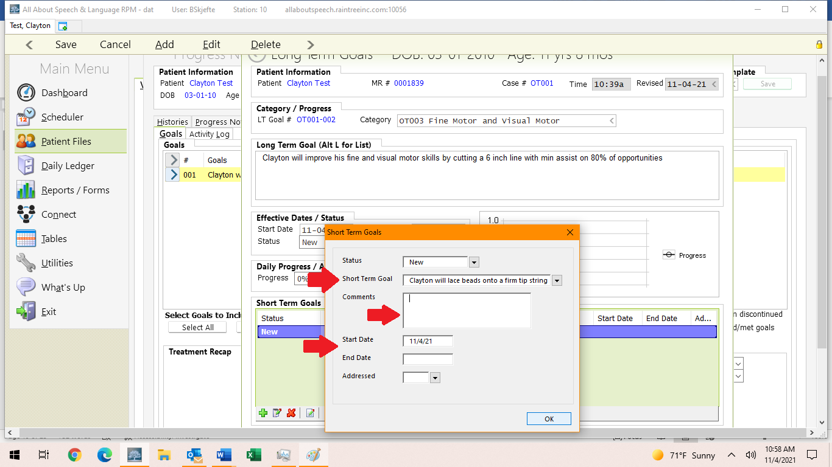

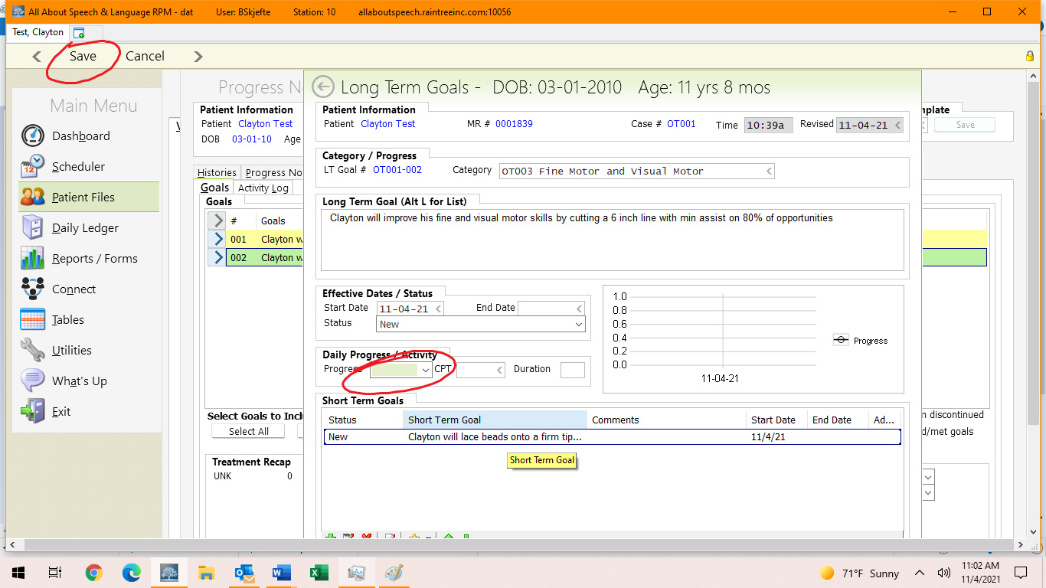
- You can get with your CM to get current clients as examples,

5. Recommendation/Plan Tab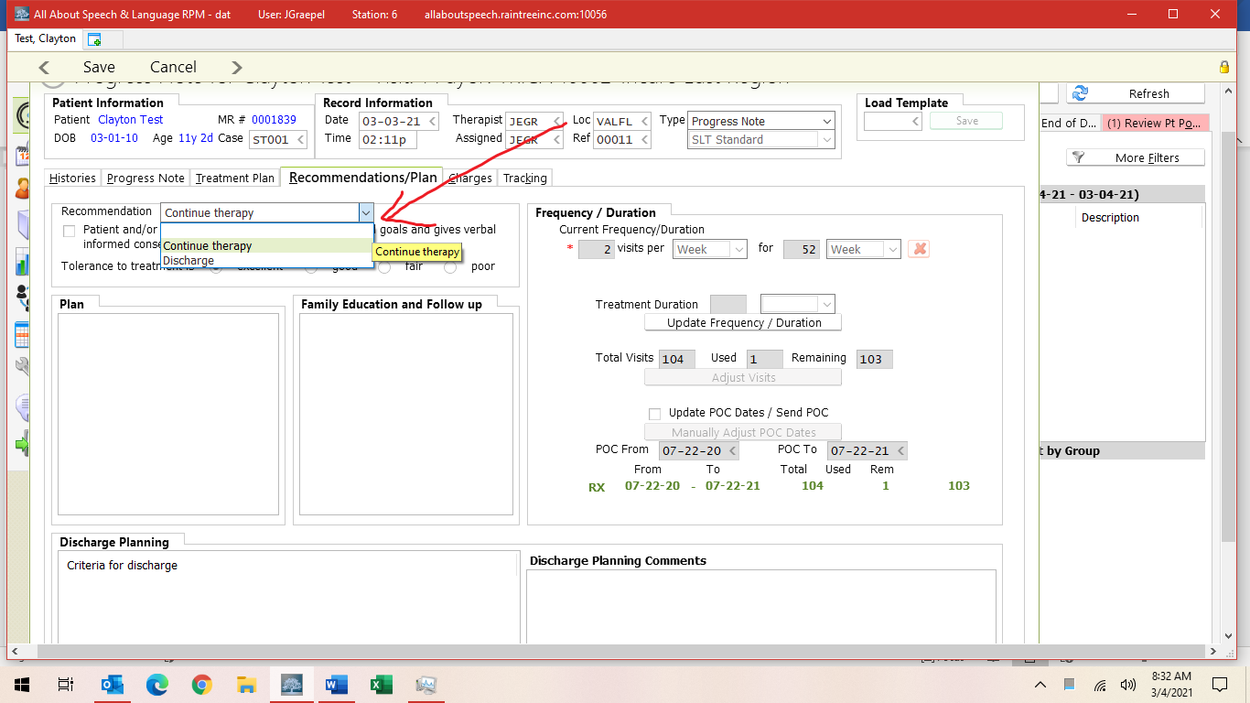
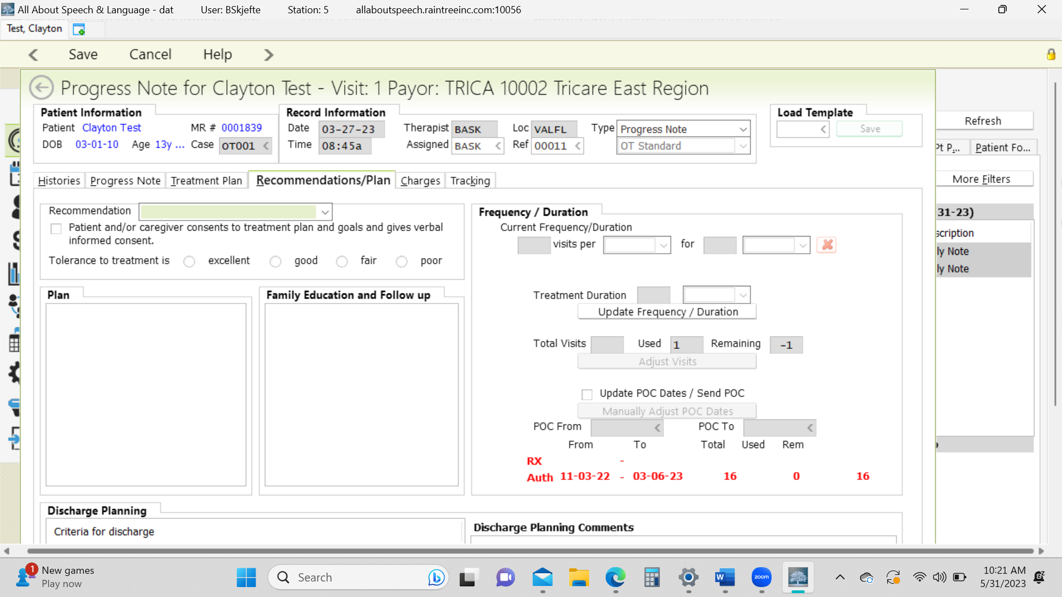
- Recommendation: Select continue therapy or discharge
- Select the parent consent box
- Select tolerance for treatment

6. Discharge Planning
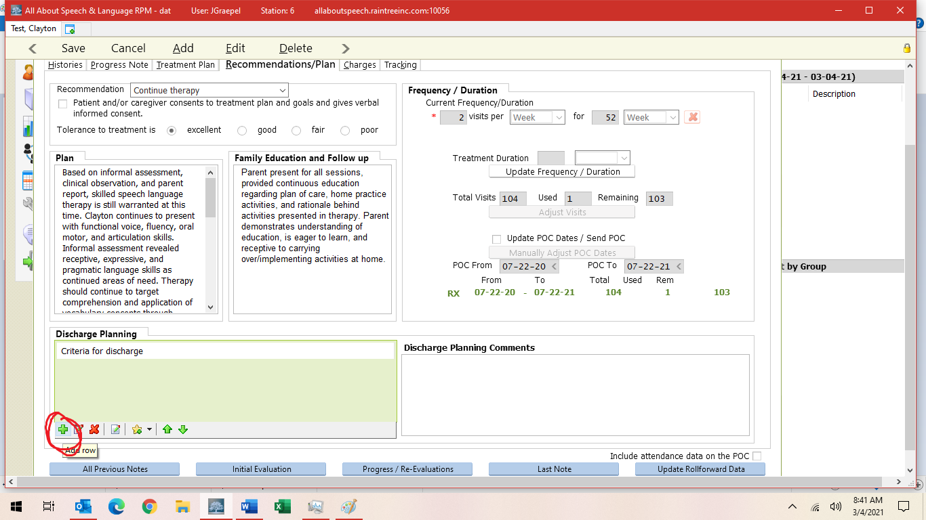

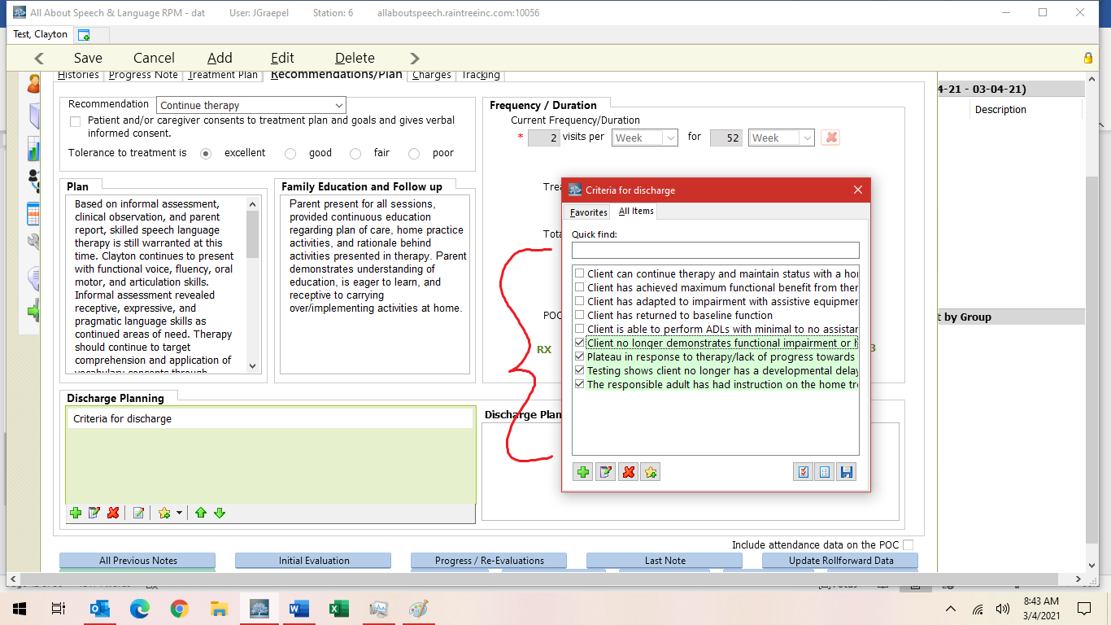

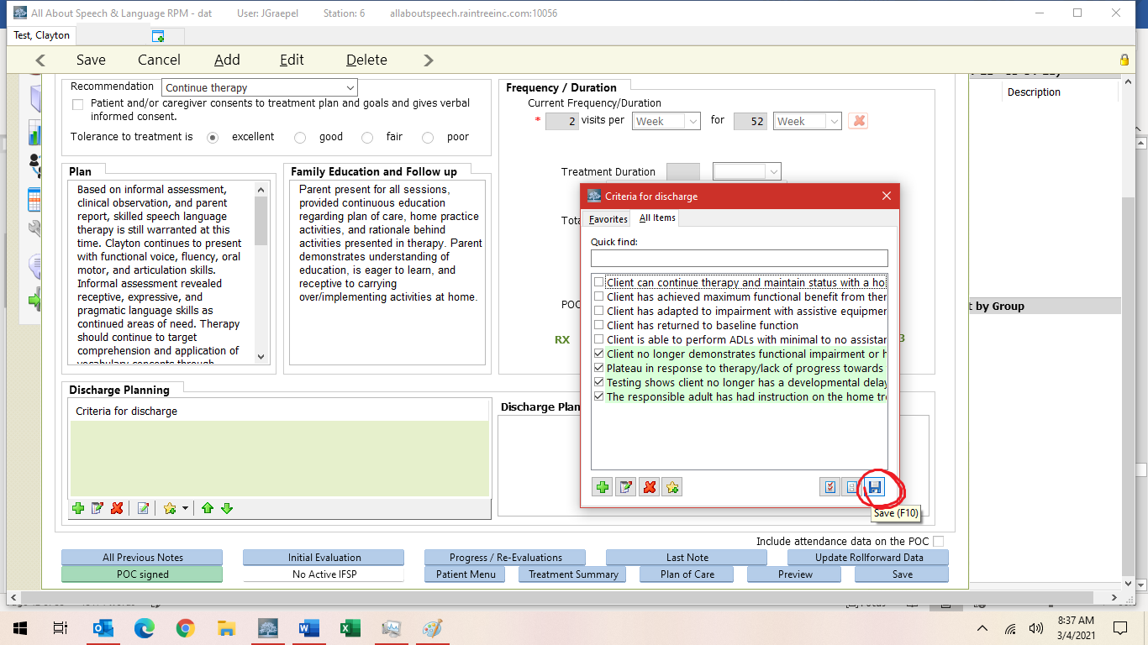

7. Charges
  - Assign charges only if you made the weekly treatment session the Progress Note; if you did it separately via the client chart, there will be no visit/no service ticket selected so charges are not enabled

***************************DURING SESSION WITH CHARGES SELF PAY*********************
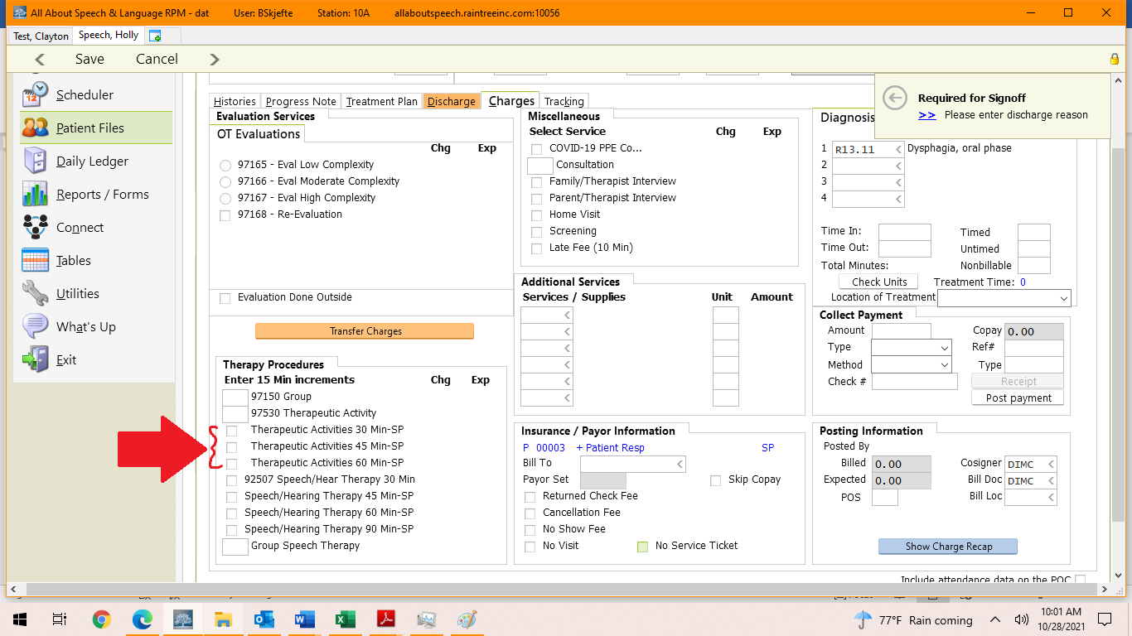

***************************DURING SESSION WITH TRICARE INSURANCE********************
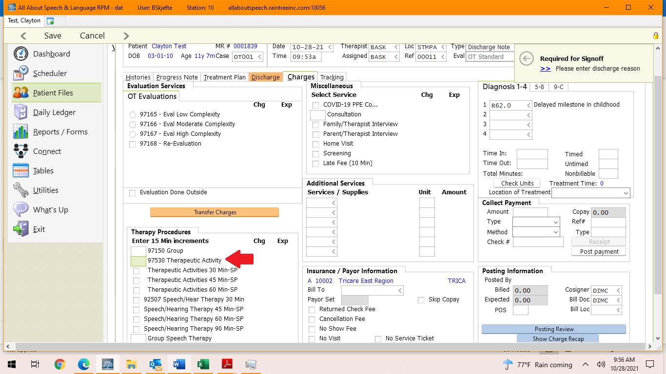

*******************************OUT OF SESSION, NO CHARGES********************************
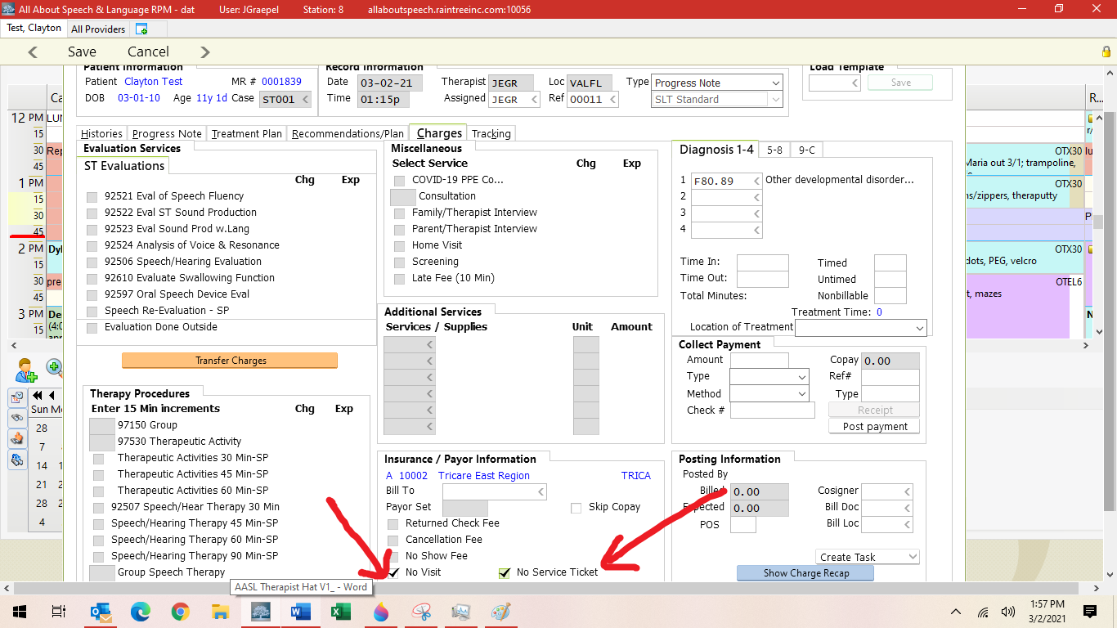

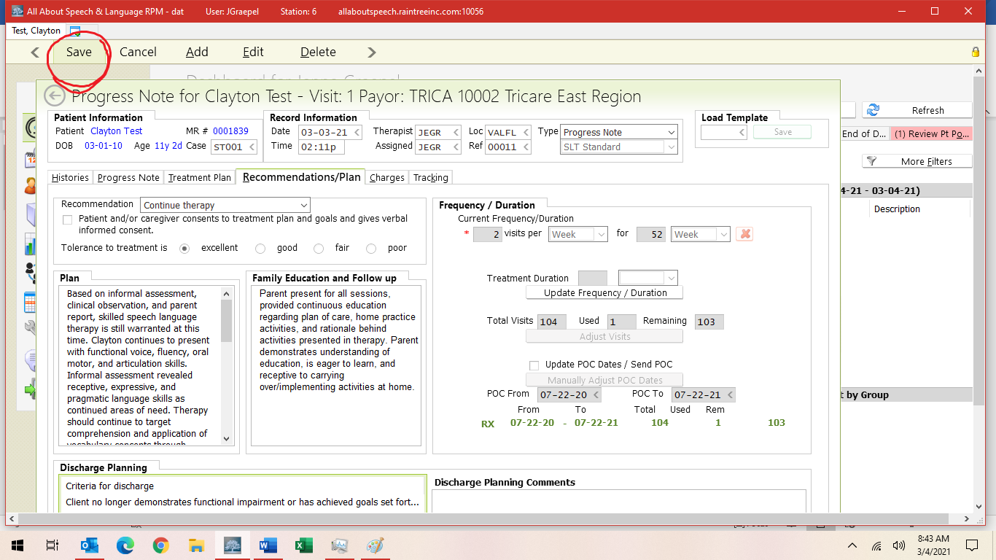

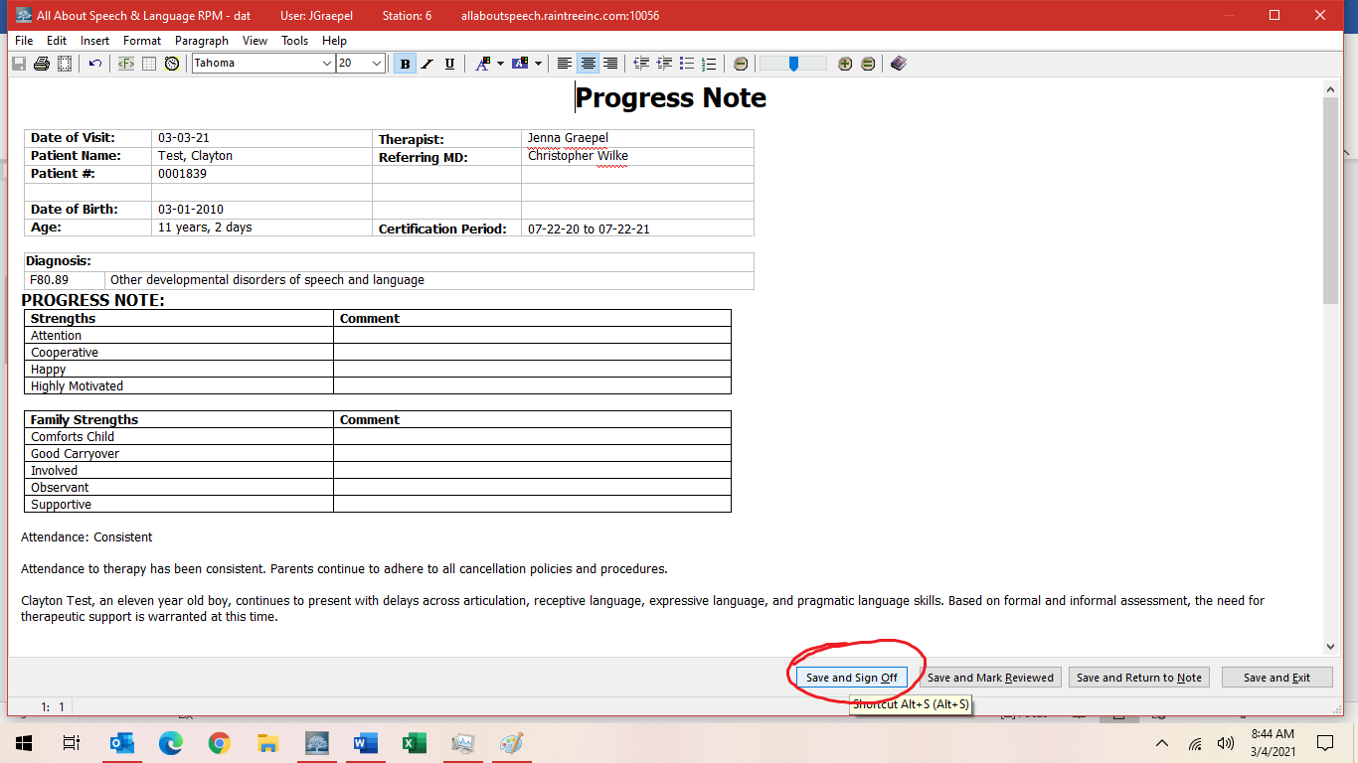

- Save and Exit and/or Save and Sign off on the note

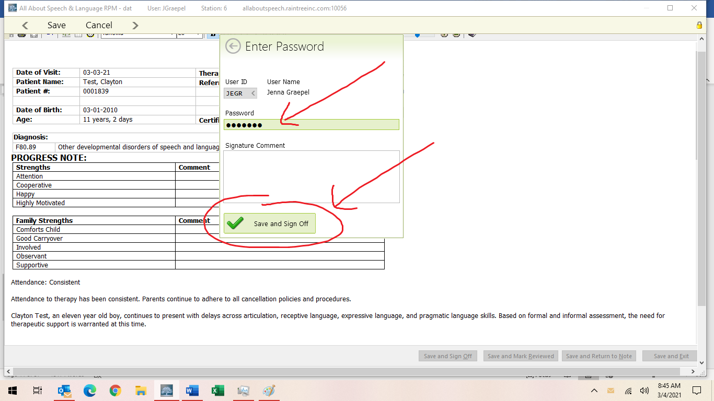

- Be sure to give the note a read-through to ensure no glaring typos or errors before signing off on the document. This is a last impression a doctor, family, or insurance reviewer will be seeing from us, so take care in your review.
- If a parent/caregiver requests to have the progress note sent to them or another professional, please inform the Front Desk. Please do so by providing client name, parent name, and specific request. They will send documentation to parents or other professionals as requested, ensuring necessary releases of information are on file.

Updated June 2023

