Contents
Tracking Re-Evaluation and Progress Note Due Dates 2
Appointment and Note Type 5
Drafting Progress Note in EMR System- Progress Note Tab 11
Adding, Meeting, Discontinuing Goals for Progress Notes (Treatment Plan Tab) 15
Recommendations and Charges Tabs 27
Cosigns: 31
Shared Clients: 32

Tracking Re-Evaluation and Progress Note Due Dates
- It is the responsibility of the treating therapist(s) to:
- track due dates for re-evaluations/progress notes
- keep their dashboard up-to-date (i.e., remove discharged or covered clients), NOTE: be sure to monitor Flex Schedule clients and communicate with your fellow therapists on sharing the responsibilities for progress notes and re-evaluations.
- ensure due dates are accurate (i.e., conversion note clients require manual updates)
- To track upcoming Progress Notes and Re-evaluations, use the chart below:
It is the responsibility of the treating therapist(s) to track due dates for re-evaluations and progress notes. Raintree is a tool that should be utilized to efficiently track these due dates and this document contains the procedure for utilizing the Caseload Tab in a therapist’s Dashboard to do so. Login to Raintree and go to your respective Dashboard, locating your Caseload Tab. See chart below for tracking to ensure no re-evaluations are missed.

Date to start scheduling | Upcoming Re-eval Dates
End of January | March and April
End of February | April and May
End of March | May and June
End of April | June and July
End of May | July and August
End of June | August and September
End of July | September and October
End of August | October and November
End of September | November and December
End of October | December and January
End of November | January and February
End of December | February and March

- To update your Caseload tab, log into Raintree and go to your respective Dashboard, locating the tab titled “Case Load”:
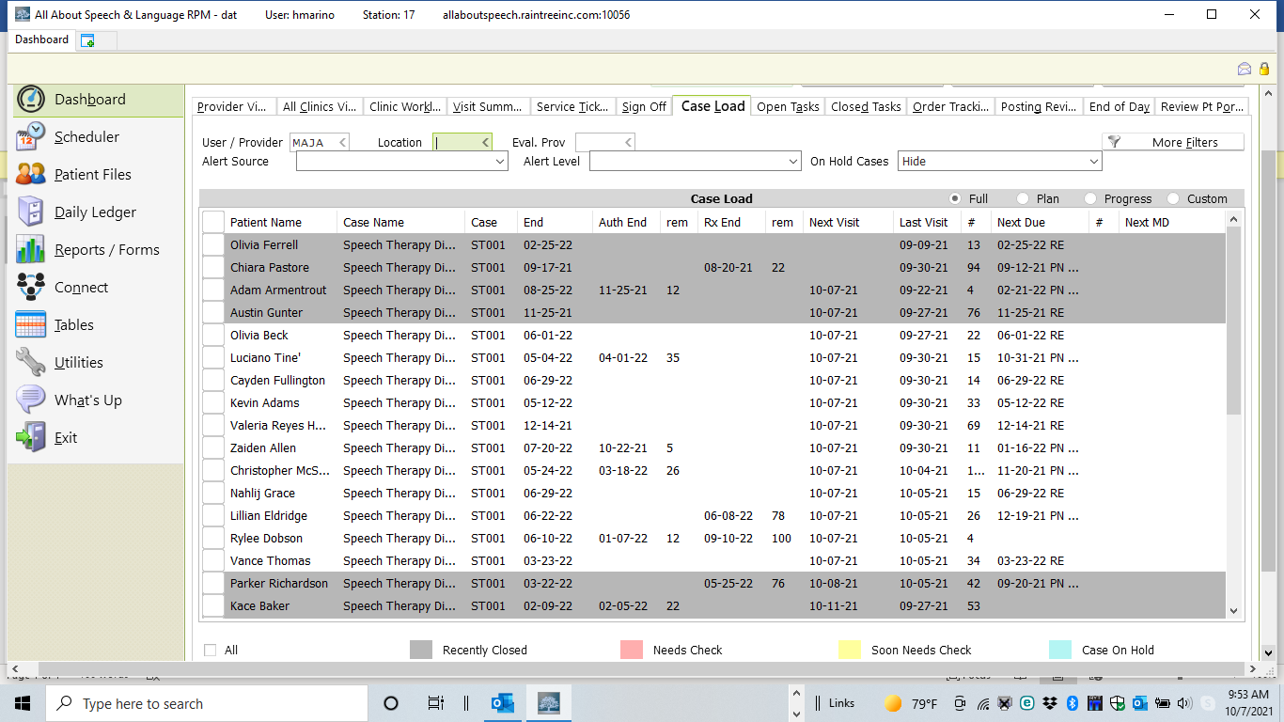

4. Remove clients seen for coverage, or clients no longer on your caseload by doing the following:
  - Select the client by checking the box next to their name
  - Select the Remove from Active Caseload button, located at the bottom of the screen. This will remove this client from your caseload list.
  - If the client dropped out or was discharged, please be sure to complete a discharge note prior to removing them from your caseload.
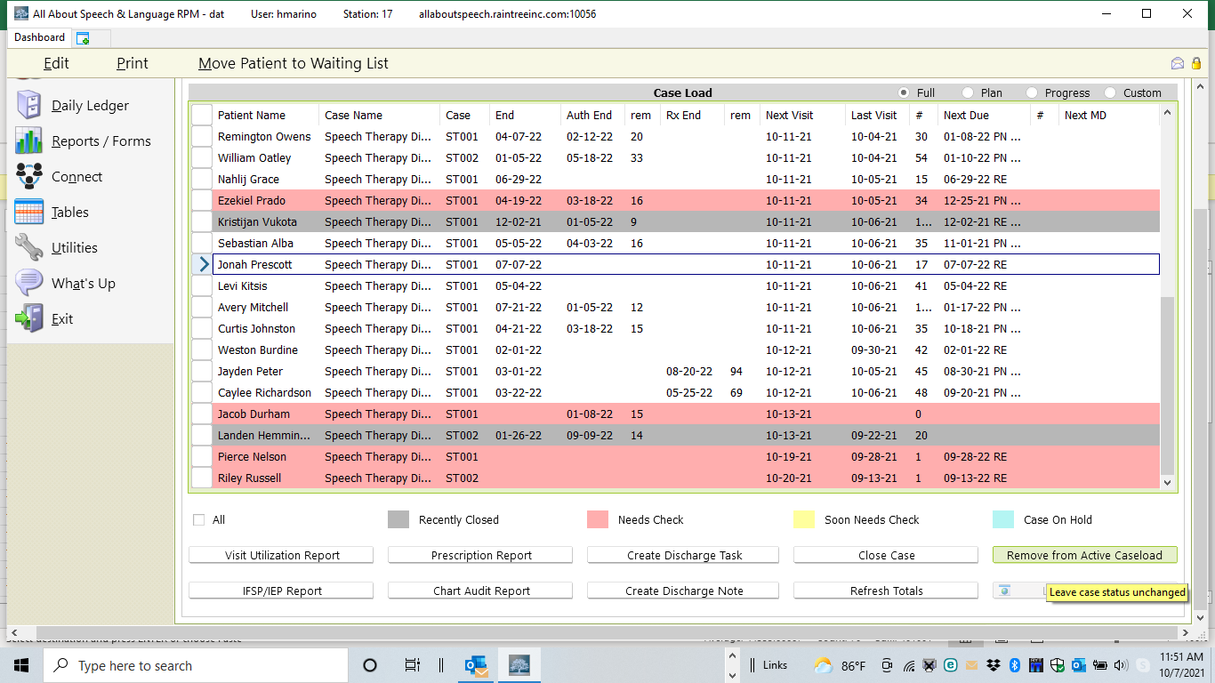
To manually update re-evaluation and progress note due dates, do the following:
- Select the name with your mouse:

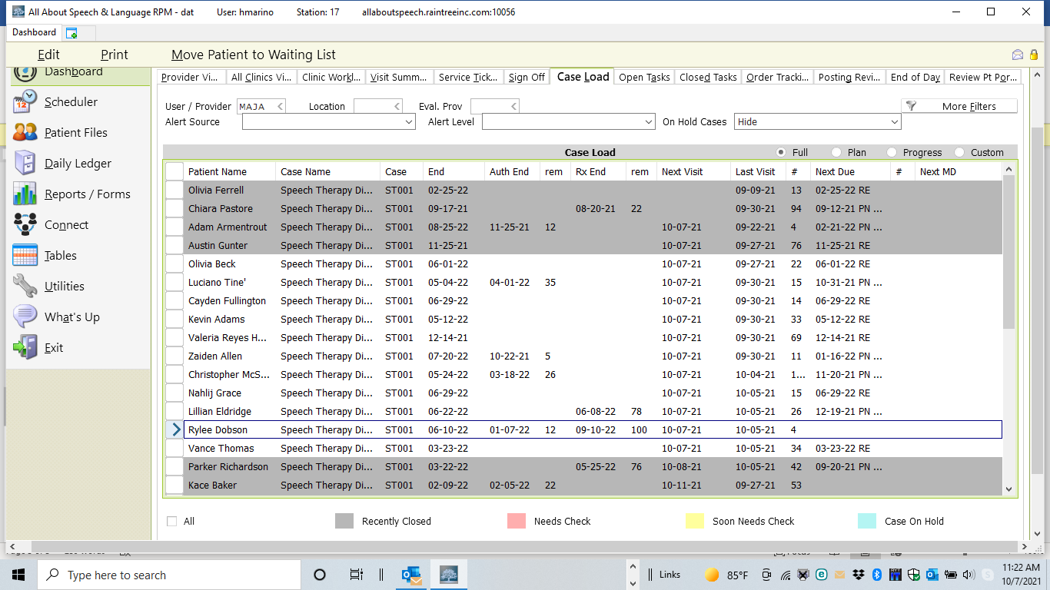

- Select Edit.
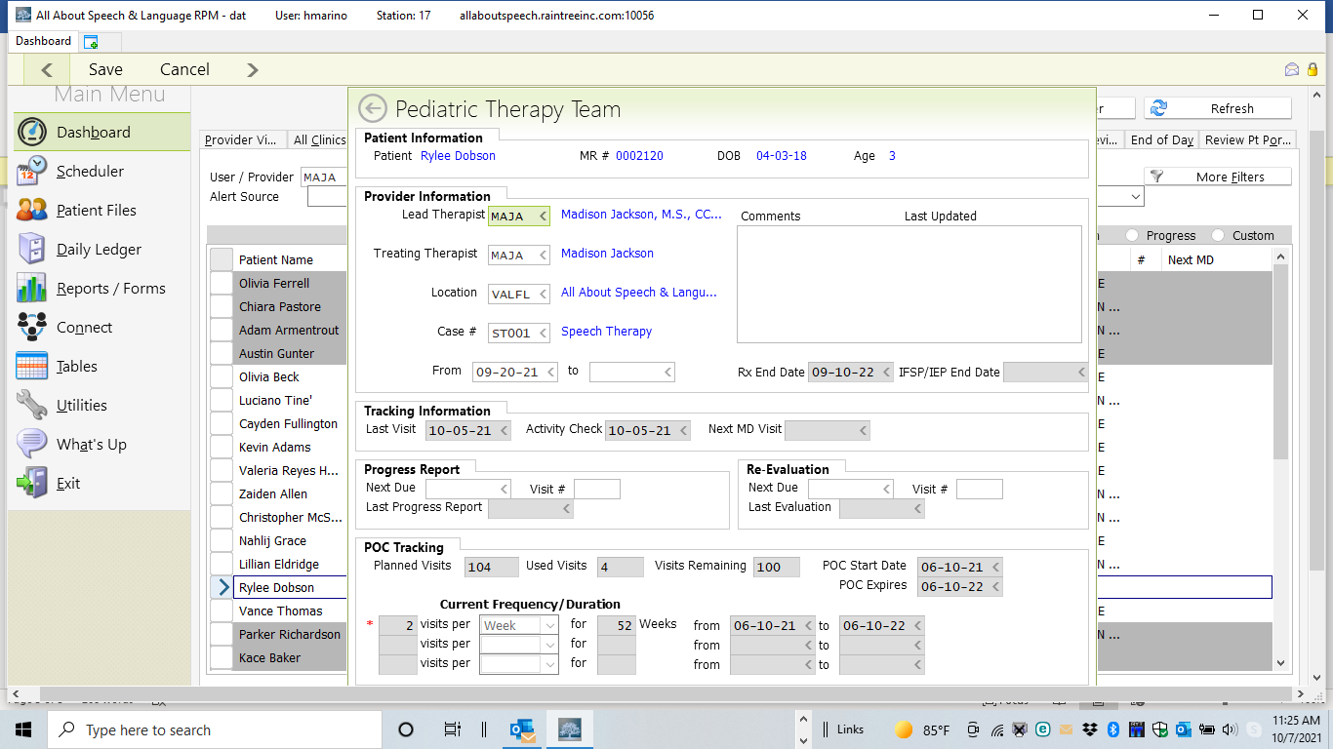
- Enter the Progress Report Next Due date based on the POC dates (6 months from evaluation date).

Appointment and Note Type
- You may change the appointment type in Raintree prior to checking in the appointment if you wish; you may still have to change the Note Type once opening the EMR. This is ONLY if you are charting the Progress Note in lieu of a treatment note for that session.
- Right click on the appointment in Raintree, select Edit. Then change the “Type” to progress note, available in the drop-down list. This should turn the appointment RED.

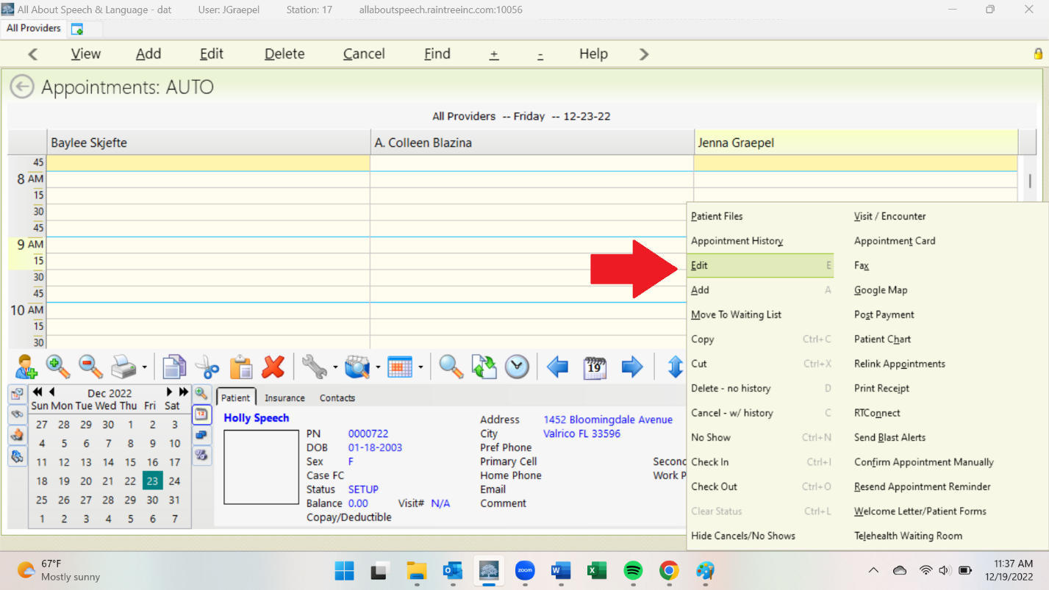

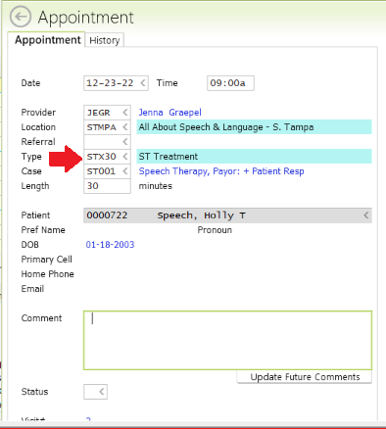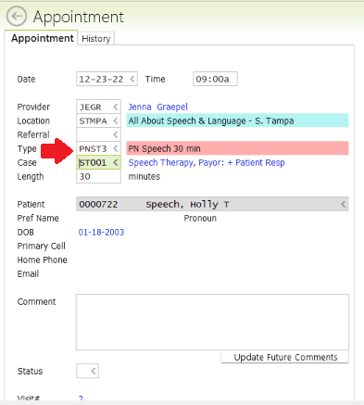

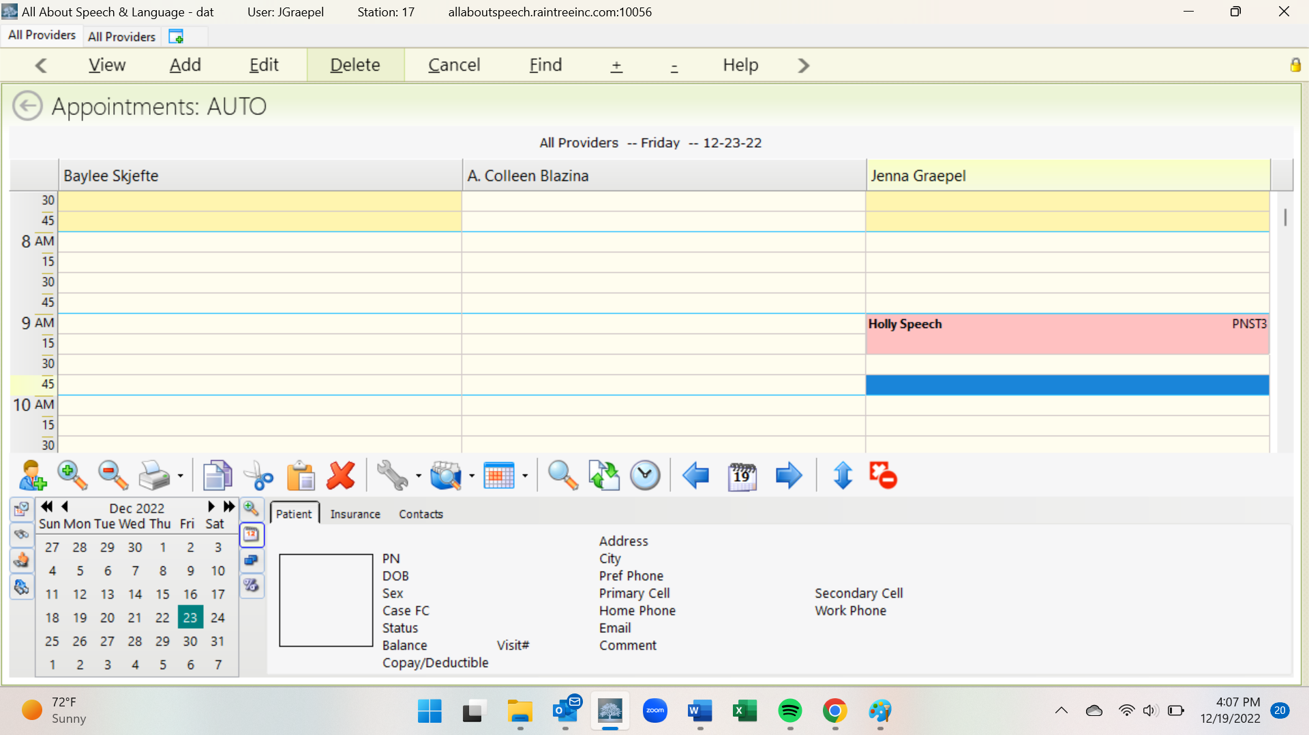

- If completing a Progress Note outside a treatment session, you can also go into the patient chart and hit A to add under Visit History, then select Long-Term Therapy Note. When it populates the note going forward on the upper right-hand side you will then need to change the Note Type to Progress Note and then under that make sure you add from the dropdown SLT Standard. You will not assign charges to this note type if it is not completed during a treatment session
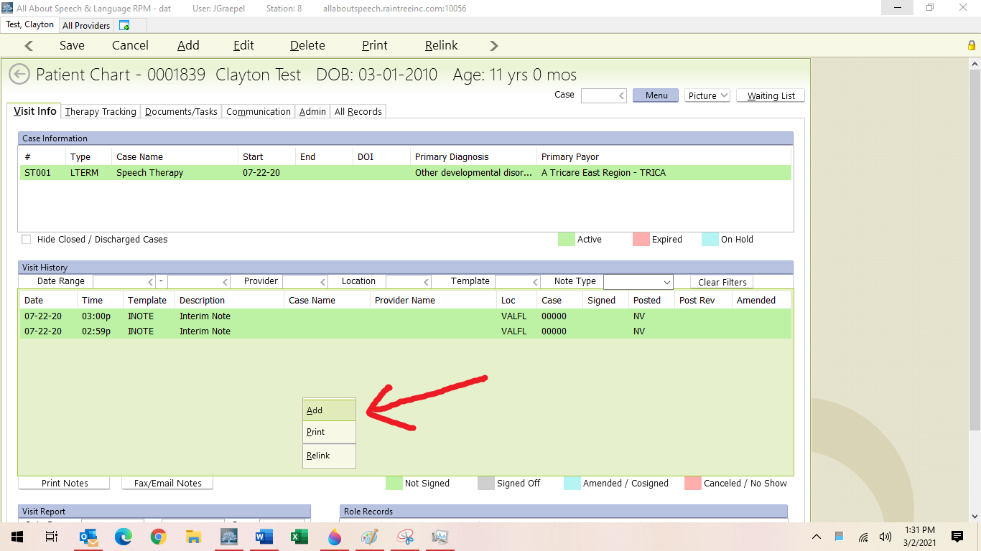

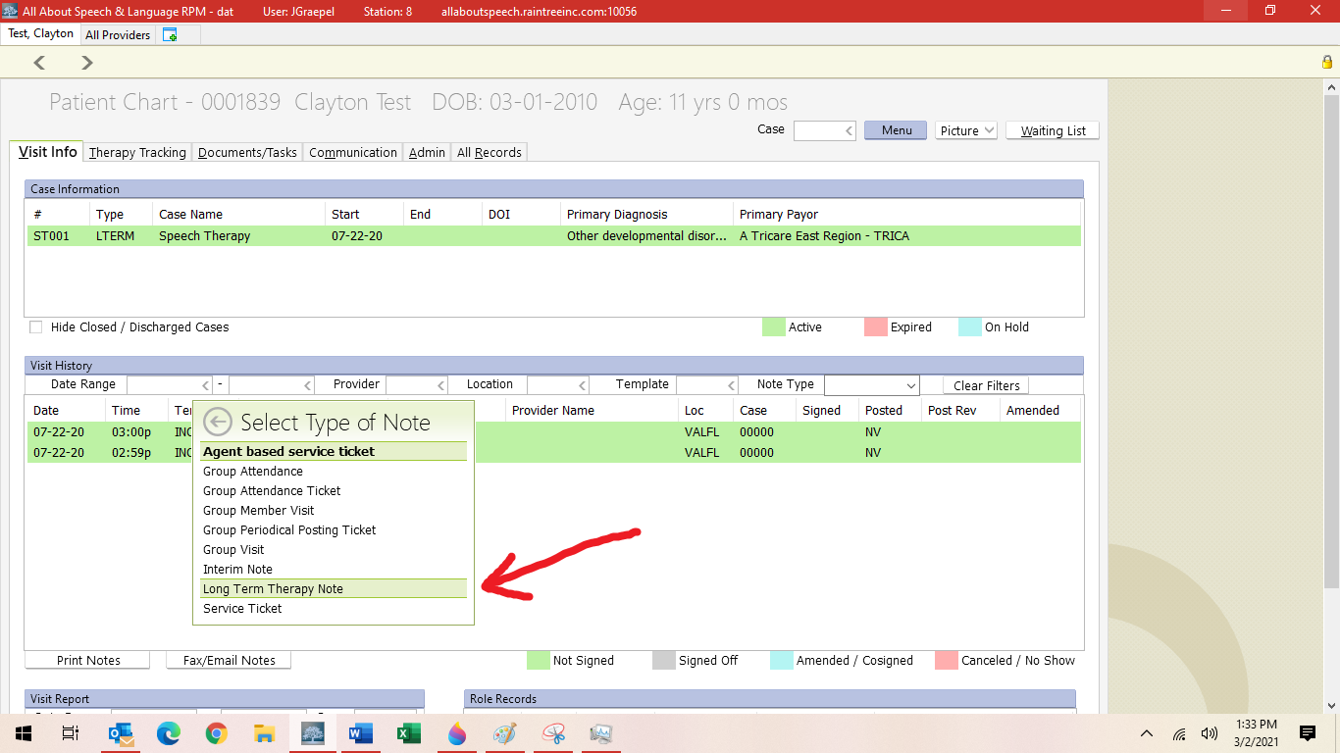

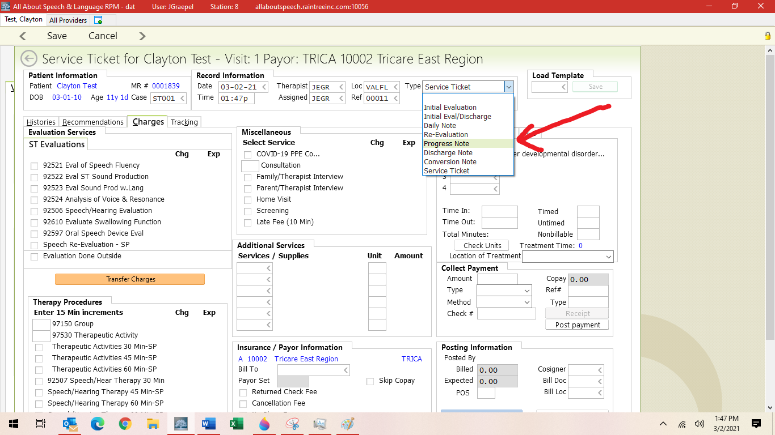

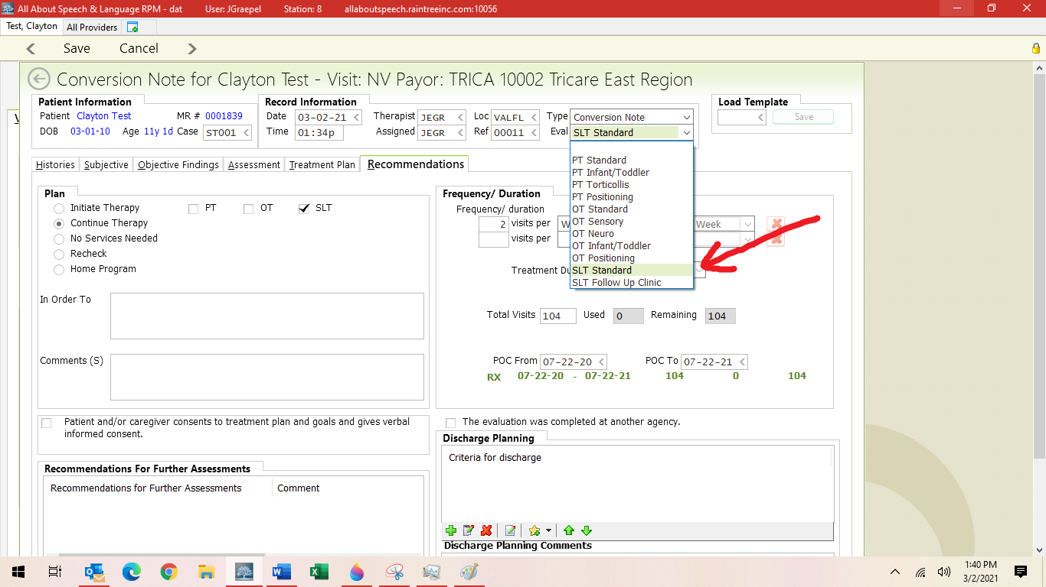
- Assign charges only if you made the weekly treatment session the Progress Note; if you did it separately via the client chart, there will be no visit/no service ticket selected so charges are not enabled

*********************************DURING SESSION WITH CHARGES*************************
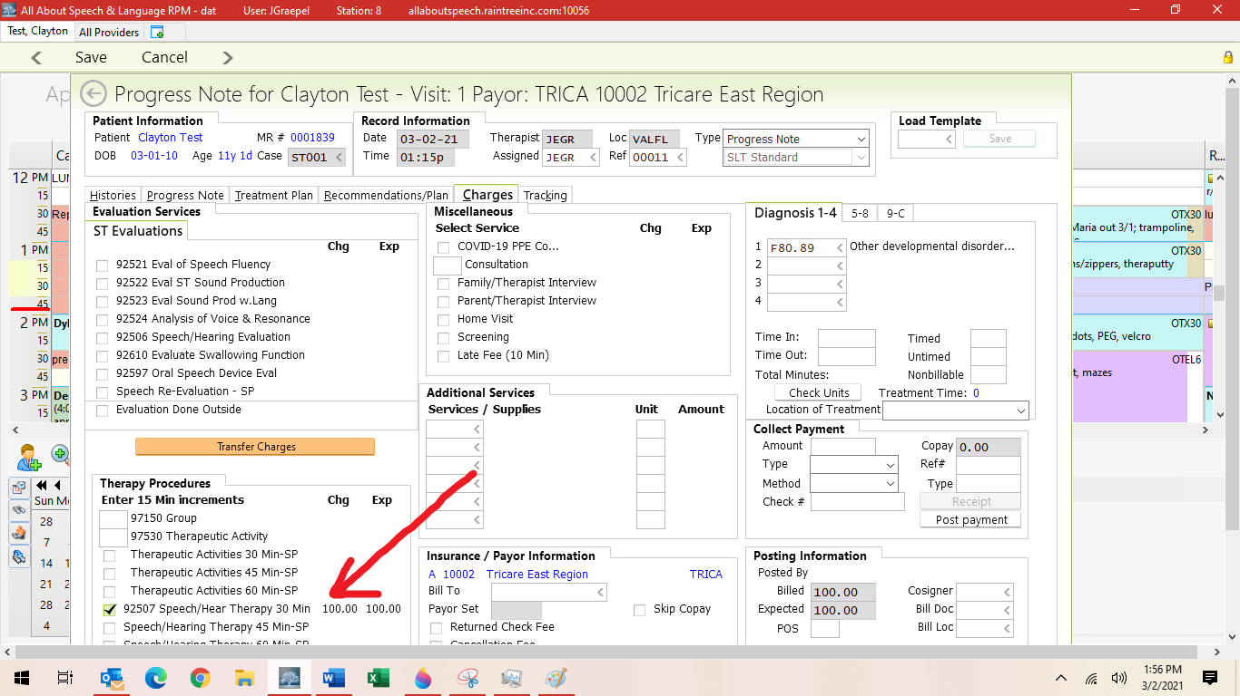

*******************************OUT OF SESSION, NO CHARGES********************************
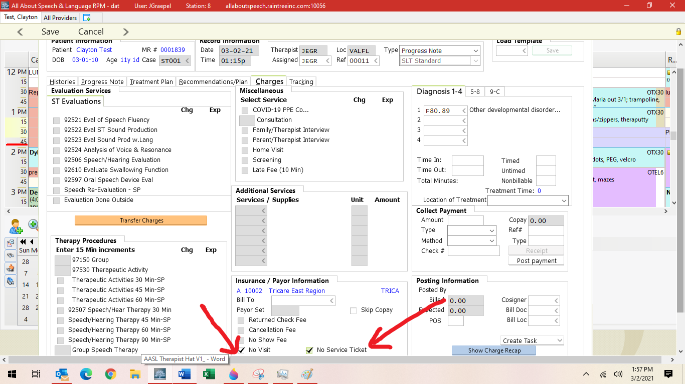
- Print any necessary documents to complete (protocols, questionnaires etc. as a part of progress note preparations, if warranted)

Drafting Progress Note in EMR System- Progress Note Tab
- Include information across the following:
  - Strengths and Family Strengths
  - Status/Attendance
  - Assessment
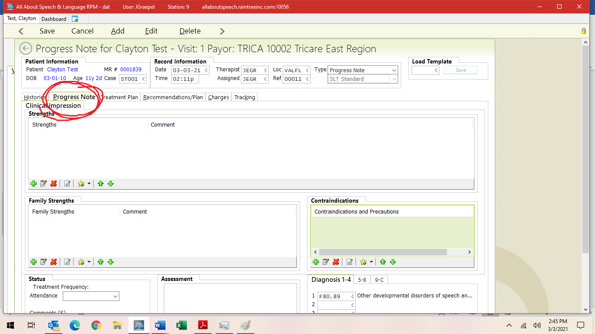

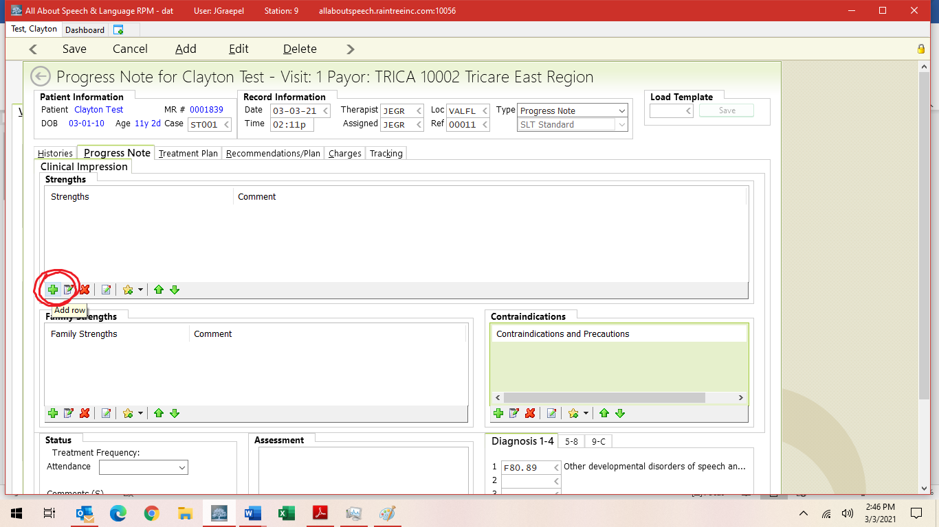

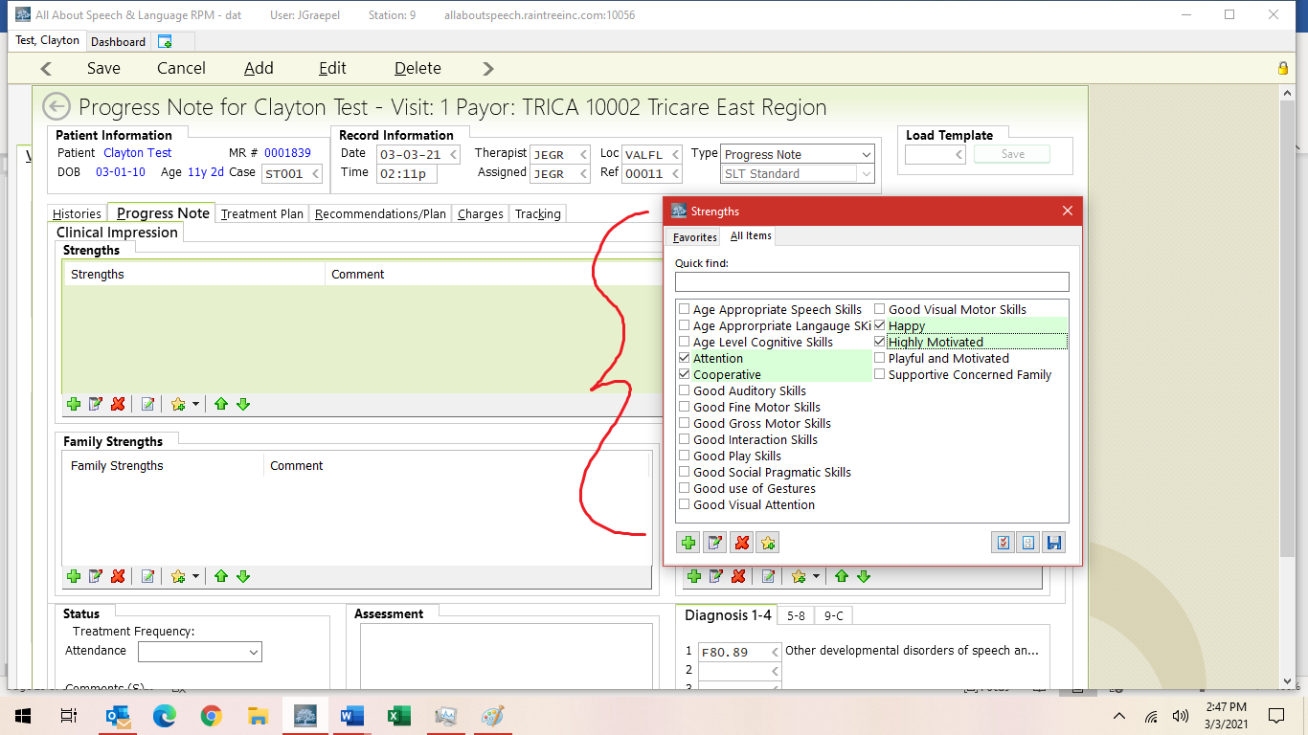
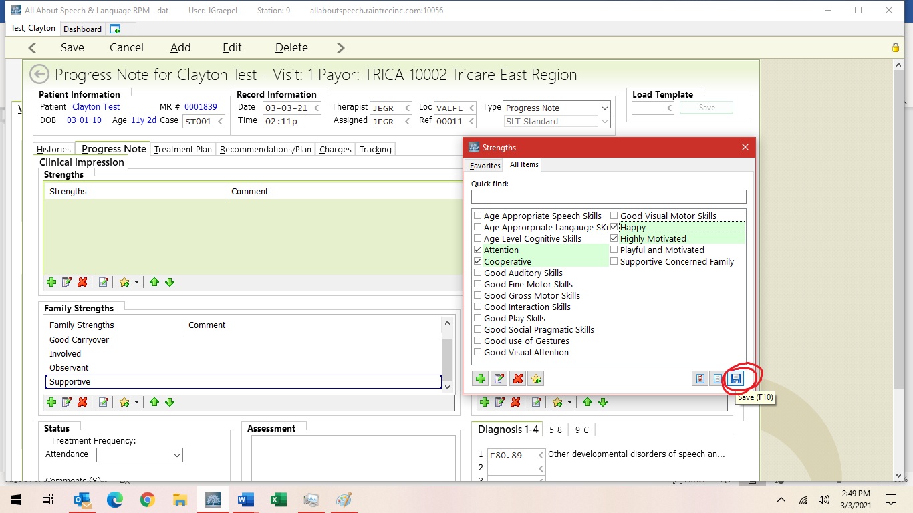

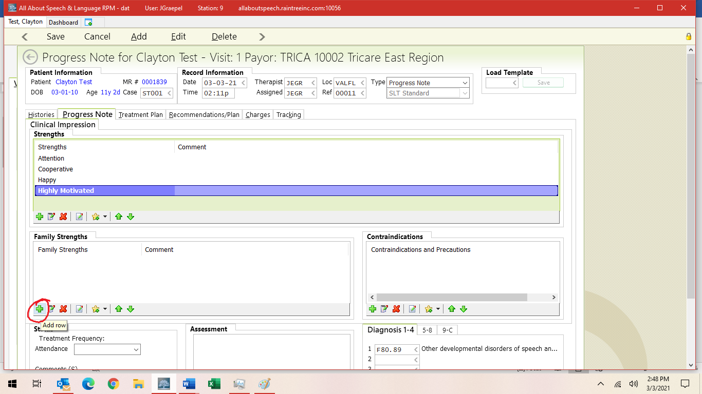

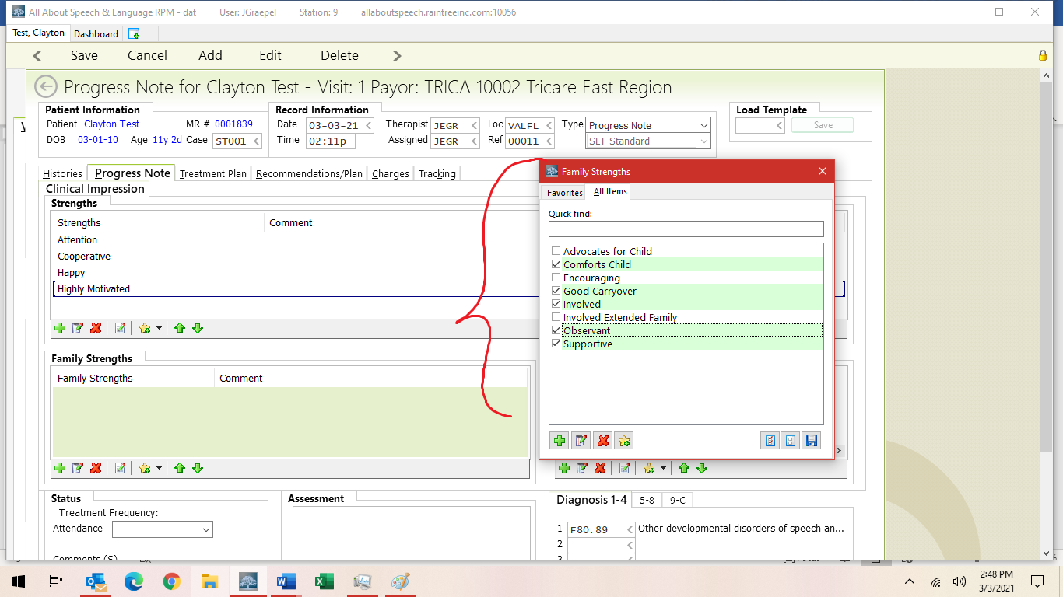

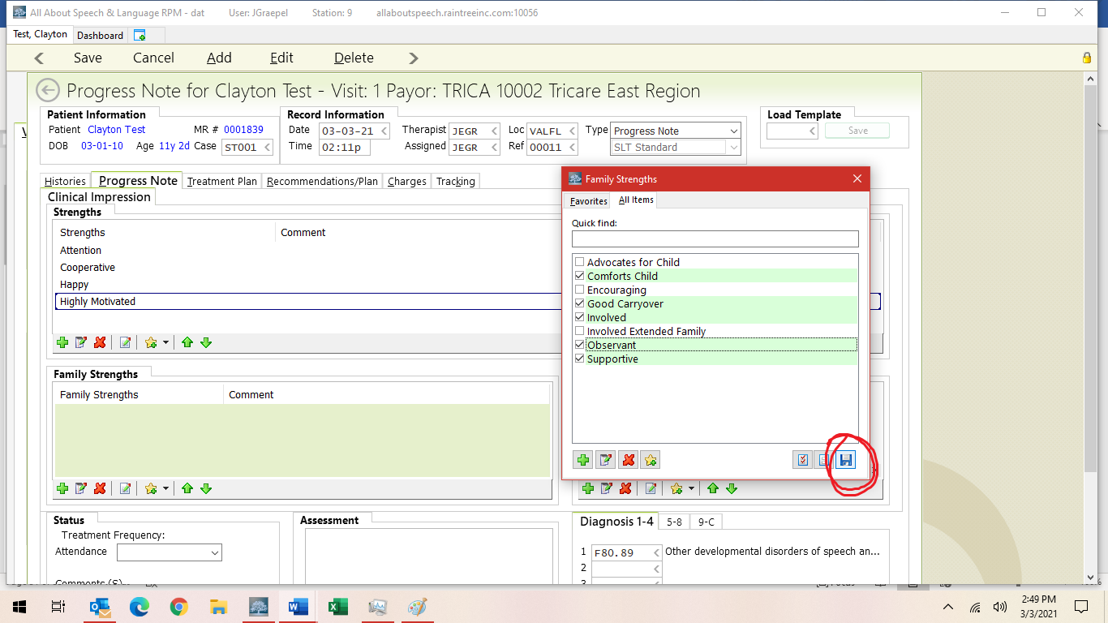

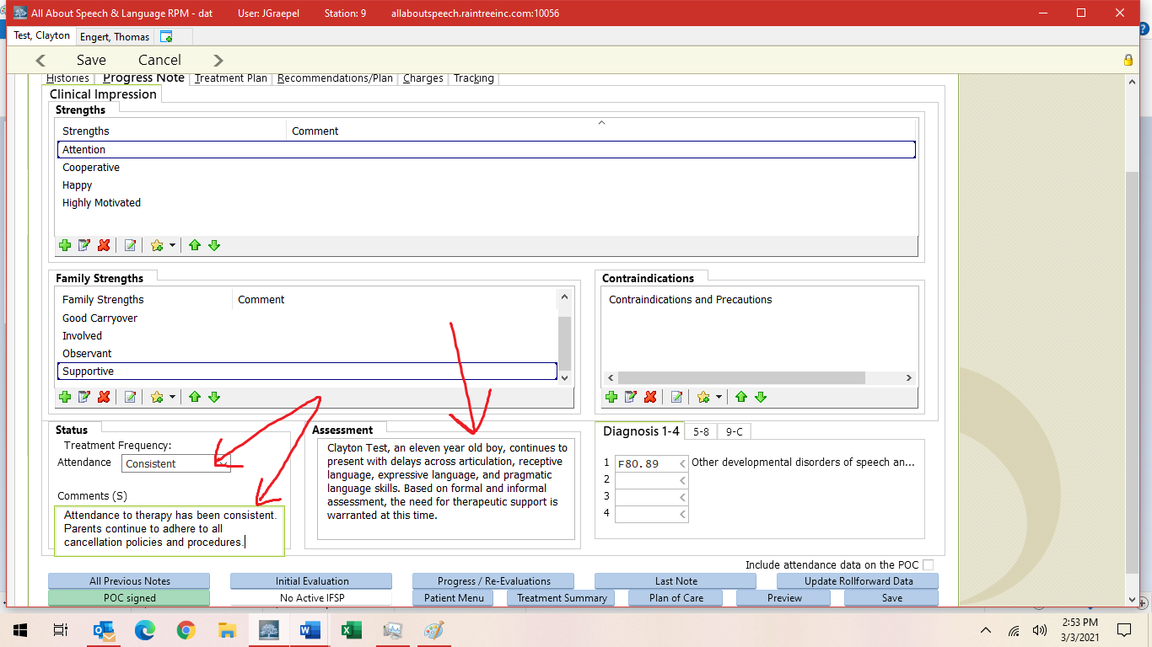
Clayton Test, an 11 year old boy, continues to present with impairments across articulation, expressive language, receptive language, and pragmatic language skills. Based on formal and/or qualitative assessment, clinical observation, and parent report, the need for therapeutic support is still warranted at this time.
Be sure to avoid use of “delay” when describing child’s areas of weakness. Use “deficit” or “impairment” instead. Additionally, use “qualitative assessment” in place of “informal assessment.”

Adding, Meeting, Discontinuing Goals for Progress Notes (Treatment Plan Tab)

- Under Goals, you are going to hit A to add.
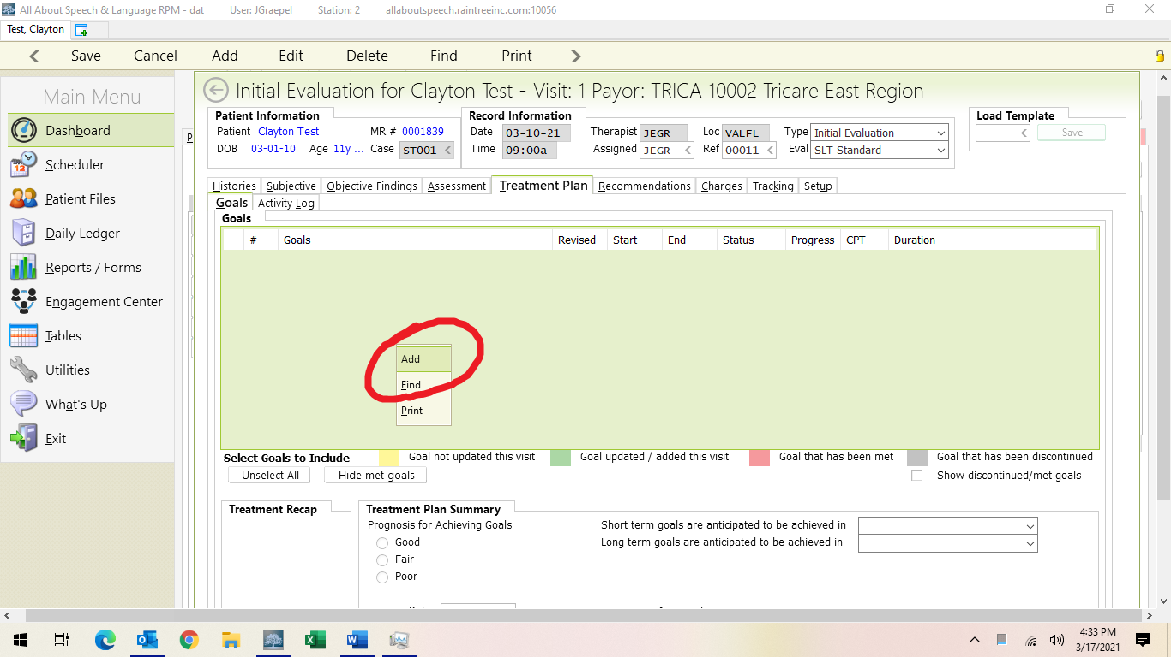

- Under Category select your long-term goal area from the drop-down arrow. Then you write your long-term goal. Please see google drive for updated pick list goals that include LTG with the STG by goal area to help you in writing appropriate long-term goals.

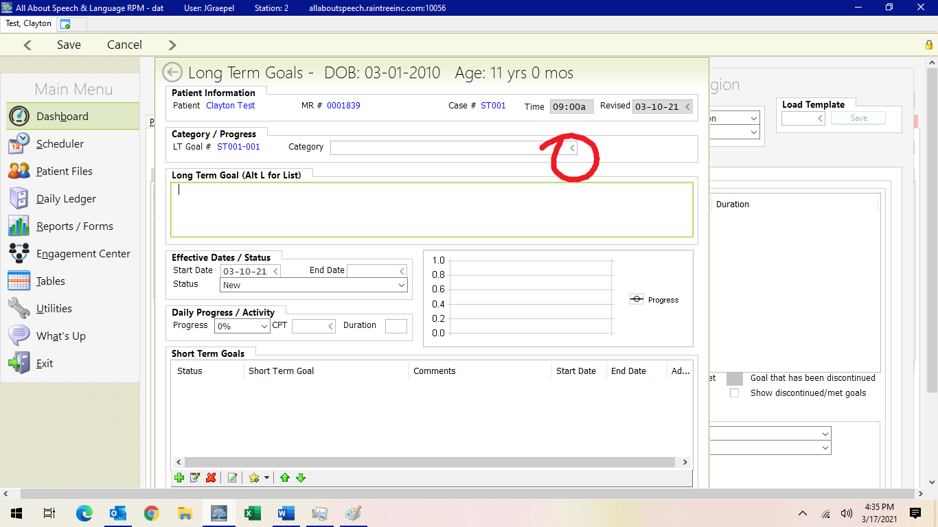

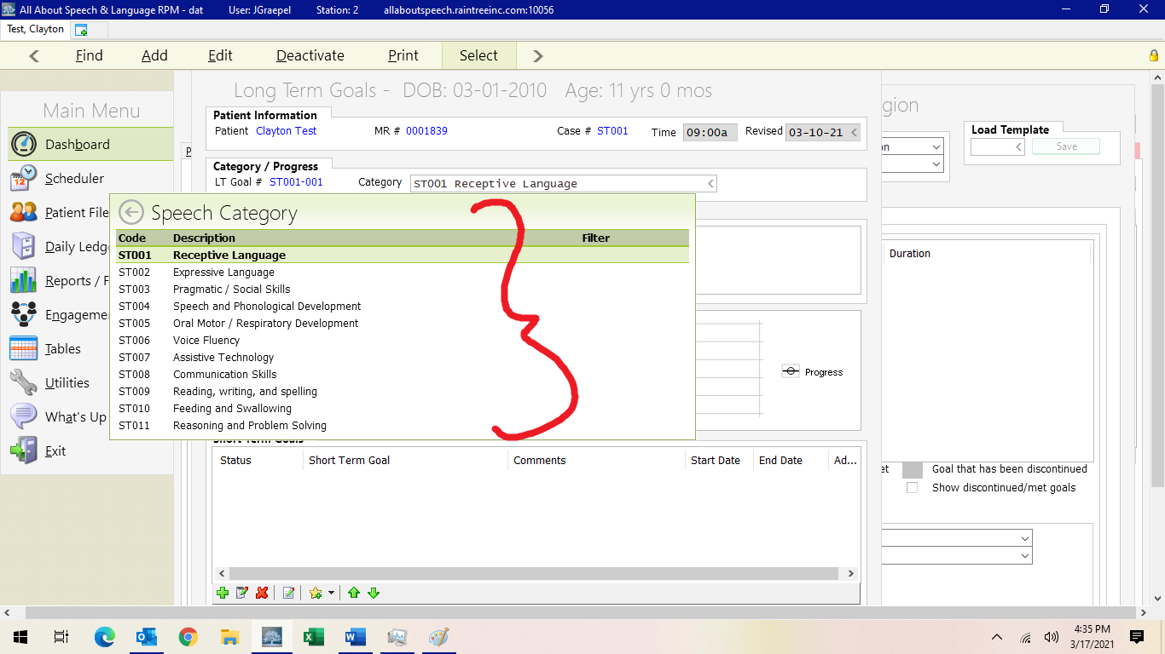

- You do not need to fill in progress on “New” goals
- Under Short-Term Goal, you are going to go down to the toolbar where you see the star with the little + and drop-down arrow box next to it. On the web-based version, you will see a star. When you click this, you will hit Load Template. Then all the templates that we have current “pick lists” for across STG areas will populate here. Select the ones that apply to your LTG objective then the entire template will load. You can toggle over the goal area to see the entire goal. If you have to edit the goal, click on the goal to highlight it in purple, then right click and edit the goal.
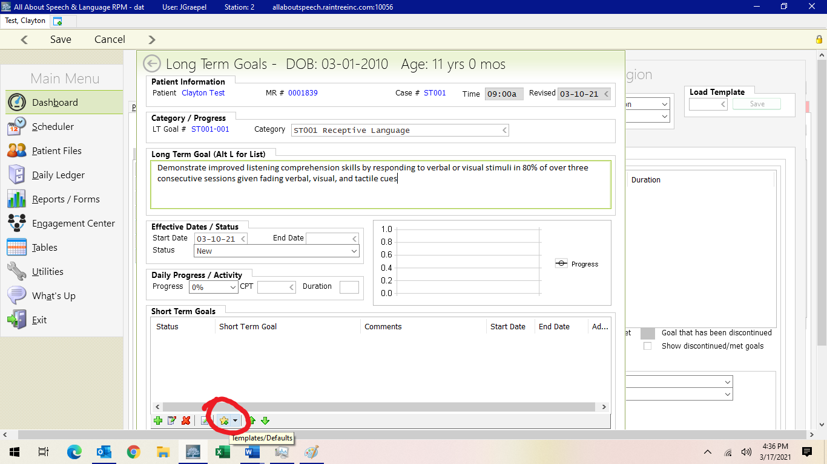

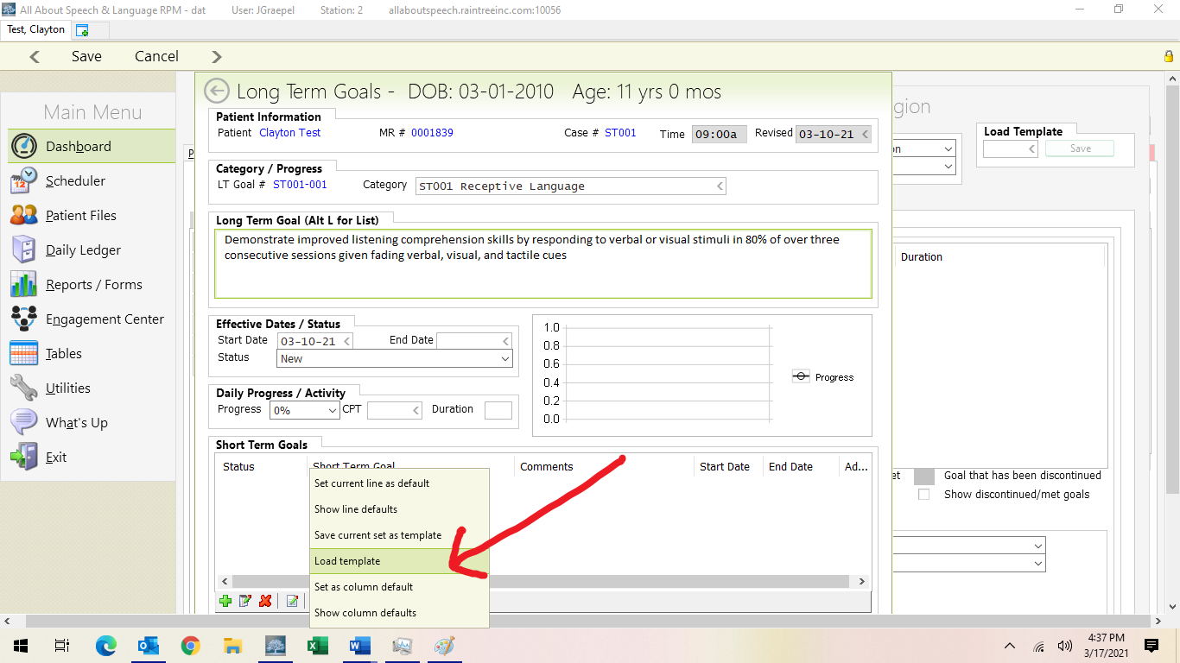

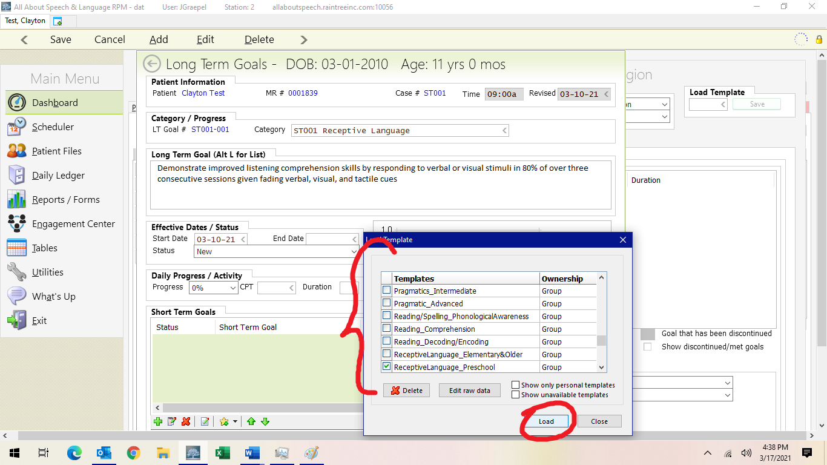

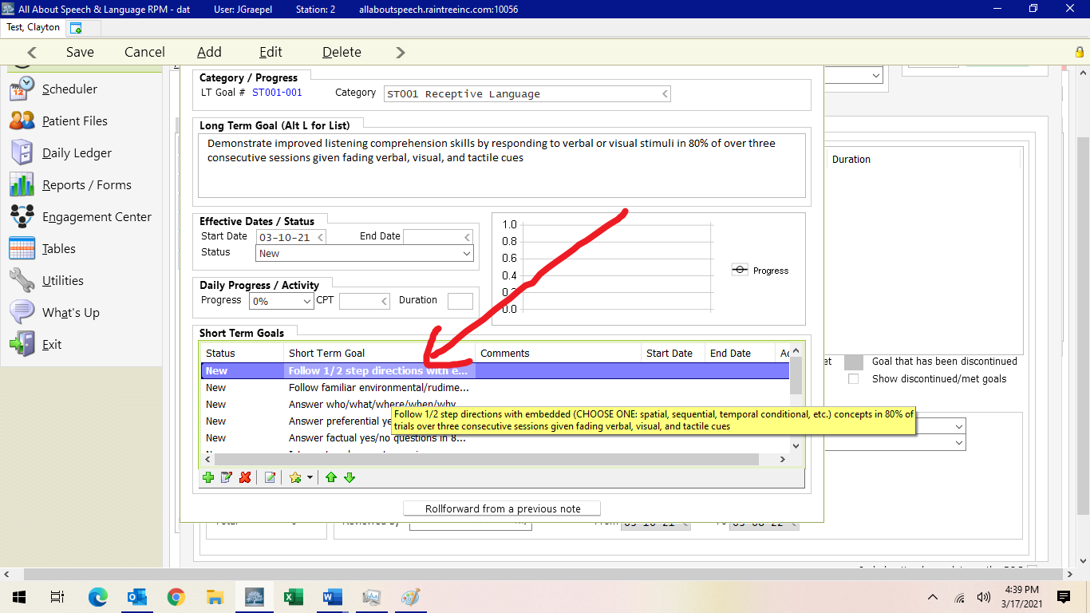
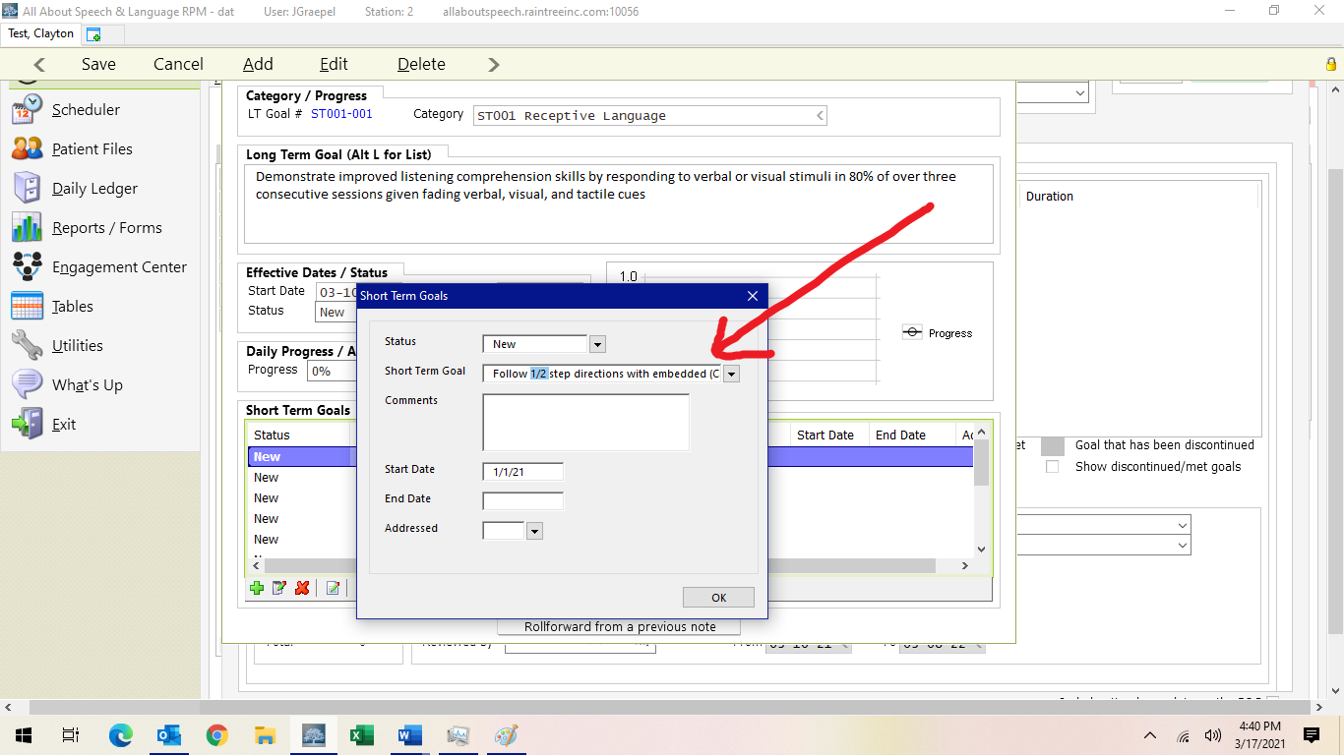

- This will mostly be necessary for articulation goals when you are inputting the specific sounds that need to be addressed in treatment.
- You will then go through and delete out with the red X button (or trash icon on web-based version) the short- term goals that are not needed to start this plan of care. We usually select no more than 4-5 short-term goal objectives as these can be updated at the time of the progress note, 6 months going forward from the date of the initial evaluation OR if short-term goals are being met and new goals need to get added sooner than this. Be sure to put the start date in each STG as well.
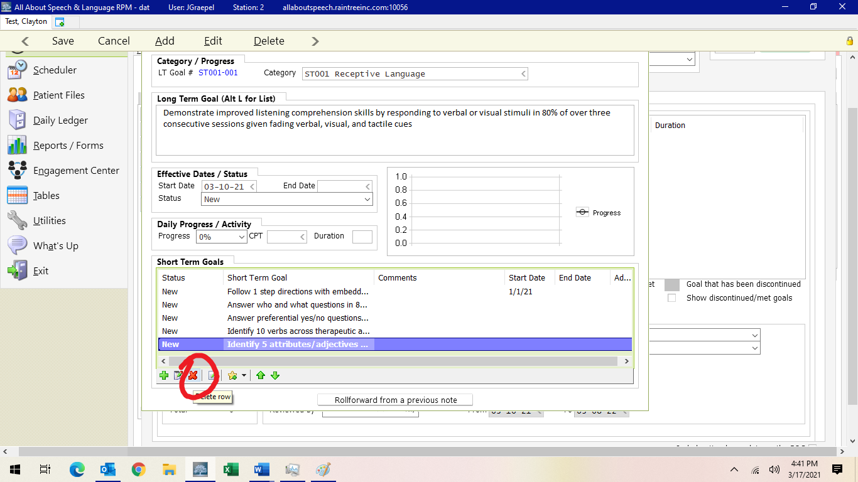

- Then you hit save.

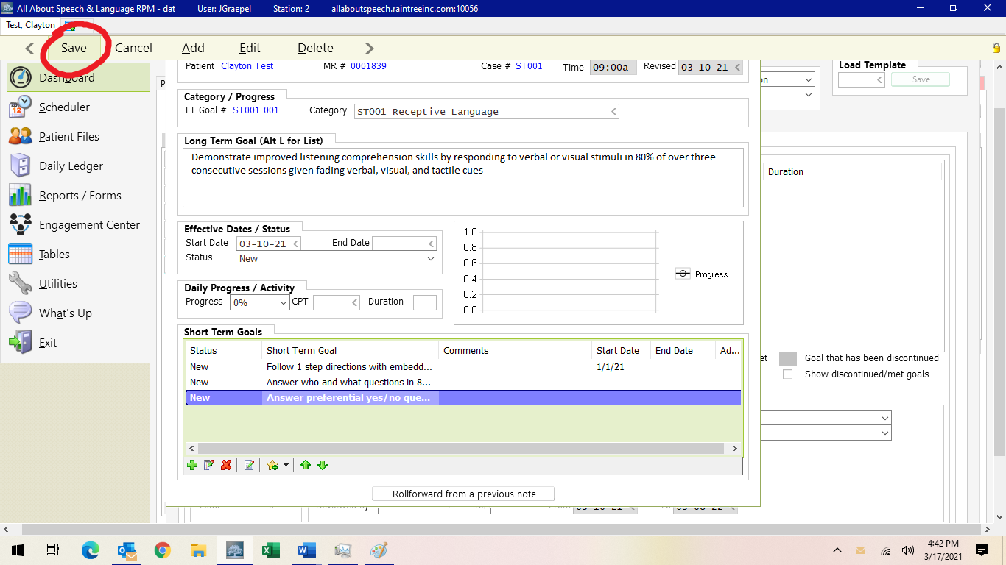

- You will repeat this process for as many LTG areas you have with STG area objectives. Use the google drive Pick List/Updated Goals Document to help you as a reference

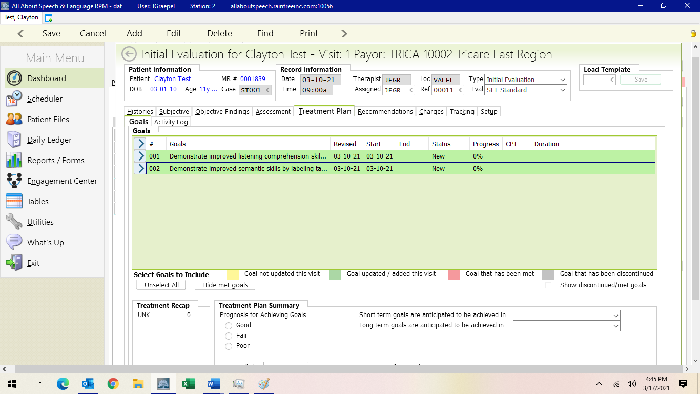

- Update and/or add any new goals, if warranted, or change the status of the goal per the drop down in this section. WE ONLY USE Ongoing, Discontinued, or Met. WE DO NOT use Hold or Updated goal status, nor to we enter “Almost Met” or “Partially Met”

- To Update goals, do the following
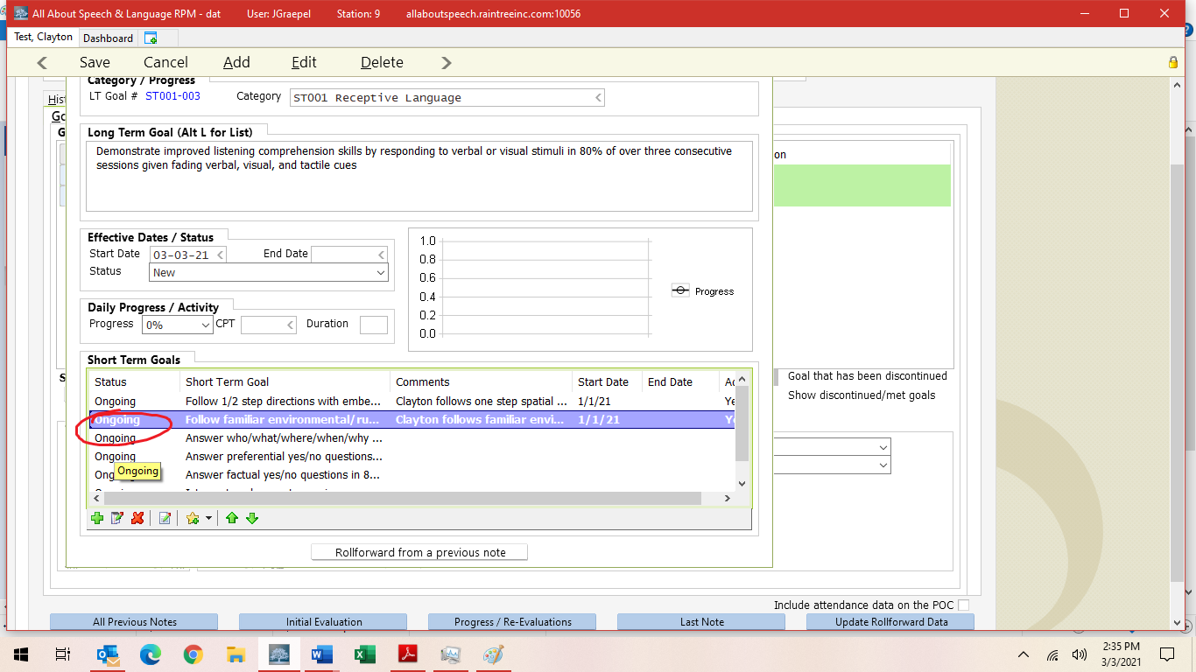

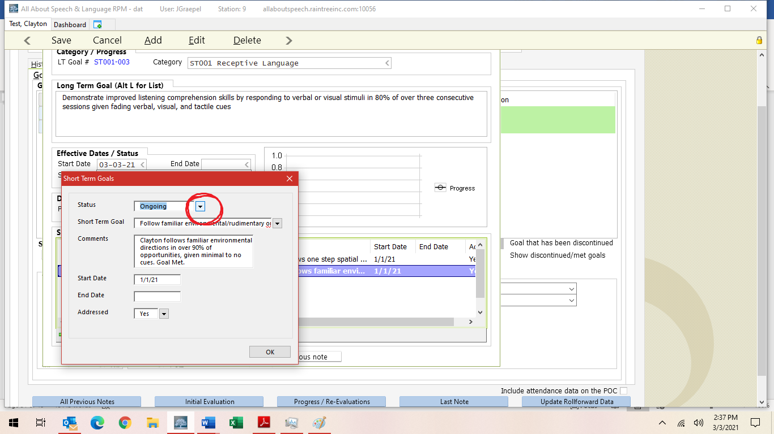

*IF A STG IS DISCONTINUED OR MET, BE SURE TO PUT AN END DATE!
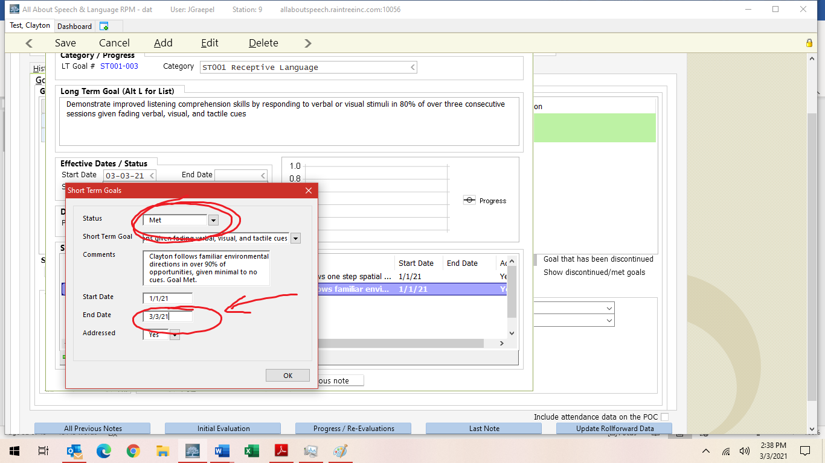
*SAME GOES FOR ANY LTG DISCONTINUED/MET (ALONG WITH STATUS CHANGE)
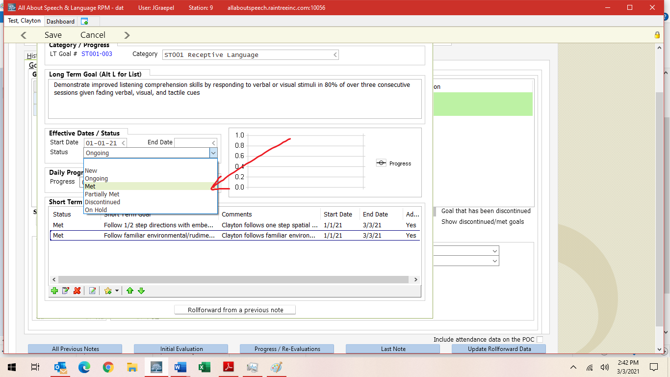

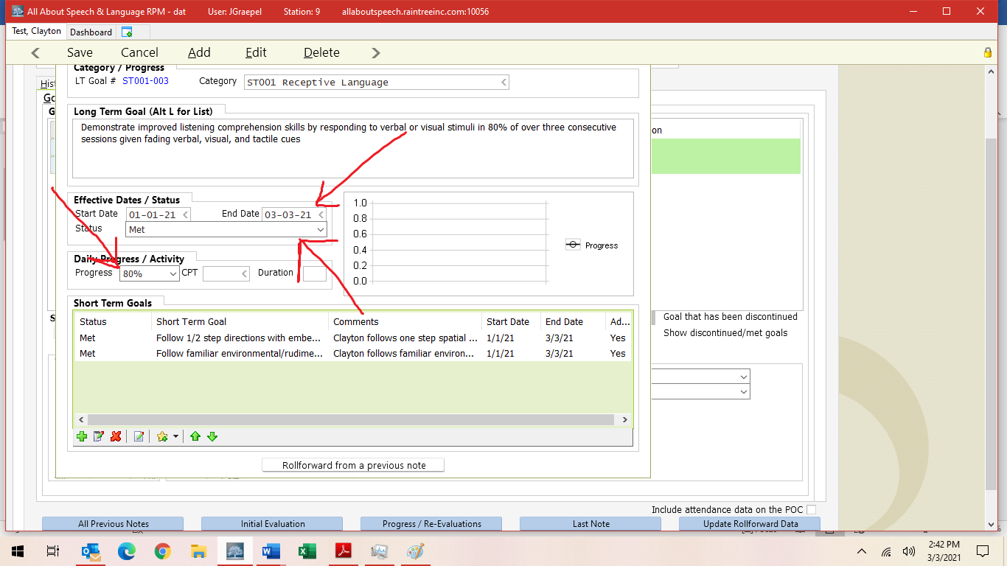

- Under Treatment Plan Summary, select prognosis, then list what STG and LTG are going to be achieved. Generally, we do 6 months for STG and 12 months for LTG; if a client has more severe deficits, you can put LTG for by discharge.
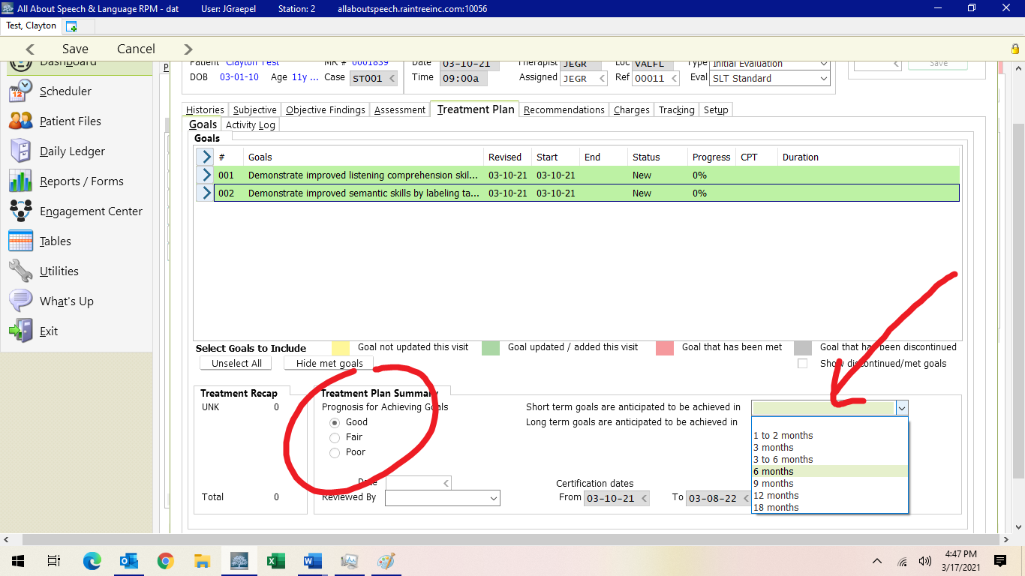

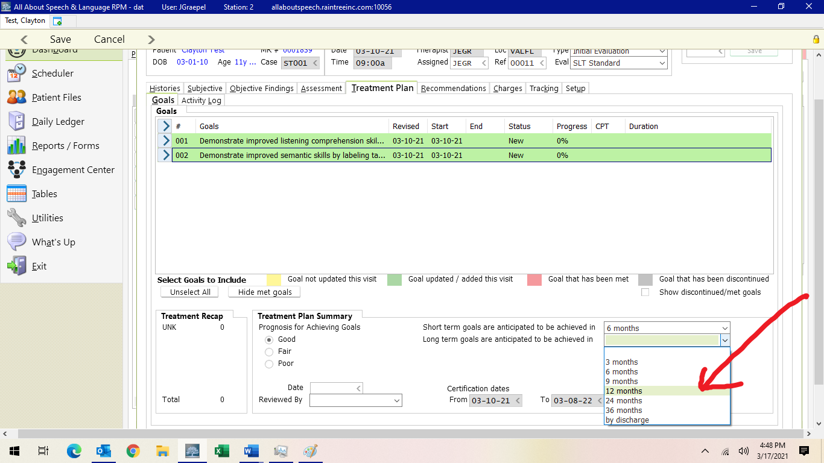

Recommendations and Charges Tabs
- Fill in Recommendations to continue with plan of care
- Recommendation: Continue treatment or Discharge

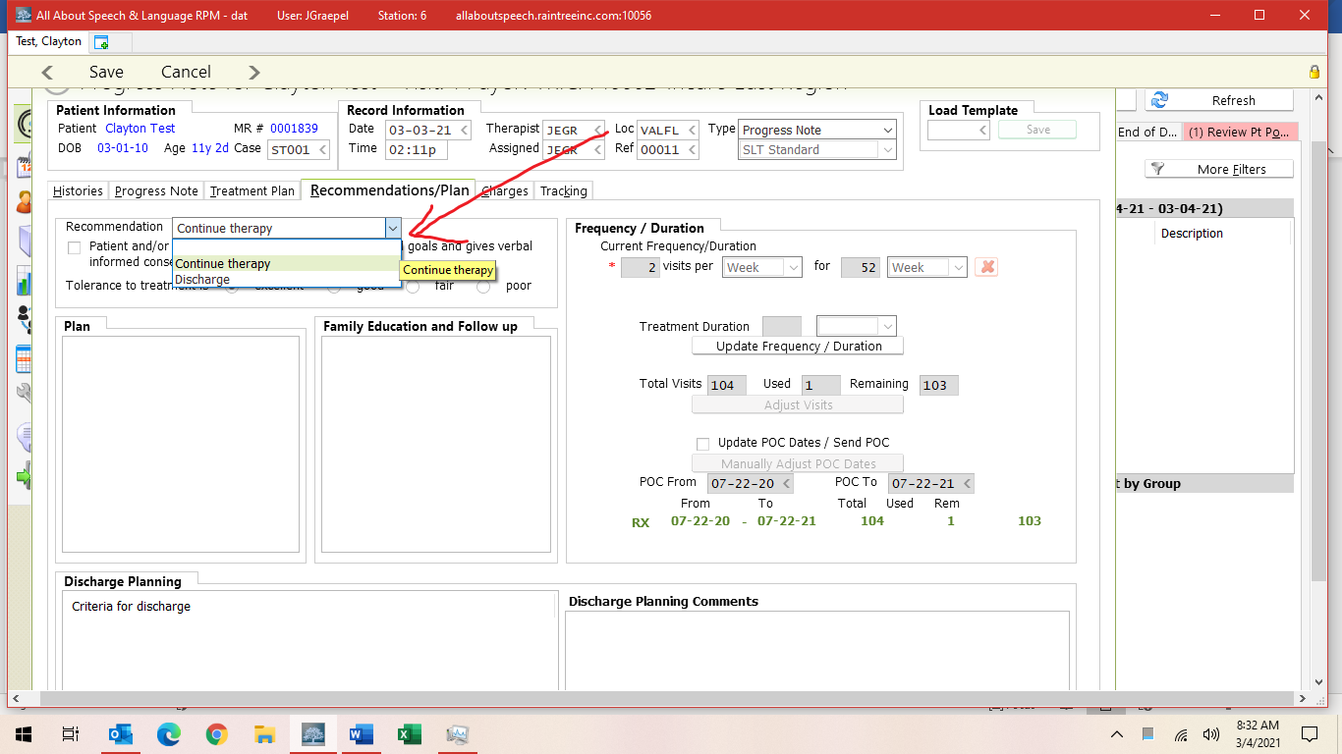

- Plan: write a small blurb about plan of care (similar to recommendations portion of an evaluation
- Example: Based on clinical observation, parent reports, qualitative assessments, and documented progress, skilled speech-language intervention is still warranted at this time. _______ readily participates in treatment. Oral motor structure/function and hearing remain within normal limits. _____ continues to make noticeable progress; however, would benefit from the prescribed amount of treatment of 2x/week ---OR--- and will continue to benefit from prescribed amount of 2x/week. While _____ has made progress, he continues to present with global deficits across receptive, expressive, and pragmatic language skills, as well as speech sound production skills. Therapy should continue to address speech sound production skills and the application of age-appropriate concepts through activities embedding such information (i.e. identifying the main idea, sequencing simple stories, inferencing, etc.). New goals have been instated to target adverbs and prediction as well as to ensure progress toward age-appropriate language skills. Upon mastery of adverbs, conjunctions should be targeted. Pragmatic language skills should continue to be addressed as well, targeting social reciprocity across various interactions. A home program/home practice should also be encouraged to promote carryover and generalization of newly learned skills. Additionally, recommendations to ______ were made to rule out any underlying conditions that may be contributing to ______. Continue to monitor _____ and initiate goals as deemed clinically necessary. These communication domains do not need to be directly addressed at this time given current areas of need, but can be layered, in conjunction with speaking tasks.

- Family Education and Follow Up: did you conduct wrap-ups? Did parent sit in on sessions? Please note here.

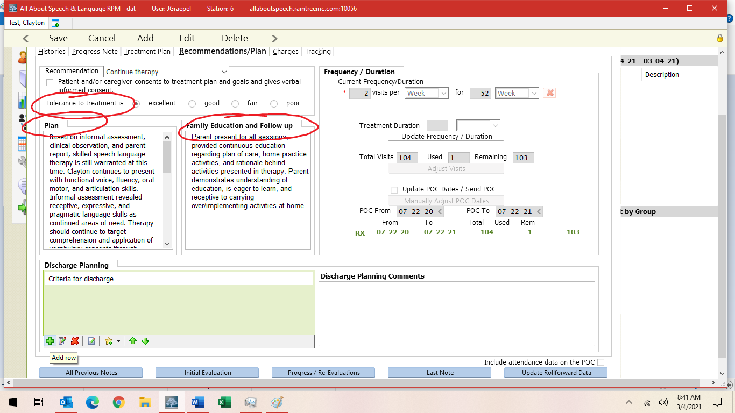

- Fill in the criteria for discharge, if changed from eval/re-eval

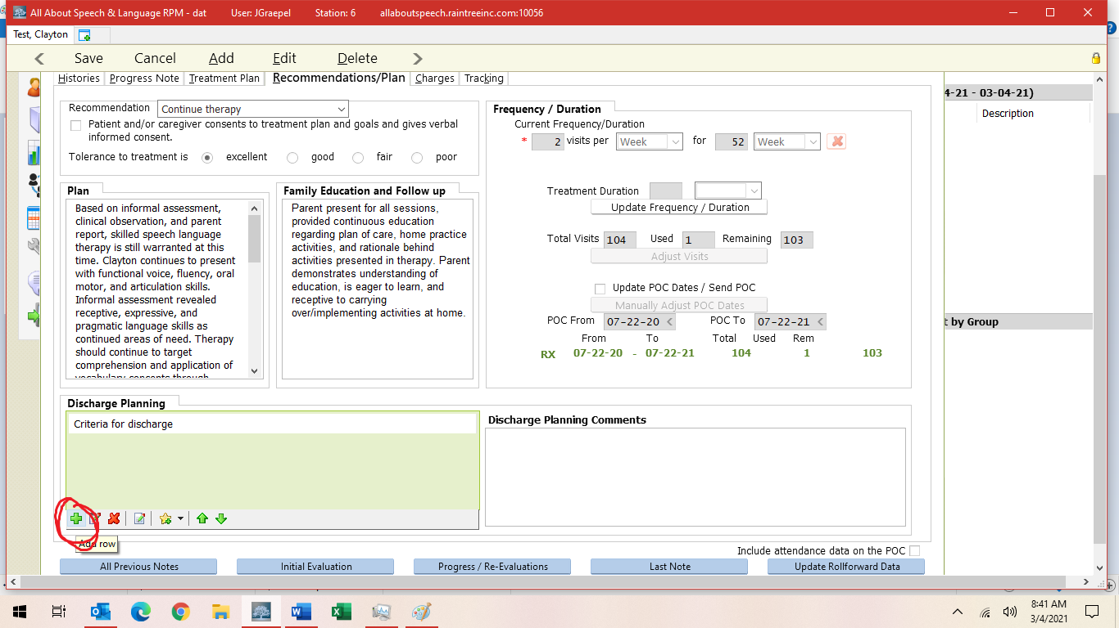

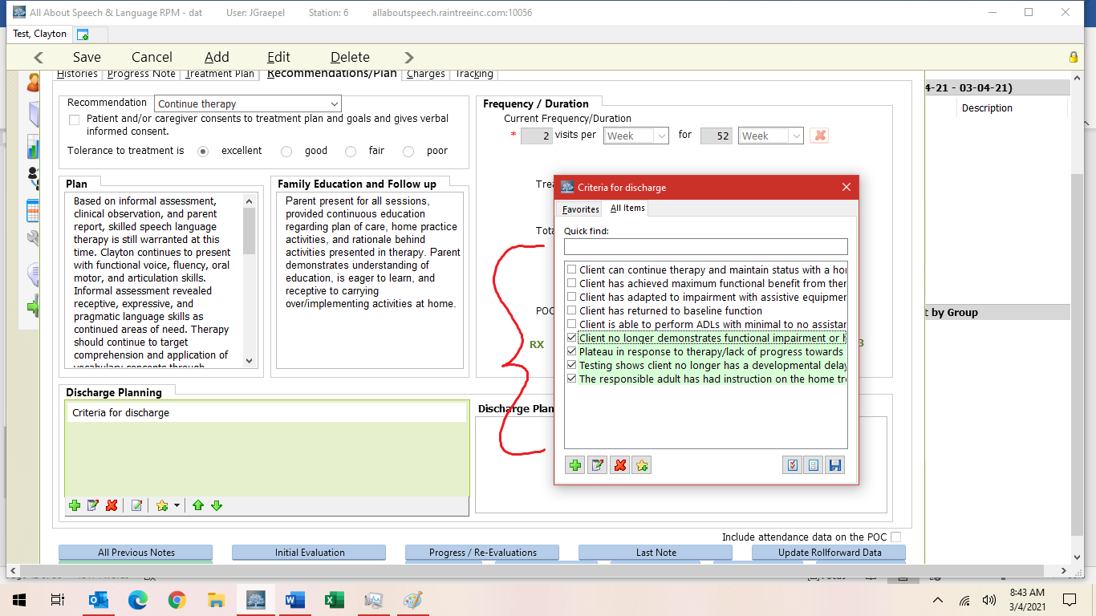
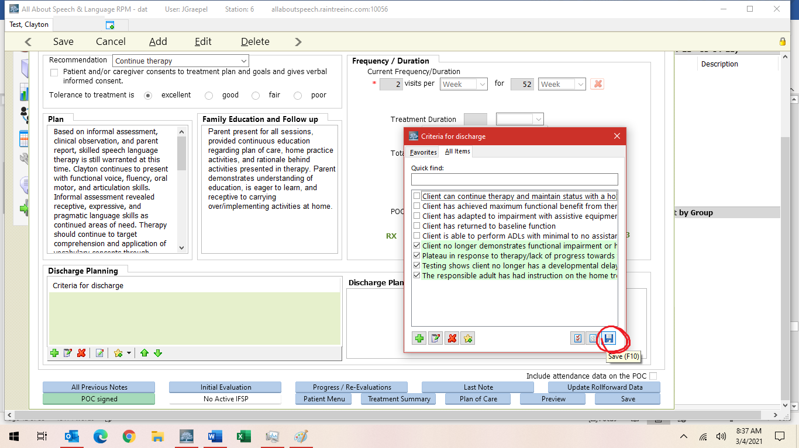

- Save and Exit and/or Save and Sign off on the note

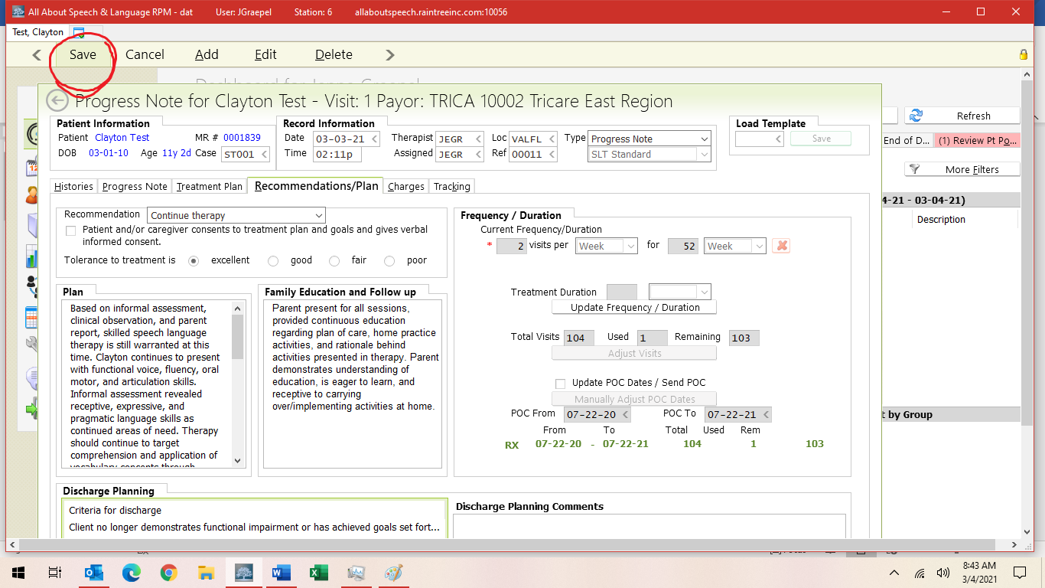

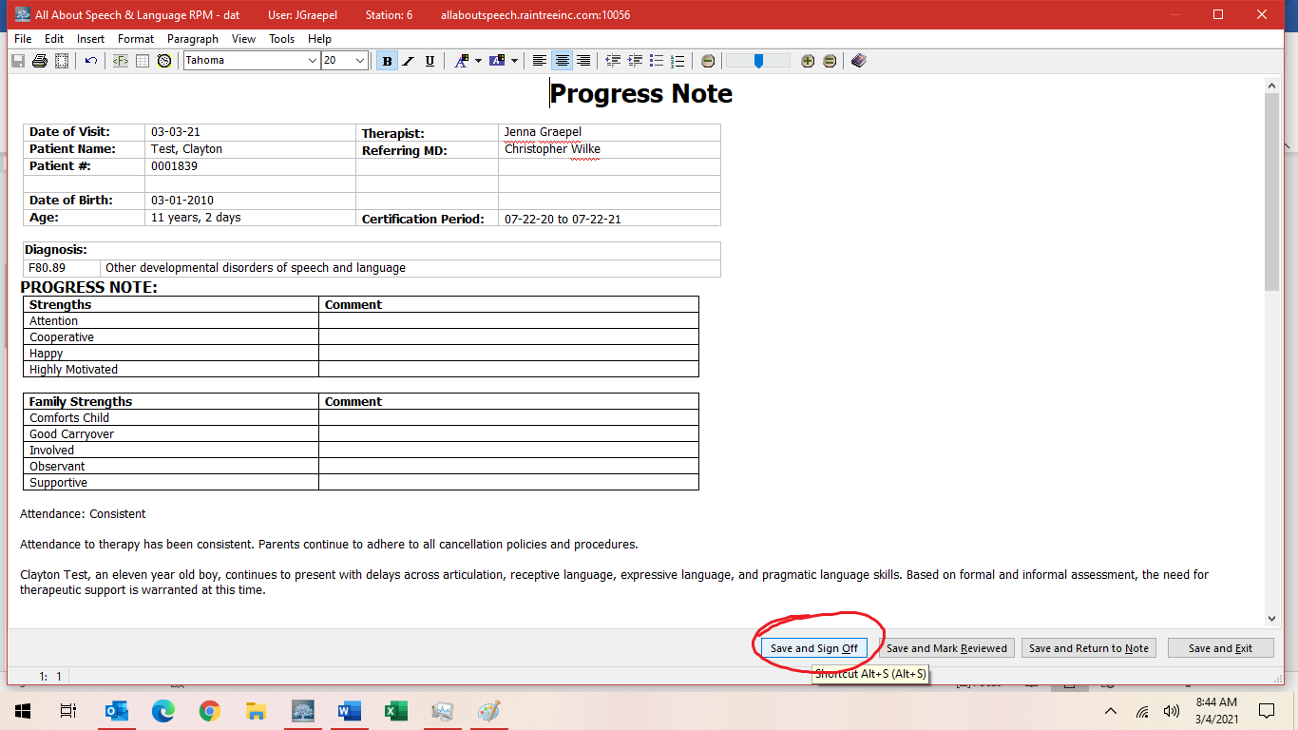

- Be sure to give the note a read-through to ensure no glaring typos or errors before signing off on the document. This is a last impression a doctor, family, or insurance reviewer will be seeing from us, so take care in your review.
- If a parent/caregiver requests to have the progress note sent to them or another professional, please inform the Front Desk. Please do so by providing client name, parent name, and specific request. They will send documentation to parents or other professionals as requested, ensuring necessary releases of information are on file.
- NOTE: Do not sign off on a client's daily note if they have an open evaluation or progress note. When you see a client for a daily treatment session who has a re-evaluation open, do not address or comment on ANY goals in the daily note until the re-evaluation is signed off. This causes issues for NEW, MET, or DISCONTINUED goals not to be able to roll forward automatically. While the re-evaluation is “open,” please input your data into the assessment portion. Once the re-evaluation or progress note has been signed off, you can then address the goals and add your data to the short- or long-term goals and comment boxes and sign off on the note.

Cosigns:
- When starting as a clinician here at AASL, all documentation will require a cosign. Upon your completion/sign off of a note, it will be sent to someone in Quality Division for review.
- Cosigns are required for the purposes of ensuring consistency of documentation across the team. Additionally, TRICARE does require a cosign until a clinician becomes an approved provider.
- Once a note is signed, it will be removed from the Cosignee’s Dashboard onto the Cosigner’s dashboard. Daily notes should be completed within two business days, progress notes or discharge notes within 2-4 business days, and evaluations/reevaluations within two weeks.
- If there are any edits that need to be made to documentation, the Cosigner will send an email outlining specific feedback. The cosigner will also designate a time which within these edits need to be made. If no time frame is specified, changes must be made within 48 hours of receiving this feedback to ensure timely completion of documentation.
- Please do all edits within the note template/detail. Do not edit the final draft page. Edits made in the final draft page result in a change to the note that prevents billing from adding charges. Billing will not be able to post charges until signed by cosigner if this occurs. It will look like this:
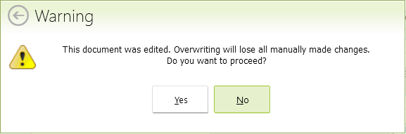
- Tips for optimizing the cosign routine:
- Familiarizing yourself with procedures as outlined in the Therapist Hat Pack
- Being proactive about seeking feedback may help reduce the time it takes for editing/completing documentation
- If you want feedback prior to signing a note, please communicate this to the Quality Division in a timely fashion so there is ample time for review.

Shared Clients:
- Often time clinicians will “share” a client (i.e Billy is seen by Ms. A Monday and Ms.B Wednesday). Please be sure to consult with the other treating clinician regarding data collection for continuity of care purposes.

