Contents
Opening Appointment 1
Subjective 3
Goals Addresses/Assessment 4
Plan 9
Charges 9
Signing Documentation 10
Providing Documentation: 12
Cosigns: 12
Shared Clients: 13
Adjusting Goals: 13

Opening Appointment
- On your daily scheduler you will right click on the client appointment in the EMR system and hit check-in UNLESS they have already checked in at the kiosk. There will be a yellow box in the upper left-hand corner to indicate a client has been checked in to their appointment.

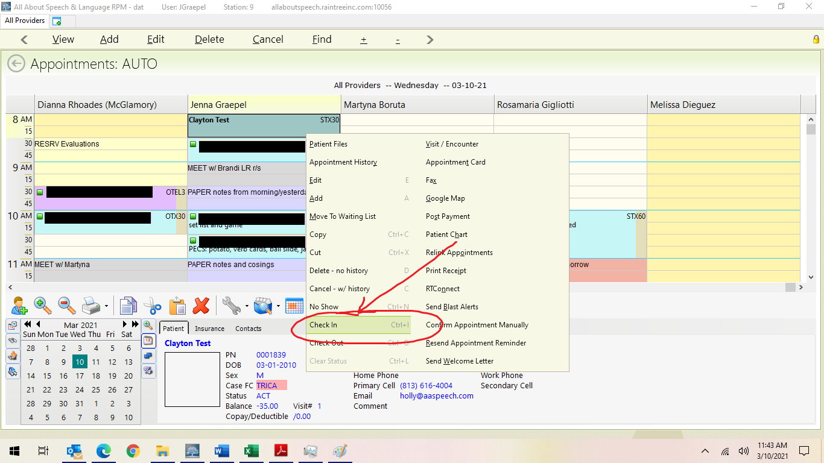

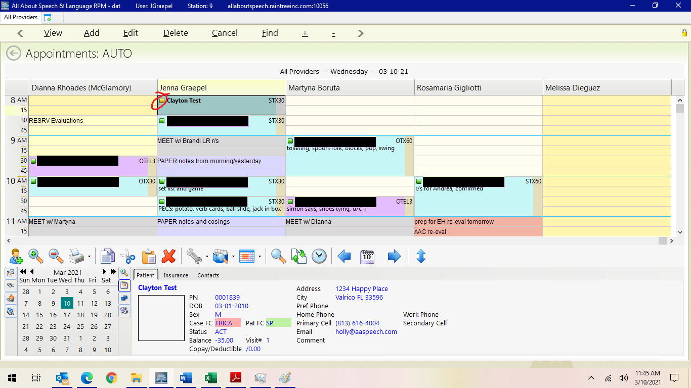

- This will initiate the daily note for that visit. Double click the appointment to open the note. You will work across the following tabs and fill out the respective information in each section

Subjective
- Use boxes to fill in (i.e. tolerated, engaged and responsive, who was present for session etc.). Please complete the following in the assessment portion so that it rolls forward for another therapist who may see this client next. Please be mindful of your word choice when adding information to the subjective section. It needs to be factual while also being pragmatic. Terminology like “abnormal”, “maladaptive” or “atypical” is not appropriate for a daily note. Cause of behaviors cannot be assumed. Appropriate examples:
- “observed to readily participate”
- “observed to be reticent to participate”
- “parent reported xxx”
- “child demonstrated _______”
- “child appeared tired/sick, observed with ______”
- “observed with _____, _____, and _____, which may have been secondary to noncompliance, avoidance, preference, stimulation, etc.
- **If a client is late, please DO NOT state in the note that the client was late. TRICARE does not like to see us billing for an expected 30-minute session that is not 30 minutes. Instead, please use the phrase “limited trials due to time constraints”
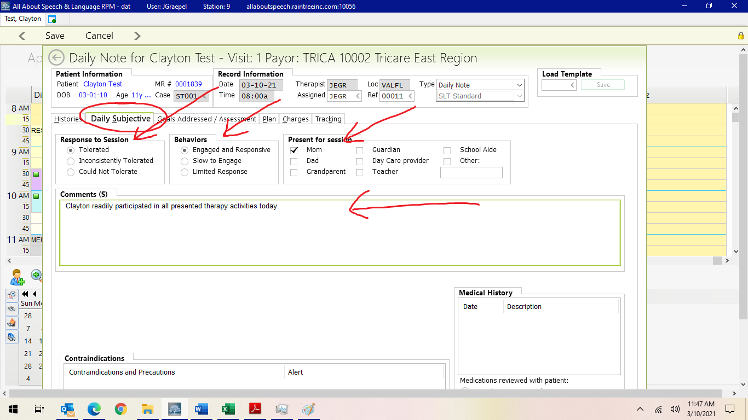

Goals Addressed/Assessment
- Assessment Box
The information below will be included in the assessment box under the goals so it rolls forward and should be modified session to session as needed/ to reflect current needs. As a reminder, you can also use the Notes to Treating Therapist box under the goals tab for any information you want to include that you do not want populating to the daily note.

Verbiage that can and should be used in documenting Daily Notes:

1. How the client transitioned:

Examples
- Client transitioned
- with ease/difficulty; w/parent/caregiver or w/o
- w/handheld assist (HHA) or transition item
- how they transitioned between activities (i.e. with use of first then language, visual aids,
star chart, etc.)

2. Any behaviors observed or strategies that were beneficial to increase overall success and productivity of session:

Examples:
- Client benefitted from 5 min of movement activities in conjunction with therapeutic tasks to increase participation (swing, jumping, trampoline, etc. specific movement breaks they like or
- Client was highly motivated to work for ____ at the end of session.
- Client required movement breaks throughout the session to improve engagement with therapist-directed tasks.
- Arhythmic/rhythmic music used to increase engagement/participation, to decrease vocal stimming, etc.

***REMINDER: DO NOT comment on self-regulation, sensory integration, etc.

3. Any equipment used (i.e. glasses, AAC, wheelchair, etc.)

Examples:
Client uses Proslate 8 equipped with LAMP WFL, Proloquo2Go, etc. with __x__ grid size, stylus, etc.

- Goal Selection:
  - Do not select any of the goals for a treatment session if a progress note or evaluation is open. Collect your data in the assessment box and you may select goals and sign off on the daily note once the previous evaluation or progress note has been completed.
  - Please now select the long-term goals (carrot arrow on the left side of each long-term goal) and double click on the long-term goal, then once the short-term goals populate (they will initially be grayed out), hit address goal button and do 1 of the following:

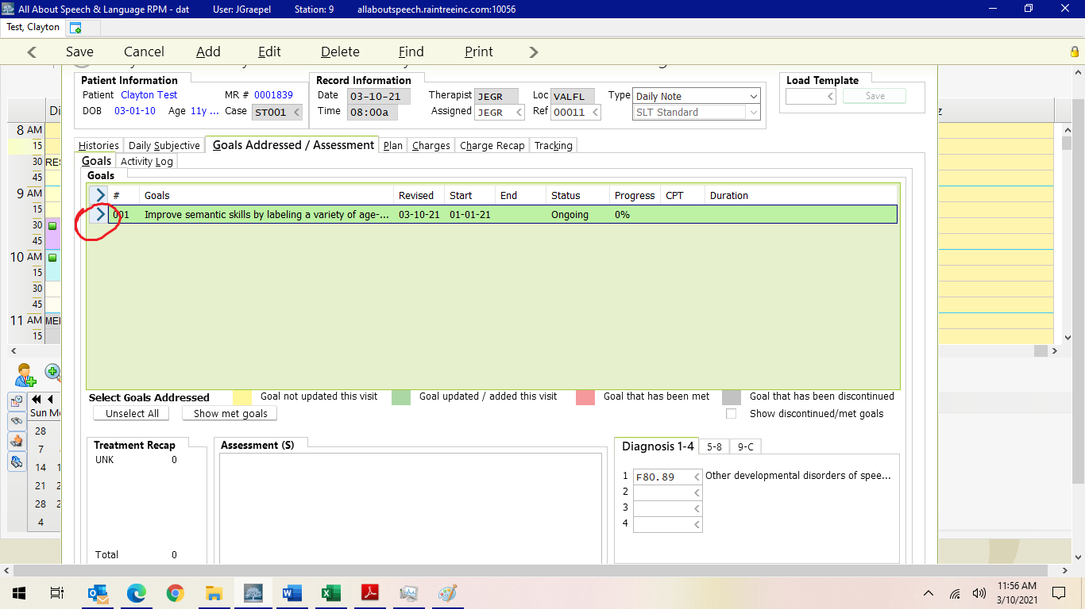

OPTION 1: Keep your daily note data in the open text box as you have been doing and just select the long-term goals and each short-term goal you addressed for that session. In the comments box you can put a general statement that says “See Data Above.” If you keep your note this way, please be mindful of the data that is denoted “Did Not Address” so that the note doesn’t become too long if Tricare requests it (delete out unnecessary parts etc.).
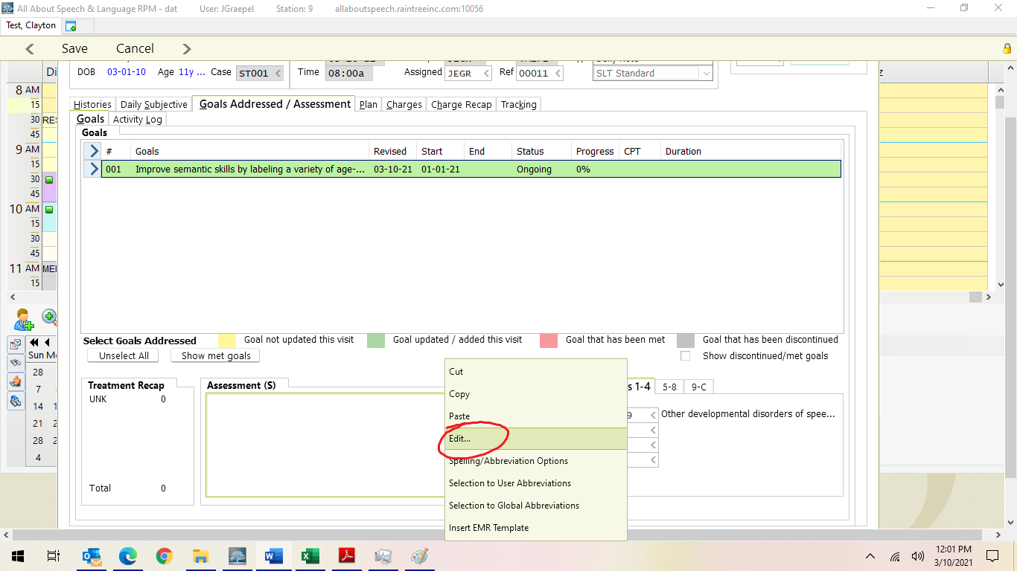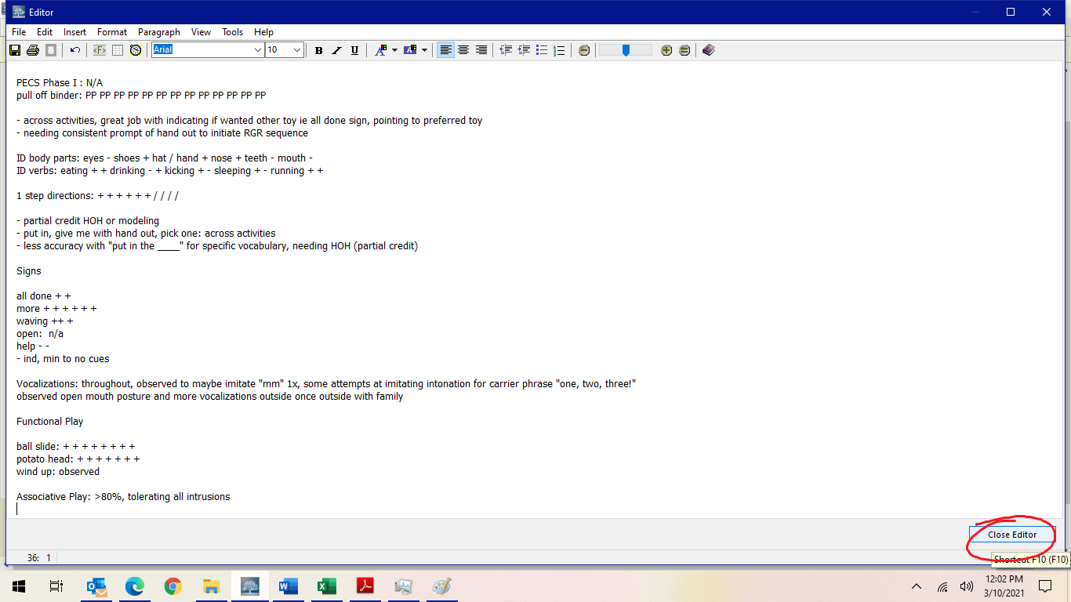

OPTION 2: Take data in the respective comment boxes for each short-term goal area.

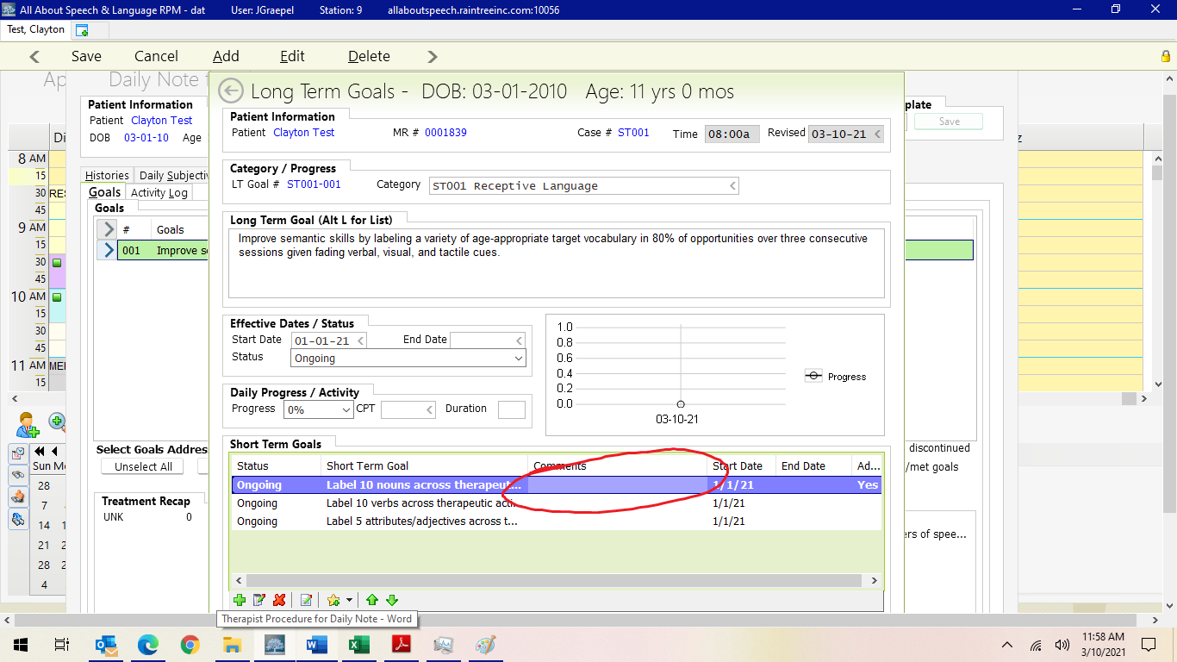
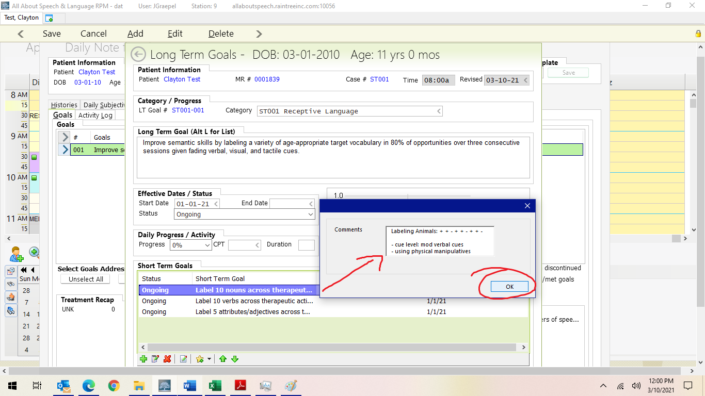

- Note: the comment boxes may limit how much information you can put in there, so use your judgment relative to what format you choose.
  - Be sure to select “Yes” (located all the way to the right) for goals you have addressed.

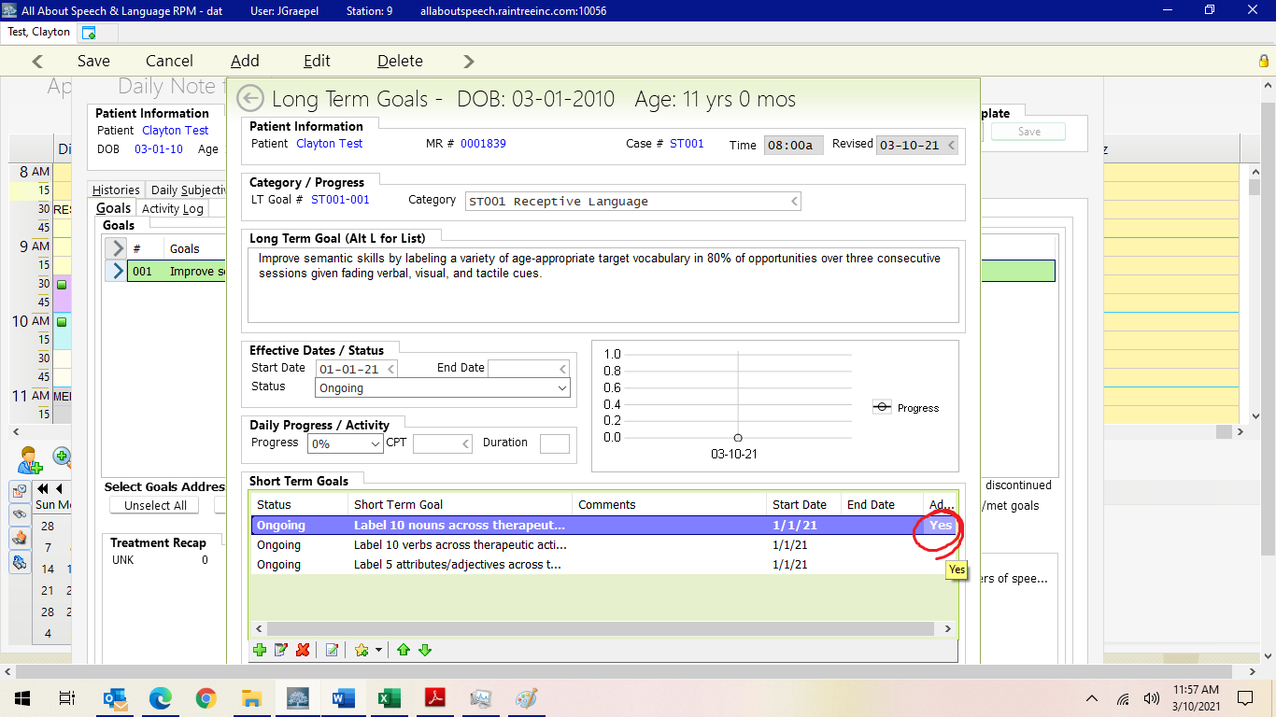

- Data/Cueing Information: When you are in the daily note and you are taking your data, please include the following:

  - Use of ‘+’ to denote full credit, ‘-‘ for no credit, and ‘/’ for partial credit
>Change to Tahoma so “I” looks like an “I”
  - Cueing Levels: note support levels: min, mod, max and type if applicable (verbal, visual, tactile, gestural/pointing, hand over hand)

Insurance reviewers/companies and parents are less likely to take the time to decipher keys while reading a daily note. While the specificity is appreciated, we are looking to keep this aspect of documentation uniform across our practice. Additionally, this creates more work for the clinician that is not necessary.
The following symbols are acceptable for use within a note:
FOR ALL NOTES:  I for Independent  NR for No Response  HOH hand over hand support | FOR AAC/PECS:  I for Independent  PP for partial prompt  FP for full prompt (this includes hand over hand support)

The following are not necessary/acceptable:
X unintelligible  R refusal (is not an objective measurement/cannot be assumed unless the child clearly states they do not want to execute the trial)  SC self-correction | M modeled  i imitated  EW expectant waiting  HEP Home exercise program

You are welcome to note this information under your objective data. Some examples (you do not have to use these specific comments, these are just for reference):

“Partial credit if imitated”  “Full credit if self corrected without prompt”  “No credit for no response”  “Max cues throughout, modeled for all trials” | “ ‘xx’ used to note unintelligible combinations within utterances” (if recording language sample)  “Modeled x5 for initial trials”  “Sent home for additional practice/reinforcement (many of our clients have a home program goal  already)”

- Other items for clarification:
  - Increasing Number of Trials in a given session: reference to CEU ideas, gold standard # trials for quantity. Discuss articulation vs language # targets. Strategically using a session’s time to be as productive as possible: “You are not there to practice your speech/language skills... they are!!” Research supporting for articulation aiming for minimum of 100 trials in a 30-minute session.
>Sand timers, electric spinner, clicker, rolling dice to help get productions in!
Partial credit as denoted by /.... use for partial accuracy, distorted, or partial credit given if additional cues were needed (above mod or max or the indicated cueing levels, etc.). Denote further what cues were needed to get that response.
Multi-step directions: how to notate accuracy of “steps/elements” within the larger direction>note in this manner for clarity in note with [-+-] or 2/3, etc.
Indicate imitated vs spontaneous

WH questions:
This is client dependent: mostly it is recorded under Receptive for “understanding” (if there’s a visual field of choices (it’s receptive) or if the client points to an answer or responds with a single word). Expressive responses to questions (1 word or a sentence): expressive responses usually recorded under another expressive language goal. If they respond beyond 1 word, the question goal might best be recorded under Expressive for Responding to/Answering Questions

Plan
- Use boxes to fill in (continue with present treatment plan etc.)
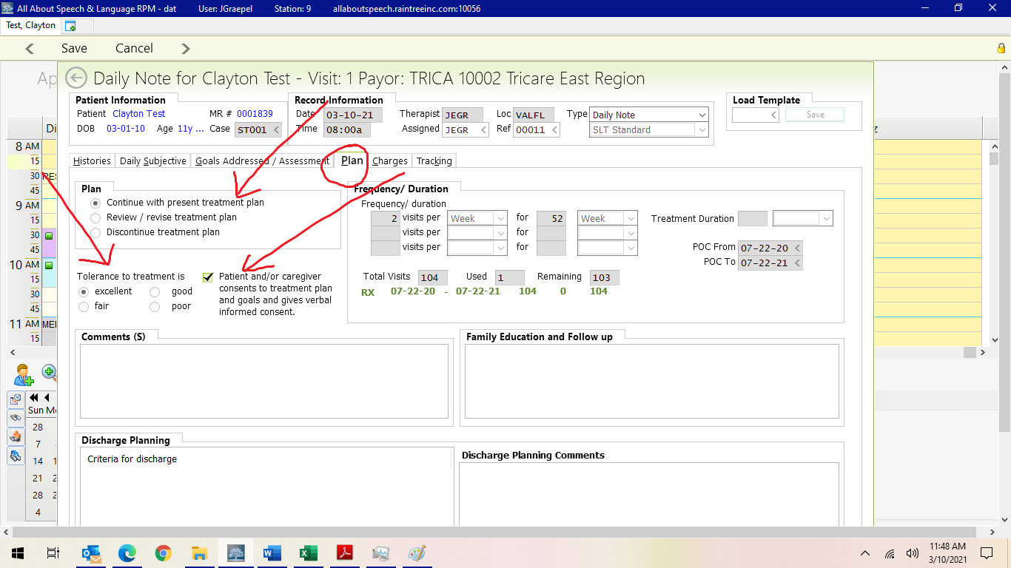

Charges
- Apply all charges to notes before end of the same business day and complete the written note by the end of the next business day. Select appropriate treatment visit length:
- 92507 Speech/Hear Therapy 30 min = all TRICARE sessions/30-minute self-pay
- Speech/Hearing Therapy 60 min -SP = 60-minute self-pay sessions
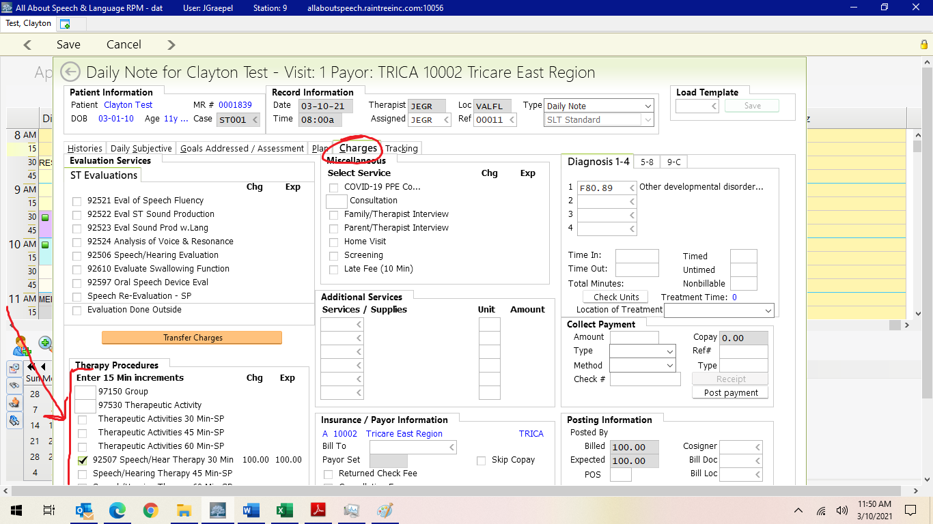

- Select “Save” to take you to the final sign off screen
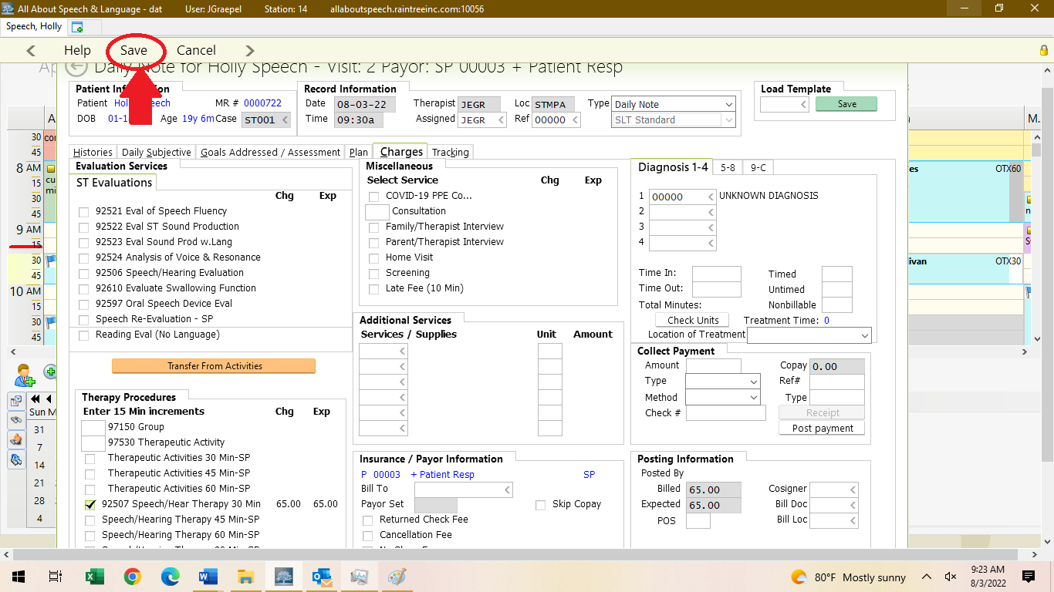

Signing Documentation
- Be sure to give the note a read-through to ensure no glaring typos or errors before signing off on the document. This is a last impression a doctor, family, or insurance reviewer will be seeing from us, so take care in your review.
- Select “Save and Sign Off” in the bottom right-hand corner. Select “Save and Exit” if the note is not yet completed or ready for signing.
- If you need to go back and revise the note, select “Save and Return to Note”. This will not delete any data in the detail of the note; however, it WILL clear any manual changes you made in the white sign off page.

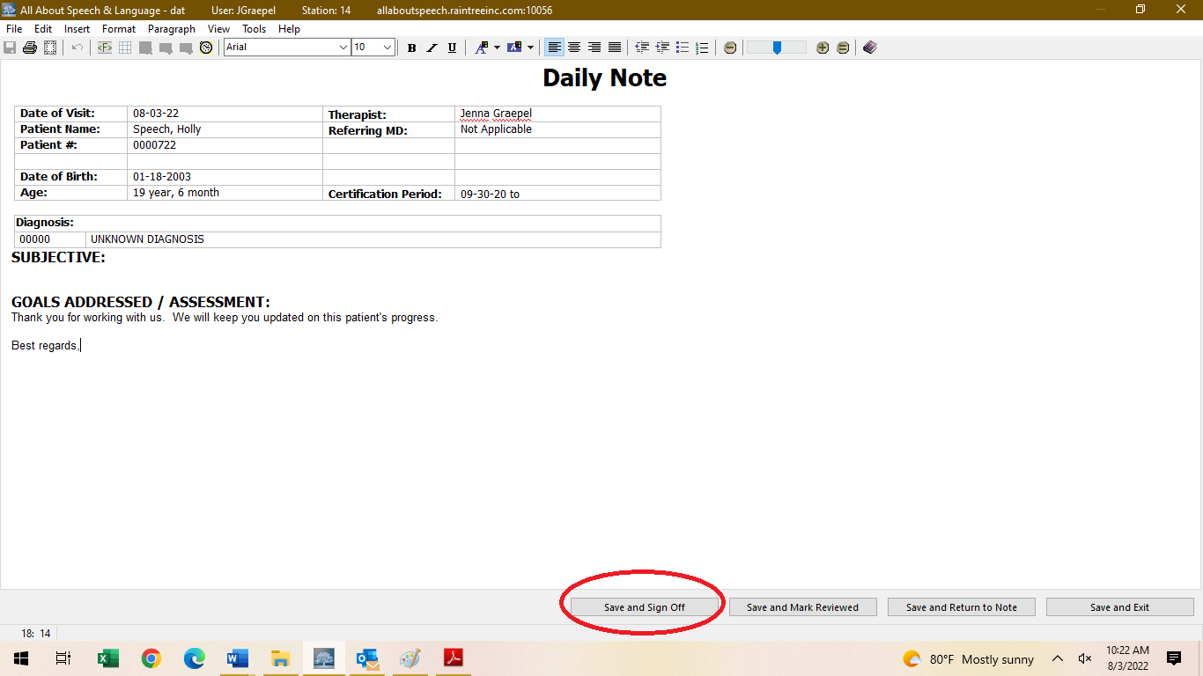

- When ready to sign, type your Raintree Password in the pop-up, then select “Save and Sign off”

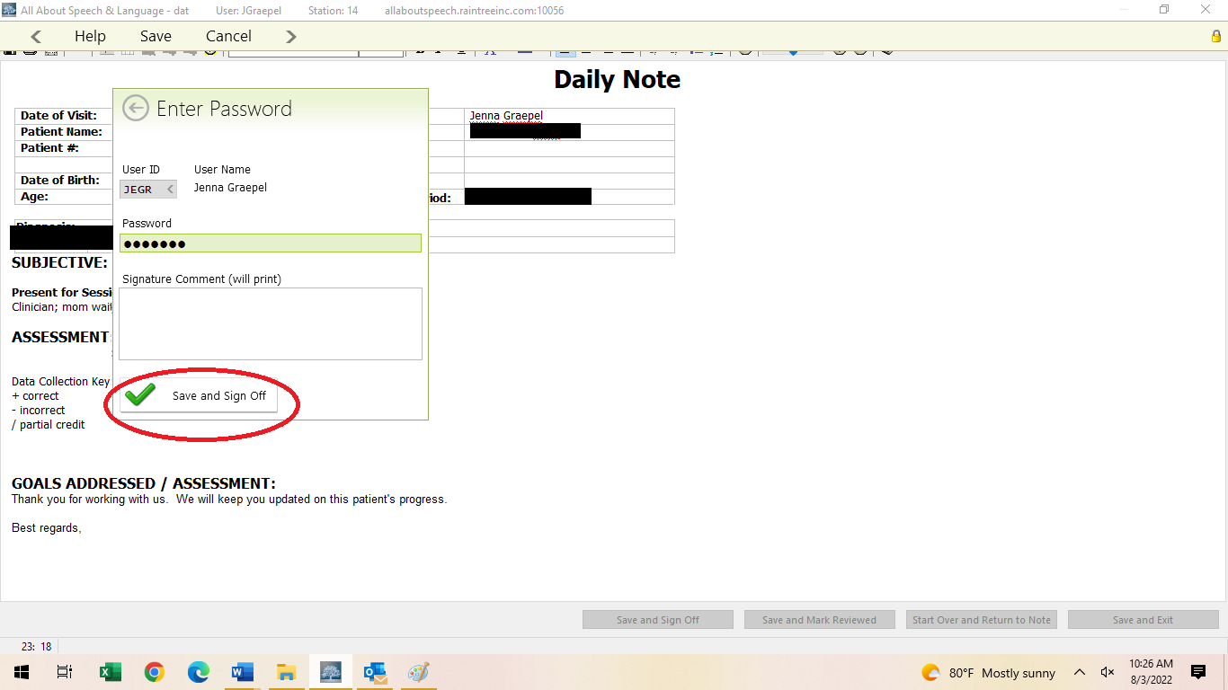

Providing Documentation:
If a parent/caregiver requests to have a note sent to them or another professional, please inform the Front Desk. Please do so by providing client name, parent name, and specific request. They will send documentation to parents or other professionals as requested, ensuring necessary releases of information are on file.

Cosigns:
- When starting as a clinician here at AASL, all documentation will require a cosign. Upon your completion/sign off of a note, it will be sent to someone in Quality Division for review.
- Cosigns are required for the purposes of ensuring consistency of documentation across the team. Additionally, TRICARE does require a cosign until a clinician becomes an approved provider.
- Once a note is signed, it will be removed from the Cosignee’s Dashboard onto the Cosigner’s dashboard. Daily notes should be completed within two business days, progress notes or discharge notes within 2-4 business days, and evaluations/reevaluations within two weeks.
- If there are any edits that need to be made to documentation, the Cosigner will send an email outlining specific feedback. The cosigner will also designate a time which within these edits need to be made. If no time frame is specified, changes must be made within 48 hours of receiving this feedback to ensure timely completion of documentation.
- Please do all edits within the note template/detail. Do not edit the final draft page. Edits made in the final draft page result in a change to the note that prevents billing from adding charges. Billing will not be able to post charges until signed by cosigner if this occurs. It will look like this:

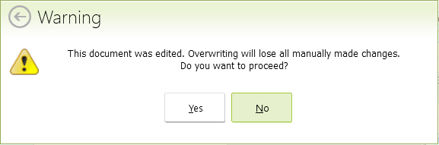
- Tips for optimizing the cosign routine:
- Familiarizing yourself with procedures as outlined in the Therapist Hat Pack
- Being proactive about seeking feedback may help reduce the time it takes for editing/completing documentation
- If you want feedback prior to signing a note, please communicate this to the Quality Division in a timely fashion so there is ample time for review.

Shared Clients:
- Often time clinicians will “share” a client (i.e Billy is seen by Ms. A Monday and Ms.B Wednesday). Please be sure to consult with the other treating clinician regarding data collection for continuity of care purposes.

Adjusting Goals:
- After the first few sessions (3-6), if you believe that many of the goals from the outside accepted report/initial evaluation are not a good fit for the child (i.e., goals have been largely met already, where child is at upon getting to know them/their current skill levels), you may open a progress note. This will be easier for you documentation-wise and allow you to be able to better adjust the goals. By doing this, you can ensure documented progress by the next progress note/re-evaluation (whichever is sooner). This does not have to be a thorough progress note, just an update of the goals to be more appropriate for the client, better guide your plan of care and reflect it more accurately. There needs to be a statement within the progress note explaining these modifications. It is imperative that you provide a rationale within comment sections of the goals; explain WHY you are adding/changing.
- If you only need to change minor parameters for at most 1-2 goals, like cue levels, % accuracy, or to mark a goal as MET, then you may do so in the context of a treatment note. This should only be done for the occasional minor change or adjustment of a goal or two so that it does not flag Tricare in any way and cause disruption for the child’s case. If you are changing criteria, you will mark the current goal as MET if increasing criteria or DISCONTINUED if lowering criteria. Include the progress as well as end date. You will then create a new goal and make the appropriate modifications to the criteria. All other changes should be done in a progress note even if it falls earlier than what would typically be required. See examples below.

Example 1: If you met a goal in current plan of care done by AASL and you need to update/modify (i.e. increase % accuracy, decrease cueing level etc.) the goal prior to progress note time: meet the goal, then create a new goal. Keep the met goal until after the next progress note/re-evaluation so it populates on that document (whichever comes first).
Long Term Goal | Status | Start Date | End Date
Demonstrate improved listening comprehension skills by responding to verbal or visual stimuli in 70% of over three consecutive sessions given moderate verbal, visual, and tactile cues | Ongoing | 02-17-22

Short Term Goal | Status | Comments | Start Date | End Date
Answer preferential yes/no questions in 70% of opportunities over three consecutive sessions given moderate verbal, visual, and tactile cues | Met | MET – Clayton responds to preferential yes/no questions in over 90% of opportunities given minimal support. | 2/17/22 | 8/4/22
Answer factual yes/no questions in 70% of opportunities over three consecutive sessions given moderate verbal, visual, and tactile cues | New | See above, met for preference | 8/4/22

Example 2: If you need to change goal criteria from an evaluation not conducted at AASL:

The other example, would be if we are getting a goal from an outside report that is unrealistic or set too high and you want to be able to show progress by progress note time, you would change the goal status to discontinued, create a new goal with the new criteria and then comment in the comments section that “criteria lowered due to current level of client functioning.”
Long Term Goal | Status | Start Date | End Date
Demonstrate improved listening comprehension skills by responding to verbal or visual stimuli in 70% of over three consecutive sessions given moderate verbal, visual, and tactile cues | Ongoing | 02-17-22

Short Term Goal | Status | Comments | Start Date | End Date
Identify the subjective pronouns of he/she in 80% of opportunities over three consecutive sessions given minimal verbal and visual cues | Discontinued | Criteria lowered due to current level of client functioning; client currently differentiates between ‘boy’ and ‘girl’ in less than 50% of opportunities. See new STG. | 2/17/22 | 8/4/22
Identify the subjective pronouns of he/she in 60% of opportunities over three consecutive sessions given maximum verbal and visual cues | New |  | 8/4/22

