Contents
Completing a Conversion Note 2
Adding or Changing Goals 9

Completing a Conversion Note
- This occurs when you have a client starting treatment at our office, but they have a current evaluation from another facility that was completed within the last 6 months
- Conversion notes should be started ASAP, prior to the first treatment session
- Once logged into the EMR, go to Patient Files, search via the client’s last name, and then click on their name when you find it from the drop down list. Then click on the patient chart

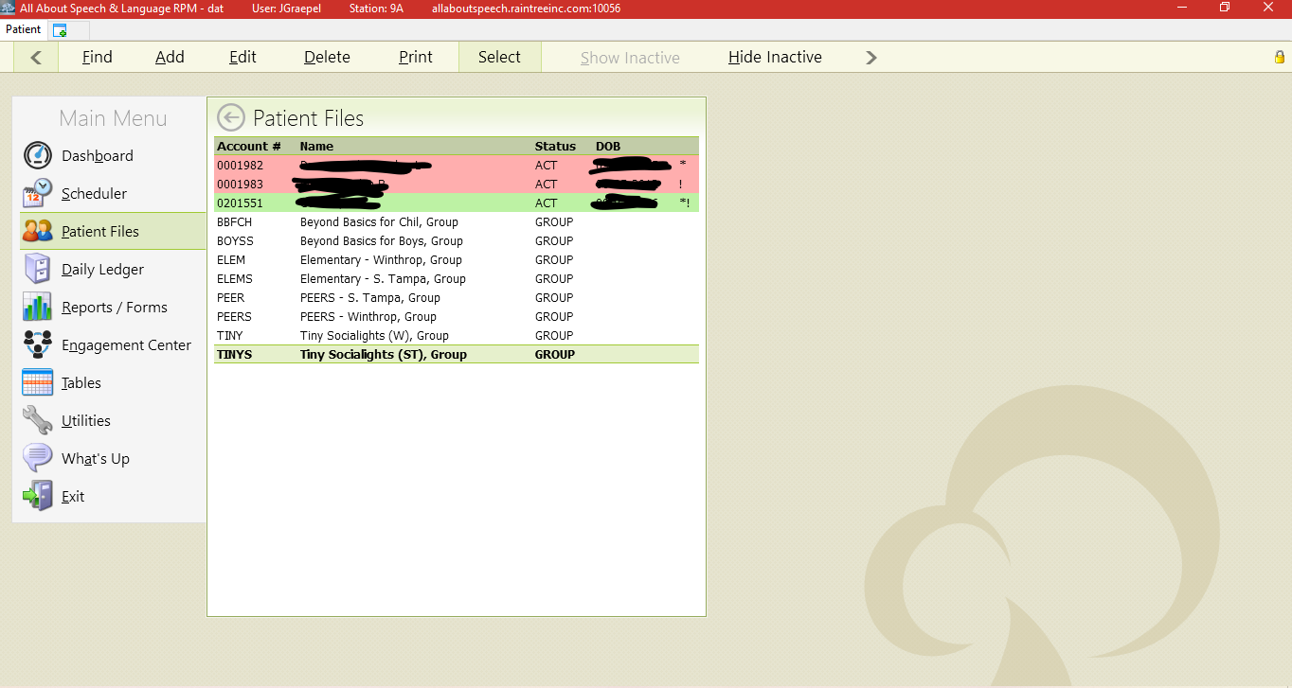

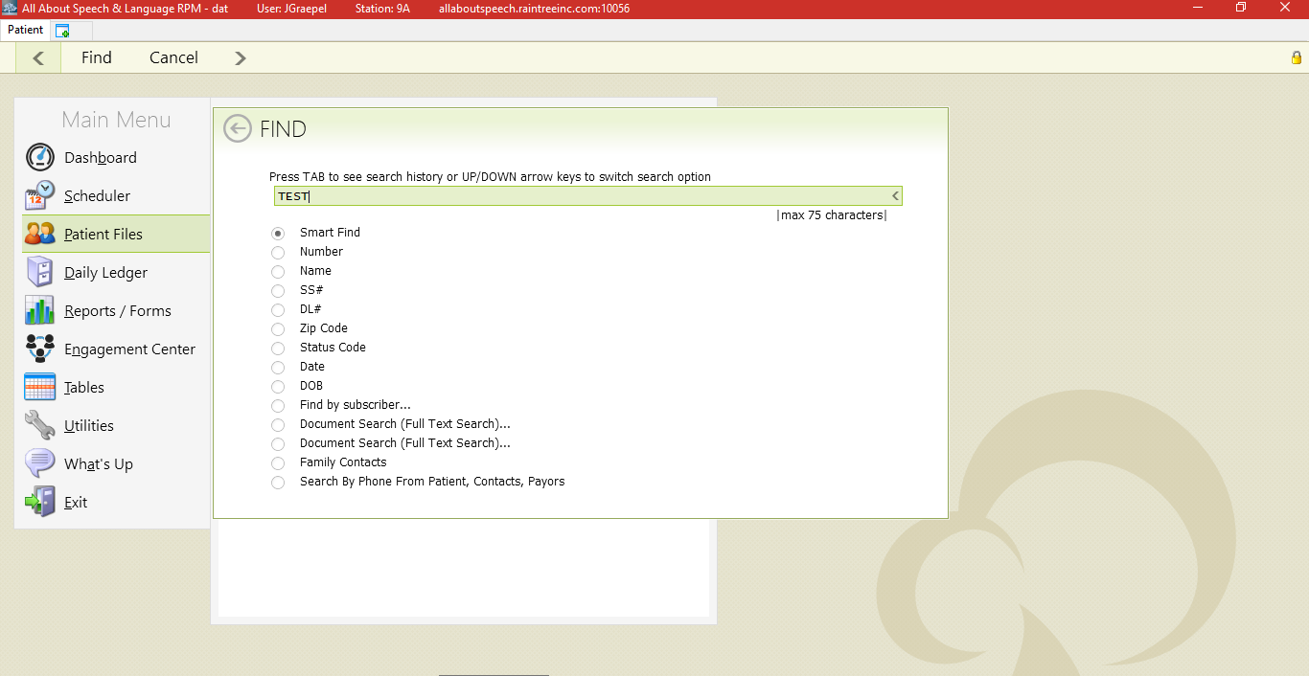

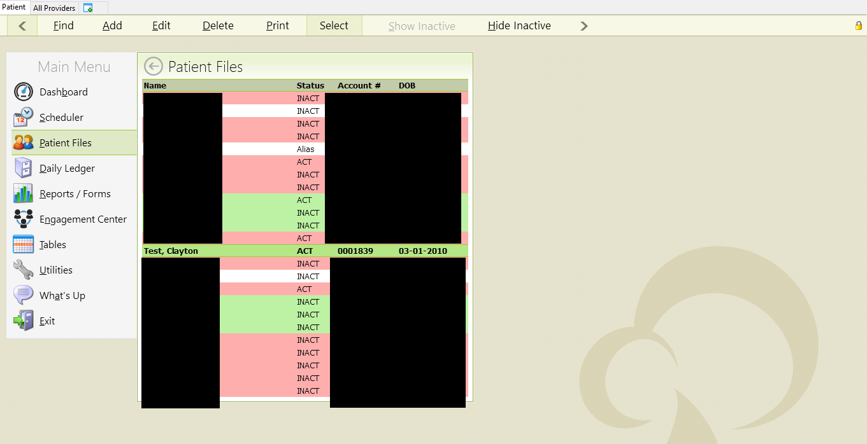
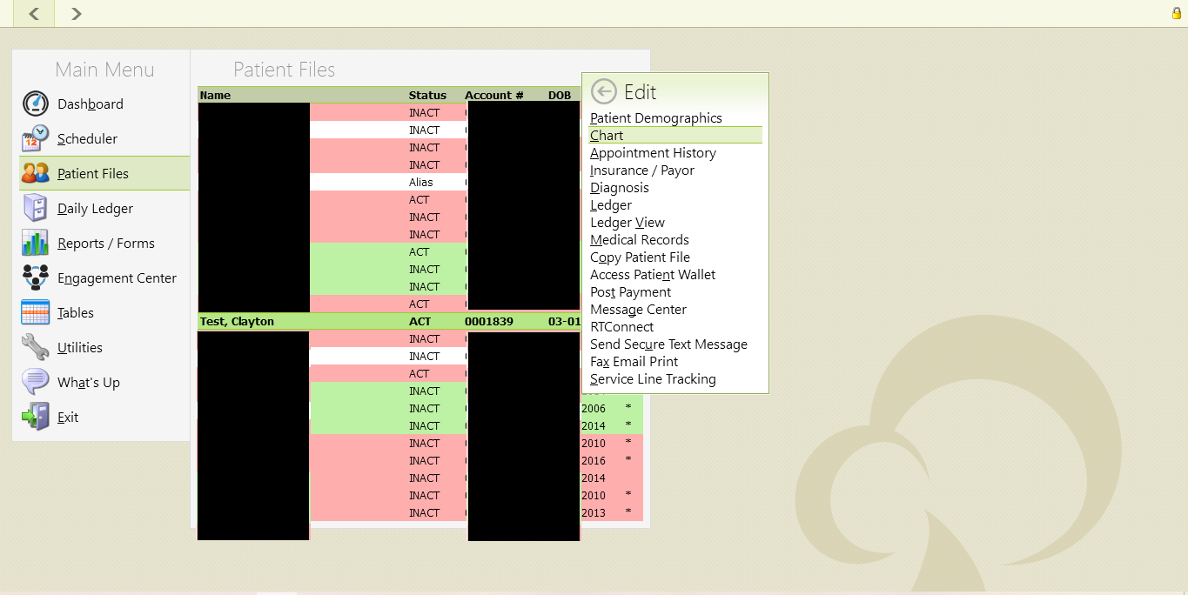

- Once in their patient chart hit A to add under Visit History, then select Long-Term Therapy Note. Select your respective discipline case (ST001 or OT001). When it populates, the note you will then need to change the Note Type to a Conversion Note on the drop down. Then under that, make sure you add from the other dropdown SLT Standard. This is located on the upper right-hand side of the note.

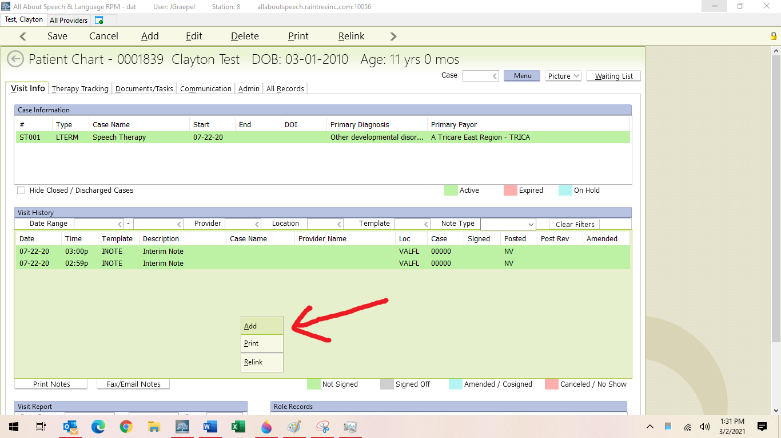

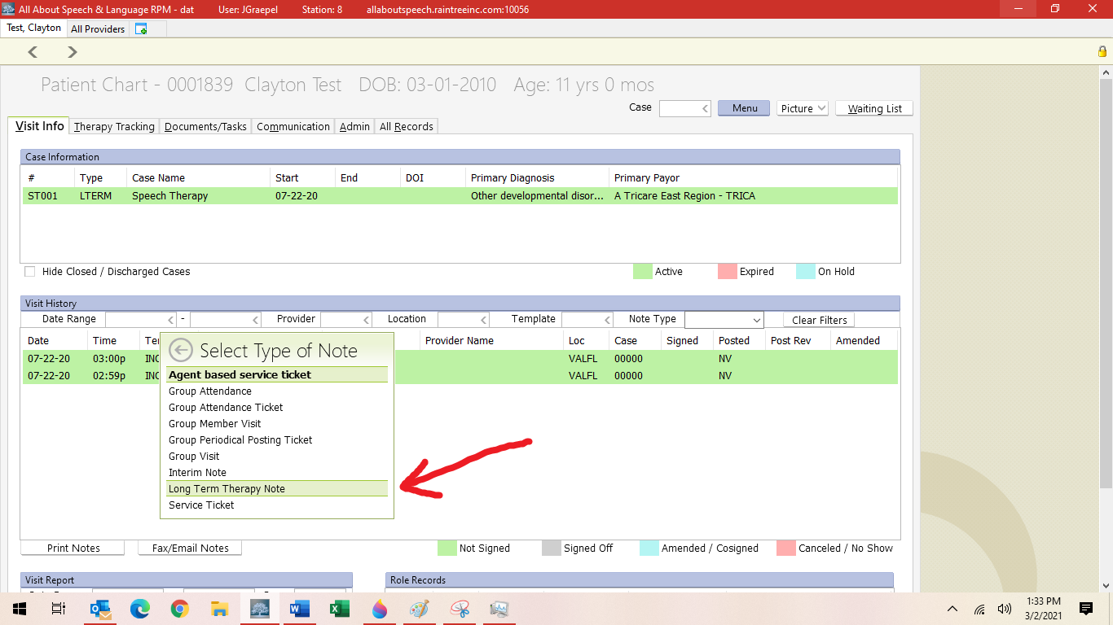

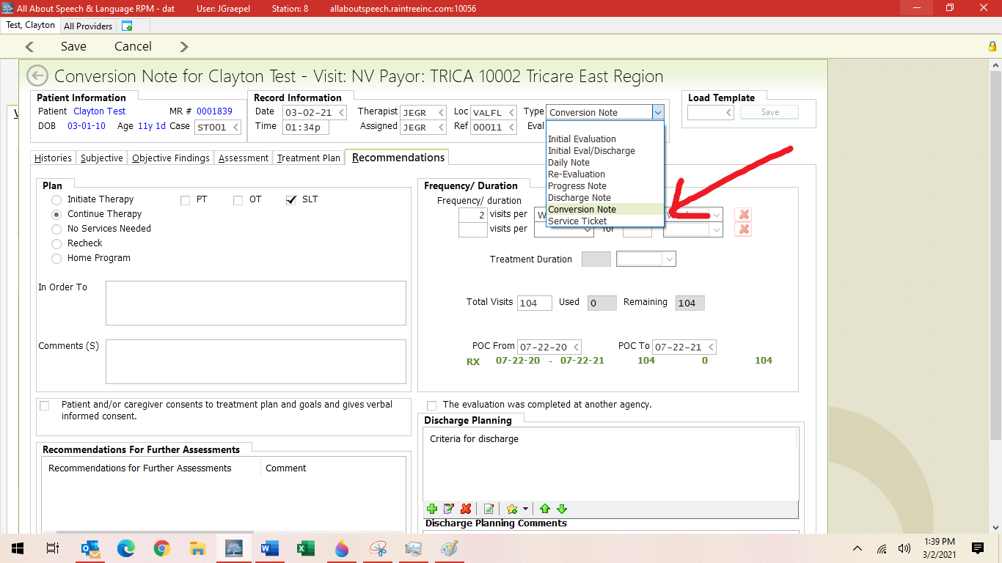

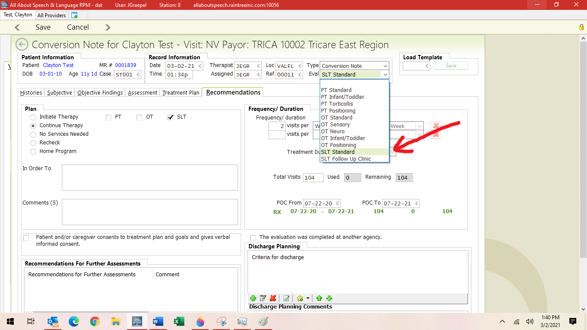

- You do not need to fill out all portions of this note template!
- Under the “Treatment Plan” tab you will add goals. Please do so the same way you would for an initial or reevaluation. We do our best to add the goals as they parallel our pick lists, but sometimes we just add them as they were written from the previous place of service; the ultimate goal is to have the goals as closely related to one another between the previous facility and ours.
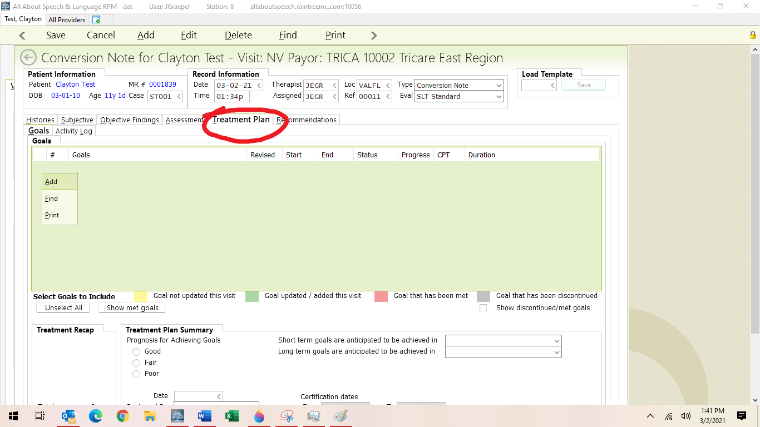

- Under the Recommendations Tab, you will add in the following:
- Frequency/Duration: 2 visits per week for 52 weeks (DEPENDING ON CLIENT, may be 1x/week, may be 3x/week)
- Treatment Duration is 30 minutes usually (rarely is it longer)
- Total number of visits will be completed by multiplying the number of visits by 52 weeks
- ***complete the certification period with POC From and POC To Dates to make sure they are in line with the initial date of the evaluation; you input the initial date of the evaluation and then put that same date but a year later denoting when it “expires” and that will warrant us to do a re-evaluation
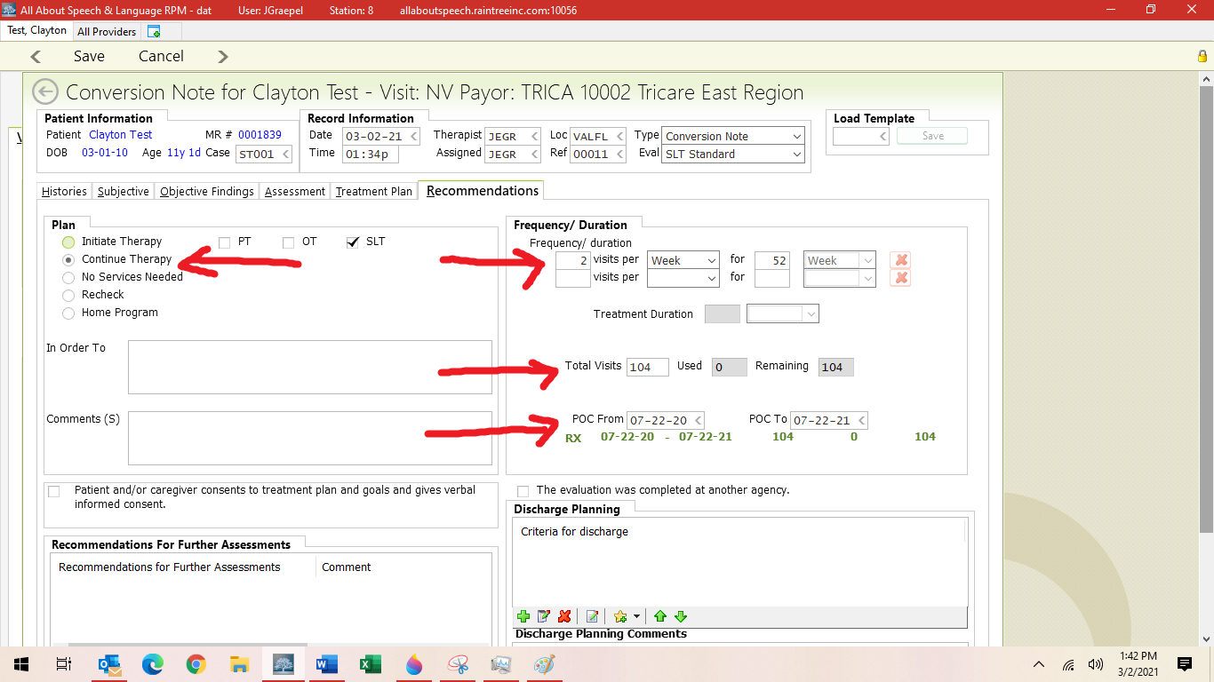

- Then you save and exit; it will not prompt you to sign off on the note
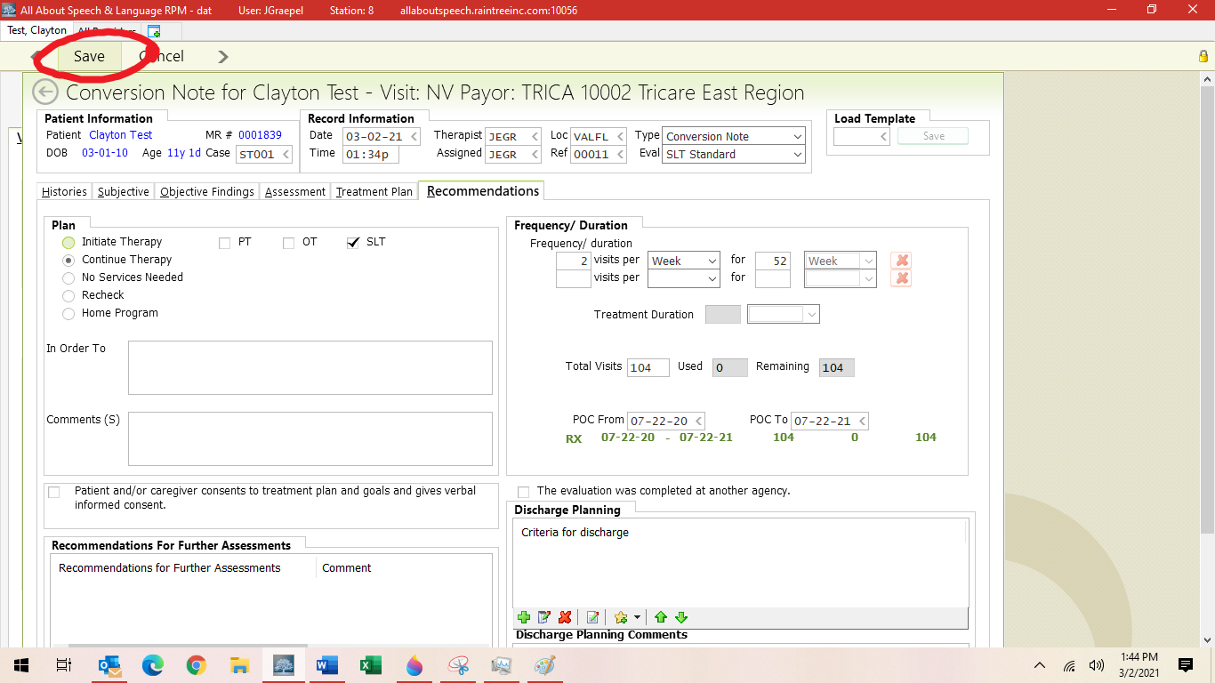

- Goals should then roll forward for the first treatment session.

NOTE: Sometimes therapists do wait to complete the conversion note until after the first visit once they get eyes on a new client if any goals need to get modified etc; this is done on a case-by-case basis. Please communicate with your CM if this course of action is taken in starting with a client who has a previous evaluation from another facility.

Adding or Changing Goals

- For a new client to AASL who comes in with an accepted, valid initial evaluation from another clinic, create a conversion note of the goals from that evaluation prior to the first session. This is the approved document that Tricare has on file for this patient prior to them coming to our office that we have agreed to accept as the dates are still within the valid timespan. Make the goals as close as possible, if not verbatim, to what was listed on the plan of care.

- After the first few sessions (3-6), if you believe that many of the goals from the outside accepted report are not a good fit for the child (i.e., goals have been largely met already, where child is at upon getting to know them/their current skill levels), you may open a progress note. This will be easier for you documentation-wise and allow you to be able to better adjust the goals. By doing this, you can ensure documented progress by the next progress note/re-evaluation (whichever is sooner). This does not have to be a thorough progress note, just an update of the goals to be more appropriate for the client, better guide your plan of care and reflect it more accurately. There needs to be a statement within the progress note explaining these modifications. It is imperative that you provide a rationale within comment sections of the goals; explain WHY you are adding/changing.

