Contents
Internal Discharge Procedure – Background 2
A note to clinicians: 3
Internal Steps for Discharge for MEETING GOALS 4
Drafting Discharge Note: All Goals Met 6
Discharge Note for any reason other than meeting goals 20
Asking for Reviews 31
Email Verbiage to Ask for Reviews 32
Closing Client Records Clarification 33

Internal Discharge Procedure – Background

Discharge from therapy is a big step! It can be a celebration of a child’s accomplishments or a decision that skilled therapy will no longer help a child in our care. These are drastically different reasons for concluding that discharge is warranted. It is essential that we always keep this in mind and how this will emotionally impact a family; everything from elation to hopelessness. And the response could be completely unexpected. We can help eliminate unexpected responses by communicating well in advance the precursors to discharge. We provide a list of items that could preempt discharge in the initial evaluation; however, every child and family circumstance and journey is different, so constant feedback and frequent reminders to the family are crucial.

Many times, we are so proud of our clients who have met their goals and no longer need our skilled therapeutic services! While this is an exciting time, it can also be a scary/overwhelming time for these families. Try to remind yourself of how long the parent has had concerns, being worried/anxious about their child’s needs, navigating obtaining diagnoses, if warranted, placing their trust in you to care for their child’s development, and coming to therapy since commencing services. Whether it was 6 months or years later, change is hard for anyone, and especially hard when you are part of navigating and initiating that change for someone in your care, who has grown to have strong affinity for you and their relationship with you and their child! This is why it is imperative that you have open communication with the caregiver, especially throughout the therapeutic process, and prime them for this moment before it actually takes place!

You can again try to imagine how the parent/caregiver may feel in this situation. More than anything, they want to help their child. These types of situations can result in the parent feeling a variety of different emotions, so we certainly want to be sensitive to those emotions and approach discharge as empathetically and tactfully as possible.

Part of our mission here at AASL is to provide optimum treatment services that foster maximizing each child’s potential; discharge falls under this category as it completes a cycle of action from initiating services, to rendering them, to ceasing them! We want to be gentle and understanding with all of our families given they have had and/or are partaking in different experiences pertaining to their child’s needs. We want them to be confident in us that we are making the right choice in supporting the “why” behind discharge, that their child is truly ready for this next step, and that we are always here for support and guidance. Perhaps you have determined that the child has met their goals in therapy or has reached a plateau, however the parent still is having difficulty with generalization and carryover in the home, school, or community setting where the child is still showing difficulty; remember, coaching, guidance, and explanation of the “why” in a sensitive way will be imperative.

It really all circles back to communication. We MUST be having an ongoing dialogue
with the family throughout the therapeutic process (in daily/weekly wrap ups on goal progress, at progress note time, at re-eval time, etc.) so there are no surprises. Noting this information in a progress note/re-evaluation and simply giving that to a parent is not enough. Again, while it might not occur as surprising to you, given we are the professionals and do this day in and day out, for families this is something that in many cases they don’t want to let go of because of the positive, life-changing impact it has had on their child and family, and the "letting go" of this skilled support is something they will always continue to rally for. It’s like an episode of your favorite TV show, or your favorite comfort food; no matter what, you are always going to seek it out to fill that craving/need and the fond memories that come with watching that show or eating that delectable meal! Yes, you are your client’s “comfort person” or “comfort team!” We’ve heard a parent describe discontinuing therapy in this way: that it’s like removing one leg of a steady chair. It can be a worrisome time for parents to now remove one aspect of their child’s success. This is why we also remind families upon discharge time that we will always be available for support. Therapy is often cyclical, especially in our younger clients; it is not a once you are done, the door is always closed. We remind families that our door is always open and we will give them our most honest feedback and recommendations, whether we encourage support elsewhere or they reinitiate support here at AASL.

When should these conversations be happening? This is where you need to use your clinical judgment to gauge when discharge may be on the horizon. Keep in mind the preparatory window a family should be given to prepare for such discharge. Progress note time is a great opportunity to communicate steps being taken toward discharge, as are re-evaluations. Additionally, as a child meets their first long term goal, or any goals thereafter, a parent should immediately be informed of such. You can do this verbally in a wrap-up session, or in an email. Email or a phone meeting may be warranted secondary to in person wrap up, especially if you feel you need to document this communication via the communication tab for record keeping purposes. This would include things like if there are any reservations about a family’s current communication around their child, if they are present for the therapy process or not, or maybe causing any tentative issues. Positive connotation for all of this correspondence is essential and we trust you are keeping that at the forefront of your dialogues and correspondences with families. *If you have questions around handling clients in these aforementioned circumstances, please reach out to management for support in handling.

A note to clinicians:

The intent of this procedure is not to dispute professional recommendations, rather it is to ensure that we are handling ourselves in a manner in line with AASL’s mission/vision, specifically the high quality of care we provide. We want it to be known that our high quality service is just that, from start to finish.

If discharge is not handled with the utmost care and concern, it can result in clients and parents being left with a bad taste in their mouth. We want each and every person who enters this clinic to leave satisfied and validated. Should we abruptly end services and not confirm all concerns have been addressed, this can lead to families leaving with misaligned expectations, disappointment, frustration, and discontentment. Consequently, this can be detrimental to our reputation, but more so than that, has the potential to inhibit our ability to be able to help other families in the future given how a family proceeds to communicate their experience about their time at AASL (i.e. word of mouth, social media, online reviews, etc.). We've all seen how negative reviews and feedback sway and influence our choices and impressions as consumers.

This procedure is in line with team members keeping the core mission and vision of AASL at the forefront of their clinical practice as well as in the owner’s desire to provide each and every clinic division team member a supportive platform around handling discharge with clients, especially when we have more challenging circumstances. We truly want to support families through “every life stage”, setting them up for growth and success not just in our setting, but beyond. Goals and how discharge is handled should reflect such!

Internal Steps for Discharge for MEETING GOALS

- When you begin to anticipate discharge for a client leading up to the re-eval, as they are meeting age expected skill level, you will first communicate this information to your CM during your CM meeting. This will be inline with when the re-eval is due that you are anticipating that the child is going to score within the average range. You will also communicate to the family what goals have been met and goals they are progressing towards meeting continually throughout the plan of care. Ideally, these conversations with parents/caregivers are to take place in person, well in advance of expected possible discharge date (i.e. no less than 1.5-2 months ahead of discharge/ re-eval). Communication with the parent should be ongoing as you anticipate your client meeting goals, and gain their input about remaining/additional concerns or challenges you can help address as you approach re-eval time. If you are not able to have an in person conversation, you need to set up a POC meeting with the parent/caregiver which can be a phone call/zoom. Again, discharge should never be a surprise to any parent given ongoing dialoguing and agreement from all parties of this plan.

- If a client situation warrants reaching out to upper management, such communication will take place by the CM, with appropriate follow up and scheduling a care plan meeting if necessary.

- Consultation with CM will be ongoing to ensure that this child is truly ready for discharge. Things to consider/prepare to communicate to CM are:
- Plan for standard assessment to further confirm WNL by a re-eval
- All areas of concern have been addressed (reference any re-evaluation surveys and have updated discussions with the family as part of your ongoing check-in’s which you can share with your CM)
- Mastery of skill at highest level of independence
- Functional application/generalization of learned skills outside of treatment session environment
- Is the primary caregiver on board with discharge? Have we comprehensively assessed ALL of their concerns? (they may have new ones since re-eval!)
- Consider additionally: if Insurance (Tricare), what goals to support generalization can I work on as the POC date comes to an end? What is the child’s given diagnosis and are there “next” skills to consider that are worth previewing given our children often need increased exposure, direct teaching, and repetition before a skill is formally acquired? If a private pay client, how can I pull in a family’s additional concerns into our treatment sessions to continue to provide benefit to their child and also follow the family’s lead for current and upcoming concerns/skills?

- Once this verbal communication has taken place with both your CM and additionally with the involved family and all parties are in agreement to proceed, you can follow up in email confirming the discharge date. PLEASE BCC Patient Scheduler, Finance Division, PCC and your CM on this written communication. You will confirm this information with your CM including home program ideas/plan and qualitative/formal assessment you will be completing to justify discharge from therapy.
- Leading up to discharge date, you are to be compiling materials you will be sharing with the family for a home program/home resources. Again, this should not be something that is taking up much of your time, but should be ideas for how the family can “fly solo” without your care and feel confident that they are able to do so in your absence. Communicate with your CM around this or use your cohorts for ideas if you don’t have particular ideas or materials in mind to share with the family on the final date of discharge. This extra care points back to AASL’s mission of supporting families and their children to the utmost and that we genuinely have concern for their continued success.
- Follow Steps for Marketing Collaboration Procedure for additional information on capturing necessary information for client discharge as well as communicating with PCC and asking for reviews.
- Ensure family has received marketing materials/request for reviews, home program materials, and discharge note as the final therapy session approaches.

Drafting Discharge Note: All Goals Met
- Once a client is getting ready for discharge after meeting goals in your outlined plan of care or a family informs you they are stopping due to relocation, school, or other reasons, a discharge note must be completed to close them out of the EMR system.
- Inform your CM and Patient Care Coordinator (PCC) of the upcoming date of discharge and if you have current clients that can fill the day/time that will be opening up on your schedule, communicate that accordingly via email so they know for scheduling new clients or other families that need additional days/times.
- As a part of informing your CM and Front Desk of upcoming client discharge, also include the PCC in the email notification of the upcoming discharge date.
- The PCC will note this and follow up with Front Desk to gather appropriate documents for follow up with Referral Source.
- For this reason, it is crucial you close out discharge notes as close to the discharge date as possible. Not doing so is going to impact the PCC in a follow up visit to the referral source to hand deliver the discharge note and follow up items.
- As a part of this visit back to the referral source, the PCC is also going to get with the clinician directly in order to obtain any examples of the client’s work, progress in structured activities, and/or pictures. Treating therapists, please be the ones to check picture and media consent using EMR system and/or help of the Front Desk to know if a client can have their picture taken as a part of sharing on social media as well as back to the Referral Source.
- Use Milestone Moments and “I Did It!” Success Story Photo boards for pictures to use when meeting goals and/or at time of discharge.
- Coordinate with PCC to help you obtain these photos so that the appropriate follow-up can take place with the referral source as a means of continuing to foster our professional relationship, continued referrals, and thanking them.
- If completing a Discharge Note outside the treatment session, go into the patient chart and hit A to add under Visit History, then select Long-Term Therapy Note. When it populates the note going forward on the upper right hand side you will then need to change the Note Type to discharge note and then under that make sure you add from the dropdown O Standard.
- 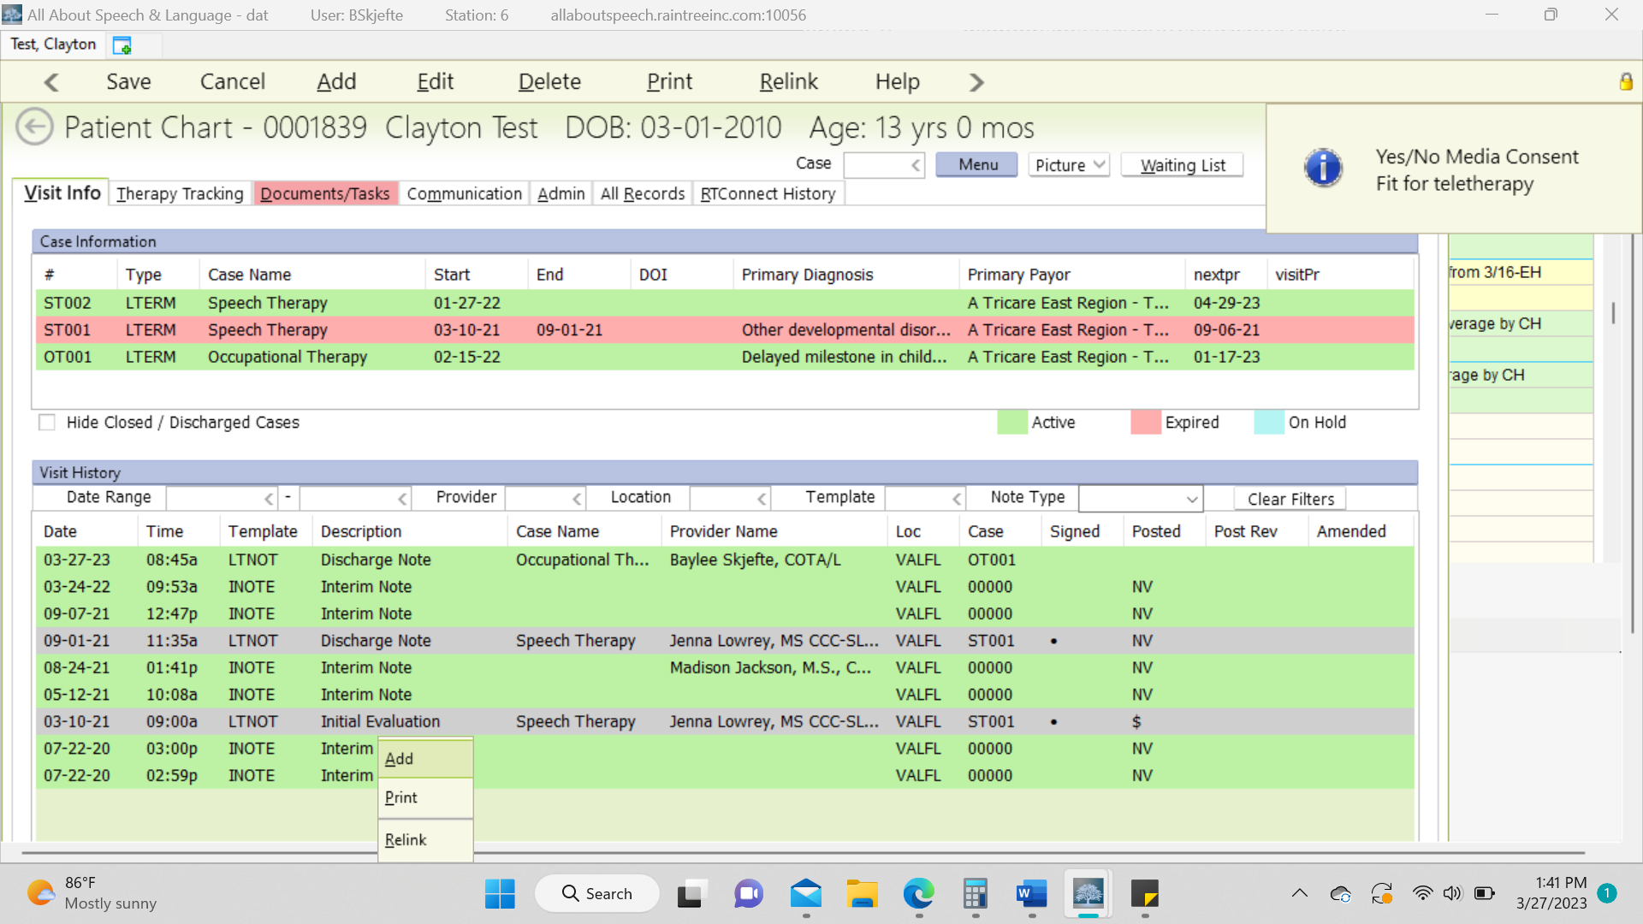

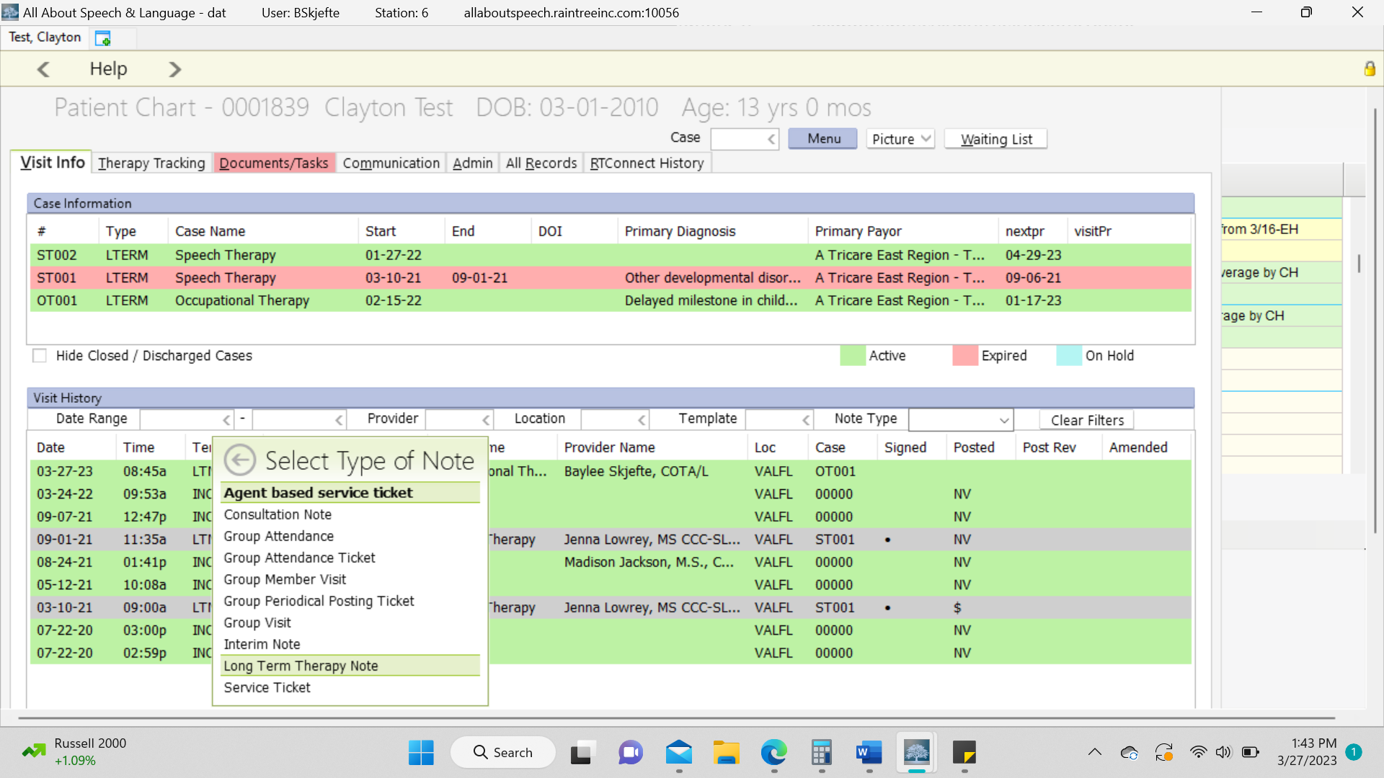

- Then go through the tabs and update across the following:
- Progress Note
- Treatment Plan
- Discharge
- Charges: (if applicable, refer to step 16)

- Progress note tab
- Comments – In this section, you will comment on the child’s progress from the revaluation to the discharge note. This will be written in a narrative format. Ask your CM for examples if needed.
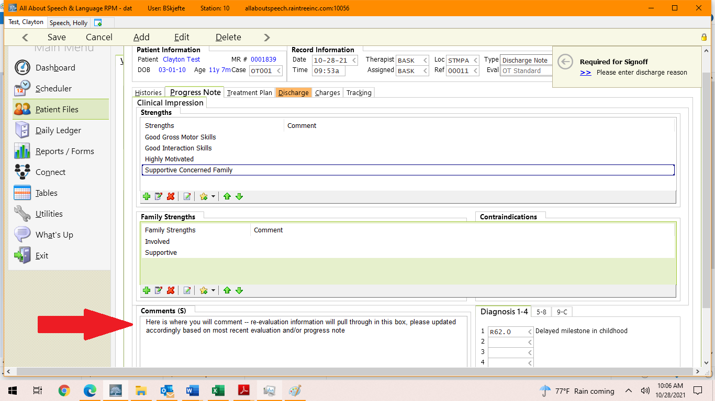

- Treatment Plan tab
- At the time of discharge, if a plan of care is completed and all goals are met, change the status of the short-term goals and long term goals to Met if they aren’t already done.
- Each met goal needs to have an end date to the goal.
- DO NOT comment or select percentage for long term goal. This field does not pull through on final sign-off sheet.
- Double click on the LTG to open up the goal to make comments.

******EXAMPLE OF CHANGING GOALS TO “MET”******
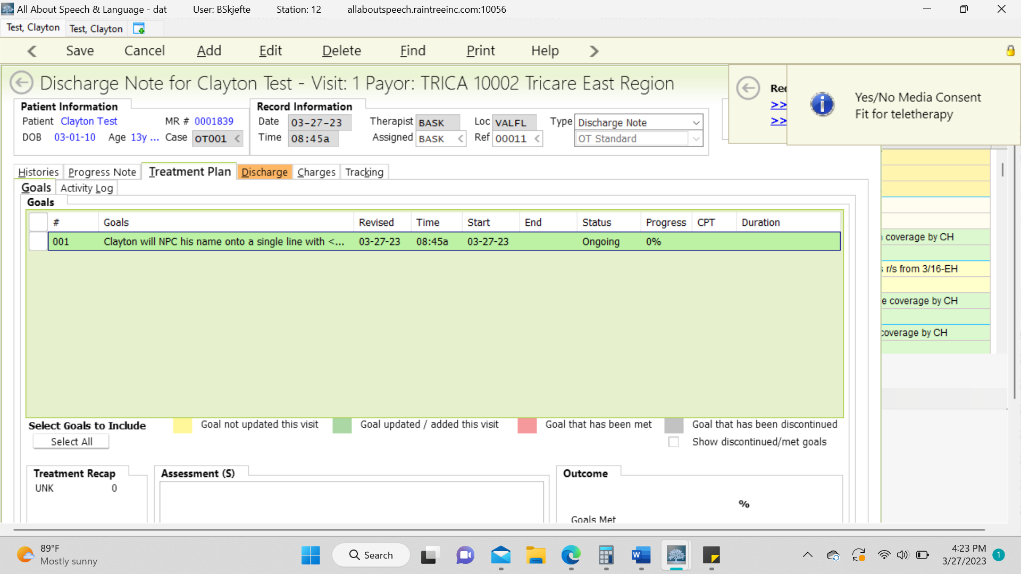

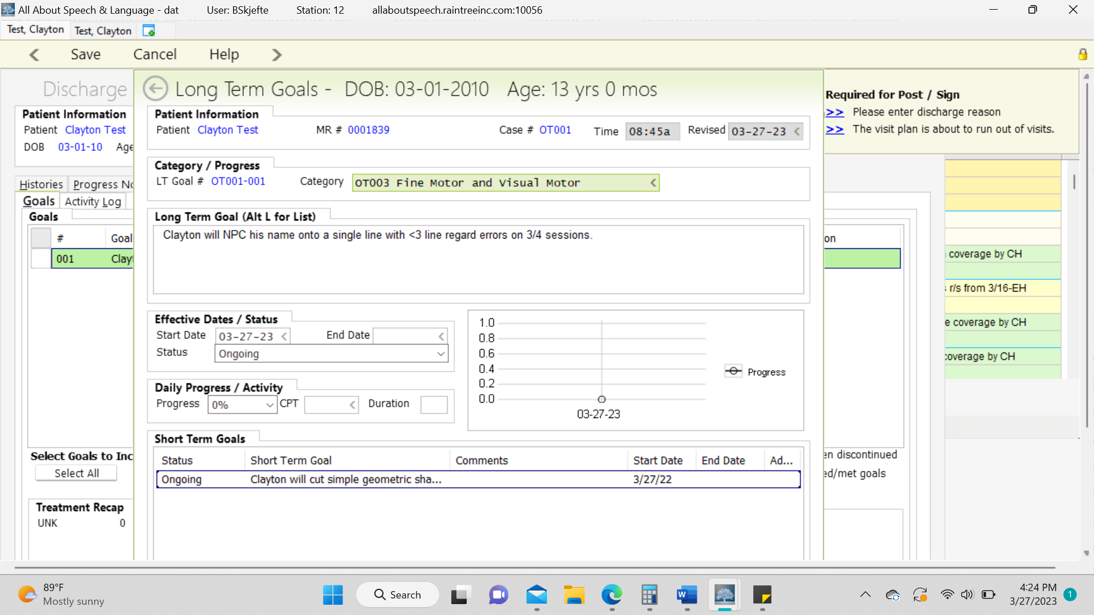

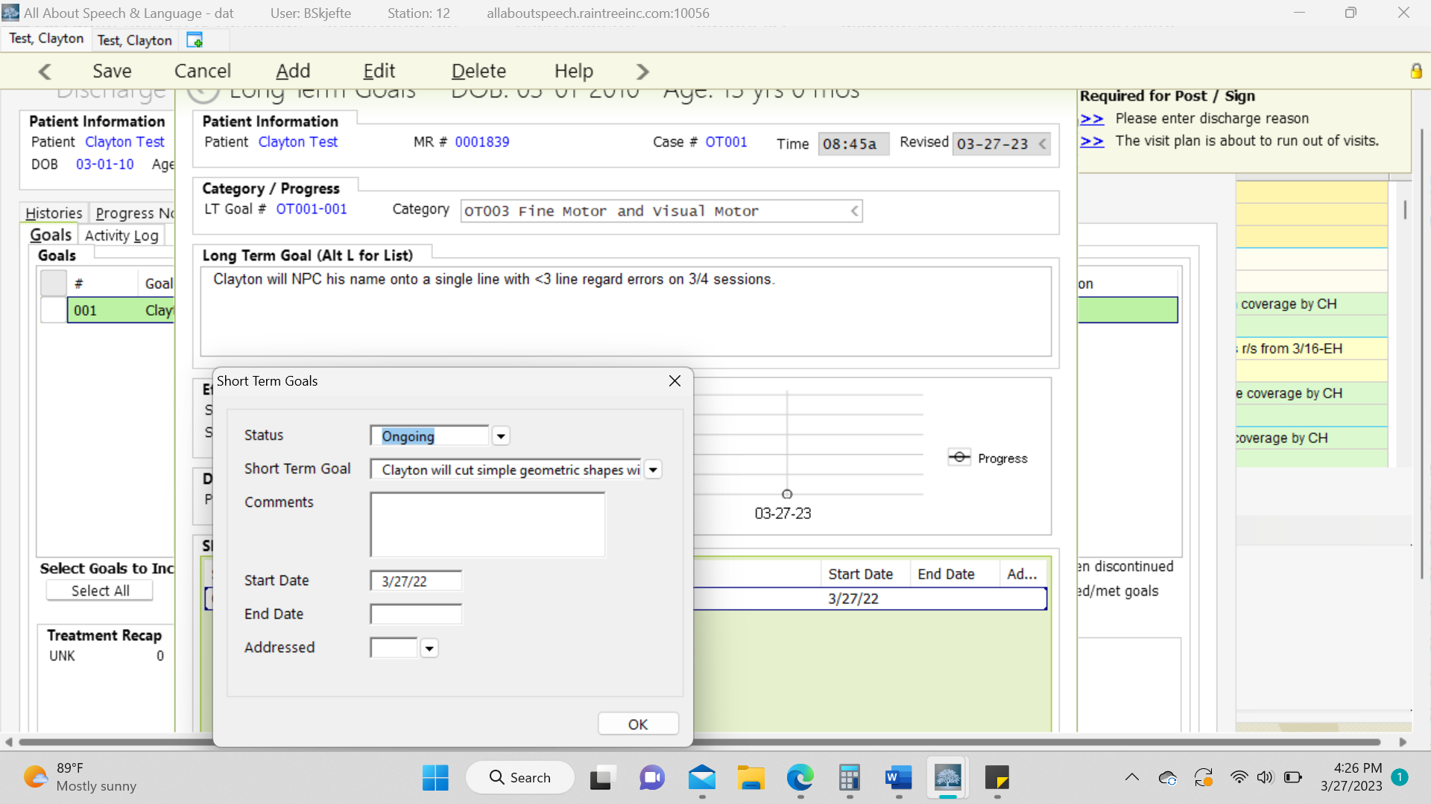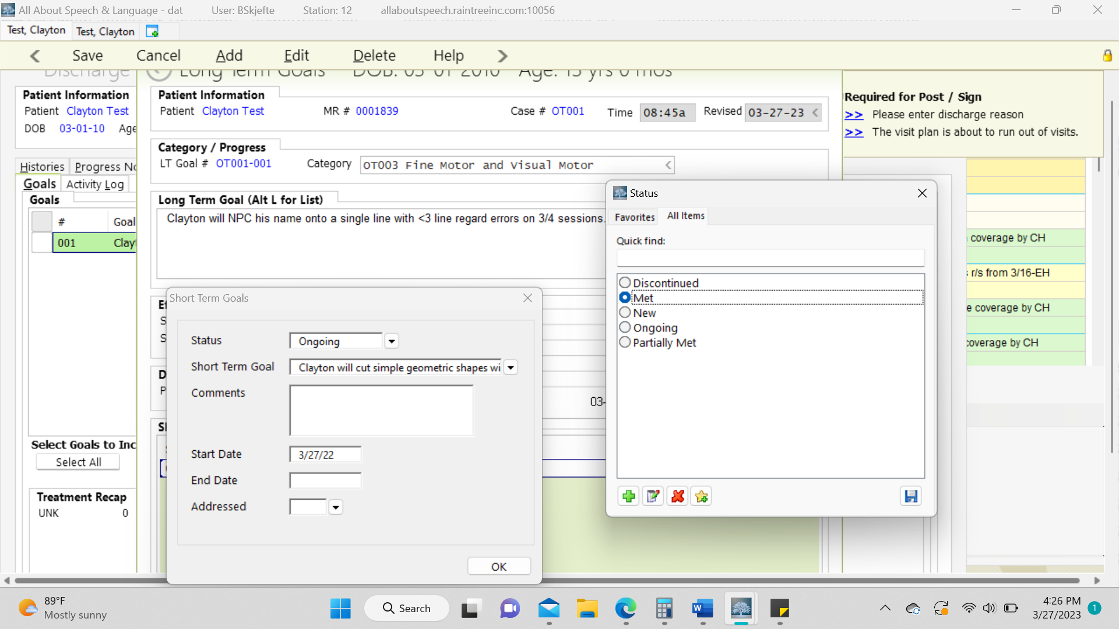

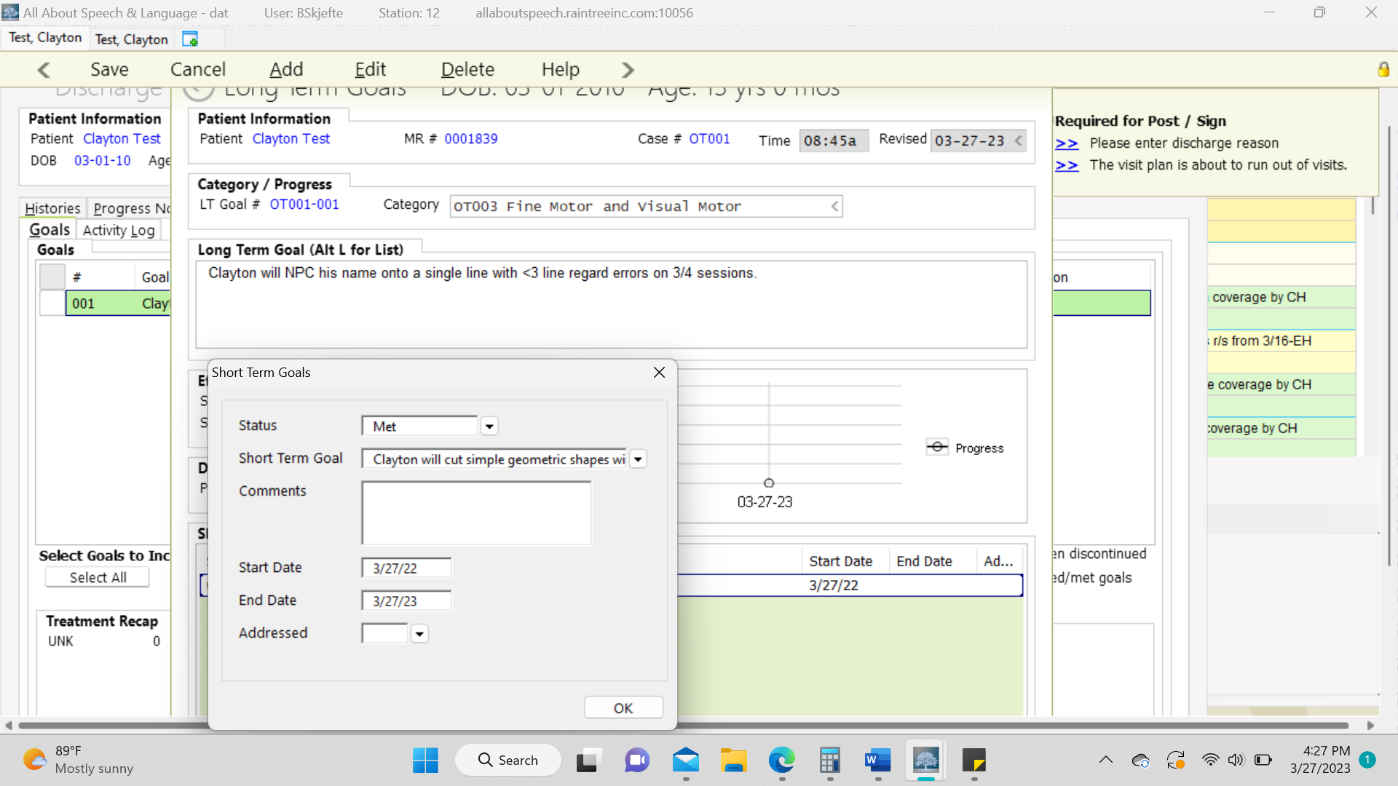

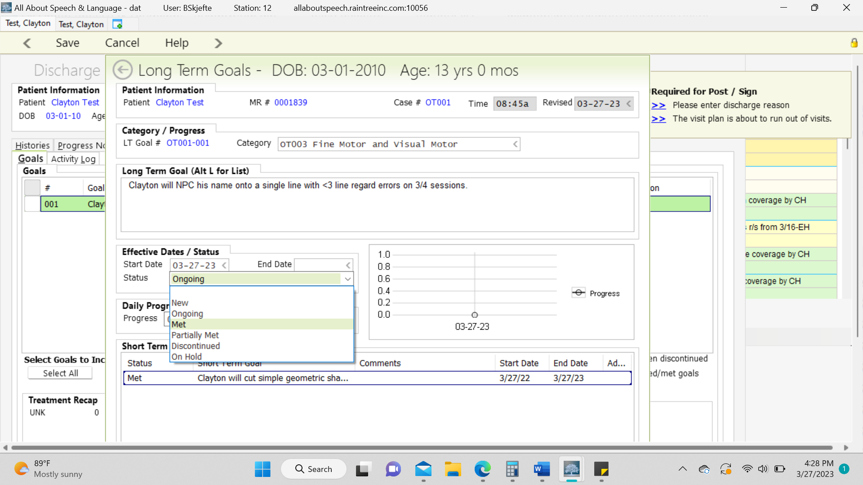

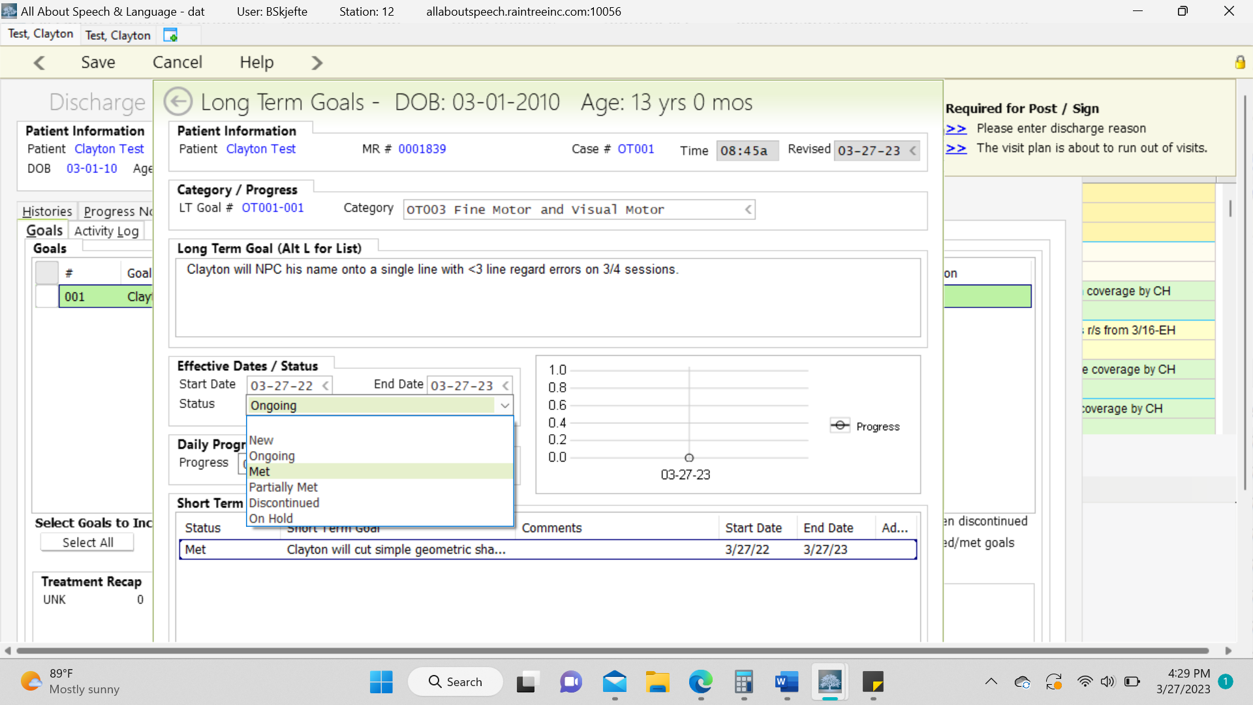

******EXAMPLE OF SELECTING LONG TERM PERCENTAGE (DO NOT DO)******
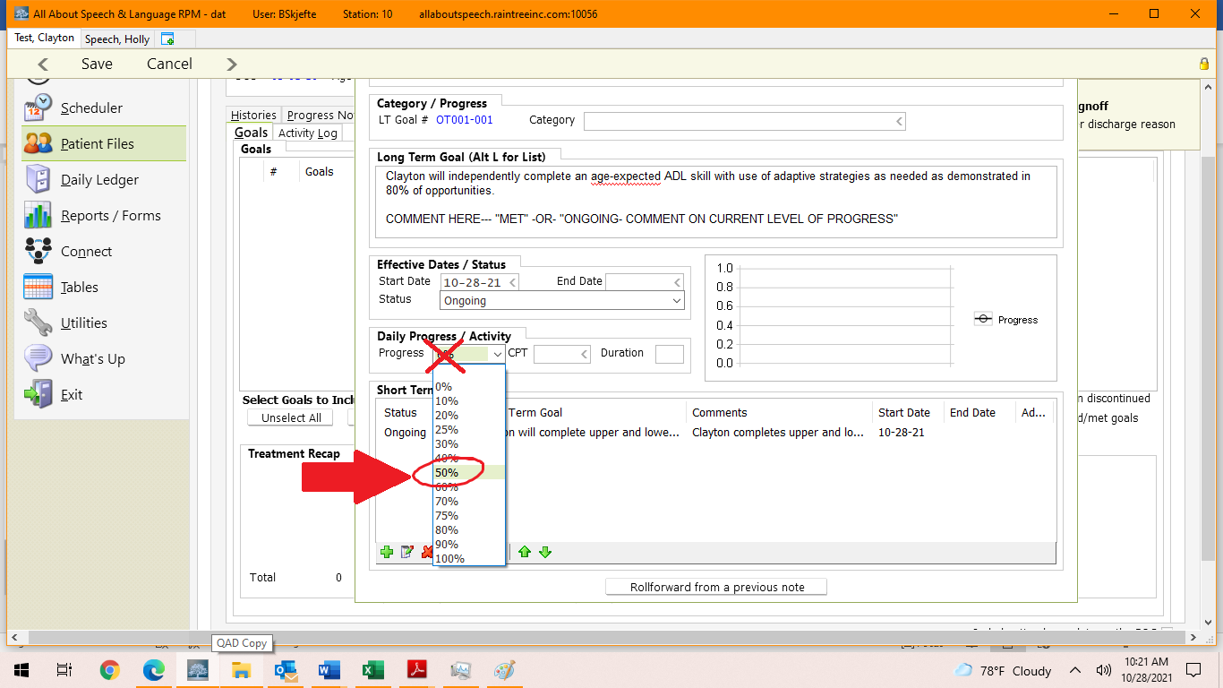

- Assessment section
- You will write a narrative form of the tx session that day in the “Assessment”. This is located right under the long term goal list. If this was not completed on a tx day, exclude this step.

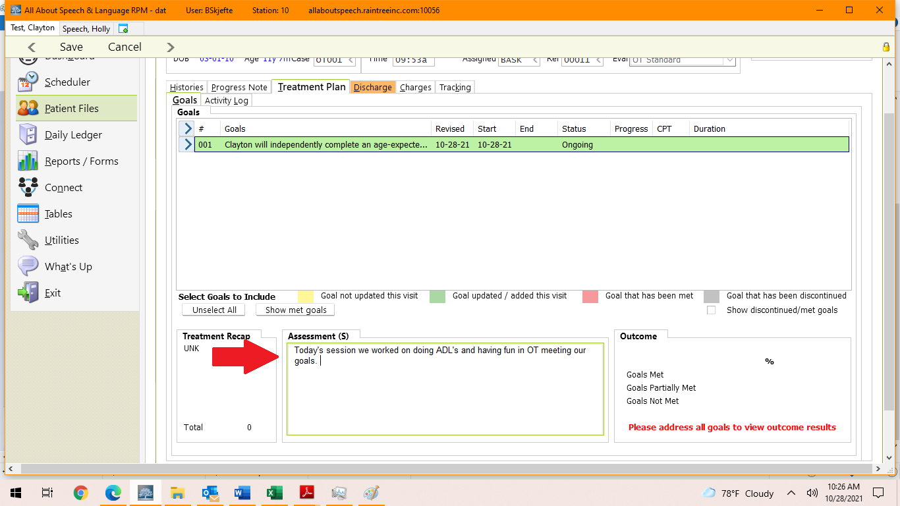

- Discharge Tab:
- Select the following
  - Discharge date
  - Discharge reason: Met all goals
  - Services Recommended: It is recommended that all clients are to follow up in 6 months if any additional concerns arise. Also add in there any additional services you are recommending for D/c, i.e. family psych, ABA, Speech Therapy
- 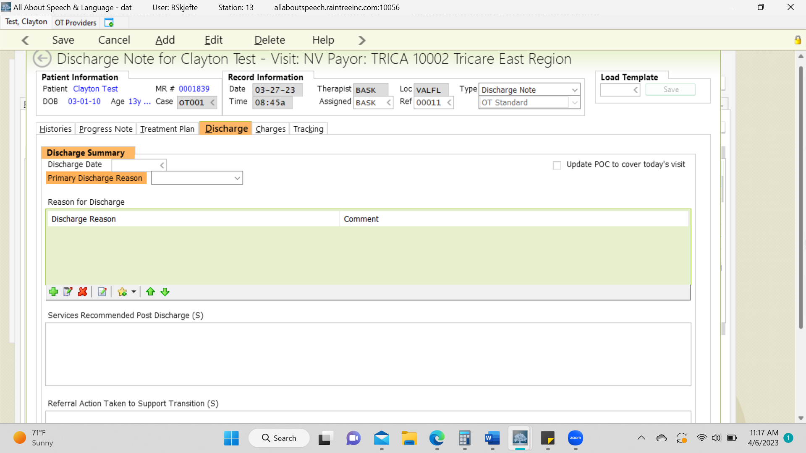

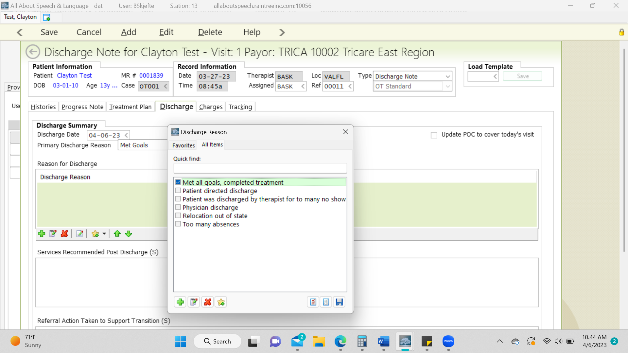

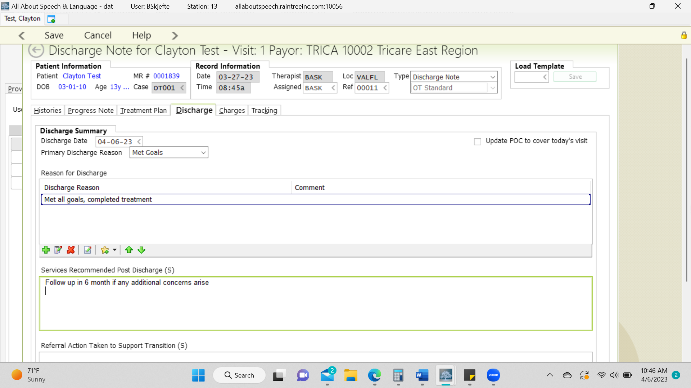

- Charge Tab
- Follow pictures below. You apply the charge if you are directly seeing the client for their last tx session. No charges are applied if you are not.

**********************************WITHOUT CHARGES*******************************
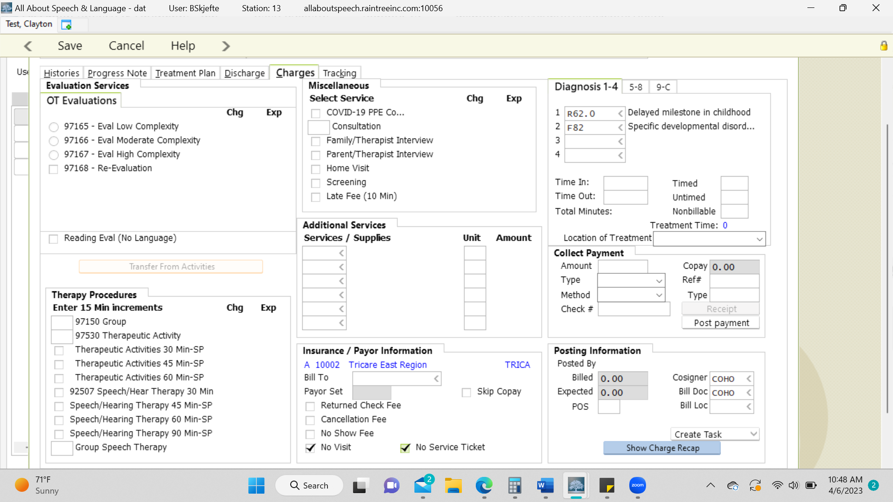

*******************************WITH CHARGES************************************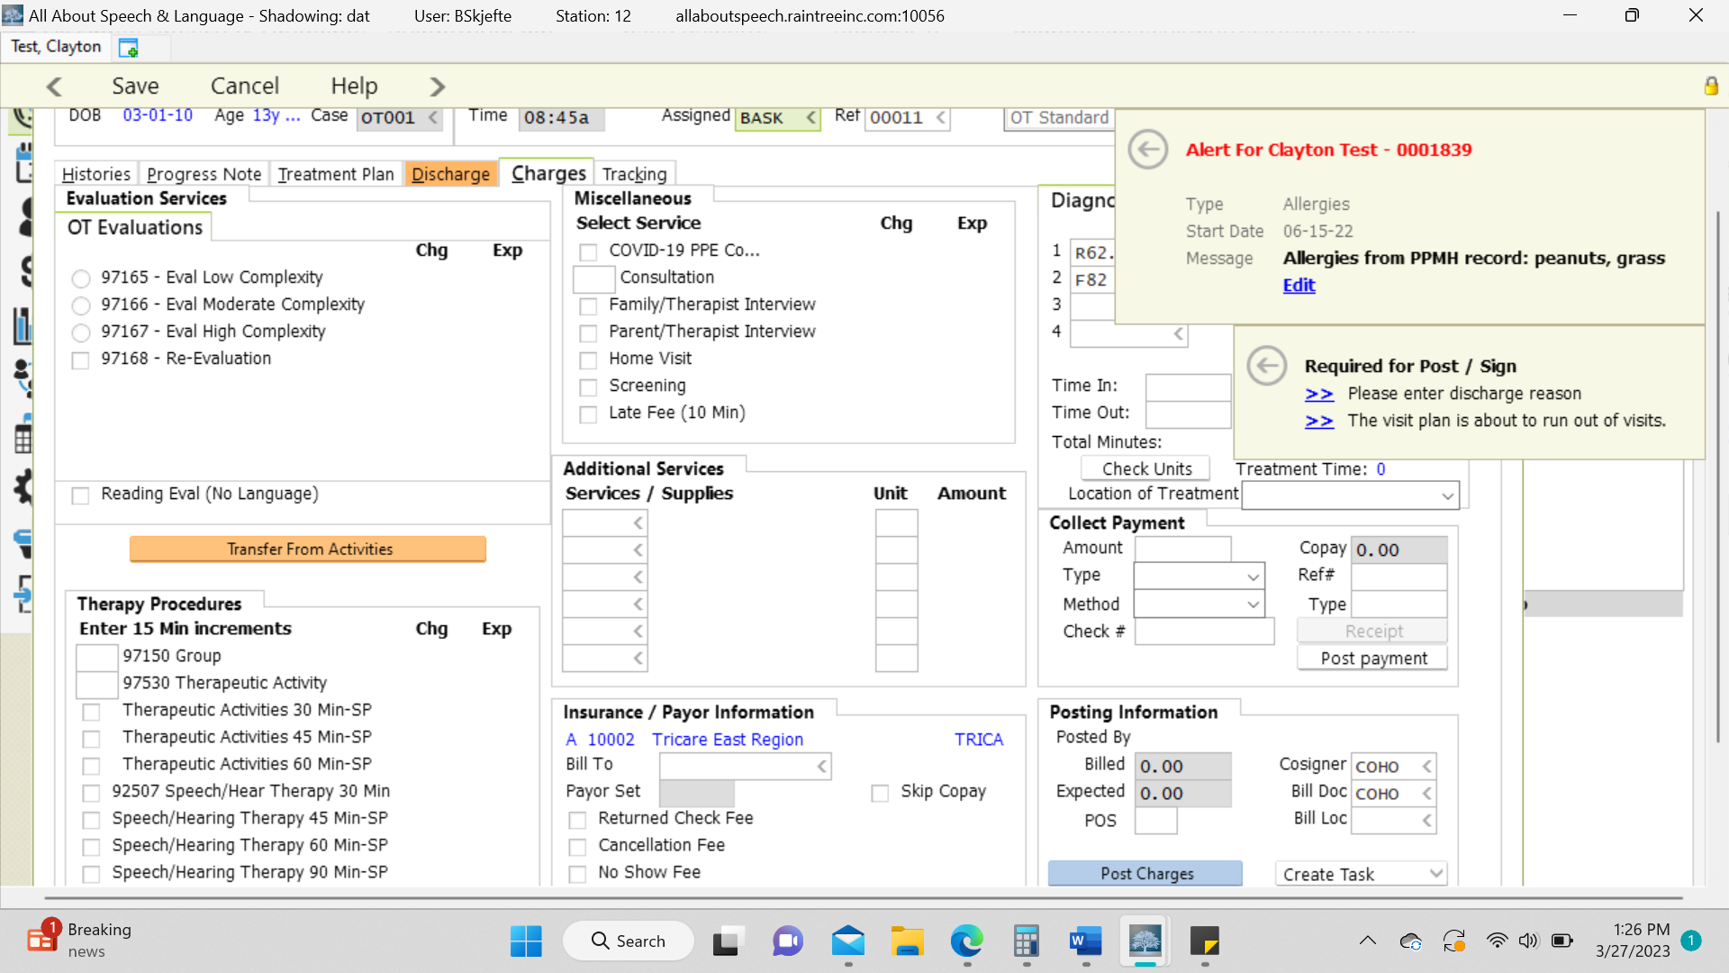

- Once you have completed all the tabs, select Save and Exit and/or Save and Sign off on the note as you would for the daily note; be sure to give the note a read-through to ensure no glaring typos or errors before signing off on the document. This is a last impression a doctor, family, or insurance reviewer will be seeing from us, so be sure to demonstrate additional care.

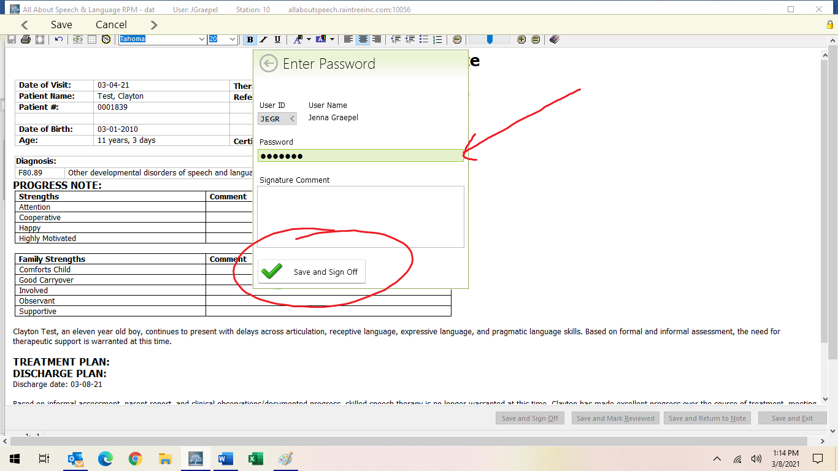

Discharge Note for any reason other than meeting goals
- A parent/ caregiver directed discharge would include the following:
- financial burden
- seeing another specialist
- prioritizing other treatment/service
- relocation
- scheduling conflict

If your client is being discharged due to the above reasons, you do not need to perform additional standardized assessments prior to discharge. Reminder, continue to notify your CM for all discharges.

- Work your way through the following tabs:
- Progress Note
- Treatment Plan
- Discharge
- Charges

- Progress Note Tab
- Comments – In this section, you will comment on the child’s progress from the revaluation to the discharge note. This will be written in a narrative format. Ask your CM for examples if needed.
- Treatment Plan tab- comment on each long term & short term goal with their current level of progress.
- Comment on all goals that are not met with the client’s most recent level of progress for the goal.
- Please DO NOT comment or select percentage for long term goal. This field does not pull through on final sign-off sheet.
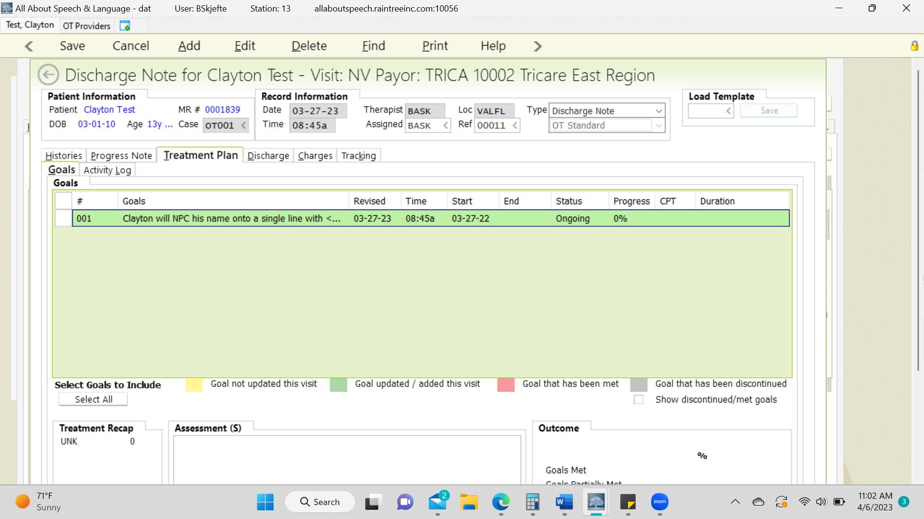

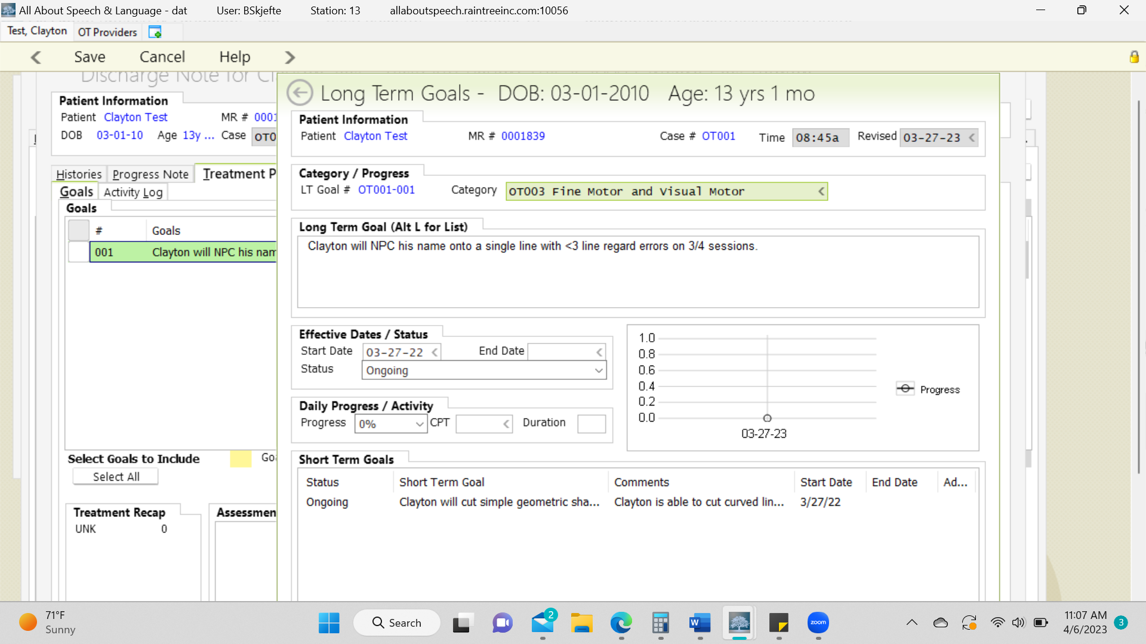
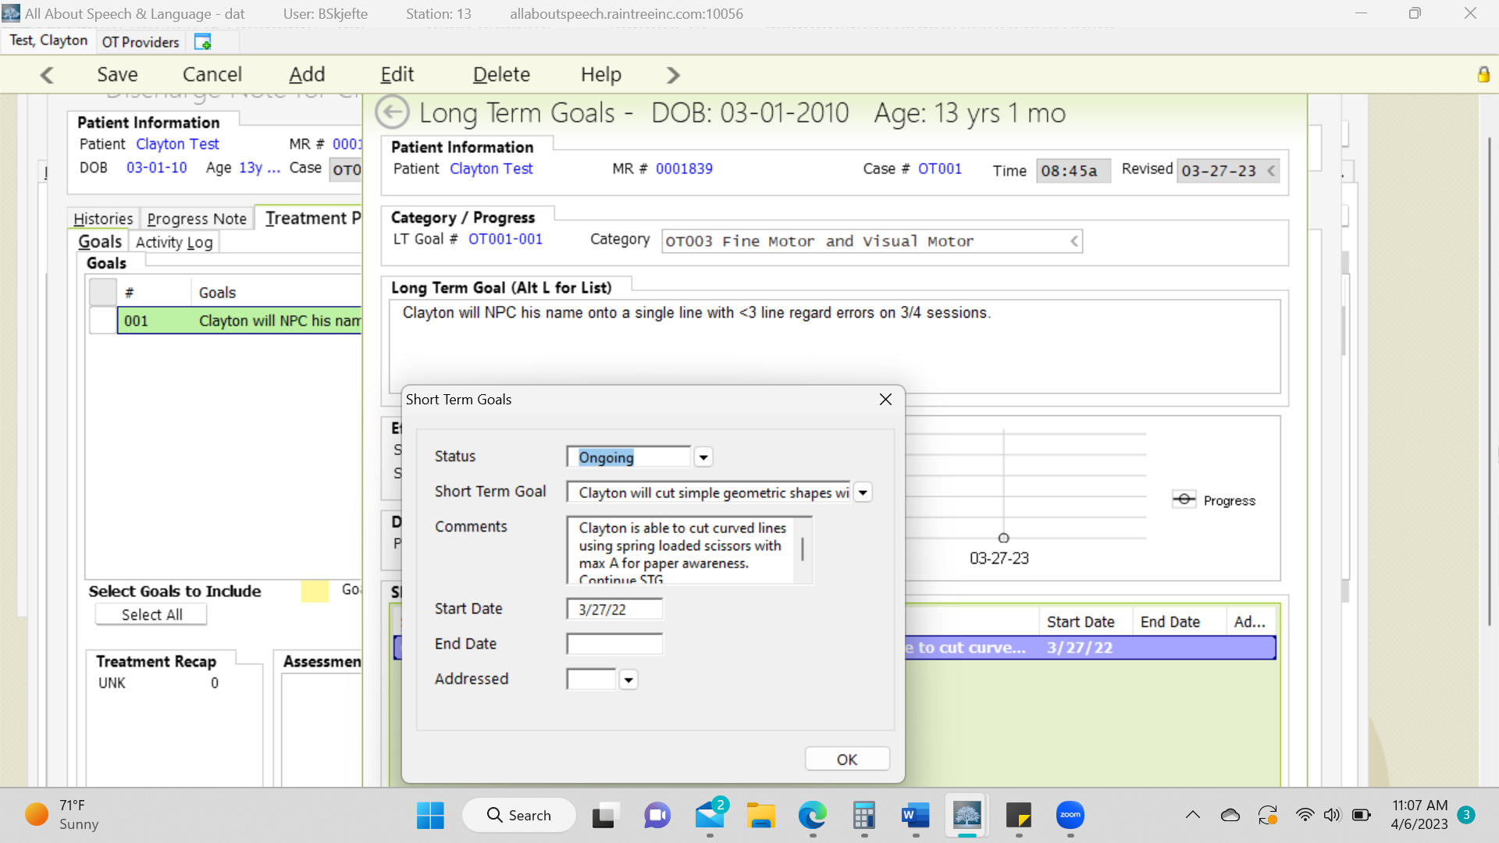

******EXAMPLE OF ONGOING GOAL WITH COMPLETED FIELDS*****
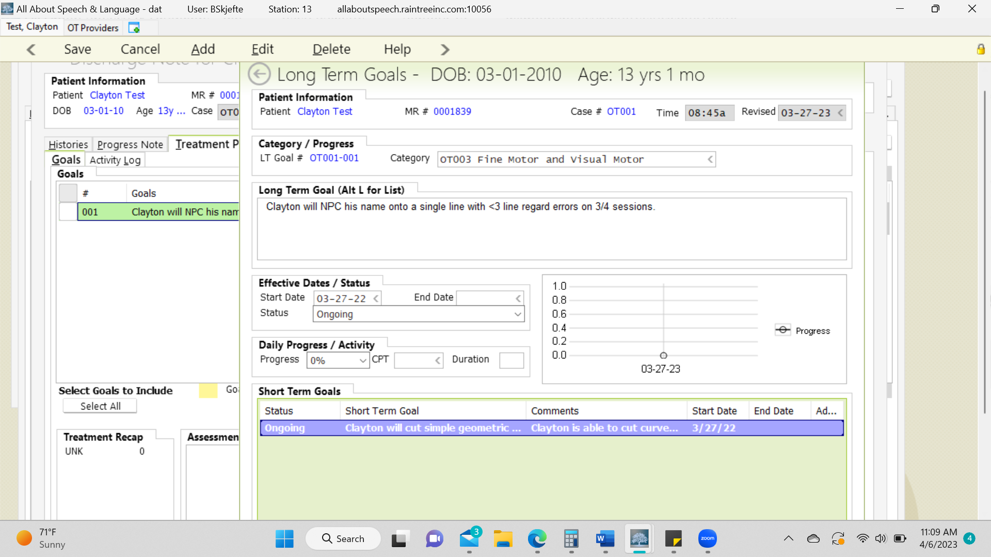

******EXAMPLE OF SELECTING LONG TERM PERCENTAGE (DO NOT DO)******
- Once you have commented on the short- and long-term goals, you will then write a narrative form of the tx session that day in the “Assessment”. You will compare data from the most recent documentation (initial eval, re-eval, progress note). This is imperative you are displaying a “complete picture” of the client. You want to ensure any other therapist could pick up on the child’s goals right where it was left off at.

- For the Discharge Tab:
- State the reason for d/c and provided to us why the client is discharging and that it is recommended to continue with occupational therapy for the frequency and duration as specified for the current plan of care (i.e. 2x/week for 30-minutes etc.) and what our continued recommendations are.

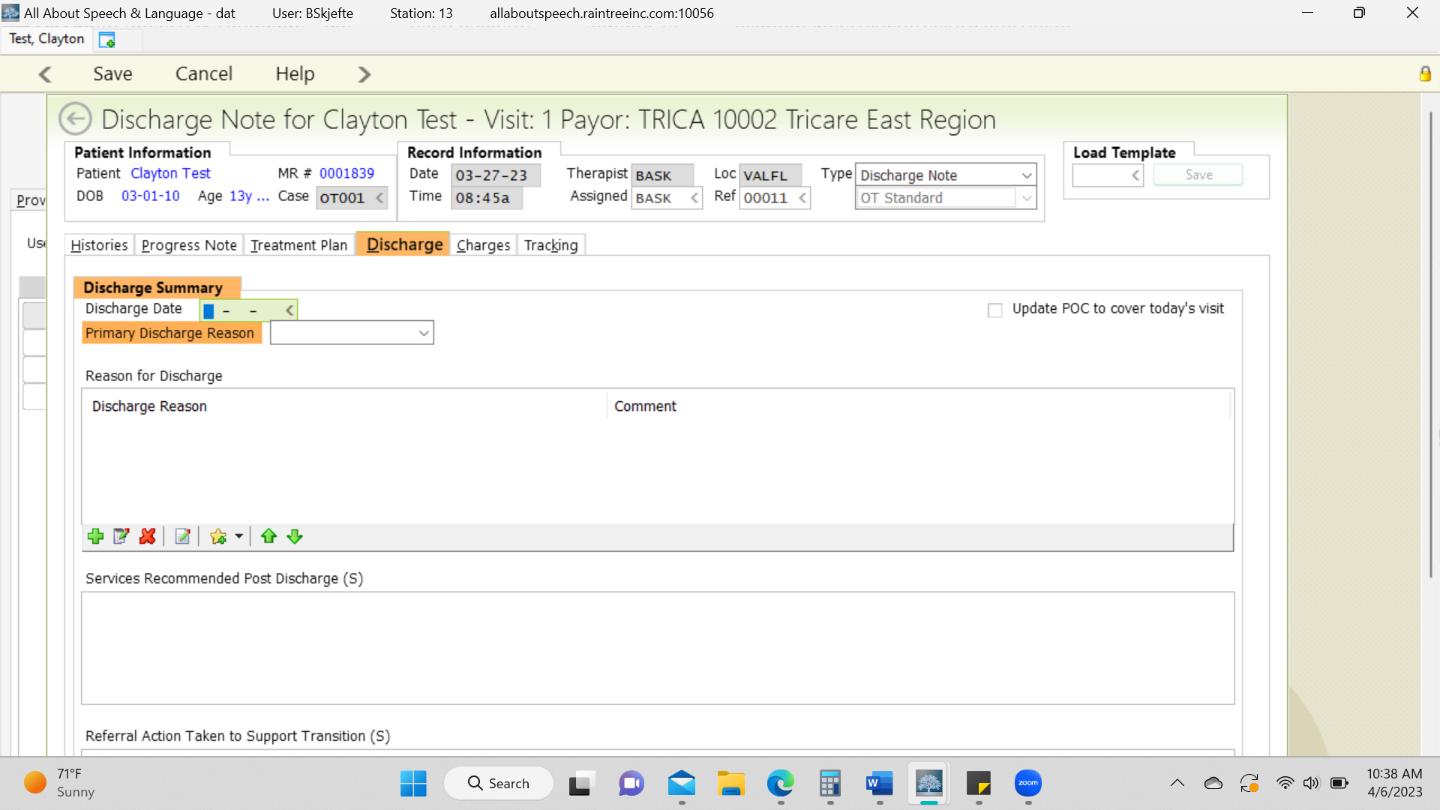

- Once you have completed all the tabs, select Save and Exit and/or Save and Sign off on the note as you would for the daily note; be sure to give the note a read-through to ensure no glaring typos or errors before signing off on the document. This is a last impression a doctor, family, or insurance reviewer will be seeing from us, so take care in your review.

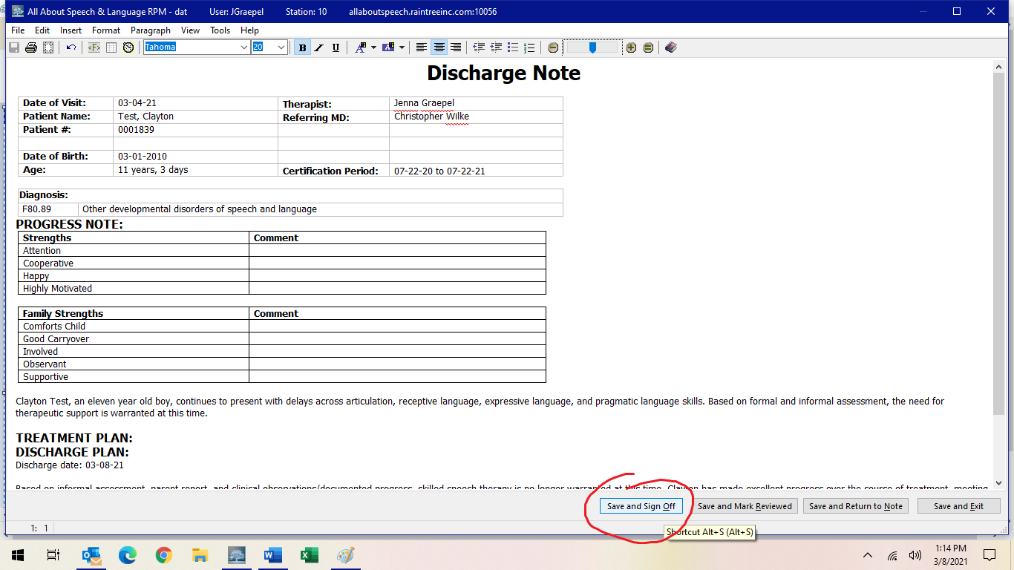

- Be sure to give the note a read-through to ensure no glaring typos or errors before signing off on the document. This is a last impression a doctor, family, or insurance reviewer will be seeing from us, so take care in your review. If you want management to have a second set of eyes to help convey any messages in how the discharge note is written/what information is included in the note, or to provide a dual signature, if discharge is for any other reason outside meeting all their goals, please communicate to them accordingly and in a timely manner for completing.
- If a parent/caregiver requests to have a note sent to them or another professional, please inform the Front Desk. Please do so by providing client name, parent name, and specific
request. They will send documentation to parents or other professionals as requested, ensuring necessary releases of information are on file.

- Be sure to give the note a read-through to ensure no glaring typos or errors before signing off on the document. This is a last impression a doctor, family, or insurance reviewer will be seeing from us, so take care in your review.

- If a parent/caregiver requests to have a note sent to them or another professional, please inform the Front Desk. Please do so by providing the client’s name, parent name, and specific request. They will send documentation to parents or other professionals as requested, ensuring necessary releases of information are on file.

Asking for Reviews
Positive reviews are what helps grow AASL through internet and social media platforms. In this digital age, people often search out and seek services based on reviews they first read online. Reviews drive continued business to AASL and they are a crucial and influential part of every business’ success; given a client’s documented experience at our office, this is a firsthand testament that shapes a potential future client’s desire to seek services with us. As a part of your direct working relationship with clients and families in the clinic division, we will be working to gather continued reviews for AASL. This is also going to occur alongside the PR and Marketing Division. As clinicians, you know the clients who are compliant, willing, motivated, and pleased with your treatment services, so these are the ideal candidates to ask for a review! Please use the verbiage below as a guide, with subsequent links!
We will also be working across other divisions of the company to also ask for reviews. While the clinic division is the most obvious, given the direct working relationship with a client and family, a client’s experience starts when they first call us, so we will be working to gather reviews across all divisions of the company going forward. The mission and vision of the owners and leadership and training they provide is reflected in each individual team member, therefore, while reviews capture one component of a client’s experience at AASL, it is reflective of their overall experience at our offices, which the owners take very seriously. By maximizing each child’s potential in every life stage, the owners strive to live out the mission and vision of AASL in everything they do.
Reviews are feedback, and while we always aim for a 5-star experience, it may not always occur or be perceived that way by a client, and it’s those reviews/experiences that provide continued feedback for AASL to continually strive to be better and live into our ideal scene. As a part of our vision shares: We created AASL because we desire to provide something more to our clients than what is just traditionally provided inside the 4 walls of a therapy room. We created AASL because we desire to provide a level of care where our clients feel like an extension of our family, knowing they are getting the best, skilled, compassionate support for their child. We are dedicated to being a premier therapy company offering a unique approach to therapy that is reflective of the needs of our clients and families; to provide quality and highly skilled speech-language and occupational therapy services, reflecting our passion for the work we do and the personal investment we dedicate to our client’s and their families; maximizing each client’s potential in a supportive, loving environment throughout each and every life stage.
If at the end of the day we are meeting the above, every part of a client’s experience at AASL will reflect this, therefore a family should be able to capture this in their feedback and review of us when all is said and done. Reviews close this loop, capturing that completed experience of their time at our office, something we want to capture and share with others so that we can continue to help more amazing children and families! A review from a happy family is one of the greatest compliments we can get and one of the greatest ways they can help us in return, while they are still under our care or when their care concludes. Many families are more than happy and glad to share their experiences, but it does require us to ask them!

Email Verbiage to Ask for Reviews
Dear ________,
Hope this email finds you well! (Insert something positive from therapy with their child. A win or milestone as examples. “I am so proud of _____ for graduating from therapy, they have come so far with their ______”).

We wanted to ask, given your firsthand experience with our company and the positive feedback we have received from you, would you be able to take a few minutes to share your thoughts by reviewing our company and therapy experience on Google, Facebook, and Yelp.

You can access a Google review by simply googling "All About Speech & Language" (clarify which office to search for S. Tampa vs. Valrico) and then on the right-hand side of the browser window where the company name and maps comes up, you can click on "write a review" and then leave one there. You are also able to add a star rating here as well!

For direct access, please click the links below:
South Tampa Google Review Link
Valrico Google Review Link
You can find us on Facebook by searching us if you already follow us, or by clicking here: https://www.facebook.com/AASLTherapy

You can also find us directly on Yelp here: https://www.yelp.com/biz/all-about-speech-and-language-riverview

Please let me know if you have any questions! We would greatly appreciate you sharing your experience with our company and your therapist(s) on our team. We know it means so much to families searching for therapy providers as they relocate or are beginning their own journey with finding a therapy provider for occupational and/or speech therapy. It means so much to us and we are so grateful for the positive feedback. Your public review is one of the greatest compliments we could get as we strive daily to make a difference in the lives of as many children and families as possible in our local community!

Thank you so very much again!

<Your name>

Closing Client Records Clarification
Following the completion and sign-off of a discharge note, therapists will receive the following prompt:

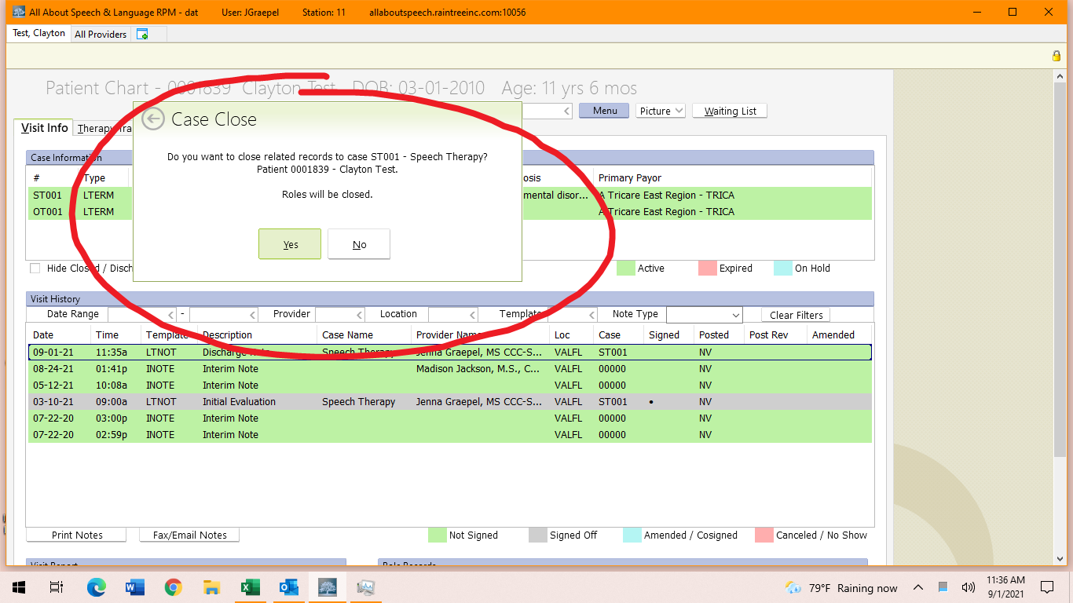

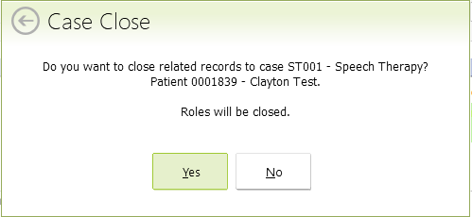

Please continue for instructions on when to select “Yes” versus ”No”

- When to select “Yes”: This means the patient is finished with treatment at AASL and will not be returning. Common reasons include but are not limited to the following: meeting goals, relocation, insurance changes, changing facilities, scheduling conflict.

- When to select “No”: This means the patient is finished with treatment at AASL at this time, but there is a possibility they will return. Common reasons include but are not limited to the following: seeking other services, taking a break, long term absence, scheduling conflict. If the parent has made any indication of resuming services, DO NOT close the record. This creates a headache for the administrative/billing departments, and also does not most accurately reflect the child’s long term course of treatment should they return.

