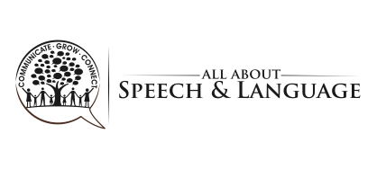

YOU DID IT!
Presented to

For
Signed

Date

