- This occurs when you have a client starting treatment at our office, but they have a current evaluation within 6 months from the initial evaluation to the time they want to start services at AASL
- In this case, you just have to add in LTG and STG based on goals and recommendations outlined in their outside evaluation.
- Once logged into the EMR, go to Patient Files, search via the client’s last name, and then click on their name when you find it from the drop down list. Then click on the patient chart

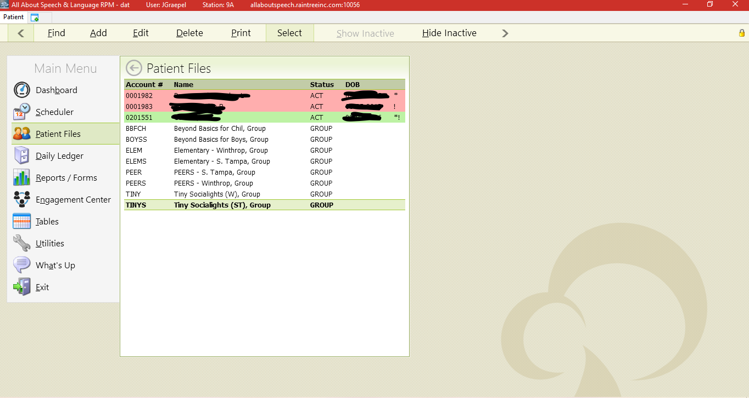

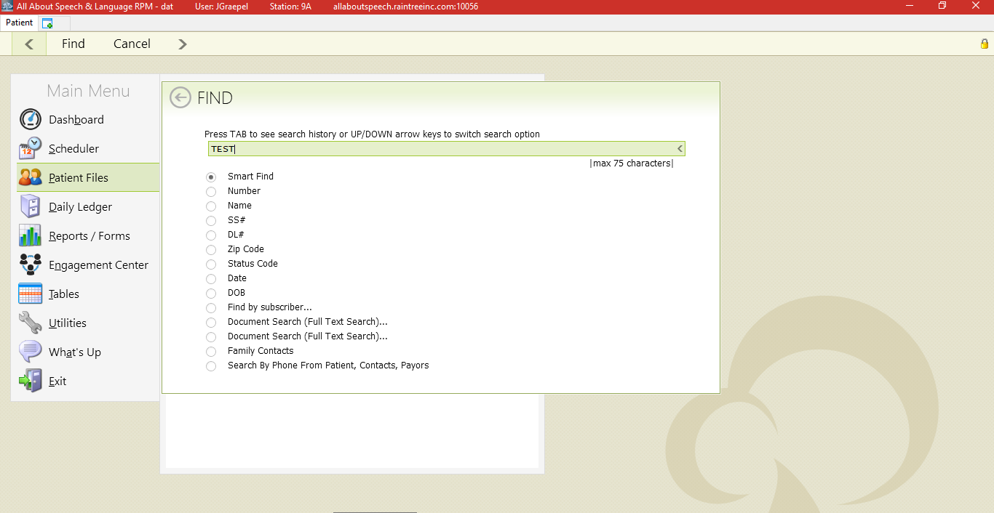

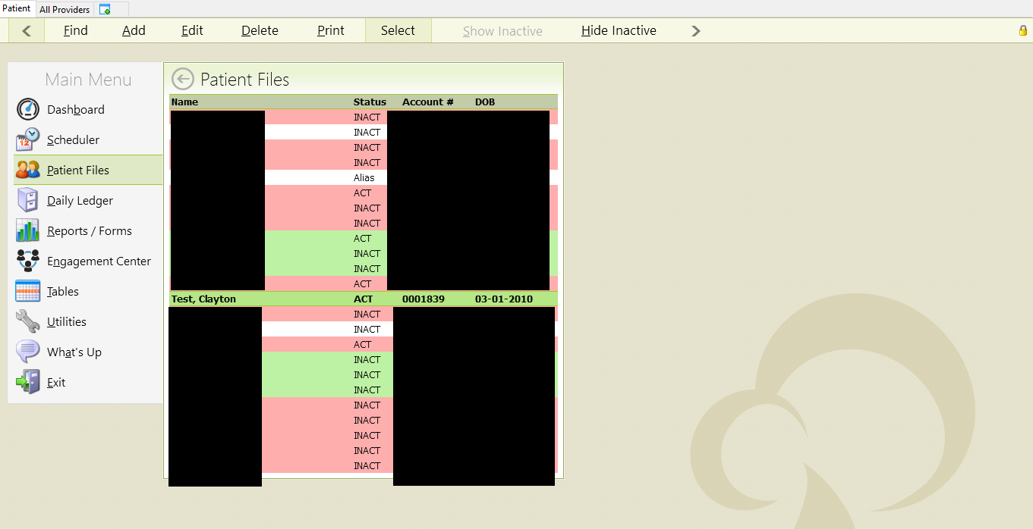
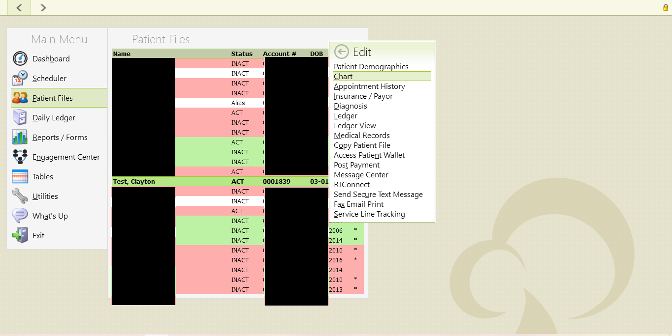

- Once in their patient chart hit A to add under Visit History, then select Long-Term Therapy Note. Select your respective discipline case (ST001 or OT001). When it populates, the note you will then need to change the Note Type to a conversion note on the drop down. Then under that make sure you add from the other dropdown OT Standard. This is located on the upper right hand side of the note.

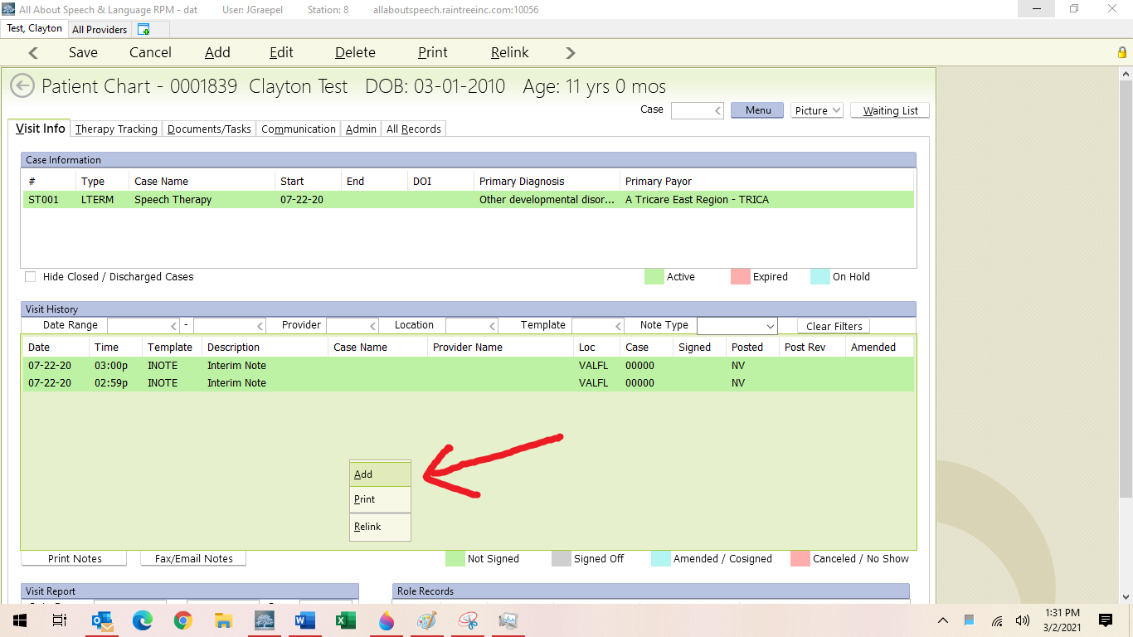

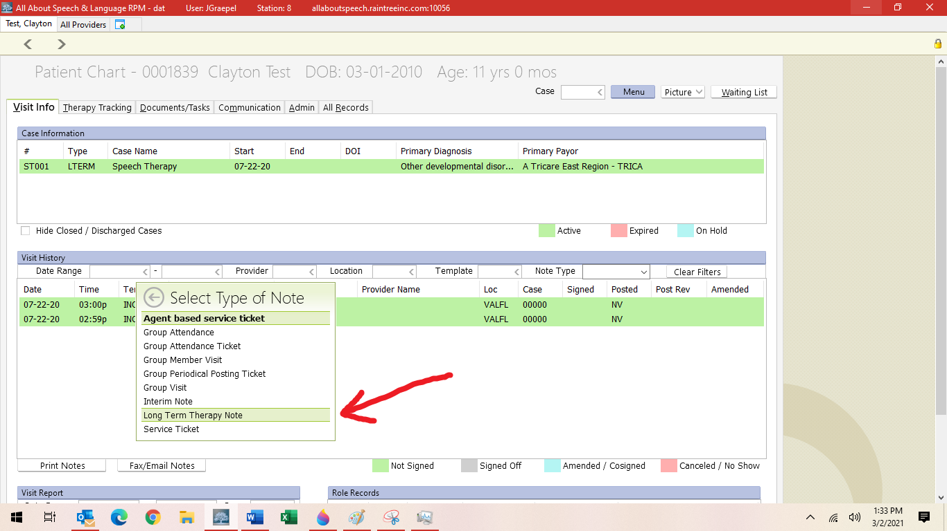
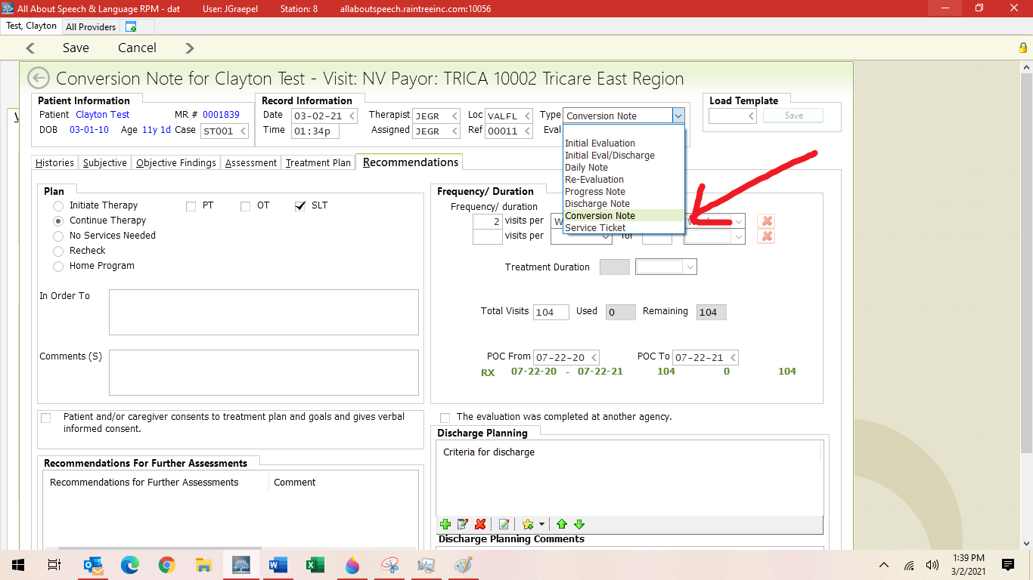

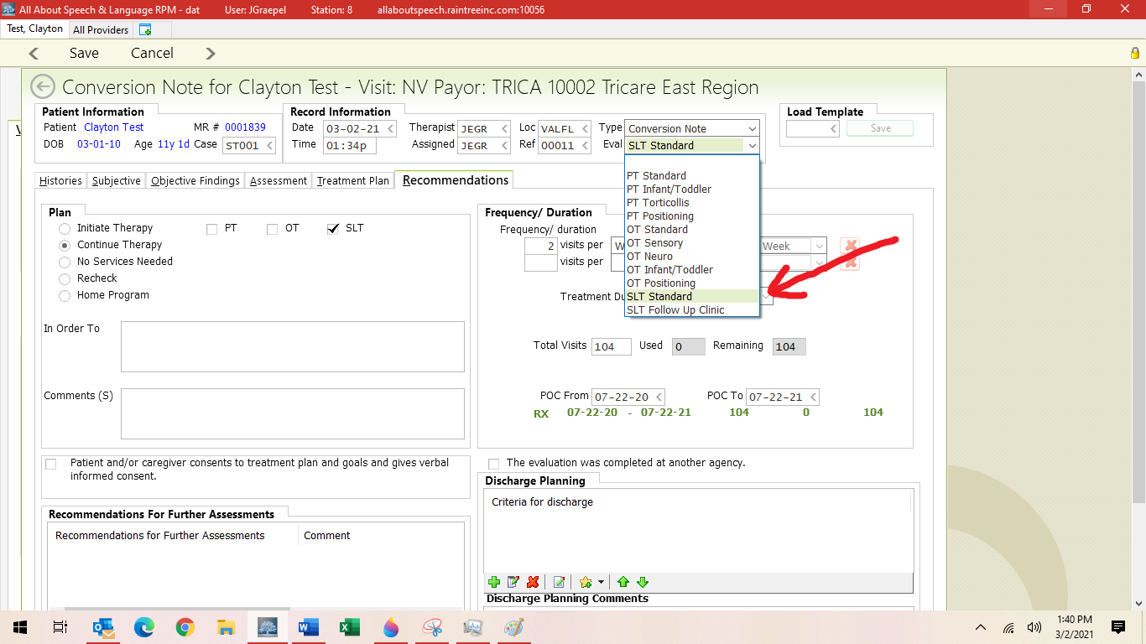

- You do not need to fill out all portions of this note template!
- Under the “Treatment Plan” tab you will add goals. Please do so the same way you would for an initial or re evaluation (See Procedure for “Completing an Evaluation”). You can use the goals from the outside evaluation or make revisions as you see fit.
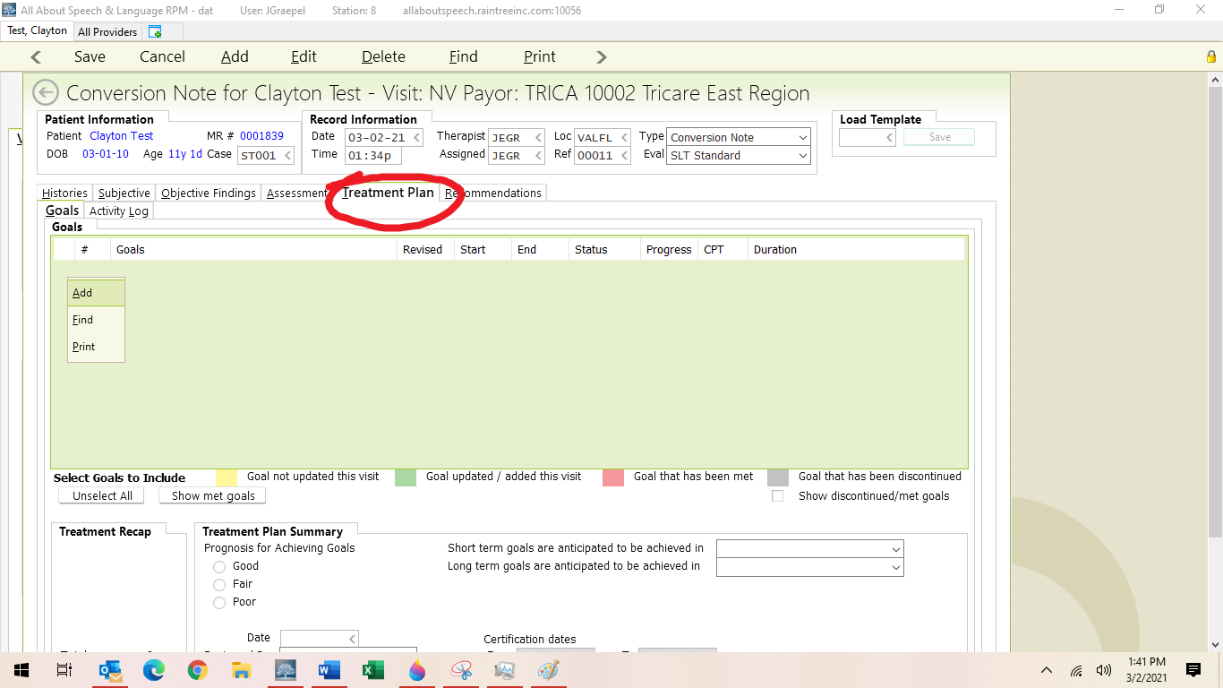

- Under the Recommendations, you just have to add in the following:
- Frequency/Duration: 2 visits per week for 52 weeks (DEPENDING ON CLIENT, may be 1x/week, may be 3x/week)
- Treatment Duration is 30-60 minutes USUALLY (rarely is it longer)
- Total number of visits will be 104 (52 weeks x 2 visits per week= 104; simple math)
- POC From and POC To Dates are in line with the initial date of the evaluation; so you input the initial date of the evaluation and then put that same date but a year later denoting when it “expires” and that will warrant us to do a re-evaluation
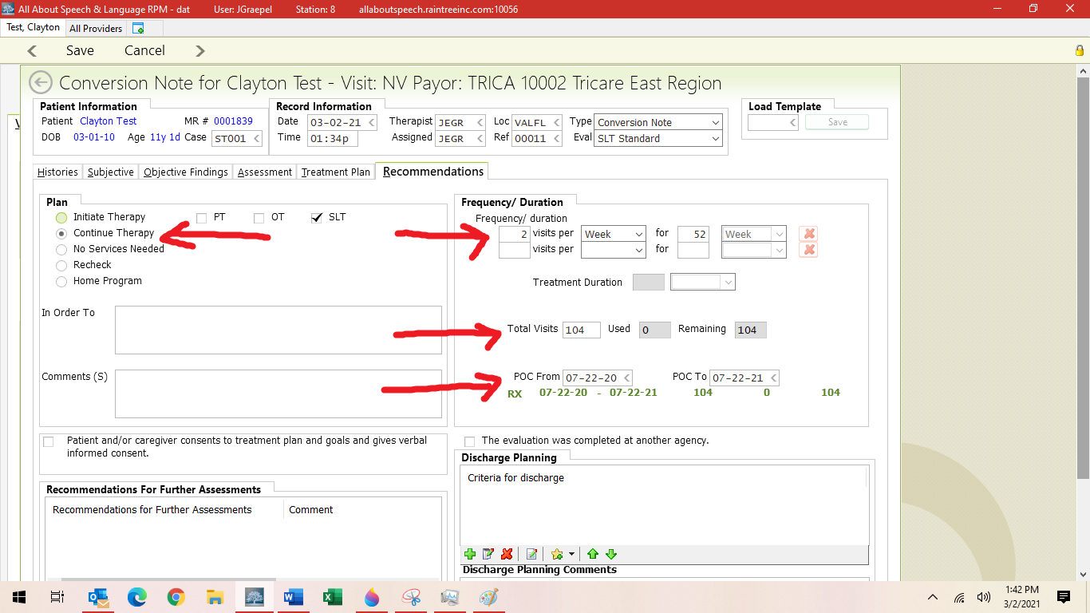

- Then you save and exit; it will not prompt you to sign off on the note
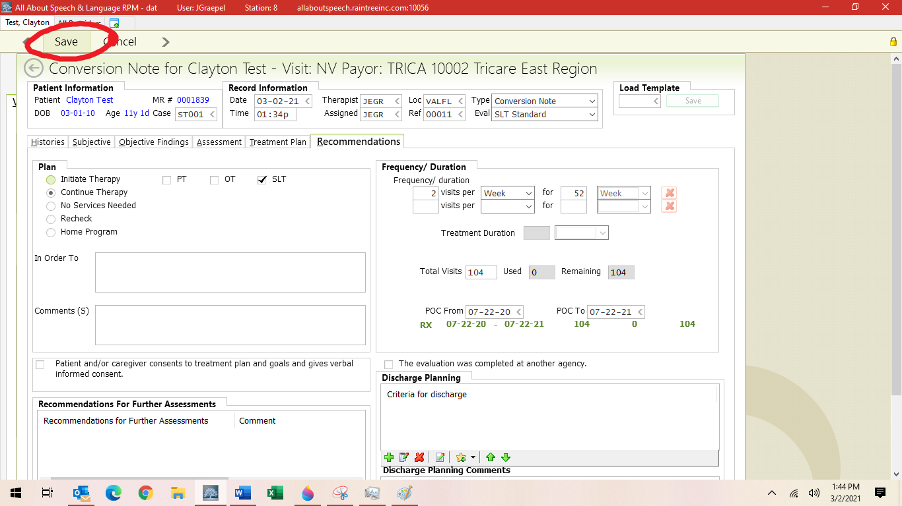

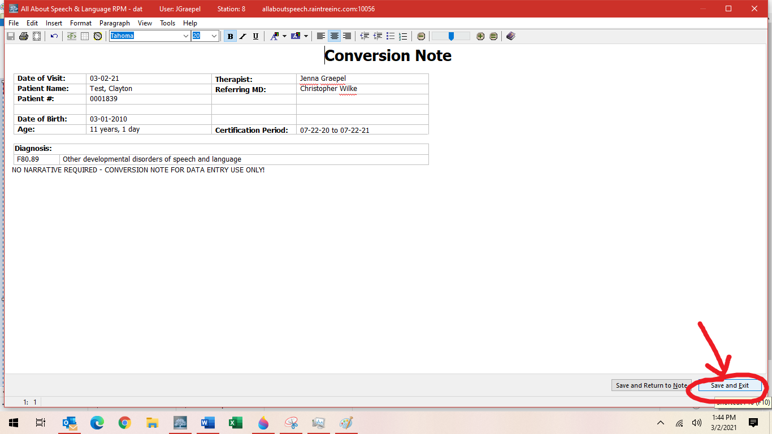

- Goals should then roll forward for the first treatment session.
- Goals rolling forward trouble shooting—see CM until procedure is written
Sometimes therapists do wait to write the conversion note until after the first visit once they get eyes on a new client if any goals need to get added etc; this is done on a case-by-case basis. Please communicate with your CM if this course of action is taken in starting with a client who has a previous evaluation from another facility.

PROCEURE AGREEMENT LOG

Sign and date with your name if you are required to know this policy. By signing you are attesting that you have received, read, and understand the policy, and will apply it as required

(Name) (Date)

