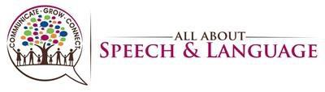

August 24,2021

All About Speech & Language
1452 Bloomingdale Ave
Valrico, FL 33596

Please contact us with any questions.

Thank you,

(name)
Speech-Language Pathologist

Phone: 813-616-4004

Phone: (813) 616-4004; Fax: (813) 330-7967
Email: info@aaspeech.com; Website: www.aaspeech.com

